Graphical Abstract

**Computational Inhibition Studies of the Human**

**Proteasome by Argyrin-based Analogues with**

**Subunit Specificity**

Eriketi Z. Loizidou and Constantinos D. Zeinalipour-Yazdi

Leave this area blank for abstract info.

|  |  |  |
| --- | --- | --- |
|  | Bioorganic & Medicinal Chemistry journal homepage: www.elsevier.com |  |

**Computational Inhibition Studies of the Human Proteasome by Argyrin-based analogues with subunit specificity**

Eriketi Z. Loizidoua* and Constantinos D. Zeinalipour-Yazdib

aDepartment of Biological Sciences, University of Cyprus, Nicosia 1678, Cyprus

bCySilicoTech Research Limited, 64 Kronou Street, Nicosia 2048, Cyprus

|  |  |
| --- | --- |
| ARTICLE INFO | ABSTRACT |
| Article history:  Received  Revised  Accepted  Available online | Proteasomes inhibitors that exhbit subunit specificity by inhibiting only one or two of the eukaryotic proteasome’s activities have higher therapeutic potential than broad proteasome inhibitors. In this work we developed a computational methodology for designing specific inhibitors for the proteasome’s active sites starting from the natural product Argyrin A. Our methodology involved the construction of “humanized” 3D models for the β1, β2 and β5 proteasome active sites, Density Functional Theory calculations and molecular docking simulations. We identify the determinants of selectivity by analysis of the binding conformations, binding site interactions and energetics of binding and propose new Argyrin analogues as inhibitors of the proteasome that may potentially exhibit subunit specificity.  2012 Elsevier Ltd. All rights reserved. |
| Keywords:  Proteasome inhibitors  Molecular docking  Rational drug design  Argyrin A |

Proteasomes recognize and digest protein substrates that have been marked for degradation by the attachment of ubiquitin. In the eukaryotic 26S proteasome the three proteolytic sites β1, β2 and β5 that exert caspase-like, trypsin-like and chymotrypsin-like activity respectively, reside within the 20S subunit1,2. Proteasome inhibitors that target the three active sites have been developed and have found applications in the treatment of cancer and autoimmune disorders3,4. Bortezomib is the first small molecule inhibitor of proteasome to be approved by FDA in 2003 for the treatment of multiple myeloma5. The clinical efficacy of Bortezomib provided the proof of principle that proteasome inhibitors are clinically viable and prompted the focus of research efforts to that area. Since then, another proteasome inhibitor, Carfilzomib, has been approved by the FDA6 for the treatment of relapsed and refractory multiple myeloma and many others have entered clinical trials4. Carfilzomib is a derivative of the natural product epoxomicin that also exhibits inhibitory activity against the proteasome. Natural products have shown an excellent track record for the treatment of cancer and have been used clinically since the early 60s. The continuous employment of natural products as a source of bioactive compounds stems from many factors including the wide space of chemical functionalities and biological activities. Other promising natural product proteasome inhibitors include the syrbactins7-11, syringolin A and glydobactin A, Argyrin A12,13 and scytonemides A and B14.

Inhibitors of the proteasome have to be highly specific and inhibit only one or two of the eukaryotic proteasomes activities in order to minimize toxic effects and maximize their therapeutic potential. Bortezomib was initially developed to inhibit the chymotrypsin-like activity of the proteasome (β5 site), but was later discovered to inhibit the caspase-activity as well (β1 site)15,16. Argyrin A showed in vivo proteasome inhibition in cells resistant to Bortezomib, suggesting that Argyrin A follows a different mechanism of proteasome inhibition, that is by preventing the destruction of the cyclin kinase inhibitor p27kip112. Furthermore, proteasome subunit knockdown and gene expression profiling studies suggested that Argyrin A is a more specific inhibitor of the proteasome than Bortezomib17. In the family of the Argyrin compounds (Argyrins A-H), analogues A and F are the most potent in terms of proteasome inhibition. Both analogues inhibit all three caspase-, trypsin- and chymortypsin-like activities however, each with different strength18.

Herein, we report the results of our effort to design new inhibitors of the proteasome with subunit specificity that are inspired by the Argyrin family of compounds. We performed an in-depth analysis of the binding conformation, binding site interactions and energetics of binding using DFT optimized molecular-docking simulations of Argyrin A to the three active sites utilizing "humanized" proteasome model.s We describe the spatial orientation of Argyrin A in each active site, and identify the determinants of selectivity. Through this, we provide our rational for the design of new argyrin analogues to identify potent and most importantly proteasome inhibitors with subunit specificity.

**Methods**

Argyrin A and analogues were …. DFT computations as implemented in GAMESS 19, with the use of Becke’s three-parameter hybrid exchange functional 20 (XC) combined with the Lee-Yang-Parr non-local correlation functional21, abbreviated as B3LYP, and the cartesian 6-31G gaussian basis set 22, augmented with one set of polarization functions on all atoms except hydrogen, denoted as 6-31G(d) (6d, 10f). Local minima for the various conformations have been confirmed by vibrational analysis and the lowest free energy conformation was used for the binding studies. Solvent effects have been implicitly considered using the integral equation formalism Polarizable Continuum Model (IEF-PCM) with a dielectric constant of 78.39. 23-26 All molecular docking studies were performed with the Autodock 4.0 suite of programs27,28 using 65x65x65 grid box centered at the inhibitors center-of-mass with a spacing of 0.375 Å. Solvent effects of the free and bound receptor-ligand complex are considered with the use of a semi-empirical force-field with charge-based desolvation details of which are described elsewhere.29,30 The Argyrin analogues were allowed rotational freedom through their maximum number of rotatable bonds, whereas “humanized” proteasome was kept rigid during the docking studies in order to take into account for the torsional entropy loss of the ligand upon binding. The free energy of binding (*ΔGbinding*) was evaluated based on the relationship, *ΔGbinding =ΔGPI* + *ΔGtor,I* + *ΔGI* , where *ΔGPI* is the energy difference of the unbound and bound proteasome-inhibitor complex, *ΔGtor,I* the torsional free energy change of the inhibitor due to binding and *ΔGI* the internal energy change due to conformational changes of the inhibitor in the bound and unbound state. The inhibition constant for the PI equilibrium going from the unbound to the bound state (P + I ↔ PI) was evaluated based on the expression, Ki = e-ΔG*binding*/RT.



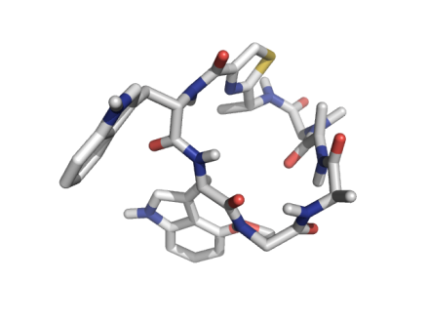

**1**

**2**

**3**

**4**

**5**

**6**

**7**

**8**

**9**

**10**

**11**

**12**

**13**

**14**

**15**

**16**

**17**

**18**

**19**

**20**

**21**

**22**

**23**

**24**

**Trp1**

**Trp2**

**Figure 1.** (Left)Optimized structure of Argyrin A at B3LYP/6-31G(d) level of theory; (Right) Chemical structure of the Argyrin analogues. For Argyrin A: R1 = CH3, R2 = H, R3 = OCH3, R4 = CH3, R5 = H, R6 = H. For Argyrin F: R1 = CH3, R2 = H, R3 = OCH3, R4 = CH2CH2OH, R5 = H, R6 = H.

**Preparation of 3D “humanized” proteasome model**

3D models of the β1, β2 and β5 sites of “humanized” proteasome were obtained by the selective in-silico site directed mutagenesis of yeast amino acids to the human equivalents at the yeast proteasome structure (PDB: 2F16)31, using the amino acid mutation utility of the Swiss PDB Viewer. The new amino acids were automatically inserted in the best configuration in terms of minimizing unfavorable contacts and maximizing hydrogen-bonding capability. The side chains of the newly inserted amino acids were optimized using the GROMOS function of the Swiss PDB Viewer program.32 Sequences of the human proteasome for the β1, β2 and β5 units were obtained from the UniProt databank (UniProt accession numbers P20618 (β1), P49721 (β2), P28074 (β5)) and were aligned to the corresponding sequences of the yeast homologs (UniProt accession numbers P38624 (PRE3), P25451 (PUP3), P25043 (PUP1), P30656 (PRE2), P23724 (C5)), using the multiple alignment mode of ClustalX 2.133,34. Table 1 shows the substitutions of the yeast amino acids to the equivalent human amino acids.

**Table 1.** Yeast to human substituted amino acids of the proteasome

|  |  |  |  |  |  |
| --- | --- | --- | --- | --- | --- |
| **β1 pocket** | | **β2 pocket** | | **β5 pocket** | |
| Yeast to human mutation | Unit | Yeast to human mutation | Unit | Yeast to human mutation | Unit |
| T20L | PRE3 | S129Y | PUP1 | Q131S | PRE2 |
| T21S | PRE3 | G96T | PUP1 | T21S | C11 |
| T22E | PRE3 | T48E | PUP1 | R91Q | PRE4 |
| S48F | PRE3 | Y24S | C5 | D114P | C5 |
| T96Y | PRE3 | G23N | PUP1 | V116G | C5 |
| S168Y | PRE3 | Q22S | PUP1 | P115M | C5 |
| A50G | PUP1 | T21A | PUP1 | F113V | C5 |
| H114D | PUP1 | T21S | PRE3 | Y96M | C5 |
| H116L | PUP1 | S20A | PUP1 | S118M | C5 |
| L115P | PRE3 |  |  | Y119M | C5 |
| L95Y | PRE3 |  |  |  |  |

**Results and Discussion**

The potential energy surface of Argyrin A was explored through Quantum-mechanical molecular dynamics simulations (QM-MM) in which the lowest lying conformer was subsequently optimized in aqueous using B3LYP/6-31G(d). The macrocyclic backbone, in the optimized structure, adopted six *trans* (N6-C7, N9-C10, N12-C13, N15-C16, N18-C19, N21-C22) and one *cis* (N3-C4) amide bond, a conformation that is frequently found in cyclic heptapeptides35. In this conformation the thiazole group is coplanar with the adjacent peptide bond, the methyl group at C15 points outwards and Trp1 and Trp2 are roughly perpendicular to each other. During the docking experiments the macrocyle was kept rigid whereas Trp1 and Trp2 were allowed to rotate providing flexibility to their relative conformation with respect to the macrocycle.

The success in designing new inhibitors using docking processes relies on the knowledge of the active site structure of the target protein. It is therefore, imperative to use structures that resemble as much as possible the 3D structures of the human protein targets. Since an X-ray structure of the human proteasome is not available, 3D models of “humanized” proteasome for each of the three binding sites, β1, β2 and β5, were prepared starting from the structure of yeast proteasome in complex with bortezomib (PDB: 2F16). Binding sites defined as the residues within 20 Å distance from Bortezomib. A reiterative process was followed in which Argyrin A was docked at each active site of the yeast proteasome and the interacting residues were identified and replaced with the human equivalents thus preparing the first series of “humanized” models. We used these models to repeat docking to Argyrin A, identify the interacting residues and replace them to the human equivalents. This process was repeated until no more yeast residues were identified in the interacting residues. Following this methodology we prepared three models for the β1, β2 and the β5 active sites.

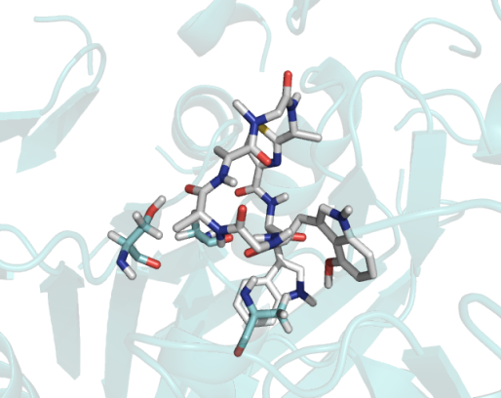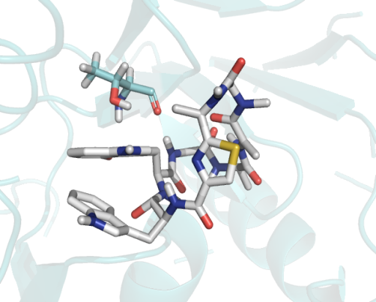

C)

A49

G47

G48

M45

C52

T1

V31

A20

T21

A22

G23

S96

B)

T21

Q22

G23

S20

I116

D114

L115

S129

Y24

T1

G168

A)

T1

S168

S129

A49

T21

T20

T22

A50

T96

G47

S118

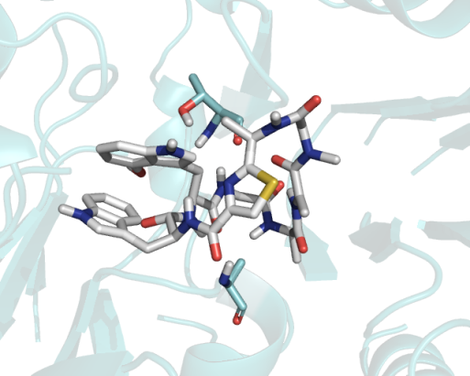

**Figure 2.** Lowest energy docked conformations of Argyrin A (grey-carbon stick representation) at the A) β1, Β) β2 and C) β5 active sites of the yeast proteasome (PDB: 2F16). Interacting residues are labeled in red, those that participate in hydrogen bonding and π-π interactions are also shown in stick representations. Red lines represent hydrogen bonds and green lines π-π stacking.

C)

P114

M118

M115

A50

A49

D51

G48

A45

G47

A20

A22

T21

S96

B)

Y129

T96

G128

G47

T1

G168

A21

N23

A)

L116

Y96

E22

G23

S129

A49

F48

G47

G50

Y168

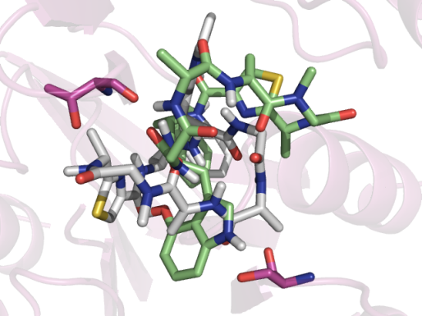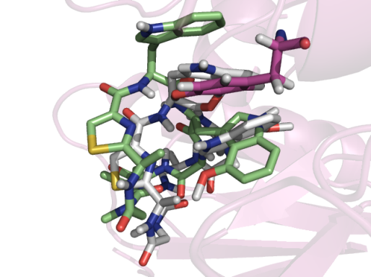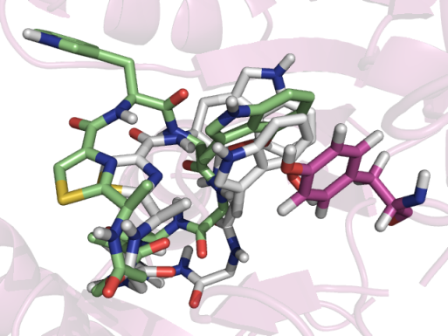

**Figure 3.** Overlay of the lowest energy binding conformations of Argyrin A at the A) β1, Β) β2 and C) β5 active sites of the 3D “humanized” proteasome models (green-carbon stick representation), to those from the yeast proteasome (grey-carbon stick representation). Interacting residues are labeled in red, those that participate in hydrogen bonding and π-π interactions are also shown in stick representations. Red lines represent hydrogen bonds and green lines π-π interactions.

Each active site of the proteasome has distinguished characteristics that account for the specificity that is shown towards the peptide substrates that it cleaves. In particular, in yeast proteasome the β1 active site (PRE3), is characterized by a basic specificity pocket (R45), favoring caspase activity, the β2 active site (PUP1), by an acidic specificity pocket (E53) favoring trypsin-like activity and the β5 active site (PRE2), by an apolar specificity pocket (M45), favoring chymotrypsin-like activity2. By taking advantage of the differences in the specificity pockets of each site it is possible to design compounds to show selectivity for either the β1, β2 or β5 binding sites.

To this end, we studied the interactions of Argyrin A to the three active sites of the yeast (Fig. 2) and the “humanized” (Fig. 3) proteasome. Similarities in the docked conformations of Argyrin A along the three active sites of the yeast proteasome are observed. In particular, in all three sites both tryptophan moieties are buried within the specificity pockets. Furthermore, hydrogen bonding interactions between T21 and an amide of the Argyrin A backbone are observed at the β1 and β2 sites, as well as hydrogen bonding between A49 and an amide of the Argyrin A backbone for the β1 and β5 pocket. In addition to this, two extra hydrogen bonding interactions that are specific to β5 are observed between residues S96, G47 and the macrocyclic backbone of Argyrin A. Further interactions specific to each binding site are limited to VDW interactions with residues S129, S168, G46, T96, T1 T21, T22, A50, S118 in the β1 pocket, S129, G168, Y24, S20, Q22, G23, D114, L115, I116 in the β2 pocket and G48, M45, C52, V31, A20, T21, A22, G23, T1 in the β5 pocket.

In the “humanized” proteasome the docked conformations of Argyrin A at each active site display unique characteristic (Fig. 3). In the β1 pocket, the backbone conformation of Argyrin A is nearly identical to the one observed with the yeast proteasome with the biggest difference being on the orientation of the tryptophan units. The latter in the yeast proteasome are nearly perpendicular to each other while in the “humanized” model they adopt a more extended conformation. Furthermore, the hydrogen bonding interaction with T21 of the yeast proteasome is not observed for the “humanized” proteasome while a new π-π interaction between Trp2 and Y168 arises. It should be noted that Y168 is specific to the human proteasome and that the corresponding amino acid for the yeast proteasome is S168. In a similar manner, the tryptophan units of Argyrin A buried within the specificity pocket of the β2 site of the “humanized” proteasome, adopt a more extended conformation to accommodate the π-π interactions with Y129. The latter is specific to the human proteasome while the corresponding amino acid for the yeast proteasome is S129. Furthermore, due to the T21A mutation the hydrogen bonding interaction between Argyrin A and yeast proteasome is not observed for the “humanized” proteasome.

G50

L116

A49

F48

G47

Y96

E22

G23

Y168

S129

A)

Y129

T96

G47

G168

G128

B)

C)

D51

G116

S112

V113

M118

M114

M115

R91

S96

G47

A22

G23

T21

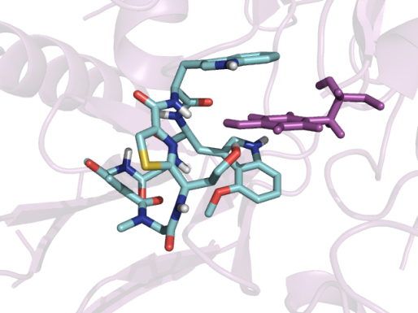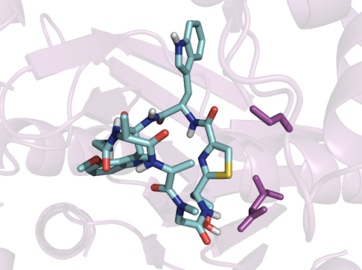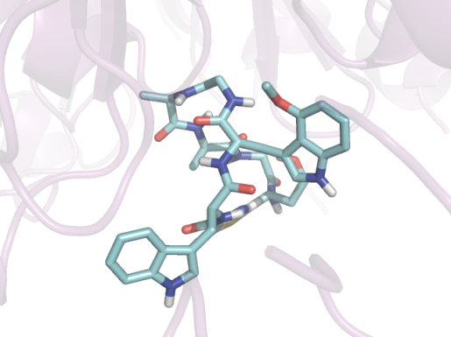

**Figure 4.** Lowest energy docked conformations of Argyrin F at the A) β1, Β) β2 and C) β5 active sites of the 3D “humanized” proteasome models. Red lines represent hydrogen bonds and green lines π-π interactions.

**Fix the legend like fig. 2and 3**

In the β5 pocket, three low energy binding conformations were observed for Argyrin A in which ….(Fig. 1S). In the most frequently found conformation (Fig. 3C), S96 is still engaged in a hydrogen bonding interaction however, with the indole hydrogen of Trp2 and T21 to a backbone NH group.

This docking methodology was also applied to another analogue, Argyrin F, to examine whether it can provide a rational for the different selectivities for each site that are observed among the two analogues (Fig. 4). The order of inhibition of proteasome activity at each site is for Argyrin A, β1 ≈ β5 > β2, and for Argyrin F, β5 > β1 ≈ β2. The order of inhibition of proteasome activity at the β1 site is Argyrin A > Argyrin F, at the β2 site, Argyrin F > Argyrin A, and at the β5 site, Argyrin F ≈ Argyrin A18. Here must mention the no correlation between DG and proteasome inhibition constansts, but that binding conformations are accurate [ref]. The interactions that are observed in the lowest energy docked conformation of Argyrin F at the β1 site are mostly dispersive. In contrast to the Argyrin A, the π-π interaction to Y168 is not observed which may explain in part the lower affinity of Argyrin F to the β1 site, than Argyrin A. Likewise, the higher affinity of Argyrin F to the β2 site may be explained by the hydrogen bond between the CH2CH2OH and Y129 in addition to the π-π interaction to Y129 that is also present in Argyrin A. Both Argyrin A and F have similar affinities for the β5 site and this is also observed in the interactions where both analogues, in addition to dispersive interactions, are engaged into two hydrogen bonds (D51 and G116 for Argyrin F). mention that D51 interacts with the OH of Argyrin F. Describe the interactions in general.

Based on these findings, the analogues in Table 2 were designed to have maximal interactions with either the β1, β2 or β5 site (Fig. 1S – 12S). CON TO DESCRIBE HOW WE DESIGNED THEM WITH GAUSSview AND THEN DOCKING AGAIN. Our approach on designing new Argyrin analogues with subunit specificity was based on the assumption that maximizing interactions in each pocket would lead to subunit specific inhibitors.

Two substitution sites were selected, R5 and R6, as designated in Fig. 1.

For example, analogues 1 to 6 were designed to have increased interactions with residues of the β1 site by forming an extra hydrogen bonding interaction with E22.

Come up with some sort of correlation between the nature of the specificity pockets for each site and the effect of the mutations i.e by introducing a polar group may have a negative effect on a hydrophobic pocket.

**Put emphasis on the analogues that exhibit specificity for either binding site i.e b1 or b2 or b5 or any combination of 2.**

**Find out the strength of p-p stacking versus H-bond**

**In my conclusions I should emphasize the differences in interactions between yeast and human proteasomes and highlight the need for using humanized models for drug design.**

**Table 3:** Novel Argyrin analogues and their computed inhibition constants as determined from molecular docking experiments for the sitesβ1, β2 and β5. For substitution points R5, R6 refer to Fig.1.

|  |  |  |  |  |  |  |  |  |
| --- | --- | --- | --- | --- | --- | --- | --- | --- |
| **Compound** | **R5** | **R6** | ***KI*Compound μM** | | | **Interacting amino acids h-bonding (red) and π-π stacking (green)** | | |
|  |  |  | **β1** | **β2** | **β5** | **β1** | **β2** | **β5** |
| Argyrin A | H | H | 2.5 | 133.13 | 0.65 | Y168 | Y129 | S96 T21 |
| Argyrin F | H | H | 9.77 | 296.84 | 0.47 | ------- | Y129 Y129 | G116 D51 |
| Analogue 1 | ΟΗ | H | 0.36 | 310.85 | 1.21 | E22 | ------- | T21 |
| Analogue 2 | ΝΗ2 | H | 1.56 | 572.32 | 6.29 | E22 S21 Y168 Y168 | Y129 | T21 |
| Analogue 3 | ΝΗCΗ3 | H | 3.19 | 546.38 | 2.38 | E22 Y168 Y95 | ------- | G47 G116 R91 |
| Analogue 4 | ΝΗ2 | OH | 2.84 | 699.65 | 7 | E22 S21 Y168 | ------- | M115 A50 |
| Analogue 5 | ΟΗ | OH | 2.16 | 266.95 | 0.81 | Y95 Y168 | ------- | S112 G116 G47 |
| Analogue 6 | H | OH | 6.9 | 207.5 | 0.36 | D51 F48 | ------- | M115 A50 |
| Analogue 7 | CH2CONH2 | H | 2.45 | 157.21 | 1.33 | S118 | T1 Y129 | T21 |
| Analogue 8 | Η | N(CH3)2 | 1.95 | 149.22 | 2.75 | F48 | D114 N23 | M115 G94 |
| Analogue 9 | Η | NHCH3 | 1.14 | 172.35 | 2.16 | Y95 | N23 | R91 G116 G47 |
| Analogue 10 | Η | SO3H | 0.13 | 37.03 | 0.17 | S24 R19 T1 S129 Y96 | ------- | M118 S129 T1 |
| Analogue 11 | Η | CH2COCH3 | 1.74 | 114.73 | 1.19 | E22 Y168 S129 T1 | Y129 Y129 | A50 S96 |
| Analogue 12 | Η | CH2COOCH3 | 2.41 | 209.27 | 1.3 | E22 | ------- | ------- |

**Acknowledgments**

Financial support by the Marie Curie International Reintegration Grant (FP7-PEOPLE-2007-4-3-IRG-204263) is gratefully acknowledged.

**References**

1. Bochtler, M.; Ditzel, L.; Groll, M.; Hartmann, C.; Huber, R. *Annu. Rev. Biophys. Biomol. Struct.* **1999,** *28*, 295-317.

2. Heinemeyera, W.; Ramosb, P. C.; Dohmenc, R. J. *CMLS, Cell. Mol. Life Sci.* **2004,** *61*, 1562–1578.

3. Kisselev, A. F.; Linden, W. A. v. d.; Overkleeft, H. S. *Chem Biol.* **2012,** *19*, 99-115.

4. Jr., S. T. P.; Shanker, A. *J Clin Cell Immunol* **2013,** *available in PMC 2013 January 16*.

5. Kane, R. C.; Farrell, A. T.; Sridhara, R.; Pazdur, R. *Clinical Cancer Research* **2006,** *12*, 2955-2960.

6. Thompson, J. L. *The Annals of Pharmacotherapy* **2013,** *47*, 56-62.

7. Krahn, D.; Ottmann, C.; Kaiser, M. *Natural Product Reports* **2011,** *28*, 1854-1867.

8. Clerc, J.; Li, N.; Krahn, D.; Groll, M.; Bachmann, A. S.; Florea, B. I.; Overkleeft, H. S.; Kaiser, M. *Chemical Communications* **2011,** *47*, 385-387.

9. Clerc, J.; Florea, B. I.; Kraus, M.; Groll, M.; Huber, R.; Bachmann, A. S.; Dudler, R.; Driessen, C.; Overkleeft, H. S.; Kaiser, M. *Chembiochem* **2009,** *10*, 2638-2643.

10. Krahn, D.; Ottmann, C.; Kaiser, M. *Current Medicinal Chemistry* **2011,** *18*, 5052-5060.

11. Archer, C. R.; Koomoa, D. L. T.; Mitsunaga, E. M.; Clerc, J.; Shimizu, M.; Kaiser, M.; Schellenberg, B.; Dudler, R.; Bachmann, A. S. *Biochemical Pharmacology* **2010,** *80*, 170-178.

12. Nickeleit, I.; Zender, S.; Sasse, F.; Geffers, R.; Brandes, G.; Sorensen, I.; Steinmetz, H.; Kubicka, S.; Carlomagno, T.; Menche, D.; Gutgemann, I.; Buer, J.; Gossler, A.; Manns, M. P.; Kalesse, M.; Frank, R.; Malek, N. P. *Cancer Cell* **2008,** *14*, 23-35.

13. Florenz Sasse; Heinrich Steinmetz; Thomas Schupp; Frank Petersen; Klaus Memmert; Hans Hofmann; Christoph Heusser; Volker Brinkmann; Peter Von Matt; Hofle, G.; Reichenbach, H. *The Journal of Antibiotics* **2002,** *55*, 543-551.

14. Krunic, A.; Vallat, A.; Mo, S. Y.; Lantvit, D. D.; Swanson, S. M.; Orjala, J. *Journal of Natural Products* **2010,** *73*, 1927-1932.

15. Adams, J. *Cancer Cell* **2004,** *5*, 417-421.

16. Berkers, C. R.; Verdoes, M.; Lichtman, E.; Fiebiger, E.; Kessler, B. M.; Anderson, K. C.; Ploegh, H. L.; Ovaa, H.; Galardy, P. J. *Nature Methods* **2005,** *2*, 357-362.

17. McConkey, D. J. *Nature Chemical Biology* **2008,** *4*, 528-529.

18. Bulow, L.; Nickeleit, I.; Girbig, A. K.; Brodmann, T.; Rentsch, A.; Eggert, U.; Sasse, F.; Steinmetz, H.; Frank, R.; Carlomagno, T.; Malek, N. P.; Kalesse, M. *Chemmedchem* **2010,** *5*, 832-836.

19. Schmidt, M. W.; Baldridge, K. K.; Boatz, J. A.; Elbert, S. T.; Gordon, M. S.; Jensen, J. J.; Koseki, S.; Matsunaga, N.; Nguyen, K. A.; Su, S.; Windus, T. L.; Dupuis, M.; Montgomery, J. A. *J. Comp. Chem.* **1993,** *14*, 1347.

20. Becke, A. D. *J. Chem. Phys.* **1993,** *98*, 5648-5652.

21. Lee, C.; Yang, W.; Parr, R. G. *Phys. Rev. B* **1988,** *37*, 785-789.

22. Hehre, W. J.; Ditchfield, R.; Pople, J. A. *J. Chem. Phys.* **1972,** *56*, 2257.

23. Cancès, M. T.; Mennucci, B.; Tomasi, J. *J. Chem. Phys.* **1997,** *107*, 3032.

24. Mennucci, B.; Tomasi, J. *J. Chem. Phys.* **1997,** *106*, 5151

25. Mennucci, B.; Cancès, E.; Tomasi, J. **1997,** *101*, 10506.

26. Tomasi, J.; Mennucci, B.; Cancès, E. *J. Mol. Struct. (Theochem)* **1999,** *464*, 211.

27. Morris, G. M.; Goodsell, D. S.; Halliday, R. S.; Huey, R.; Hart, W. E.; Belew, R. K.; Olson, A. J. *J. Comp. Chem.* **1998,** *19*, 1639-1662.

28. Huey, R.; Morris, G. M.; Olson, A. J.; Goodsell, D. S. *J. Comp. Chem.* **2007,** *28*, 1145-1152.

29. Loizidou, E. Z.; Sun, L.; Zeinalipour-Yazdi, C. *J. Mol. Recognit.* **2011,** *24*, 678-686.

30. Loizidou, E. Z.; Zeinalipour-Yazdi, C. D.; Christofides, T.; Kostrikis, L. G. *Bioorg Med Chem* **2009,** *17*, 4806-4818.

31. Groll, M.; Berkers, C. R.; Ploegh, H. L.; Ovaa, H. *Structure* **2006,** *14*, 451.

32. Guex, N.; Peitsch, M. C. *Electrophoresis* **1997,** *18*, 2714-2723.

33. Larkin, M. A.; Blackshields, G.; Brown, N. P.; Chenna, R.; McGettigan, P. A.; McWilliam, H.; Valentin, F.; Wallace, I. M.; Wilm, A.; Lopez, R.; Thompson, J. D.; Gibson, T. J.; Higgins, D. G. *Bioinformatics* **2007,** *23*, 2947-2948.

34. Thompson, J. D.; Gibson, T. J.; Plewniak, F.; Jeanmougin, F.; Higgins, D. G. *Nucleic Acids Research* **1997,** *25*, 4876-4882.

35. Mechnich, O.; Hessler, G.; Kessler, I.-I. *Helvetica Chimica Acta* **1997,** *80*, 1338-1354.

**Computational Inhibition Studies of the Human Proteasome by Argyrin-based Analogues with**

**Subunit Specificity**

Eriketi Z. Loizidou and Constantinos D. Zeinalipour-Yazdi

SUPPORTING INFORMATION

B)

M115

A50

R91

D51

A46

G116

M45

A49

P114

G47

K33

V31

A27

A20

A22

T21

T1

A)

G116

R91

G48

G47

M115

M118

P114

V113

S112

T21

A22

G23

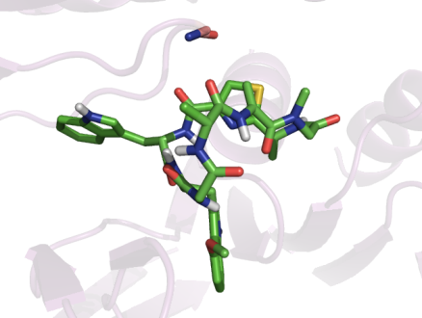

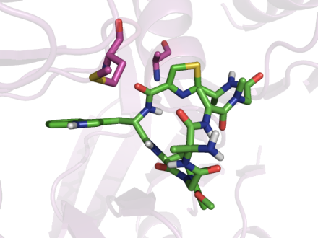

**Figure 1S.** Alternative binding modes of Argyrin A at the β5 active sites of the 3D “humanized” proteasome model. Red lines represent hydrogen bonds and green lines π-π interactions.

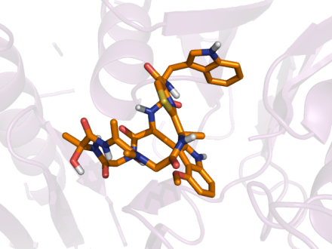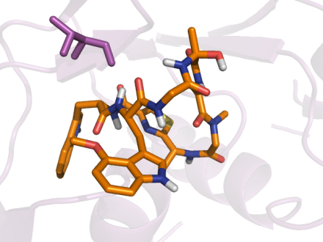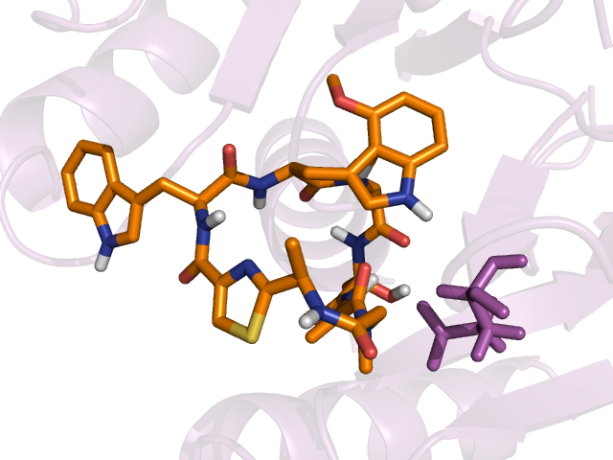

B)

T96

G128

A21

S22

G168

Y129

T21

D51

M45

A50

A46

S96

A49

G48

G47

T1

M118

V31

P114

M115

A20

A22

C)

E22

D50

L116

A49

F48

Y96

G47

S21

G23

Y168

A)

**Figure 2S.** Lowest energy docked conformations of analogue 1 at the A) β1, Β) β2 and C) β5 active sites of the 3D “humanized” proteasome models. Red lines represent hydrogen bonds and green lines π-π interactions.

B)

Y129

T96

Y98

G47

N23

G168

T1

A21

T21

M115

P114

M118

A22

A50

D51

S96

G48

A49

G47

A20

V31

M45

A46

C)

Y95

E22

S21

Y168

N94

A49

F48

A)

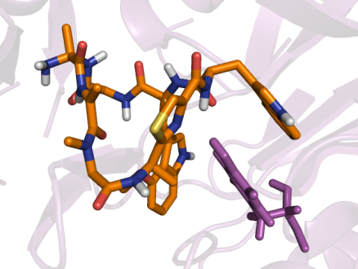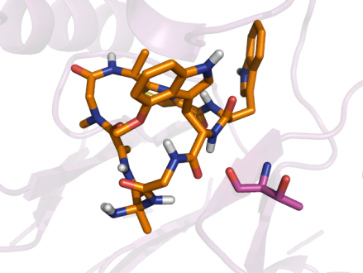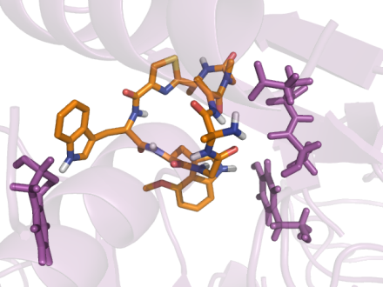

**Figure 3S.** Lowest energy docked conformations of analogue 2 at the A) β1, Β) β2 and C) β5 active sites of the 3D “humanized” proteasome models. Red lines represent hydrogen bonds and green lines π-π interactions.

C)

G47

R91

G116

G48

T21

A22

G23

M115

S112

V113

M118

P114

A)

E22

Y168

Y95

N94

F48

A49

S24

Y96

B)

T96

G47

T1

Y129

G168

N23

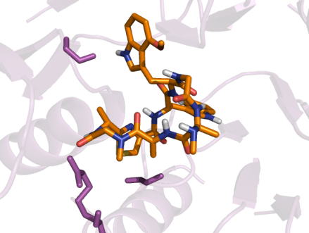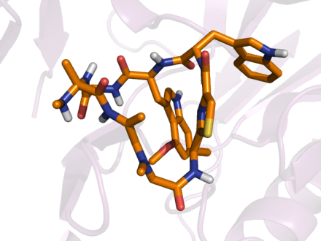

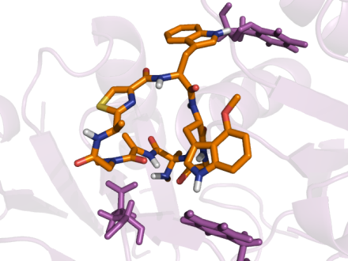

**Figure 4S.** Lowest energy docked conformations of analogue 3 at the A) β1, Β) β2 and C) β5 active sites of the 3D “humanized” proteasome models. Red lines represent hydrogen bonds and green lines π-π interactions.

C)

M115

A50

R91

D51

G116

P114

A45

A46

G47

A27

A20

T21

A22

T1

A)

Y168

S21

E22

F48

A49

Y96

Y95

N94

T96

E48

D114

Y129

S22

G23

N23

B)

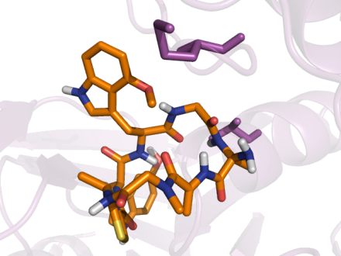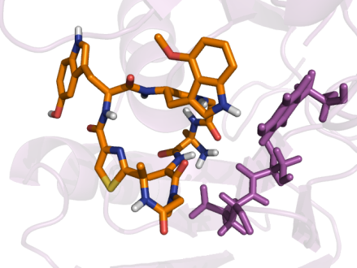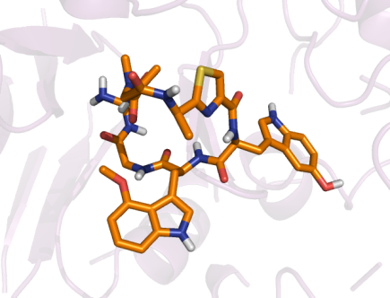

**Figure 5S.** Lowest energy docked conformations of analogue 4 at the A) β1, Β) β2 and C) β5 active sites of the 3D “humanized” proteasome models. Red lines represent hydrogen bonds and green lines π-π interactions.

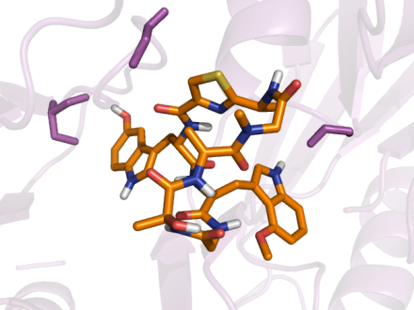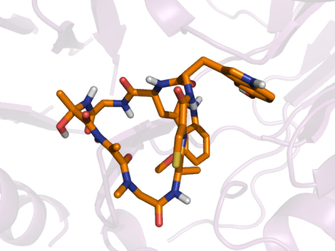

A)

Y95

Y168

Y96

G23

E22

S21

L116

A49

G50

G47

F48

C)

S112

G116

G47

M119

G120

M118

P114

M115

R91

G48

T21

A22

G23

B)

T96

G47

Y129

T1

G168

N23

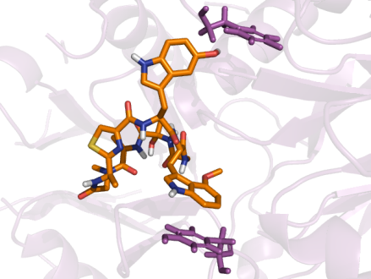

**Figure 6S.** Lowest energy docked conformations of analogue 5 at the A) β1, Β) β2 and C) β5 active sites of the 3D “humanized” proteasome models. Red lines represent hydrogen bonds and green lines π-π interactions.

C)

A50

M115

V31

M118

P114

G116

A49

D51

G47

T1

R91

A27

T21

A22

A)

F48

D51

S21

E22

G23

Y96

A49

L116

B)

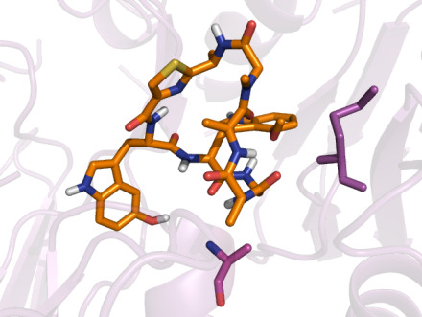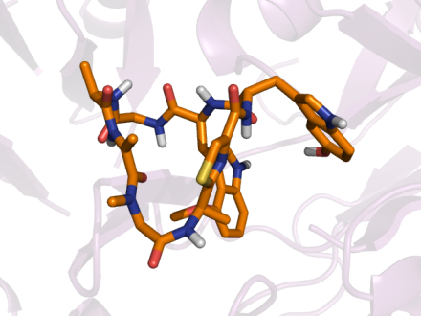

T96

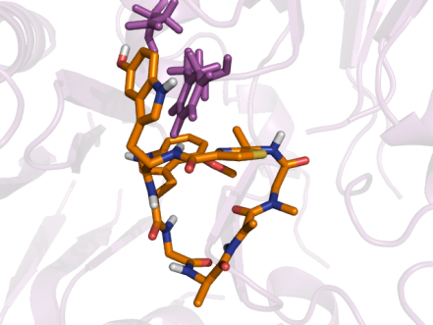

G47

T1

N23

Y129

G168

**Figure 7S.** Lowest energy docked conformations of analogue 6 at the A) β1, Β) β2 and C) β5 active sites of the 3D “humanized” proteasome models. Red lines represent hydrogen bonds and green lines π-π interactions.

C)

T21

A50

M115

S96

G47

G48

A46

A49

M45

P114

M118

T1

A20

A22

G23

B)

Y129

T1

G47

F132

G23

N23

S24

I24

A)

S118

E22

G23

S24

Y168

Y96

G47

F48

A49

D114

L116

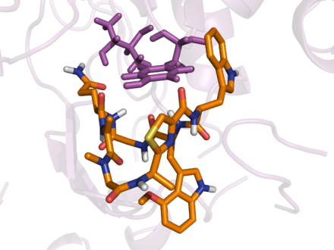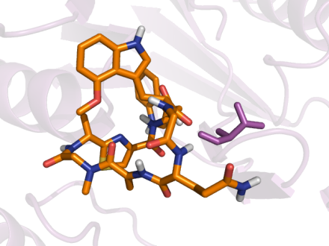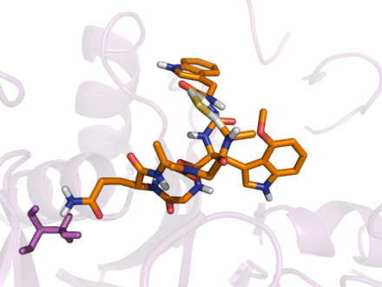

**Figure 8S.** Lowest energy docked conformations of analogue 7 at the A) β1, Β) β2 and C) β5 active sites of the 3D “humanized”

proteasome models. Red lines represent hydrogen bonds and green lines π-π interactions.

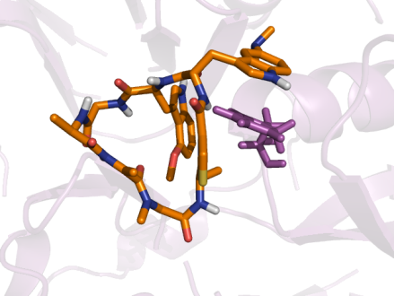

C)

G94

G116

G47

G48

A49

R91

D51

A50

M115

P114

M118

A20

A22

T21

T1

R19

Y168

A)

F48

R91

D51

L116

A49

Y96

E22

S24

G23

B)

D114

N23

A49

T96

A21

S22

S24

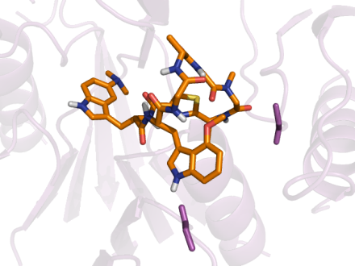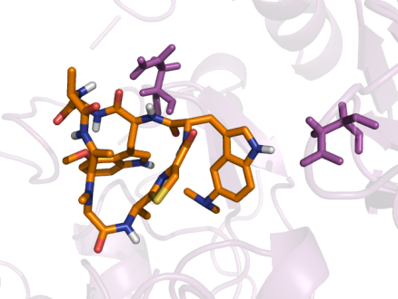

**Figure 9S.** Lowest energy docked conformations of analogue 8 at the A) β1, Β) β2 and C) β5 active sites of the 3D “humanized” proteasome models. Red lines represent hydrogen bonds and green lines π-π interactions.

A)

Y95

Y96

F48

G50

L116

A49

G47

E22

G23

S129

Y168

B)

N23

S24

S22

G168

A21

Y129

G47

T96

E48

D114

A49

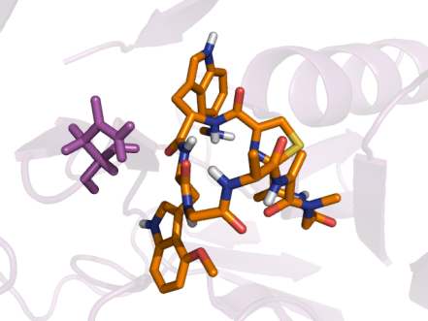

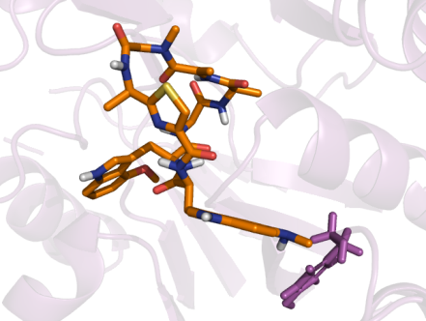

**Figure 10S.** Lowest energy docked conformations of analogue 9 at the A) β1, Β) β2 and C) β5 active sites of the 3D “humanized” proteasome models. Red lines represent hydrogen bonds and green lines π-π interactions.

C)

A49

T1

S129

M118

G47

A20

S96

Y168

R19

G23

T21

A22

B)

T1

D114

E48

T96

A21

S22

Y129

G168

A)

S24

Y168

T1

Y96

F48

G47

S129

S21

R19

G23

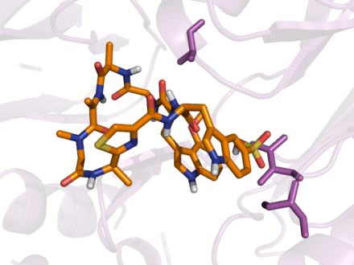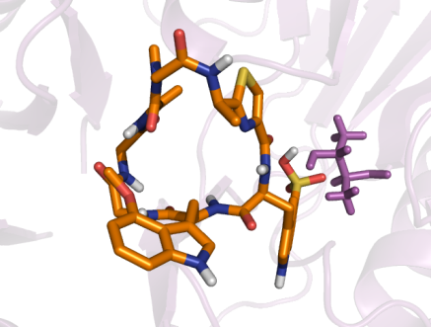

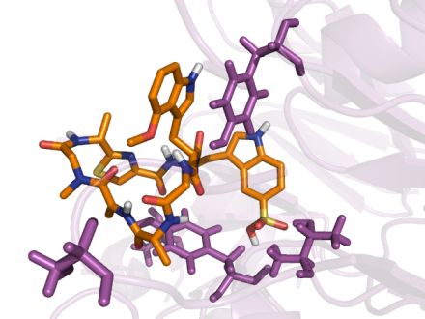

**Figure 11S.** Lowest energy docked conformations of analogue 10 at the A) β1, Β) β2 and C) β5 active sites of the 3D “humanized” proteasome models. Red lines represent hydrogen bonds and green lines π-π interactions.

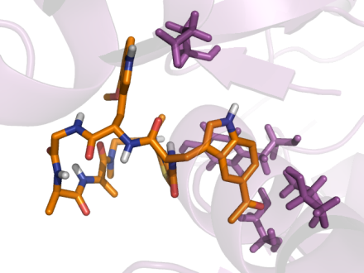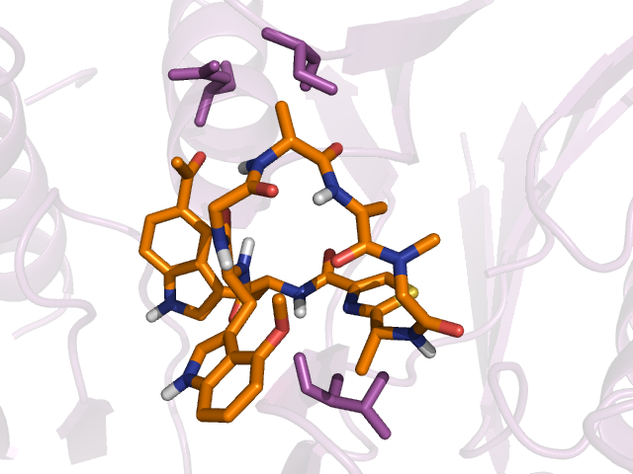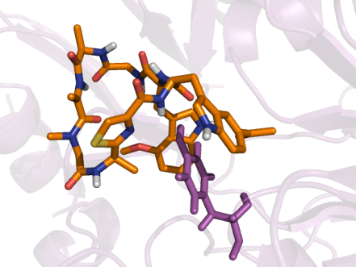

C)

D51

S96

T21

A50

A49

P114

G48

G47

G23

Y168

A22

A)

S129

T1

Y168

E22

Y96

F48

G47

G23

S21

B)

Y129

Y98

A46

T1

A21

G168

N23

**Figure 12S.** Lowest energy docked conformations of analogue 11 at the A) β1, Β) β2 and C) β5 active sites of the 3D “humanized” proteasome models. Red lines represent hydrogen bonds and green lines π-π interactions.

C)

G94

R91

S96

A46

G47

P94

D51

C52

M45

A50

A49

D116

M118

P114

M115

A20

A)

E22

D51

G50

L116

F48

Y96

S21

G23

B)

T96

G47

G128

T1

A21

N23

Y129

G168

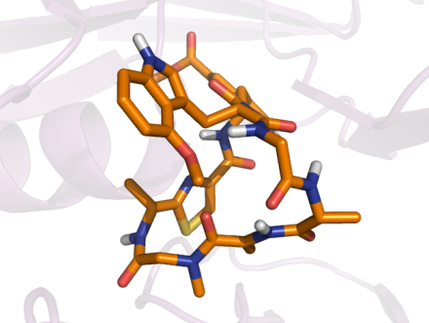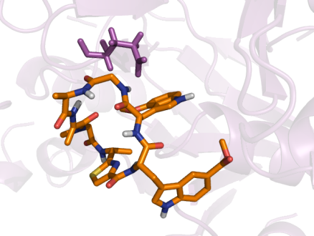

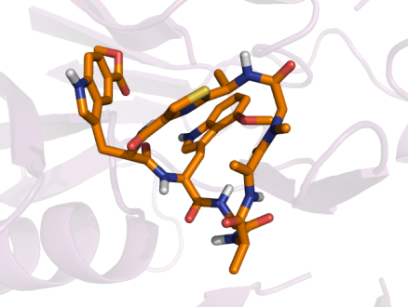

**Figure 13S.** Lowest energy docked conformations of analogue 12 at the A) β1, Β) β2 and C) β5 active sites of the 3D “humanized” proteasome models. Red lines represent hydrogen bonds and green lines π-π interactions.