Socio-Technical Talk: How Speech Acts Coordinate Student Project Work in Digital Group Messaging

Victoria Uren¹, Sian Joel-Edgar², &Yu-Chun Pan²
¹Aston University, Birmingham, UK
²Northeastern University, London, UK
v.uren@aston.ac.uk; sian.joel-edgar@nulondon.ac.uk; y.pan@nulondon.ac.uk;

Completed Research

Abstract
Digital messaging platforms have become essential infrastructure for collaborative project work, yet we lack systematic understanding of how students use language performatively to coordinate tasks in these spaces. Whilst studies have examined social media usage patterns, few apply robust theoretical frameworks to analyse the communicative intentions in project-based messaging. This paper addresses this gap by investigating speech acts, i.e., the performative dimensions of language, in student group communication across different project stages. Through vignette-based analysis of 204 university students' responses, we demonstrate that speech act patterns: directives, expressives, commissives, and assertives, vary significantly by project stage rather than by demographic factors such as gender, age, or discipline. Students strategically adapt their communicative intentions—requesting, apologising, committing, or asserting—based on task context rather than personal characteristics. These findings advance Speech Acts theory in digital contexts and offer practical implications for supporting effective collaboration in educational and professional settings through contextually appropriate communication.

Keywords: Group communication, Social media, Speech acts, Task orientation

1.0 Introduction
Collaborative project work increasingly unfolds through digital messaging platforms rather than face-to-face meetings. Whether in WhatsApp groups, Microsoft Teams channels, or Slack workspaces, teams now coordinate tasks, negotiate responsibilities, and resolve conflicts through group chats (Treem and Leonardi, 2013). Yet whilst these platforms have become the infrastructure for collaboration, we know surprisingly little about how people use language as performative action in these spaces. When someone writes "can someone check this?" they are not merely transmitting information. Instead, they are performing a request intended to produce certain action. When another responds "sorry, I'm behind schedule," they perform an apology whilst implicitly negotiating task timelines. Streams of communication are composed in the rhythm of everyday conversation and project timelines (Ansari and Khan, 2020). Yet, while messaging systems are integral to how people now collaborate, understanding the pattern of communicative intention remains hidden (Karimi et al, 2024). This shift to text-based coordination could carry risks. When communicative intentions are misaligned, e.g., when a request is perceived as mere information-sharing, or when a commitment is interpreted as a vague suggestion, coordination failures follow. A team member who reads "it would be good to check the figures" as an observation rather than a directive may never act on it; a response of "I'll try to look at it" may be understood as a firm commitment by one party and a tentative possibility by another. Such misalignments, compounded across dozens of daily messages, can erode trust, duplicate effort, and ultimately jeopardise project outcomes. By understanding the performative nature of chat messages (Orlikowski and Scott, 2013), we can inform both the design of collaboration platforms and the development of communication guidance for students and professionals navigating increasingly text-dependent teamwork.

This paper addresses these gaps by investigating how students employ speech acts across different project stages in digital group messaging. Drawing on Speech Act theory (Austin, 1962; Searle, 1969), we analyse how directives (requests, suggestions), expressives (apologies, thanks), commissives (promises, commitments), and assertives (statements, claims) function to coordinate collaborative work, through a vignette-based study with 204 university students, presenting eight scenarios representing different project stages and analysing their responses through the lens of Speech Act theory. The paper reviews relevant literature, describes our vignette methodology, presents findings, discusses implications, and concludes.

2.0 Relevant Work

2.1 Digital Collaboration
Digital communication platforms have fundamentally transformed how collaborative work unfolds in both industry and educational contexts. These platforms afford virtual co-presence, collective problem-solving, and persistent communication histories, that are features crucial to effective project coordination. Research demonstrates that social media tools provide software developers opportunities to learn from one another and offer motivational support throughout development cycles (Ansari and Khan, 2020). This recognition has spawned dedicated project management platforms such as Trello and Asana, which integrate social media features like commenting and notifications with task tracking, acknowledging that successful projects require both instrumental coordination and social interaction.
Group messaging platforms possess distinctive affordances that differentiate them from other communication modes and warrant specific investigation. Unlike email, which typically follows formal conventions and tolerates delayed responses measured in hours or days, group messaging operates with an informal register and carries implicit expectations of rapid reply. Unlike face-to-face interaction, messaging lacks the non-verbal cues, such as the tone of voice, facial expression, and physical presence, that help interlocutors interpret communicative intent and detect misunderstanding in real time. Furthermore, group messaging is characterised by collective visibility, as the messages remain accessible to all group members, creating a shared textual record that serves both as coordination infrastructure and as an archive of commitments made and tasks assigned (Leonardi, Huysman, and Steinfield, 2013). This visibility means that speech acts performed in group chats carry a particular social weight, e.g., a public commitment to complete a task, that could differ meaningfully from a private promise. These features position group messaging as a hybrid communication form. Understanding how students navigate these affordances when coordinating project work requires analytical frameworks attuned to the performative dimensions of language in this specific context.
In the context of higher education, groupwork is highly beneficial for teaching students the soft skills of working together as a team, that go beyond subject knowledge (Smith et al, 2009). Research has shown that collaborative learning promotes many skills needed in industry such as good communication, teamwork, sharing ideas, dealing with conflict and problem solving (Hammar Chiriac, 2014). Although there are often some restrictions on groupwork in academic assessment (often due to complexities of individualised marking allocation) it remains prevalent in higher education.
Many studies have identified students as active users of social media. For instance, Smith and Storrs (2023) found that undergraduate students spent 2–3 hours a day on social media. This usage included academic endeavours such as discussing assignments, sharing resources, group planning and collaborating on group projects. Greenhow et al., (2020) showed how social media can enable participation and active learning and Tess (2013) has shown how social media can enhance idea-sharing and collaboration. Therefore, it is no surprise that, in groupwork settings, students typically deploy social media as a tool to coordinate their activities. In order to teach students appropriate techniques to negotiate often complex team dynamics and communication we need to understand how students speak to one another in a text based social media particularly in contexts where different kinds of action are desired to reach the intended outcome.
Despite social media's centrality to student collaboration, relatively few studies have systematically examined task-based communication behaviours in project contexts. Conde et al. (2020) took a learner analytics approach to analyse student project related activity in the Telegram app comparing communications measures, such as the numbers of long and short messages sent, with average grades. Ferdous and Ikram (2017) carried out content analysis of three Facebook groups’ communications by software engineering students. Ngaleka & Uys (2013) carried out conversation analysis of WhatsApp chats produced by students collaborating on research assignments. Juárez-Ramírez, Pimienta-Romo and Ocegueda-Miramontes (2013) produced a classification of interaction types between team members in distributed student programming projects, based on the authors’ “personal experience in project management”. Two of these studies (Ferdous and Ikram, 2017; Juárez-Ramírez, Pimienta-Romo and Ocegueda-Miramontes, 2013) while they consider the content of communication, lack theoretical foundations for their classifications of communication types.
2.2 Speech Act Theory and Socio-Technical Perspective

Speech Act theory, developed by Austin (1962) and refined by Searle (1969, 1979), provides a theoretically grounded framework for analysing the performative dimensions of language. The theory of Speech Acts puts forward that different communicative purposes are served by different communicative (i.e. speech) acts: suggestions, requests, promises, questions, commitments, emotional expressions. These speech act functions can occur individually or within group narratives. They also provide a framework for understanding communication that needs to occur to complete project. Searle (1969) described speech acts as description and action. For example, by requesting something, a person is saying they would like something done and expecting the hearer of the utterance to perform said action. A speech act is broken down into the locutionary text (the literal utterance), the illocutionary text (the intended meaning) and the perlocutionary (how an utterance is understood, and its actual effect). The illocutionary speech, or the speaker's intent the purpose of the act) can be broken down into 5 categories: assertive (the speaker states something is the case), directive (the speaker tries to make the hearer perform an action), commissive (the speaker commits to performing an action), expressive (expresses how the speaker feels) and declarative (changes the state of the world, e.g. “I do” spoken in the context of a marriage ceremony). Speech act analysis can uncover how groupwork conversations involve the coordination of activity, negotiation of tasks, expression of emotions and commitments to undertake work, thus providing an understanding of the collaborative dynamics at work (Searle, 1979 and Vanderveken, 1990).

Viewing digital communication through a socio-technical lens emphasises that messaging platforms are not neutral conduits but active elements shaping collaborative practices (Orlikowski and Scott, 2016). Previous studies have shown that digital communication tools result in more than transmission of information (Hutchby, 2013). People will respond, perform and act upon the information that is conveyed to them. It is therefore crucial to be aware of the intended action from a speech utterance, because if we do not understand the intention of the speech, detrimental circumstances can unfold, reiterating well-known understanding that technology can both enable and restrain collaborative practices (Desanctis and Poole, 1994). For example, if the responder does not complete the intended action after hearing the speech utterance, a project may fail. Misalignment between intended illocutionary force and perceived meaning has been shown to disrupt coordination, team working, damage trust, and jeopardise collaborative outcomes in virtual project environments (Winograd & Flores, 1986; Maznevski and Chudoba, 2000). Understanding speech acts in digital project work therefore has practical implications for system design, team training, and communication guidance.

2.3 Research Gap and Study Contribution

This study investigates two research questions. First, we establish the landscape of messaging platform usage: RQ1: Which social media platforms do students use for groupwork collaboration? Understanding platform preferences provides essential context for interpreting communication patterns, particularly as different platforms offer different affordances for coordination.

Second, we examine the core theoretical question: RQ2: How do speech acts vary across different project stages in student group messaging? This question probes whether communicative intentions remain stable or shift as projects progress from formation through execution to completion, and whether such patterns are shaped by project context or individual characteristics.

The theoretical significance of this study lies in extending the use of Speech Acts as an analytical lens for understanding project-based communication through the application of a vignette methodology. Although Speech Acts have been used to analyse digital communication (Dresner and Herring, 2010; Carr et al, 2012; Tsoumou, 2020; Jegede, 2024), we extend this area by looking at project-based communication and consider this through a vignette methodological approach.

The research can also practically inform digital work communication strategies by understanding how people communicate and what types of speech are used at different project stages. This research can inform future research to ascertain which speech acts are typically used, should be used and which are more effective for different contexts. Businesses and organisations can then optimise their digital communication to produce the most successful outcomes. This could be expanded, with social media influencers or corporate marketing campaigns being more successful in their communication and achieving the outcome that they’re looking for. Additionally, there are practical educational implications as the same understanding can help students to successfully communicate to get the best outcome in group project tasks and beyond. Understanding the communication patterns, through the research presented here, can inform students on best practice for adjusting their communication for future collaborate work (a vital skill for industry). In both areas, education and business, understanding communication patterns through the lens of its performative intent can help inform and guide the development of social media affordances and strategy that better support coordination, clarity of understanding and teamwork cohesion.

3.0 Method

The core of the research used a vignette-based survey design. A vignette can be defined as “a short, carefully constructed description of a person, object, or situation, representing a systematic combination of characteristics” (Atzmueller and Steiner, 2010). The vignettes took the form of a snippet of dialog, to which participants were asked to respond. The data was collected using an electronic survey hosted on the Prolific research data collection platform. The survey questions, including literature sources used in the design, vignettes, raw data and the coding manual used in the qualitative analysis have been archived, and are available under a creative commons license at https://doi.org/10.17036/researchdata.aston.ac.uk.00000666.

A convenience sample of participants were selected using Prolific’s pre-screening features in 2023. All Prolific users must be over 18. To be included participants had to be current students of any gender or nationality. Their degree programme needed to be at any University where English is the main language of instruction, to give them the language skills to complete the vignettes. Three filter questions were applied to exclude students with less than 1 year of higher education, those who had not used a direct messaging app, and those who had not used one for a groupwork task.

Vignette Content | Waziak (2010) Framework | Searle (1969) Speech Acts
Start up: Your team have all provided their contact details and said hello in the chat and are trying to decide how to begin. What do you say?
Bob: Has anyone ever done a business plan? | Task-related | Directive
Ali: not me! |  | Expressive
Cathy: me neither but I looked online. we need exec summary, product description, market analysis, strategy, financial plan, stuff like that | Informative | Assertive
Ali: should we find out about the widget first? | Product | Directive
You: insert your response…
Table 1. Example of vignette construction.

The survey comprised three parts. Firstly, five questions confirming consent; a negative response to any of these terminated the survey for the participant. Secondly, ten questions on demographics and experience of using social media. Thirdly, eight related vignettes constructed to follow the progress of a typical student project from inception to submission. The tone and broad narrative direction of the vignettes was inspired by chatlogs submitted by students taking a final year undergraduate project module in IT and Business. Neither the students’ actual text nor real events were used to preserve their privacy. In order to create a variety of realistic work scenarios within the vignettes, the Wasiak (2010) framework was used, which provides categorisation of business communication. Furthermore, the vignettes were written so that the final statements in the sequences, to which students were prompted to make their responses, also represent a range of speech acts. Before the main study, a pilot study was conducted that asked if the speech was typical for student group communication. This was confirmed by respondents. Similarly, a cycle of coding was undertaken and repeated to ensure inter-coder reliability, until a Kappa of 76% was achieved which is considered to be good/excellent (Landis & Koch, 1977). Table 1 provides one example of a vignette to be used in the study demonstrating how the exchange represents a range of both Waziak and speech acts elements.

4.0 Results

The majority of the (n = 204) participants had substantial university experience with 73% of them having 3 or more years of experience and 94% being of 21 or over (table 2). There is an even gender balance (M/F 95/101) and representation from a good range of disciplines. The population of the sample is representative of experienced students.

It was a requirement for participation in the study that the students had used messaging tools for collaborating on at least one group task, and they proved to be active users. All the participants reported using messaging apps at least once per day (Figure 1) and a small majority (54.4%) reported using them more than 9 times a day. In terms of time spent, about 2 thirds of students (68.7%) choose one of the options in the middle of the range between 30 minutes and 3 hours of usage per day.

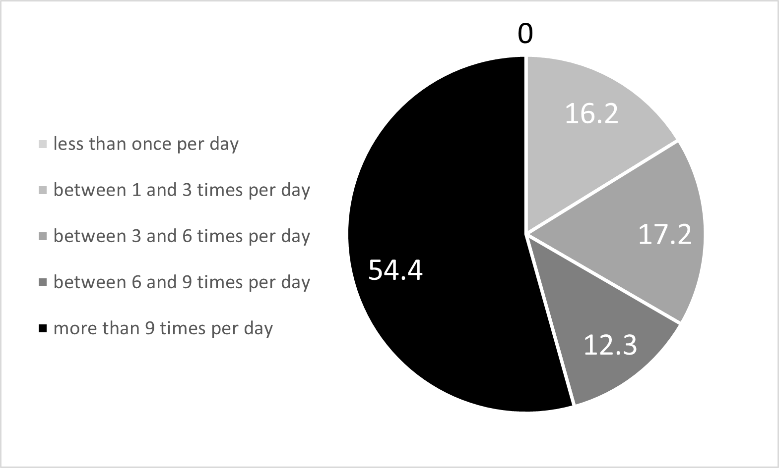 | 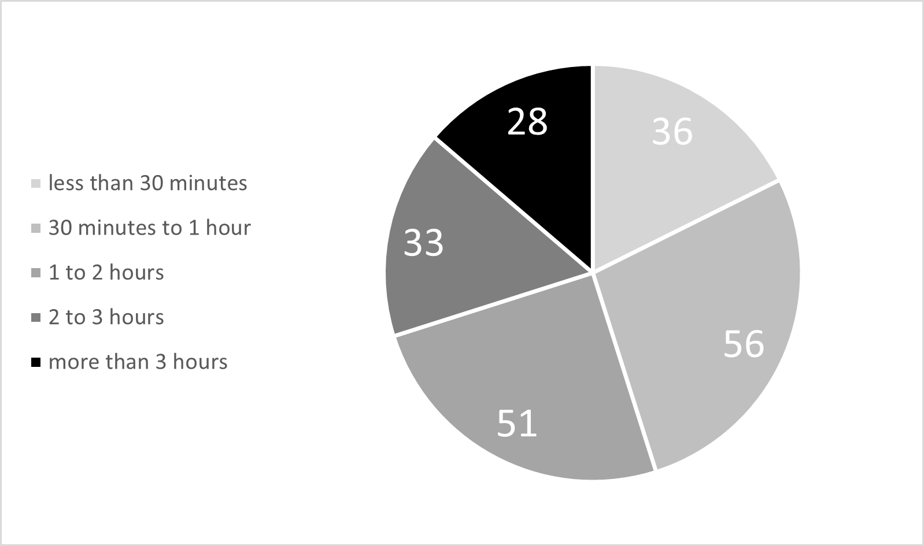
Figure 1. Intensity of messaging platform use as percent (%) of respondents, left: by number of times accessed per day, right: by time spent.
The messaging services (Figure 2, left), with users n>50 were WhatsApp (n=163), FaceBook Messenger (n=107), MSTeams (n=85), Telegram Messenger (n=65) and Instagram Direct (n=55). Typically, the students had used more than one messaging system, with only 15.2% selecting just one system. The average was 3.14 systems per user, and the maximum was 11 systems.

The general usage of systems by number of users was similar to usage for groupwork activities (Figure 2). The teamwork use score for each system was 3 for each user who responded they had used it more than 3 tasks, 2 for 2-3 tasks and 1 for one task. The highest scoring systems were WhatsApp (score=449), MSTeams (score = 302), FaceBook Messenger (score = 290) and Instagram Direct (score = 102). Differences indicate systems which were more used for social purposes (TikTok, Instagram Direct, Twitter an SnapChat) and those used more for groupwork (MSTeams, and to a lesser extend, Zooom and VLEs).

The Declaration speech act was never used, perhaps because students lack the authority to change situations declaratively, but must negotiate decisions within peer groups. Students may feel that they do not have the authority for declaration statements, and this may evidence the idea of disempowerment and illocutionary silencing (Fisher, 2010). Chi-squared tests were conducted to determine whether there were any differences in the patterns of speech act usage for the remaining four acts across different demographics and levels of social media usage and experience of using messaging tools in groupwork, across students from different disciplines and across the vignettes. These are summarised in Table 2. The only factor for which we could reject the null hypothesis that all responses come from the same population, was the vignette, the context they were responding in. This reinforces the idea that communication pattern is shaped by context (Fisher, 2010).

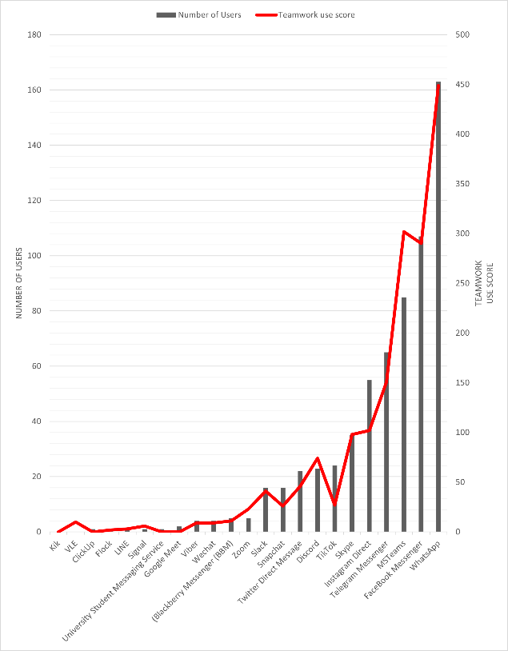
Figure 2. Left: Users per Messaging platform, right: usage score for number of groupwork tasks on Messaging platforms.

Factor | Measured as | Chi-Squared P
Age | 18-25, 25+ | 0.36
Gender | Male, Female | 0.77
Years at University | 1, 2, 3 and 4+ | 0.74
Groupwork frequency | <1, 1, 2 to 3 and 3+ projects | 0.65
Discipline | Medical & Health Sciences  Engineering & Technology  Natural Sciences  Social Sciences  Business & Law  Arts  Humanities | 0.99
Vignette |  | 0.00
Table 2. Chi-square results per factor.

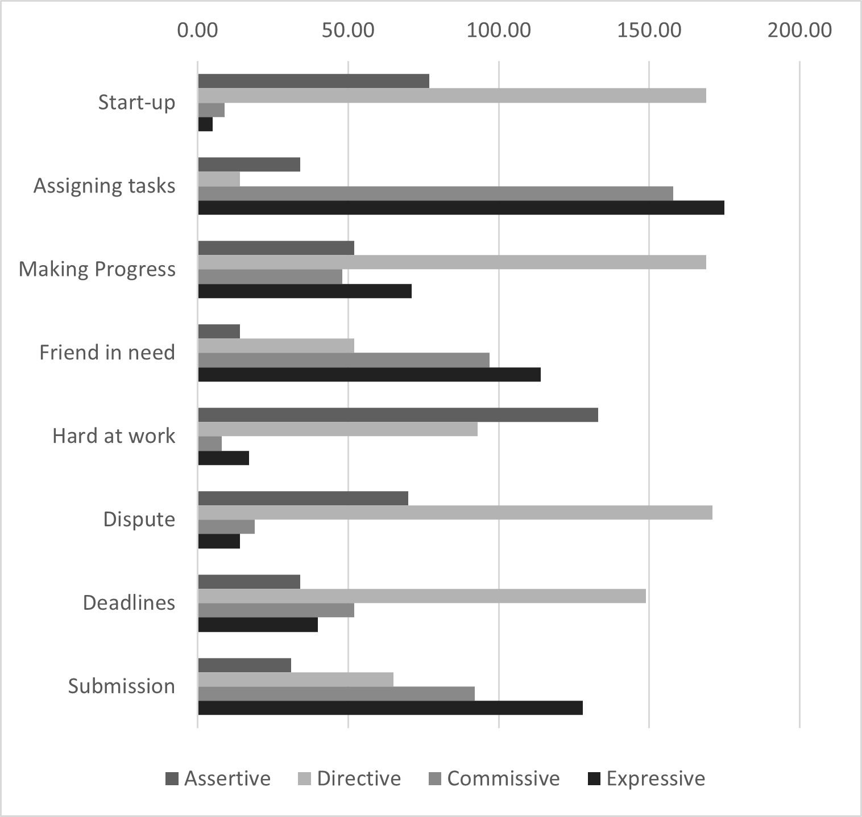
Figure 3. Speech Acts per vignette.

In the start-up scenario the prompting message in the vignette is a question, a Directive. The most common response is also a Directive, but now taking the form of a suggestion about what actions the group should begin with. The second most common response is an Assertive, which sometimes responds to the earlier part of the chat to supply information on past experience with the business plan task, and is sometimes a statement of agreement.

In Assigning tasks, the vignette places participants in an awkward position, having overslept and missed a planned meeting. Again, the prompting statement of the vignette is a Directive. The dominant speech act in the responses here, however, is Expressive, to apologise, and Commissive, since in this social situation the participant has little choice but to accept to undertake the actions proposed by their teammates. The Assertives used are, for instance, a statement concerning the cause of their absence. A few students were not truthful in their responses, supplying more socially acceptable excuses.

The Making Progress vignette flips the social dynamic. Now another person (Cathy) is unable to make a planned meeting, and her final speech acts are Expressive and Commissive. The Dominant speech act in the responses here is Directive, most often asking or suggesting to her to find some way to resolve the problem. The next most common are Expressive responses, typically reassuring her or expressing concern about the task. Assertives include variants of “I understand” which were coded as Assertives, but could be interpreted as indirect Expressives, illustrating the ambiguous nature of some of the messages, or that individuals have a pluralistic intention to their communication.

In the Friend in Need vignette, another team member (Ali) makes himself available to help. This practice of cooperative behaviour prompts Cathy to volunteer useful information with Assertive and Commissive final statements. Commissives are common to the response patterns here, as the respondents say what they will do in response to these offers of help and information. Expressives are also well used speech acts expressing thanks to the team members who have helped.

The Hard at Work vignette was included to illustrate the, not uncommon, situation in instant messaging where posts do not form a coherent dialogue (e.g. Ngaleka & Uys, 2013). It ends with three Directives, each in the form of a question as the team try to clarify their shared understanding. Assertives, stating an opinion on the issue, and Directives, suggesting steps to take to reach a mutual understanding, are the commonest communication actions used in this vignette.

The Dispute vignette puts the respondents in a situation that requires conflict resolution, with the two other team members (Cathy and Bob) at odds with each other and both making Expressive speech acts. Directives dominate the responses here, but different forms are used, some participants ask questions, others give instructions. It is worth noting that, during coding, the Dispute scenario required more rounds of discussion and adjustment than most, as many participants made indirect or ambiguous speech acts under these conditions. There was little use of direct Expressives (despite a subtext of annoyance in some responses) or of Commissives, but some Assertives, such as stating possible compromises as an indirect Directive, did occur. Many respondents take a conciliatory approach, but some take the side of one or other teammate, either on the interpretation of facts or critiquing their behaviour.

The Deadlines Approach vignette is similar to the Making Progress one, as one team member (Cathy) cannot fit in a face-to-face meeting, but on this occasion ends with a Commissive. There is no emergency here (unlike the Making Progress vignette) and the Directive speech act is dominant. Participants suggest practical actions, such as changing the meeting time or holding a video call instead.

The Submission vignette’s prompts are Expressive and Directive speech acts. It concerns social practices around celebrating successful completion of the project rather than task-related actions. It shares with Friend in Need the dominance of Expressive speech acts. The Expressives are up-beat, combining thanks and celebration. Commissives and Directives typically are either committing the speaker to going to the bar to celebrate the end of the project or include the whole group, making a Directive. Some Assertions could be interpreted as indirect formulations of other acts, typically indirect Expressives, such as “we deserve it”.

5.0 Discussion

In addressing RQ1 (Which social media platforms are used by students for groupwork?) we found that the intensity of messaging apps usage found in this study is in line with previous research e.g. (Alkhalaf, Tekian and Park, 2018, Ogaji et al, 2017). The most used platforms for groupwork, WhatsApp, MSTeams, Facebook Messenger, Telegram Messenger and Instagram Direct, overlap with the most highly used platforms reported previously, in which WhatsApp, Instagram, FaceBook, YouTube and Twitter (now X) consistently appear in recent literature on the top 5 platforms used by students internationally, e.g. (Alamri, 2019; Al-Qaysi, Mohamad-Nordin and Al-Emran, 2020; Bashir, Malik & Mahmood, 2021; Jeminiwa et al., 2021; Nacheva & Jansone, 2022; Uma et al., 2021). We note the emergence of two relative newcomers, Telegram Messenger and MSTeams, in the evolving landscape of students’ social media system choices. When general system use was compared to use for groupwork, TikTok and Facebook moved to lower rankings, indicating these are more associated with personal and entertainment uses.

In addressing RQ2 (How does student communication change depending on different project stages) we show that the contextual background of actions required to achieve the different project tasks and social practices of teamwork were the main factors that influenced which type of speech would typically be used. The desired actions were shown in our study to be the basis in which students would respond to stay on task. This can be expanded upon to show that students know how to communicate appropriately, at a given project point. This bodes well for project skills at university and beyond as students appear to be aware of the type of message that should be used at different stages. It also demonstrates the affordances of social media as a seamless and useful tool for coordinating group work. This reinforces the view that social media can be used to support collective knowledge sharing (Razmerita, Kirchner and Nabeth, 2014), tacit knowledge (Panahi, Watson and Partridge, 2012) and project management (Karimi et al, 2024).

The research advances understanding of how social media messaging acts not merely as a medium of exchange, but as the infrastructure that structures and scaffolds the performance of collaborative work. In our study, we sought to understand if students chose their speech responses to a project task in a similar way, and our findings show that peoples’ intensions are indeed similar at project stages which call for specific actions (e.g. work distribution or problem-solving) and practices (e.g. conciliation, congratulation). This suggests that people’s intensions align and chosen speech act matches with the project management stage (Jeong, 2003), and that this is the appropriate response to achieve performance of the project. Responses that do not follow this pattern (for example, if they are AI-generated) may not be optimal. Furthermore, if we know that one type of speech act is more effective than another, we can make recommendations to the communicator. Thus, understanding which speech acts are most effective at different project stages will help educators and team leaders support clearer communication and reduce coordination failures. For students, these platforms are socio-technical scaffolds, framing how tasks are performed at different project stages, and, by recommending appropriate speech acts to given context, we can help improve their project performance. Understanding speech acts provided by humans through a digital channel can also help to identify where AI-generated responses fail to align with human communicative norms. This highlights the need for greater contextual sensitivity in chatbot messaging systems.

The theoretical contribution of this research lies in the application of speech acts to the socio-technical domain of student group projects through a digital medium. Our research shows that communication intention varies across project stages, e.g., more directives at start-up, more commissives near deadlines. Our research extends the theory of speech acts (Austin, 1962; Searle, 1969) by applying this to task-orientated, project-based communication. This strengthens academic understanding of context-dependent communicative intent.

As with all research, the study has limitations. First the vignette method, while it provides a controlled experimental setting which was designed to be naturalistic, does not provide truly natural text, and clearly the communicative acts did not drive real actions in the world. However, the method allowed us to collect data in an anonymised manner which protected the privacy of the participants, as well as yielding a larger volume of messages than we could have obtained otherwise. Second, project based student communication can often result in some types of Speech Acts not being present. For example, Declaration Speech Acts require some level of authority (e.g. “I am changing the deadline”) and are unlikely to be spoken by a group of student peers. As such, the full range of Speech Acts is not shown in our dataset. Third, the use of the Waziak et al (2010) framework was used as a way to ensure that the vignette represented a range of work related communication purposes found in project based context. Future work could utilise the integrate of the Waziak et al (2010) framework with Speech acts to offer a pedagogical or reflective tool to support student communication practices over project lifecycles. Fourth, the cohort was not balanced in terms of age and years of study. This prevented us being able to observe whether communication behaviour evolved with maturity. This could be corrected by a longitudinal study aimed at examining the learning of communication practices in social media. With the emergence of AI support for work communication, the possibility arises of technology nudging users to communicate in different ways. There is an opportunity to investigate whether AI suggested responses can lead people to change their communication behaviour, including speech act selection. Well-designed AI prompting systems should encourage communication that facilitates both task completion and team cohesion.

References

Al-Qaysi, N., Mohamad-Nordin, N., & Al-Emran, M. (2020). What leads to social learning? Students’ attitudes towards using social media applications in Omani higher education. Education and Information Technologies, 25(3), 2157-2174. http://dx.doi.org/10.1007/s10639-019-10074-6
Alamri, M. M. (2019). Undergraduate students’ perceptions toward social media usage and academic performance: A study from Saudi Arabia. International Journal of Emerging Technologies in Learning (Online), 14(3), 61. https://doi.org/10.3991/ijet.v14i03.9340
Alkhalaf, A. M., Tekian, A., & Park, Y. S. (2018). The impact of WhatsApp use on academic achievement among Saudi medical students. Medical teacher, 40(sup1), S10-S14. https://doi.org/10.1080/0142159X.2018.1464652
Ansari, J.A.N., Khan, N.A. Exploring the role of social media in collaborative learning the new domain of learning. Smart Learning Environments, 7, 9 (2020). https://doi.org/10.1186/s40561-020-00118-7
Atzmueller, C. and Steiner, P.M. (2010) Experimental vignette studies in survey research, Methodology, 6(3), pp.128-138. https://doi.org/10.1027/1614-2241/a000014
Austin, J.L., 1962, How to do things with words, University Press Oxford.
Bashir, I., Malik, A., & Mahmood, K. (2021). Social media use and information-sharing behaviour of university students. IFLA journal, 47(4), 481-492. https://doi.org/10.1177/0340035221991564
Carr, C.T., Schrock, D.B. and Dauterman, P., 2012. Speech acts within Facebook status messages. Journal of language and social psychology, 31(2), pp.176-196. https://doi.org/10.1177/0261927X12438535
Conde, M. Á., Rodríguez-Sedano, F. J., Fernández, C., Gutiérrez-Fernández, A., Fernández-Robles, L., & Castejón Limas, M. (2020, October). A Learning Analytics tool for the analysis of students’ Telegram messages in the context of teamwork virtual activities. In Eighth International Conference on Technological Ecosystems for Enhancing Multiculturality (pp. 719-724). https://doi.org/10.1145/3434780.3436601
DeSanctis, G. and Poole, M.S., (1994). Capturing the complexity in advanced technology use: Adaptive structuration theory. Organization science, 5(2), pp.121-147. https://doi.org/10.1287/orsc.5.2.121
Dresner, E. and Herring, S.C., (2010). Functions of the nonverbal in CMC: Emoticons and illocutionary force. Communication theory, 20(3), pp.249-268. https://doi.org/10.1111/j.1468-2885.2010.01362.x
Ferdous, S., & Ikram, N. (2017). Communication and Coordination Using Facebook: A Case Study of Distributed Software Development. Journal of Information Science & Engineering, 33(6). https://doi.org/10.6688/JISE.2017.33.6.7
Fisher, A., (2010). Speech‐act theory as a new way of conceptualizing the ‘student experience’. Studies in Higher Education, 35(5), pp.505-512. https://doi.org/10.1080/03075070903118039
Greenhow, C., Galvin, S. M., Brandon, D. L., & Askari, E. (2020). A Decade of Research on K–12 Teaching and Teacher Learning with Social Media: Insights on the State of the Field. Teachers College Record, 122(6), 1-72. https://doi.org/10.1177/016146812012200602
Hammar Chiriac, E., 2014, Group work as an incentive for learning – students’ experiences of group work, Frontiers in Psychology, 5, https://doi.org/10.3389/fpsyg.2014.00558
Hutchby, I., (2013). Conversation and technology: From the telephone to the internet. John Wiley & Sons.
Karimi, R., Baghalzadeh Shishehgarkhaneh, M., Moehler, R.C. and Fang, Y., 2024. Exploring the Impact of Social Media Use on Team Feedback and Team Performance in Construction Projects: A Systematic Literature Review. Buildings, 14(2), p.528. https://doi.org/10.3390/buildings14020528
Jegede, O.O., (2024). Speech Acts in the Digital Sphere: A Corpus-Based Exploration of Interactional Dynamics on Social Media Platforms. Corpus-based Studies across Humanities, 2(2), pp.359-383. https://doi.org/10.1515/csh-2024-0023
Jeong, A.C., (2003). The sequential analysis of group interaction and critical thinking in online. The American Journal of Distance Education, 17(1), pp.25-43. https://doi.org/10.1207/S15389286AJDE1701_3
Jeminiwa, R., Shamsuddin, F., Clauson, K. A., Cain, J., & Fox, B. I. (2021). Pharmacy students' personal and professional use of social media. Currents in Pharmacy Teaching and Learning, 13(6), 599-607. https://doi.org/10.1016/j.cptl.2021.01.043
Juarez-Ramirez, R., Pimienta-Romo, R., & Ocegueda-Miramontes, V. (2013, July). Supporting the software development process using social media: Experiences with student projects. In 2013 IEEE 37th Annual Computer Software and Applications Conference Workshops (pp. 656-661). IEEE. https://doi.org/10.1109/COMPSACW.2013.82
Landis, J.R. and Koch, G.G., (1977). The measurement of observer agreement for categorical data. biometrics, pp.159-174. https://doi.org/10.2307/2529310
Leonardi, P. M., Huysman, M., & Steinfield, C. (2013). Enterprise social media: Definition, history, and prospects for the study of social technologies in organizations. Journal of computer-mediated communication, 19(1), 1-19. https://doi.org/10.1111/jcc4.12029
Maznevski, M. L., & Chudoba, K. M. (2000). Bridging space over time: Global virtual team dynamics and effectiveness. Organization science, 11(5), 473-492. https://doi.org/10.1287/orsc.11.5.473.15200
Nacheva, R., & Jansone, A. (2022). Current Perspectives in Social Media Supported E-Learning. Baltic Journal of Modern Computing, 10(1). https://doi.org/10.22364/bjmc.2022.10.1.05
Ngaleka, A., & Uys, W. (2013, June). M-learning with whatsapp: A conversation analysis. In International Conference on e-Learning, Reading UK, pp. 282-291.
Ogaji, I. J., Okoyeukwu, P. C., Wanjiku, I. W., Osiro, E. A., & Ogutu, D. A. (2017). Pattern of use of social media networking by Pharmacy students of Kenyatta university, Nairobi, Kenya. Computers in Human Behavior, 66, 211-216. https://doi.org/10.1016/j.chb.2016.09.035
Orlikowski, W.J. and Scott, S.V., 2016. Digital work: A research agenda. A research agenda for management and organization studies, Ed. Barbara Czarniawska. Northampton, MA: Edward Elgar Publishing, 2016. 88-96.
Panahi, S., Watson, J., & Partridge, H. (2012). Social media and tacit knowledge sharing: Developing a conceptual model. World academy of science, engineering and technology, 64, 1095-1102. https://doi.org/10.5281/zenodo.1061479
Razmerita, L., Kirchner, K. and Nabeth, T., 2014. Social media in organizations: leveraging personal and collective knowledge processes. Journal of Organizational Computing and Electronic Commerce, 24(1), pp.74-93. http://doi.org/10.1080/10919392.2014.866504
Searle, J.R., 1969, Speech acts An essay in the philosophy of language, Cambridge University Press.
Searle, J.R., 1979. Expression and meaning: Studies in the theory of speech acts. Cambridge University Press.
Smith, B.L., MacGregor, J., Matthews, R. & Gabelnick, F. (2009). Learning Communities : Reforming Undergraduate Education. Jossey-Bass.
Smith, E.E., Storrs, H. Digital literacies, social media, and undergraduate learning: what do students think they need to know?. International Journal of Educational Technology in Higher Education, 20, 29 (2023). https://doi.org/10.1186/s41239-023-00398-2
Tess, P. A. (2013). The role of social media in higher education classes (real and virtual)–A literature review. Computers in human behavior, 29(5), A60-A68. https://doi.org/10.1016/j.chb.2012.12.032
Tsoumou, J.M., 2020. Analysing speech acts in politically related Facebook communication. Journal of Pragmatics, 167, pp.80-97. https://doi.org/10.1016/J.PRAGMA.2020.06.004
Treem, J.W. and Leonardi, P.M., (2013). Social media use in organizations: Exploring the affordances of visibility, editability, persistence, and association. Annals of the International Communication Association, 36(1), pp.143-189. https://doi.org/10.1080/23808985.2013.11679130
Uma, E., Nieminen, P., Mani, S. A., John, J., Haapanen, E., Laitala, M. L., ... & Kaur, K. (2021, October). Social media usage among dental undergraduate students—A comparative study. In Healthcare, 9(11) p. 1408. MDPI. http://doi.org/10.3390/healthcare9111408
Vanderveken, D., 1990. Meaning and speech acts: Volume 1, principles of language use. Cambridge university press.
Wasiak, J., Hicks, B., Newnes, L., Dong, A. and Burrow, L., 2010. Understanding engineering email: the development of a taxonomy for identifying and classifying engineering work. Research in Engineering Design, 21(1), p.43-64. https://doi.org/10.1007/s00163-009-0075-4
Winograd, T. and Flores, F., (1986). Understanding computers and cognition: A new foundation for design (Vol. 335). Norwood, NJ: Ablex publishing corporation.

