From brief to co-design: building authentic university-industry partnerships in challenge-based learning
Rebecca Maccabe and Yu-Chun Pan
Northeastern University London

Abstract
Higher education faces growing pressure to prepare students for complex, inter-disciplinary problem solving through authentic engagement with industry. Yet challenge-based learning scholarship at undergraduate level remains thin, with most empirical accounts concentrated in engineering or postgraduate contexts. This case study addresses that gap through three action research cycles, in which two inter-disciplinary, credit-bearing electives were successively redesigned in response to student and partner feedback, delivered at a London-based university between 2024 and 2025. Drawing on student surveys, focus groups and partner reflections, the analysis reveals four inter-connected tensions: 1) balancing experiential learning with student expectations for structure; 2) moving beyond surface-level industry engagement; 3) reconciling academic rigour with practical application; 4) embedding transferable skills development implicitly rather than as an explicit add-on. From these tensions, the paper proposes a four-pillar reconceptualisation of challenge-based learning: meta-learning, ecosystem thinking, deep partnering and mutual value creation. The framework is offered as a practical guide for educators designing iterative, partner-integrated experiential courses, with specific design moves for each pillar that can be adapted to local disciplinary and institutional contexts.

Key Words

experiential learning, inter-disciplinary education, student co-creation, action research, employability

Introduction
As global challenges become increasingly complex and inter-connected, higher education (HE) institutions face pressure to prepare students for collaborative, inter-disciplinary problem solving in professional contexts. This case study examines how two inter-disciplinary elective courses at a London-based university, part of a global university network of thirteen campuses, address this pedagogical challenge.
The institution has positioned experiential learning as a core educational approach, formally embedded in the programme specification template used for all undergraduate provision and recognised within the degree structure through credit-bearing electives. The two courses examined here were designed explicitly around inter-disciplinary, partner-integrated, challenge-based learning. They were introduced to address a specific pedagogic problem: students across the institution had limited opportunities to integrate disciplinary knowledge across subject boundaries, to engage with authentic industry challenges in their first and second years and to articulate the transferable skills they were developing through that engagement. The courses were also designed as a pilot, with a view to scaling the model across the wider curriculum once the pedagogic approach had been refined.
This case study contributes to the challenge-based learning literature in three ways. First, it offers an empirical account of iterative co-design between course teams and industry partners at undergraduate level, where existing scholarship has been concentrated largely on engineering and postgraduate contexts. Second, it documents how a challenge-based learning model evolved across three iterations, revealing tensions that a single iteration case study cannot. Third, it proposes a four-pillar reconceptualisation of challenge-based learning, intended as a practical framework for educators designing partner-integrated experiential courses.

Literature review
Experiential learning underpins student-centred education, highlighting learning through firsthand experiences, critical reflection and active involvement in real-world situations (Kolb, 2014). The model of Kolb et al. (2017) defines learning as a continuous cycle of concrete experience, reflective observation, abstract conceptualisation and active experimentation. Contemporary implementations span cooperative education, work-integrated learning, project-based learning and challenge-based learning, with recent scoping reviews highlighting authenticity, structure and student agency as core design features in undergraduate experiential environments (Beard and Wilson, 2018; Duchatelet et al., 2024; Kang et al., 2022; Tembrevilla et al., 2024).
Co-creation engages students in tasks typically performed by teachers, including curriculum design, assessment development and educational decision-making (Geurts et al., 2024). Boomer (1992) introduced the curriculum negotiation model, amplifying student influence through structured opportunities to shape their educational programmes. Applying this model requires viewing curriculum as fluid and evolving rather than fixed (Bron, 2014). Research shows co-creation enhances engagement, empowerment and learning outcomes while developing critical thinking and collaboration (Bovill et al., 2011).
Challenge-based learning offers authentic, real-world contexts that give practical meaning to both experiential and co-creative educational processes. Challenge-based learning is an educational approach that involves students in addressing real-life issues through teamwork and inter-disciplinary methods, promoting meaningful learning and a sense of civic duty (Nichols et al., 2016). The challenge-based learning framework is typically organised around three iterative phases: ‘engage’ (where learners and partners frame the big idea, essential question and challenge), ‘investigate’ (where learners develop guiding questions, conduct research and synthesise findings), and ‘act' (where learners design, prototype, implement, evaluate solutions and share their learning). These phases are used as an organising principle for the analysis of course development that follows.
This approach evolved from problem-based and project-based learning traditions, requiring students to identify, investigate and propose solutions to authentic challenges within their communities, thereby bridging the gap between academic theory and practical application (Doulougeri et al., 2024). Furthermore, challenge-based learning's focus on authentic assessment methods that involve real-world outcomes and community involvement supports modern educational objectives, which aim to equip students for engaged citizenship and continuous learning in a complex, globalised society (Gallagher and Savage, 2023).
Recent scholarship demonstrates that challenge-based learning with authentic industry partnerships develops both disciplinary knowledge and critical transferable skills (Helker et al., 2025; Höffken and Lazendic-Galloway, 2024). When combined with co-creation approaches, these methods address the challenge that students struggle to articulate their skills development (Pool and Sewell, 2007), while developing essential skills that constitute graduate employability (Andrews and Higson, 2008; Tushar and Sooraksa, 2023).
Despite this growing literature, three gaps remain. First, empirical accounts of challenge-based learning at undergraduate level are limited; recent systematic and scoping reviews concentrate on engineering and postgraduate contexts (Tembrevilla et al., 2024) or treat experiential learning environments as a single category without disaggregating by partnership intensity (Duchatelet et al., 2024). Second, single-iteration case studies dominate the literature, leaving largely unanswered the question of how challenge-based learning design evolves through iterative co-design with partners. Third, the integration of challenge-based learning with student co-creation, where students help shape the course as well as engaging with the partner challenge, has been theorised (Bovill et al., 2011; Geurts et al., 2024) but rarely documented as an iterative practice. This case study addresses these three gaps through three iterations of two interdisciplinary electives at a London-based university.

Method
Action-research methodology guided the iterative development of two experiential, inter-disciplinary elective courses across three academic cycles, the first-year course ran twice and the second-year course once. This approach involves systematic cycles of planning, acting, observing and reflecting (Kemmis, 2009), with attention to how practices, understandings and conditions evolved throughout course development (summarised in appendix 1).

About the Courses
The credit-bearing experiential courses were introduced in January 2024, undergoing three cycles of iterative development with forty-two students from diverse disciplines. Available as open electives, the courses employ partner-engaged methodologies addressing global challenges. Two external partners contributed:
- A global sustainability thinktank and advisory firm
- A UK-based technology company integrating machine learning with behavioural change strategies for energy reduction
The substantive content and pedagogical evolution of each iteration is summarised in appendix 1 (action-research cycles) and table 1 (course design summary), with student and partner feedback informing the redesign of subsequent cycles as set out in the analysis.

Data Collection
Course developments were informed by three key sources: student feedback surveys, focus groups and external partner reflections. End-of-semester surveys were distributed to all students after course completion, yielding responses from seventeen students across the three courses. Additionally, a focus group was conducted for each course level, with three first-year students and six second-year students participating. External partners also provided reflections on their experience following course completion, contributing valuable insights to the development process. The data were originally collected for course evaluation purposes and subsequently analysed for this case study. In the analysis that follows, individual student survey respondents are referred to as Student A onwards (n=17 across the three iterations) and focus group participants as Participant A onwards (n=9 across two focus groups).

Ethics Statement
The Research Ethics Committee at Northeastern University London approved this study, which is aligned with the BERA (2024) Ethical Guidelines for Educational Research. Participation was voluntary, all student responses are fully anonymised, and external partners are described at sector level only.

Data Analysis
Data from each source (surveys, focus groups, and partner reflections) were first reviewed individually before being compiled for thematic analysis using Braun and Clarke's (2006) six-phase framework. This involved familiarisation with the data, the generation of initial codes, the development of overarching themes and their iterative review and refinement until a coherent thematic structure emerged. Themes were then tested across the three iterations to reveal patterns that held across rather than within iterations.
The table below presents the systematic evolution of challenge-based learning (CBL) pedagogy across three academic cycles, demonstrating progressive refinement in the engage, investigate and act phases. Each cycle incorporated lessons learned from student feedback, partner evaluations and pedagogical assessment.
Table 1. Course Design Summary
CBL Phase | Pedagogical Element | Iteration 1 | Iteration 2 | Iteration 3 | Evidence for the design change
ENGAGE | CBL Introduction | Theoretical explanation of CBL as pedagogical concept. | Framed as a pedagogical and employability benefit for students. | Embedded as part of course DNA, introduced via active, experiential tasks. | Students were initially confused about the course purpose until mid-semester.  "Nobody knew exactly what we were doing until so much later, maybe week 4 or 5."
ENGAGE | Challenge Framing | Broad, open-ended global challenge. | Refined challenge brief: global challenge contextualised locally | Encourage personal connection and values alignment; solving global challenges in local context. | Students valued meaningful work but found open-ended briefs unclear.  "The task was a bit vague, and it was not totally understood initially."
ENGAGE | Partner Visibility and Interaction | Three touchpoints: briefing, ideas testing, final presentations; plus, guest lecture on challenge theme. | Three structured touchpoints: challenge briefing, ideas testing session, final presentations. Student-centred partner interaction. | Same three touchpoints; but the students not only prepare for meeting the external partner but also actively "work" with them; co-design approach. | Students preferred active over passive partner engagement.  "I like how interactive it was; how there were many different speakers and people coming in to assess our understanding."
ENGAGE | Positioning of skills development | Explicit transferable skills development with focused workshops (teamworking, problem definition, research, presentation skills, reflection). | Implicit skills development; students learn through doing. | Balanced integration of academic theory with implicit transferable skill development. | Students resisted standalone skills workshops, finding them irrelevant to the project.  "The course spent a lot more time on team building than actually research, and we felt inadequate in our research."
INVESTIGATE | Project structuring | Promotes student resourcefulness and independent learning; mirrors professional development courses. | Project-focused structure with interim deadlines for progress monitoring. | Highly scaffolded approach with thematic structure, interim milestones, and cumulative working portfolio. | Students needed clearer structure and a consistent faculty lead.  "A strong faculty lead so they can develop a good rapport with them, rather than having multiple contributors regularly."
INVESTIGATE | Theory-Practice balance | Faculty-provided tools and techniques with student autonomy in application. | Entire course structured around project deliverables with step-by-step processes. | Balance between academic theory and practice; thematic structure including theory and research, creative problem solving and solution development. | Students wanted academic rigour but not traditional lectures.  "Incorporate more workshops, more interactivity, less lectures."
INVESTIGATE | Research process | Unstructured research process; students are free to explore the problem anyway they see fit. | Clearly broken-down research process (desk-based research, literature review, primary market research, data analysis culminating in research paper). | Comprehensive and structured research process with clear individual contributions to team research. | Unstructured research left students feeling underprepared.  "There was a real opportunity to learn more theoretically and explore case studies on a deeper level."
INVESTIGATE | Feedback loops | Informal opportunities to test ideas with the external partner and industry mentors in conservation. | Opportunity to test ideas with the external partner and industry mentors, with more preparation done before the sessions to get the greatest input. | Emphasis on action planning following feedback; students co-design solutions with industry mentors; feedback actively responded to in the moment. A formalised process to obtaining and acting on feedback. | Partners noted students arrived underprepared; students wanted feedback to lead somewhere. "Could be better prepared for the mentoring sessions."
INVESTIGATE | Balance of teamwork/  independent work | Primarily team-based collaborative work. | Primarily team-based work, with some independent research. | Begin as team, undertake independent research, reconvene as team; individual research contributions ensure comprehensive team outcomes. | Team-only structures limited individual research quality and accountability.  "We felt inadequate in our research."
ACT | Assessment design | Individual assessment at midpoint and end of semester; focus on understanding of challenge, solution development and reflective report. | Individual assessments aligned with research process: academic poster presentation, research paper, reflective report. | Continuous assessment through working portfolio; interim deadlines contribute to final evaluation plus reflective report. | Students valued process support but needed clearer expectations from the outset.  "More clarity around the assessments from week 1."
ACT | Partner feedback integration | Ideas testing mid-way through and formative presentations to external partner. External partner provides written feedback. | Ideas testing mid-way through and formative presentations to external partner. External partner provides written feedback. Debrief with the external partner on the experience. | Students required to show how they've incorporated partner feedback; emphasis on acting on feedback. External partner offers questions to reflect on at the end of the course, and these student reflections are shared with them. | Students wanted to understand the real-world impact of their work.  "Whether any of their solutions were helpful to the employer, and what may come of them."
ACT | Presentation practice | Dedicated session on public speaking skills. | Progress demonstrated from draft content to final version. | Mock presentations with faculty before final presentation to external partner. | Students and partners suggested more contextually framed, better-prepared presentations.  "Pitching to industry rather than academic presentation."
ACT | Reflection structures | Reflective report at the end of semester. Reflection on action. | Reflective report and debriefs at end of semester. Reflection on action. | Action-oriented reflection; emphasis on ‘doing’ at each stage; active response to feedback throughout process. Reflection in action. | End-of-semester reflection alone was insufficient; students needed ongoing prompts throughout.  "Lots of creative and constructive feedback throughout the process."
The research design reflects the focused, contextually situated nature of action research. The dataset is drawn from three iterations of two electives at a single London campus, with student survey responses (n=17), focus group participation (n=9), and partner reflections (n=3 across two organisations). Findings are not intended to be statistically generalisable; rather, in line with action research conventions (Kemmis, 2009; McNiff, 2017), they offer transferable insights for educators working in comparable institutional contexts. The absence of longitudinal data is acknowledged, and the study establishes a foundation for follow-up research examining how these experiential approaches influence graduate trajectories over time.

Analysis
The following key themes arose from the student survey results, focus groups and external partner reflections:

Pedagogical structure and learning design
The analysis revealed a fundamental tension between experiential learning and student expectations of traditional academic teaching. Students consistently valued the project-based learning model and real-world application, yet struggled with the initial ambiguity inherent in experiential learning approaches. Student A appreciated "how the course aims to offer a different educational experience compared to other courses", while Student B valued the project's social purpose. However, this appreciation was tempered by confusion about expectations: Student C found the task "a bit vague, and… not totally understood initially", and Student D reported an "overwhelming lack of guidance from course leaders" with no clarity until "week 4 or 5". Students recognised the value of experiential learning but required more explicit scaffolding to navigate the transition from lecture-based learning to self-directed inquiry.
This challenge is exacerbated in courses involving multiple instructors from academia and industry, where competing perspectives intensify student confusion. Focus group data revealed a preference for unified leadership, with Participant A calling for "a strong faculty lead… rather than having multiple contributors regularly". This finding informed iterative course developments, with increased scaffolding and project structuring implemented, facilitated by a main faculty lead. Student feedback subsequently reflected growing satisfaction: Student E praised the course as "well structured, every step of the process is broken down… you are never left to wonder", and Student F valued "the teaching and all of the steps involved in the process to allow us to develop the final project".

Industry partnership and authentic learning
The strongly positive response to external partnerships illuminates the power of authentic learning contexts for student engagement. Students valued work that had measurable positive effect, real-world application, and insights from industry professionals. Student G commented: "I like that we had a lot of engagement with external individuals who brought in their opinions and experiences. I also liked the opportunity to apply in class learnings to real world problems." External partnerships served not merely as motivational tools but also helped students to understand the relevance of their academic work. However, the desire for deeper involvement indicated that surface-level partnerships do not fully realise their potential, with Student H suggesting site visits to "help students visualise the bigger picture". Student feedback revealed a clear preference for more immersive rather than passive partner experiences.
Across the three cycles, external partners were involved at the same three touchpoints (challenge briefing, ideas testing and final presentations) but shifted from passive provision of briefs and feedback to active partnership with students. This involved co-designing solutions such as regenerative roadmaps alongside industry mentors, ensuring industry feedback became actionable while offering authentic professional collaboration rather than passive receipt of expert knowledge. The shift was positively received: Student G praised the interactivity and varied speakers "to assess our understanding", and Student I noted that the experience changed "how I now view working with external organisations". Active industry involvement elevated the quality of student deliverables while creating mutually beneficial outcomes for both students and partners.

Balance between theory and practice
Perhaps most significantly, the feedback revealed continuing tensions around course identity and academic legitimacy. Student J's concern that the course was "quite different from other more academic ones" and Student G's request for more "data-driven insights" suggest that experiential learning approaches must carefully navigate perceptions of academic rigour. Participant B argued that "a stronger narrative is needed around these courses as the titles and the course descriptors appear to promote more of the soft skills element and do not feel academic", while Participant C identified an opportunity for deeper theoretical engagement with the regenerative economy. However, students preferred interactive workshops and project work over traditional lectures (Student K: "incorporate more workshops, more interactivity, less lectures"). To address this tension, the course was redesigned around a thematic structure integrating theory and research with creative problem-solving and solution development.
Student feedback revealed resistance to explicit soft skills development, with participants preferring competencies to be developed implicitly through project work. Student D reported that the course "spent a lot more time on team building than actually research", while Student A wanted to "work on the project from the beginning and take out sessions on emotional intelligence and teamworking". Student L echoed this, advocating "less time spent on things less relevant to the project". In response, transferable skills workshops on teamworking and presentation were removed in favour of initiating the challenge brief from the outset and embedding skills development implicitly into the project structure. Students were nevertheless encouraged to reflect explicitly on these competencies at the end of the course, enabling them to articulate their skills to prospective employers. Participant D suggested redefining presentation skills as "pitching to industry" rather than as academic presentation, demonstrating how context can enhance student engagement and perceived relevance.

Assessment design

Student feedback revealed strong support for the process-focused assessment approach. Students particularly valued the structured support system: Student M appreciated the "preset mini deadlines to help break down the project", and Student N praised the "lots of creative and constructive feedback throughout the process" from faculty, peers and industry professionals. The individualised attention within the team-based format was meaningful: Student O had received "a lot of assistance with work, especially on a personal level". However, the transition from outcome-focused to process-focused assessment created some challenges. Student B requested "more clarity around the assessments from week 1" and Student G asked why the team's presentation remained formatively assessed despite being the "main component of the project". Students also sought greater connection to real effects, with Participant E asking "whether any of their solutions were helpful to the employer". In response, external partners now provide detailed feedback on team presentations addressing the value and potential organisational impact of the solutions.

External partner feedback

External partners provided strongly positive feedback, highlighting both the experience's value and the quality of student contributions. One partner praised the work quality ("both groups did an excellent job") while another noted having "absolutely come away with ideas from the students for improving its offering". The success stems from creating genuinely mutual value: by designing challenges that align with students' developing expertise, the course generates solutions of real significance to organisations. As one partner observed: "There have been some really great ideas from the students about how to effectively communicate the savings from our solutions to people." Partners also identified areas for enhancement: students could "be bolder with their ideas" and "could be better prepared for the mentoring sessions". These insights led to enhanced preparation activities before partner meetings, structured action planning following feedback sessions and mock presentations to strengthen final deliverables.

Evaluation
Returning to the three contributions to the challenge-based learning literature identified in the introduction, the analysis above provides empirical grounding for an iterative co-design account at undergraduate level, exposes tensions that emerge across rather than within iterations and supports a reconceptualisation of challenge-based learning grounded in those tensions. The analysis reveals four inter-connected tensions, each pointing to a dimension of challenge-based learning that requires systematic attention. First, students' confusion until week 4 or 5, set against their appreciation of the 'different educational experience', shows that challenge-based learning needs to embed continuous reflection about how learning happens, not only what is being learned: a meta-learning imperative. Second, requests for 'more immersive rather than passive experiences' and the desire to know whether their work was useful to the partner indicate that surface-level industry engagement is insufficient and that deep, sustained, bidirectional partnering is needed. Third, the tension between wanting 'more academic' content while preferring 'workshops, more interactivity, less lectures' points away from a binary between theory and practice and toward an ecosystem in which academic and industry perspectives are woven together. Fourth, students' support for process-focused assessment alongside their desire to understand real-world effects suggests that challenge-based learning needs authentic deliverables that generate mutual value rather than simulated outputs.
Taken together, these tensions point to a reconceptualisation of challenge-based learning as a relational, responsive learning ecosystem built on four interconnected pillars (figure 1):
- Meta-learning engages students in continuous reflection about their learning processes and collaborative approaches, fostering the self-awareness crucial for continuing personal and professional development.
- Ecosystem thinking positions learning as a web of relationships between students, faculty and industry professionals, where everyone contributes and everyone benefits.
- Deep partnering involves external organisations not as occasional visitors but as integral parts of the learning process, with visible and sustained engagement.
- Mutual value creation ensures the creation of authentic, meaningful deliverables that address real-world challenges and demonstrate measurable positive impact for all stakeholders.
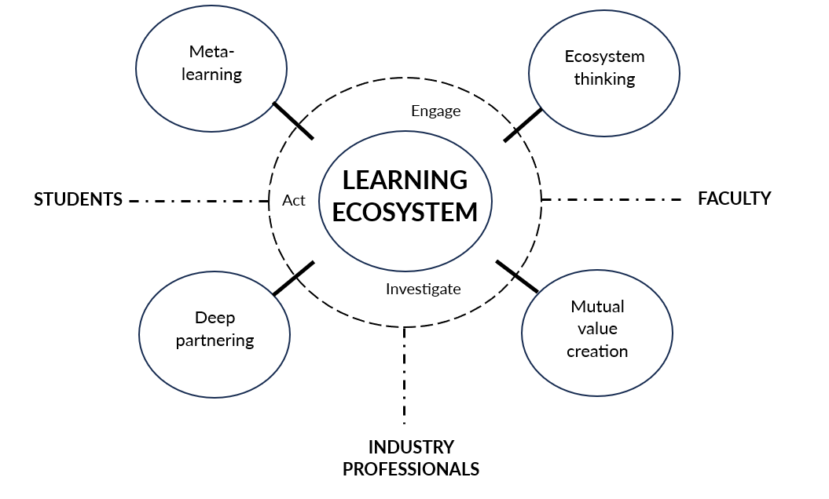
Figure 1: Reconceptualisation of challenge-based learning
In practice, this framework suggests four design moves for educators developing partner integrated challenge-based learning. Meta-learning is best embedded as a graded, longitudinal thread (for example, a structured reflective portfolio scaffolded across the course) rather than collapsed into a final reflective piece. Deep partnering is supported by contracting partners for sustained touchpoints across the course (briefing, midpoint review, prototype feedback, final showcase) rather than treating them as guest speakers. Ecosystem thinking is operationalised by designing assessment tasks that require students to draw on both academic literature and partner expertise within a single deliverable, rather than separating 'theory' and 'application' across distinct assignments. Mutual value creation begins at the briefing stage, by co-writing the challenge with the partner so that student outputs address a real, time-bound need that the partner can act on. The four pillars are offered as a guide for educators designing iterative, partner-integrated challenge-based learning rather than as a prescriptive model and as such are intended to be adapted to local disciplinary, institutional and partner contexts.

Reference list
Andrews, J. and Higson, H. (2008) 'Graduate employability, "soft skills" versus "hard" business knowledge: A European study.' Higher Education in Europe, 33(4), 411-422. Available at: https://doi.org/10.1080/03797720802522627 (Accessed: 2 May 2026).
Beard, C.M. and Wilson, J.P. (2018) Experiential Learning: A Practical Guide for Training, Coaching and Education. 4th edn. London: Kogan Page. ISBN: 9780749483036
Braun, V. and Clarke, V. (2006) 'Using thematic analysis in psychology.' Qualitative Research in Psychology, 3(2), 77-101. Available at: https://doi.org/10.1191/1478088706qp063oa (Accessed: 2 May 2026).
British Educational Research Association (2024) Ethical Guidelines for Educational Research. 5th edn. London: BERA. Available at: https://www.bera.ac.uk/publication/ethical-guidelines-for-educational-research-fifth-edition-2024 (Accessed: 2 May 2026).
Boomer, G. (1992) 'Negotiating the curriculum.' In: Boomer, G., Lester, N., Onore, C. and Cook, J. (eds.) Negotiating the Curriculum: Educating for the 21st Century. London: Falmer Press, 4-14. ISBN: 9780750700191
Bovill, C., Cook-Sather, A. and Felten, P. (2011) 'Students as co-creators of teaching approaches, course design, and curricula: implications for academic developers.' International Journal for Academic Development, 16(2), 133-145. Available at: https://doi.org/10.1080/1360144X.2011.568690 (Accessed: 2 May 2026).
Bron, J.G. (2014) 'What students want to learn? Involving students in negotiating the social studies classroom curriculum.' Journal of International Social Studies, 4(1), 3-16. Available at: https://www.iajiss.org/index.php/iajiss/article/view/87/130 (Accessed: 2 May 2026).
Doulougeri, K., Vermunt, J.D., Bombaerts, G. and Bots, M. (2024) 'Challenge-based learning implementation in engineering education: A systematic literature review.' Journal of Engineering Education, 113(4), 1076-1106. Available at: https://doi.org/10.1002/jee.20578 (Accessed: 2 May 2026).
Duchatelet, D., Cornelissen, F. and Volman, M. (2024) 'Features of experiential learning environments in relation to generic learning outcomes in higher education: A scoping review.' Journal of Experiential Education, 47(3), 400-423. Available at: https://doi.org/10.1177/10538259231211537 (Accessed: 2 May 2026).
Gallagher, S.E. and Savage, T. (2023) 'Challenge-based learning in higher education: an exploratory literature review.' Teaching in Higher Education, 28(6), 1135-1157. Available at: https://doi.org/10.1080/13562517.2020.1863354 (Accessed: 2 May 2026).
Geurts, E.M., Reijs, R.P., Leenders, H.H., Jansen, M.W. and Hoebe, C.J. (2024) 'Co-creation and decision-making with students about teaching and learning: A systematic literature review.' Journal of Educational Change, 25(1), 103-125. Available at: https://doi.org/10.1007/s10833-023-09481-x (Accessed: 2 May 2026).
Helker, K., Bruns, M., Reymen, I.M. and Vermunt, J.D. (2025) 'A framework for capturing student learning in challenge-based learning.' Active Learning in Higher Education, 26(1), 213-229. Available at: https://doi.org/10.1177/14697874241230459 (Accessed: 2 May 2026).
Höffken, J. and Lazendic-Galloway, J. (2024) 'Engaging for the future: challenge-based learning and stakeholder partnerships in sustainability education.' Sustainable Earth Reviews, 7(1), 20. Available at: https://doi.org/10.1186/s42055-024-00087-6 (Accessed: 2 May 2026).
Kang, J., Roestel, N.M. and Girouard, A. (2022) 'Experiential learning to teach user experience in higher education in past 20 years: A scoping review.' Frontiers in Computer Science, 4, 812907. Available at: https://doi.org/10.3389/fcomp.2022.812907 (Accessed: 2 May 2026).
Kemmis, S. (2009) 'Action research as a practice-based practice.' Educational Action Research, 17(3), 463-474. Available at: https://doi.org/10.1080/09650790903093284 (Accessed: 2 May 2026).
Kolb, D.A. (2014) Experiential Learning: Experience as the Source of Learning and Development. 2nd edn. Upper Saddle River, NJ: Pearson FT Press. ISBN: 9780133892406
Kolb, A.Y. and Kolb, D.A. (2017) 'Experiential learning theory as a guide for experiential educators in higher education.' Experiential Learning and Teaching in Higher Education, 1(1), 7-44. Available at: https://nsuworks.nova.edu/elthe/vol1/iss1/7 (Accessed: 2 May 2026).
McNiff, J. (2017) Action Research: All You Need to Know. London: Sage. ISBN: 9781473967502
Nichols, M., Cator, K., Torres, M. and Henderson, D. (2016) Challenge Based Learning: User Guide. Redwood City, CA: Digital Promise. Available at: https://www.challengebasedlearning.org/wp-content/uploads/2019/02/CBL_Guide2016.pdf (Accessed: 2 May 2026).
Pool, L.D. and Sewell, P. (2007) 'The key to employability: developing a practical model of graduate employability.' Education + Training, 49(4), 277-289. Available at: https://doi.org/10.1108/00400910710754435 (Accessed: 2 May 2026).
Tembrevilla, G., Phillion, A. and Zeadin, M. (2024) 'Experiential learning in engineering education: A systematic literature review.' Journal of Engineering Education, 113(1), 195-218. Available at: https://doi.org/10.1002/jee.20575 (Accessed: 2 May 2026).
Tushar, H. and Sooraksa, N. (2023) 'Global employability skills in the 21st century workplace: A semi-systematic literature review.' Heliyon, 9(11), e21023. Available at: https://doi.org/10.1016/j.heliyon.2023.e21023 (Accessed: 2 May 2026).

Appendix
Appendix 1: Summary of course development
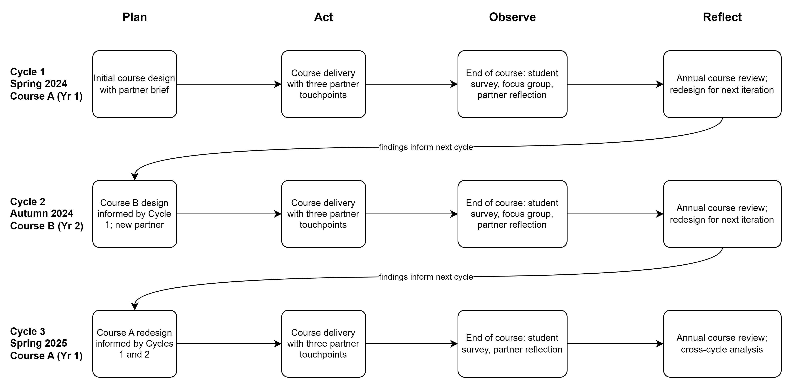

'Iterative' here refers to the action research convention in which a course is delivered, evaluated and redesigned in successive cycles, with each cycle informed by the previous one, rather than simply repeated in identical form.

