Digital Haematology
Optimising communication to patients with venous thromboembolism: development of a provider toolkit

Health-care professionals are faced with the challenge of communicating diagnostic, treatment, and prognostic information to patients. Communication about a venous thromboembolism diagnosis often occurs in a chaotic acute care setting. These settings might be crowded, noisy, and anxiety-provoking, making effective communication and shared decision-making challenging. As a result, patients may lack trust in their health-care professional and perceive their care to be inferior, which could exacerbate anxiety.¹ Specific drivers of suboptimal venous thromboembolism communication include: incomplete information, information overload, e.g., giving too much information too fast and at the wrong time, and real or perceived discrepant messages from multiple health-care professionals. Additional pitfalls include use of medical jargon, metaphors, alarmist language, adverse non-verbal clues, lack of attention to health literacy, or culturally incongruent language.⁴⁻⁷
To aid in the complex journey of venous thromboembolism management, Vasculearn Network (formerly the North American Thrombosis Forum) established a global, multidisciplinary steering committee of health-care professionals, trainees, communication experts, mental health experts, and patients with lived experience of venous thromboembolism. Consensus was achieved, resulting in the development of an educational communication toolkit (appendix). The interactive, evidence-based resource describes methods for optimal communication and enhances patient engagement with the objective to improve therapeutic compliance along with patient-experience and venous thromboembolism quality outcomes. The taskforce conceptualised a health-care professional-facing tool to convey essential information for communication at the time of a venous thromboembolism diagnosis and in the weeks or months that follow using best practices for communication. The target audience for this toolkit is any health-care professional involved in the care of patients with venous thromboembolism from diagnosis onwards.
The content generation strategy comprised three phases: mapping a venous thromboembolism patient journey, conducting an inventory of relevant patient information, and identifying best practices for communication. Patient journey mapping is a method to understand opportunities for enhancing communication of diagnoses and diseases.^{8,9}
The structure of the toolkit was based on timepoints, key topics, and pivotal moments within the patient journey (appendix). Three main time periods were identified. The immediate phase includes the diagnostic encounter, immediate management decisions, and patient orientation to the diagnosis and treatment of acute venous thromboembolism, representing the time from diagnosis to about 1 week. The intermediate phase includes the initial response to therapy and resumption of usual activities, occurs primarily in the outpatient setting, and covers the first 1–2 months of treatment. The long-term phase captures concerns surrounding extended-phase treatment and response to venous thromboembolism therapy, including the selection and duration of anticoagulation, risk for recurrent venous thromboembolism, and identification of any complications or underlying conditions that impact management. This period is defined as 3–6 months post-event and beyond.
We compiled common experienced-based patient and caregiver questions about venous thromboembolism. Existing resources from the National Blood Clot Alliance, World Thrombosis Day, Thrombosis Canada, and Vasculearn Network’s patient content database were reviewed. The essential communication content was then mapped onto the patient journey timeline. A comprehensive literature review was conducted to identify tools and best practices for effective patient communication. Evidence from the review was supplemented with personal experiences reported by taskforce members, health communication guidelines, the VitalTalk tool, and the Serious Illness Conversation Guide. Taskforce review and discussion about the quality of identified best practices led to a consensus list of final recommendations (appendix).
The resulting digital health-care professional toolkit is accessible by computer, tablet, or mobile phone. Using the patient journey as a cornerstone, visitors can delve into topics relevant to venous thromboembolism diagnosis or treatment by either scrolling or filtering based on their interests. A tab was created to toggle between the health-care professional and patient perspectives to emphasise the contrast between informational needs across the timeline (figure). In an open review at the 2024 International Society of Thrombosis and Haemostasis Congress (with 20 respondents), 70% reported that they agreed or strongly agreed with the following statements: “The toolkit design is intuitive and easy to navigate”, “the toolkit content is clear”, and “the toolkit is useful for teaching health-care professionals how to communicate with patients”. The final toolkit is freely available online at http://communication.thrombosis.org/.

In conclusion, we have developed a novel communication toolkit to enhance health-care professional and patient understanding of the patient journey along the spectrum of venous thromboembolic disease. We highlight key aspects of communication with the intention of facilitating stronger communication between health-care professionals and patients and improving outcomes of care for patients and their caregivers. We are planning implementation and impact studies.

Frederikus A Klok, Scott C Woller, Aviva Schwartz, Samarth Mishra, Pantep Angchaisuksiri, Julie Bayley, Jeffrey Habert, Jackeline Hernandez-Nino, Rachael Hunter, Jeffrey A Kline, Dieuwke Luijten, Hart K MacDur, Zoubida Tazi Mezalek, Nancy Mburu, Simon Noble, Toby Richards, Ana Thereza C Rocha, Parham Sadeghipour, Rosa Talerico, Liesbeth van Vliet, Kerstin de Wit, Grégoire Le Gal

Department of Medicine - Thrombosis and Hemostasis, Leiden University Medical Center, Leiden, Netherlands (FAK, DL); Department of Medicine, Intermountain Medical Center, Murray, UT, USA (SCW); Department of Internal Medicine, University of Utah School of Medicine, Salt Lake City, UT, USA (SCW); Vasculearn Network, Wakefield, MA, USA (AS); Medical College of Georgia, Augusta, GA, USA (SM); Department of Medicine, Ramathibodi Hospital, Mahidol University, Bangkok, Thailand (PA); Patient representative, Northeastern University London, London, UK (JB); University of Toronto, Toronto, ON, Canada (JH); Atrium Health – Wake Forest University School of Medicine, Winston-Salem, NC, USA (JH-N); Swansea University, Swansea, UK (RH); Wayne State University, Detroit, MI, USA (JAK); Patient representative, USA (HKM); Mohamed V University, Rabat, Morocco (ZTM); Patient representative, Nairobi, Kenya (NM); Cardiff University, Cardiff, UK (SN); University of East London, London, UK (TR); Universidad Federal de Bahia Salvador de Bahia, Salvador, Brazil (ATCR); Vascular Disease and Thrombosis Research Center, Rajaie Cardiovascular Institute, Tehran, Iran (PS); Università Cattolica del Sacro Cuore, Milan, Italy (RT); Leiden University, Leiden, Netherlands (LMvV); Queens University, Kingston, ON, Canada (KdW); Department of Medicine, Ottawa Hospital Research Institute at the University of Ottawa, Ottawa, ON, Canada (GLG)
f.a.klok@LUMC.nl
Frederikus Klok received research funding from Bayer, Bristol Myers Squibb, BSCI, AstraZeneca, MSD, Leo Pharma, Actelion, Farm-X, The Netherlands Organisation for Health Research and Development, The Dutch Heart Foundation, and the Horizon Europe Program, all outside this work and paid to his institution. Scott Woller received research funding from Johnson & Johnson Innovative Medicine paid to his employer without direct salary benefit or support; all outside this work and paid to his institution. Aviva Schwartz received consulting fees from Novartis outside of this work and is Co-Chair of the Vasculearn Network Medical Advisory Board. Pantep Angchaisuksiri received research funding from Novo Nordisk, Sanofi, and Spark Therapeutics, and is President of the International Society on Thrombosis and Haemostasis. Jeffrey Habert has received consulting fees from Elvium, Otsuka, Eli Lilly, Boehringer Ingelheim, HLS Therapeutics, Eisai, and Idorsia and honoraria from MDBriefcase, Liv, MedPlan, Master Clinician Alliance, Academy, Bridge, PeerVoice, Seacourses, Thrombosis Canada, Meducom, Canadian Heart Research Centre (CHRC), CPD Network, CTC Medical Communications, STA, Collaborative CME and Research Network (CCRN), Telus Health, EOCI Pharmacomm, AgenceUnik, Humber Hospital, Alliance for Best Practices in Health Education, and Canadian Society of Endocrinology and Metabolism. He has participated in Data Safety Monitoring Boards for Boehringer Ingelheim, Eli Lilly, Elvium, Takeda, Bausch, AstraZeneca, Novartis, Lundbeck, Novo Nordisk, Janssen, Eisai, HLS Therapeutics, Otsuka, Idorsia, Pfizer, Amgen, AbbVie, GSK, Bayer, and Valeo. Rachael Hunter received honoraria from Pfizer and Biogen and support for attending the Multiple Sclerosis Research Organisation UK. Jeffrey Kline received research funding from the National Institutes of Health, Centers for Disease Control and Prevention, and Human Animal Bond Research Institute, all paid to his institution, payment for expert testimony for medical malpractice cases, and is on the Board of Directors at the PERT Consortium. Simon Noble received payment from Leo Pharma to support research staff and is a Medical Director and Trustee at Thrombosis UK. Toby Richards received research funding from National Institute for Health and Care Research Efficacy and Mechanism Evaluation (NIHR EME), National Health and Medical Research Council (NHMRC), Australian and New Zealand Society for Vascular Surgery (ANZSVS), university grants, honoraria from Pharmacosmos and Metagenics, support for meetings and travel, and receipt of equipment from Radiometer. He has participated in Data Safety Monitoring Boards for SPACE RCT and INTACT and the Advisory Board for Pharmacosmos. He holds leadership or board roles National Association of Testing Authorities, Australia (NATA), Royal Australasian College of Surgeons (RACS) and serves on the Trial Steering Committee for POISE 3, ECST 2, GLAD, and FUNNY. He is the Director of The Iron Clinic and VeinCare London and the Vascular lead for 18-Week Support. Ana Thereza Rocha received honoraria from Sanofi. Grégoire Le Gal received honoraria from Aspen Pharma, Emcure, Pfizer, and Sanofi. All other authors declare no competing interests

FAK and DL were supported by the Dutch Thrombosis Foundation. GLG holds the Chair on Diagnosis of Venous Thromboembolism from the Department of Medicine, University of Ottawa. SN holds a Marie Curie Chair in Supportive and Palliative Medicine. We thank Vasculearn Network (Wakefield, MA, USA), formerly the North American Thrombosis Forum, for their invaluable comments and support during this work. This work was supported by corporate sponsorship from Bristol Myers Squibb and its Alliance partner, Pfizer, to Vasculearn Network, formerly the North American Thrombosis Forum. The funder of this work had no role in the design, preparation, or writing of the report or subsequent toolkit. No honoraria were paid to panel members.

For more on the patient experience see:
1. Hunter R, Lewis S, Noble S, Rance J, Bennett PD. "Post-thrombotic panic syndrome": A thematic analysis of the experience of venous thromboembolism. Br J Health Psychol 2017; 22: 8–25 https://doi.org/10.1111/bjhp.12213
2. Klok FA, Ageno W, Ay C, et al. Optimal follow-up after acute pulmonary embolism: a position paper of the European Society of Cardiology Working Group on Pulmonary Circulation and Right Ventricular Function, in collaboration with the European Society of Cardiology Working Group on Atherosclerosis and Vascular Biology, endorsed by the European Respiratory Society. Eur Heart J 2022; 43: 183–89 https://doi.org/10.1093/eurheartj/ehab816
3. Huisman MV, Barco S, Cannegieter SC, et al. Pulmonary embolism. Nat Rev Dis Primers 2018; 4: 18028 https://doi.org/10.1038/nrdp.2018.28
4. Webb D, Kim K, Tak CR, Witt DM, Feehan M, Munger MA. Patient Satisfaction With Venous Thromboembolism Treatment. Clin Appl Thromb Hemost 2019; 25: 1076029619864663. https://doi.org/10.1177/1076029619864663
5. Genge L, Krala A, Tritschler T, et al. Evaluation of patients' experience and related qualitative outcomes in venous thromboembolism: A scoping review. J Thromb Haemost 2022; 20: 2323–41 https://doi.org/10.1111/jth.15788
For more on pitfalls in the communication of health-care professionals with patients see:
6. Hernandez-Nino J, Thomas M, Alexander AB, Ott MA, Kline JA. Communication at diagnosis of venous thromboembolism: Lasting impact of verbal and nonverbal provider communication on patients. Res Pract Thromb Haemost 2022; 6: e12647 https://doi.org/10.1002/rth2.12647
7. de Wit K. Do physicians contribute to psychological distress after venous thrombosis? Res Pract Thromb Haemost 2022; 6: e12651 https://doi.org/10.1002/rth2.12651

For more on patient journey mapping see:
8. Bulto LN, Davies E, Kelly J, Hendriks JM. Patient journey mapping: emerging methods for understanding and improving patient experiences of health systems and services. Eur J Cardiovasc Nurs 2024; 23(4): 429-33. https://doi.org/10.1093/eurjcn/zvae012
9. Davies EL, Bulto LN, Walsh A, et al. Reporting and conducting patient journey mapping research in healthcare: A scoping review. J Adv Nurs 2023; 79(1): 83-100. https://doi.org/10.1111/jan.15479

For the literature review on best practice for patient communication see:
Res Pract Thromb Haemost 2025; 9: 102835 https://doi.org/10.1016/j.rpth.2025.102835
For the VitalTalk tool see http://www.vitaltalk.org/
For the Serious Illness Conversation Guide see https://www.ariadnelabs.org/serious-illness-care/serious-illness-care-program/
For the final toolkit see: https://communication.thrombosis.org/
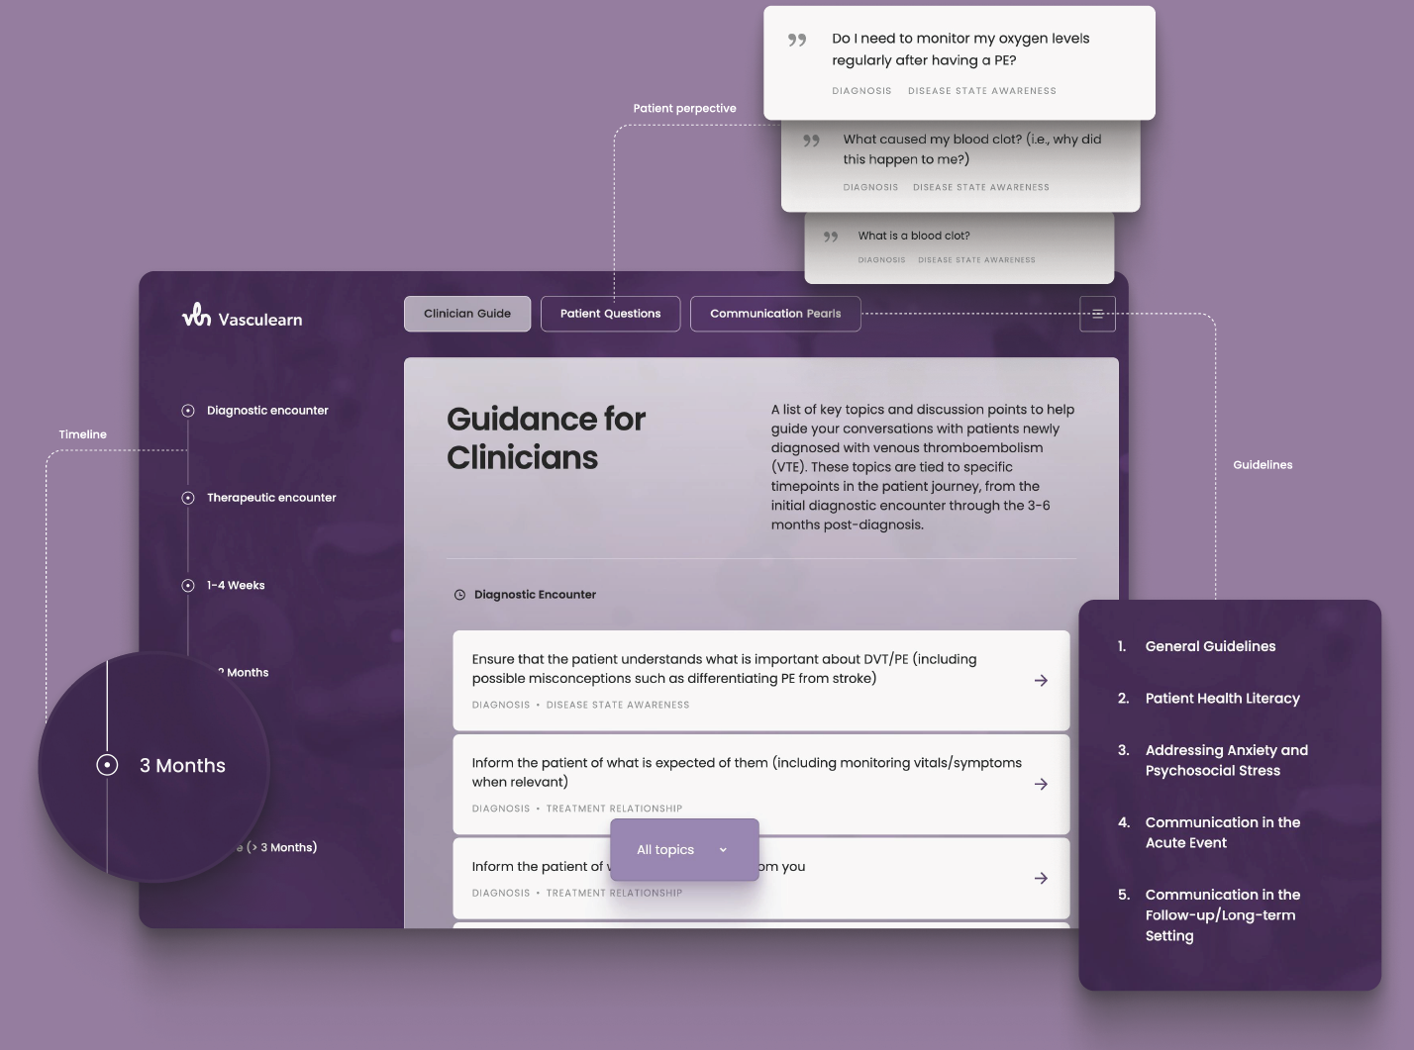
Figure: Screenshots of the final online toolkit

