XGBoost Model for Predicting Property Prices in the UK Real Estate Market

Peter Amaechi Nwora1, Fadi Safieddine2, and Md Atiqur Rahman Ahad1

1Dept. of Computer Science and Digital Technologies,
University of East London, Docklands,
University Way, London E16 2RD, UK
{u0018330, mahad}@uel.ac.uk
2Devon House, 58 St Katharine's Way, London
Northeastern University, London E1W 1LP, UK
fadi.safieddine@nulondon.ac.uk

Abstract. This study contributes to the enhancement of the predictive models and mitigating regression problem, using data science machine learning approach. It critically evaluates studies that have been done within the predictive valuation, forecasting models, using the current technological trends in machine learning, through the proposed framework: Sustainable Feature Machine Learning Agile Framework (SFMLAF). SFMLAF suggests that our proposed model based on XGBoost demonstrated better accuracy based on these results; utilizing the following validation metrics: XGBoost RMSE: 0.444, MAPE: 1.94%, MAE: 0.234. The required datasets were sourced online from the UK government property sold dataset, under the Open Government licence v.3.0, focusing on four UK cities with the following data observations: London: 658,337, Peterborough: 44,635, Leeds: 102,984, and Manchester: 154,626. In conclusion, the proposed predictive model aims to deliver practical benefits for real estate professionals, homebuyers and sellers by enhancing the accuracy and reliability of property valuation in the UK market.

Keywords: XGBoost, Machine Learning, Ensemble Model, Real Estate.
1 Introduction
This research complements existing work in property price prediction; primarily focusing on gaps identified in the literature review. The research seeks to address the UK property price prediction regression problem. Hence, the need to review some of the algorithms used in the literature review, which were processed through the proposed framework on UK Property Price Paid data [1]. This methodological process and data transformation has been developed to establish the correlations between the dependent and independent variables/features, which helps to identify the features that contribute to the property price prediction.
Several authors [2-18], have used different algorithms through different frameworks and model development to tackle the property price prediction, with success, but on different datasets, regions, locations and within different context [2]; which is also in line with the motivation of this study.
This paper is organized as follows: Section 1.1 presents a brief summary of the literature review, Section 1.2 presents the research methodology, then followed by results and discussion in Section 2.2. Section 3 concludes the paper with future guidelines.
1.1 Literature Review
This study’s contribution to science, and filling the identified gaps; which is within the large data and best algorithm that can be applied on the UK property sold data is significantly necessary. For instance, [3] reviewed these three algorithms PCA, Multiple Linear Regression (MLR) and Gradient Boosting Machine (GBM); and proposed GBM as the higher predicted model. This study, [4] proposed deep neural networks (DNN) and Price Component Analysis as DNN-PCA, with achieved accuracy of 90%-95%.
Similar study was conducted in France [2], which suggests that geo data (longitude and latitude) of the location of the property plays a huge role in predicting accuracy, having compared seven algorithms and credited previous works done in their used literature review, but acknowledged that results achieved, and data used had been proposed on different context and location. Whereas [5], proposed Random Forest as the best performed algorithm after validating with R2 90% and lesser RMSE.
Relatively [6], like in our current study, used data from four Chinese cities, and proposed XGBoost over KNN and NLP; with these results XGBoost = MAE (0.0332) and MAPE (8.70%), NPL = MAE (0.0405) and MAPE (10.09%), KNN = MAE (0.0447) and MAPE (13.01%), considering lesser MAE and MAPE. Support Vector Machine-based approach was proposed by [7] with 96.2% accuracy. Ref. [8] acknowledged that many models and systems have been developed in recent times to supplement and easy up the property appraisal process, models like regression model, neural networks, fuzzy systems and hybrid approaches, but leaned towards the machine learning as a better option based on their achieved results. Authors of [9] and [10] proposed Hybridization and (BP Neural Network and Elman Neural Network) respectively. References [11] and [12] in the same quest for a better model proposed Twin Support Vector Regression (TSVR) and Maximum Likelihood Estimation (MLE).
Reference [13] proposes RNN with the outcome of the research which proves the possibilities of integrating Deep learning methods with statistical learning algorithm. Based on their findings their study concludes that LSTM has a great potential on AVM and other regression applications and used MAPE and MAE as the evaluation metrics: LASSO: MAE (58.661), MAPE (31.24%), SVR: MAE (57.225), MAPE (29.83%), Proposed model: MAE (46.926), MAPE (24.03%). [15-16] proposed these models respectively Deep Neural Network (DNN), Principal Component Analysis (PCA) and Artificial Neural Network (ANN), where [17] proposed state-of-the-art deep learning-based model known as Deep Spatiotemporal Hybrid Network (DSHN); which primarily harnessed these algorithms: Convolutional Neural Network (CNN), Long Short-term Memory (LSTM), and Artificial Neural Network (ANN) in synergy in achieving their proposed hybrid model. With confidence of their model outperforming the baseline models with these results: which indicated that the proposed DSHN model outperforms the baseline models with an Area Under Curve (AUC) of about 0.800, an accuracy of 75.7%, and a false alarm rate of 0.217. Though [18] prosed the same algorithm as proposed by [15], but with this outcome 69.95%, deemed a higher predicted accuracy over other models tested.
In contrast, this current study achieved these results: Bagging (Ensemble) algorithm performed better in the ensemble model across the four cities with these accuracy RMSE:0.509, MAPE:3.76%, MAE:0.286). Whereas our proposed model ranked better in accuracy in overall, based on the results stated here considering these seven algorithms, full results in Table 1: ARIMA RMSE: 0.598, MAPE: 3.39%, MAE: 0.417, Holt Winters RMSE: 0.729, MAPE: 4.07%, MAE: 0.487, Decision Tree RMSE: 0.609, MAPE:3.14%, MAE:0.382, XGBoost RMSE:0.444, MAPE:1.94%, MAE:0.234, Neural Network RMSE:0.523, MAPE:2.61%, MAE:0.324, KNN RMSE:1.206, MAPE:3.74%, MAE:0.880, Random Forest (Ensemble) RMSE:0.597, MAPE:4.51%, MAE:0.370.
The literature review generally suggests that the benefits of applying machine learning in the property price prediction is huge, irrespective of location and context. The use of the latest technologies have emerged in recent years, and more and more sectors are either moving toward exploring these, or are already implementing data and analytics; data science, and often creating a specific department that focuses on machine learning area, to enable the right experts with the data science knowledge to help in the growth of the organization leveraging the power of machine learning and artificial intelligence.
The real estate sector is not left behind in this new data explosion and data revolution era, as one would put it. As part of the motivation to carry out this research, the identified gaps in the data used by different authors has helped as a motivation to apply some of the algorithms in the literature review in our collected UK dataset, the data slice approach of the 4 UK cities, revealed the best performing algorithm with large dataset, as well as revealing how long it takes an algorithm to run a single model, which is a challenge on its own, as our current study reveals that some algorithms can run overnight, to achieve any result. But our proposed model is efficient and timely.
It has been acknowledged by different authors that real estate sector boasts of huge datasets that are untapped and do have the capacity to be in the forefront of showcasing the value add, and importance of adapting the new technologies, such as the ones data science presents us with; cannot be overemphasized.
[23] agrees that the real estate sector possess huge data and information that often that are not accountable or reportable due to the complexity of the industry and as well as the property valuation process; thus recognises the various investment asset classes there is in the sector. Tapping into these data with the new technologies can create new ways in which datasets can be unlocked, explored in a most efficient sustainable way, that contributes to the streamlined decision-making process that is effective, and just in time; for both current and future decisions that will help the sector to function effectively and efficiently.
It is worth noting that the process is wholly dependent on the features identified and considered in the machine learning model, in this research we have reengineered the features, which makes up of our independent variables as follows: location of the property, how well looked after is the property (i.e. the condition of the property), if the property is old or new; Property type, Property characteristics, and considers our dependent variables as the selling price of the property at a time (T), and as well consider the historical sold prices as the past trends; the features are based on the datasets used. As a matter of readily available data, features like CPI rate, Employment and Unemployment rates have been included in the model,
There are huge possibilities to integrate further features that affects property prices, such as crime, inflation , recession, and financial down turn as a result of global phenomenon beyond human capabilities, policies, social media sentiments [19], urbanization, encompassing migration and infrastructural development.
1.2 Research methodology
This section introduces the research methodological process adopted for this research. Every research task requires a clear methodology to achieve reliable results. This chapter outlines the methods used for this research and the underlying data collection, and the tool used that helped to enhance the process successfully. [20] in his book, created a complete user guide for any progressive final year student in various postgraduate levels, as a reference guide of how to get the structure of the expected writings and content of any given thesis, hence a reference was drawn from the book on quantitative research method, which ideally is in line with this study.
Data was collected from various sources and profiled to a working data model. The data contains approximately 29 million rows, which got processed through the Extract, Transform and Load (ETL) process of the datasets. The historical dataset has been accumulated from 1995 – March 2024. For the purposes of this research, a flexible profiling and reduction of the dataset had been applied to make the process of the data analysis much smoother, thereby reducing the data to four UK cities, and a 10-year lookback on the collected data up to March 2024.

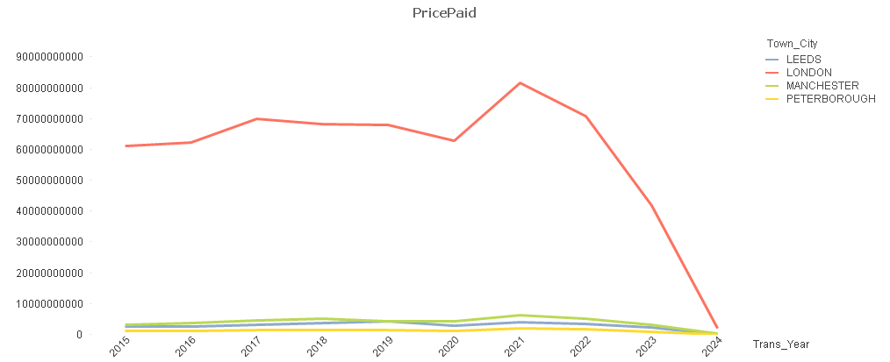
Fig.1. UK property sold data collection line chart from 2015 – Mar 2024

The diagram in Fig.2 clearly shows the data collection process of the property price data.

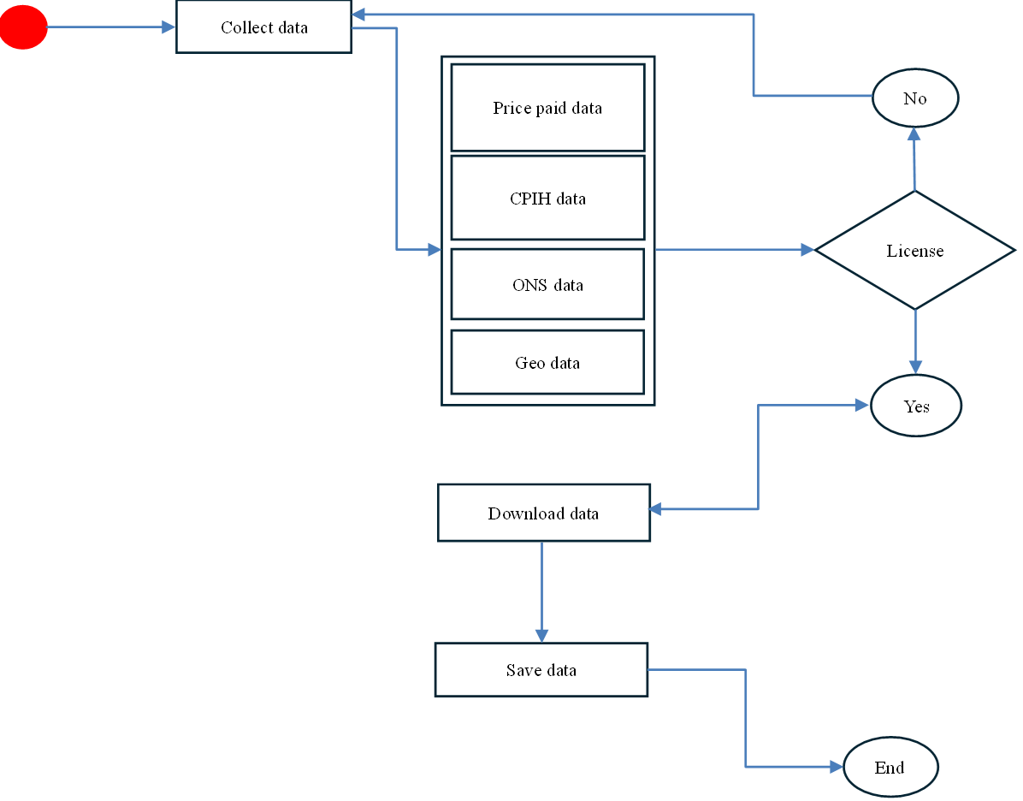

Fig.2. UK property sold data collection flowchart

1.3 Machine learning process
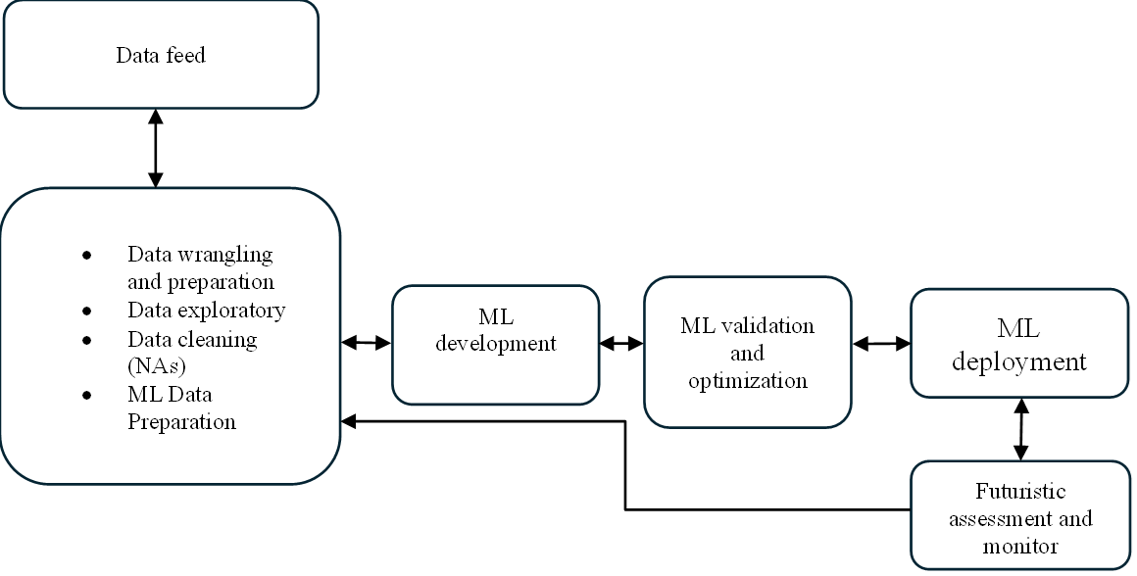
Fig. 3. Machine learning process flow. (Double arrow has been used in the flow process to show, the flexibility of the data flow process, and the sustainability of the model, to incorporate future changes in agile mode at any point in time)

The design captured the flow of the required data from various sources, which gets profiled and cleaned as required, the initial step of the data transformation follows ETL (Extract, Transform and Load) process, which was done in QlikView with Structured Query Language (SQL) capabilities. After multiple iterations of the data and joining of the tables, which allowed the successful development of the data model, which is in parallel with the ETL.
The data model was eventually visualized in QlikView, and data slice approach adopted through which the four UK cities (London, Peterborough, Leeds and Manchester) data were exported. The entire data is held on the QlikView, and through the right parameter the required are exported to the staging folder in (csv) format. Though the bigger picture of this process is not covered and not within the scope of this study.
1.4 QlikView - Data model for the PPD
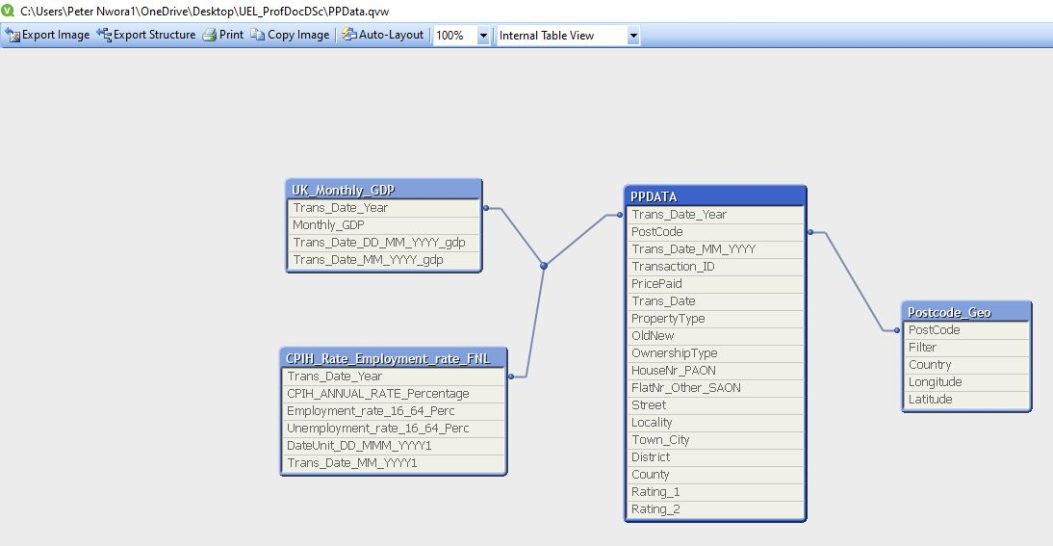

Fig. 4. Property Price Paid Data Model generated in QlikView personal edition.

2 Machine Learning development process
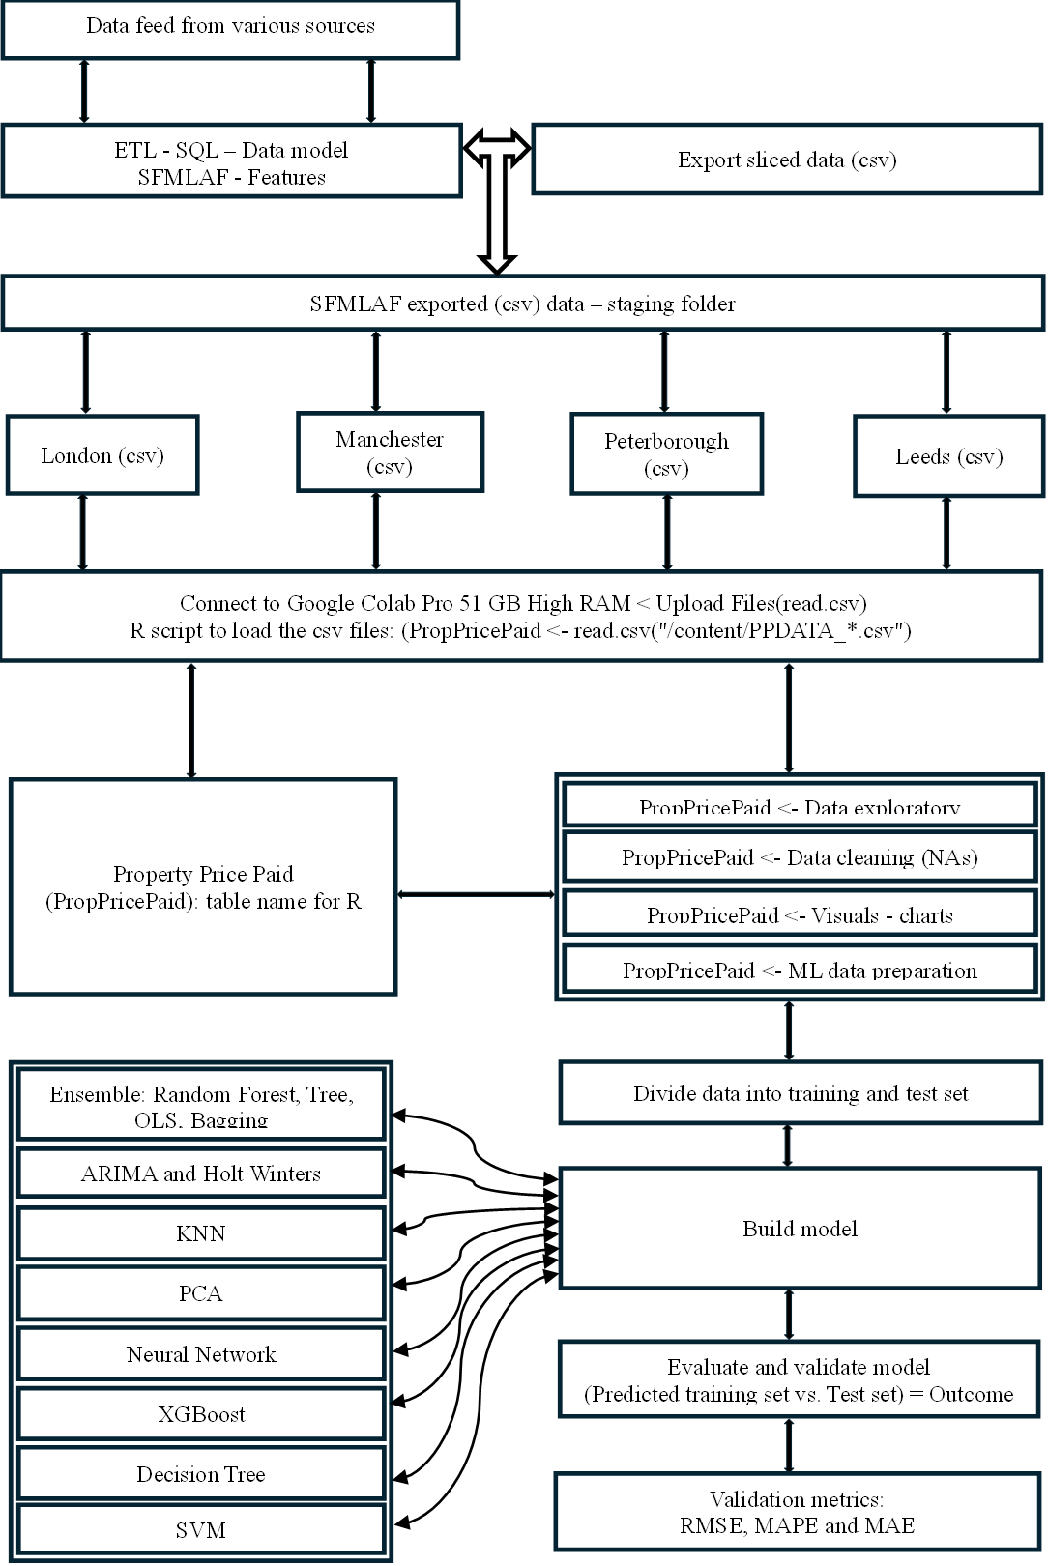
Fig. 5. Overview of the machine learning development process used in this study.
2.1 The Metrics
The machine learning results based on the chosen metrics, these metrics become the yardstick of measurement to determine the most accurate predicted results.

RMSE : Stands for ‘Root Mean Squared Error’ and can mathematically be represented in the following way, formular wise:

RMSE = sqrt [(∑(Pi – Oi)) / n] (1)

By way of measuring the predicted values and the observed values, the above formular was used to work out the square root of the achieved results which is essential in determining the final RMSE results between the two groups. The ultimate goal was to establish the difference and how close or far off the predicted values are from the real values in average. As seen in our various developed models where datasets were divided into training and test sets; which forms the significant basis for our RMSE test, and categorically establishes the result on how well the model has performed in accuracy, as a matter of acceptance, the lower the RMSE achieved the better in accuracy has the model performed, lesser RMSE value = Higher accuracy.

Our formular therefore; could be explained as follows:

- ∑ = sigma sign which also means ‘Sum’ mathematically
- Pi is the predicted value in i^{th} observation in the data
- Oi is the observed value in the i^{th} observation in the data
- n is then the amount of the sample size of the property price paid data.

A snippet from this study on one of the data test on RMSE can be referenced as an example:
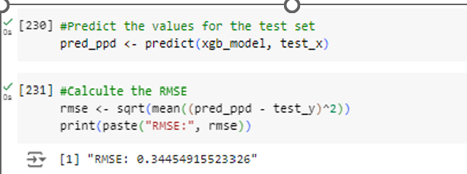

Fig. 6. A snippet from RMSE calculation which shows the equation in practice

MAE

Mean Absolute Error; As a matter of uniformity and in parallel with other studies MAE is one of the widely used metrics looking from the statistic and machine learning perspective, it gives a sense of understanding on how well the model has performed. The essence of using this metric is due to its popularity within the regression modelling perspective, the factors that make this matric stand out are the ease of use, understanding and interpretation, it has also been seen to be reliable and fit for purpose in determining accuracy of a model. This metric is so robust in the sense that it can handle datasets with outliers, and doesn’t allow it to affect the expected results. It has the ability to provide errors generated from the model, hence helps to determine the best model.
The formular can be represented mathematically as follows:

MAE = (1/n) ∑(i=1to n) |y_i- ŷ_i| (2)

Where:
- n is the number of the observations in the Property Price Paid dataset
- y_i is the real value
- ŷ_i is then the predicted value
Again this formular follows the same criteria of calculation as seen in the RMSE calculation, where test data is checked against the training set.
Another snippet from one of the modules where MAE was used to test a model’s predictive accuracy.

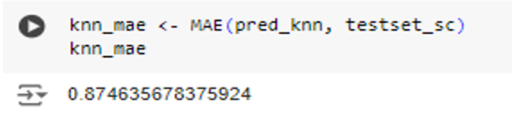
Fig. 7. A snippet from MAE calculation which shows the equation in practice

MAPE

Mean Absolute Percentage Error: is one of the commonly used in evaluating predictive model performance and accuracy, represents as percentage value, which makes it a lot easier to translate the results, and end users can easily relate to the percentage representation of the accuracy. MAPE is relative measure of error; and is the percentage equivalent of MAE metric.

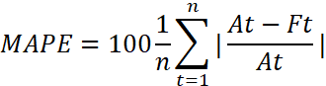 (3)

Where

- n is the number of times the calculations occurred
- A_{t} is the actual value of the property paid data
- F_{t} is the predicted value.
This is a MAPE calculation taken from Peterborough XGBoost model as an example.

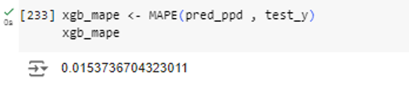

Fig. 8. A snippet from MAPE calculation which shows the equation in practice
2.2 Results and Discussion
The results provide valuable insights into the key factors influencing property prices. For example, the study in France demonstrated that geographic location significantly improves prediction accuracy [2]. This has been taken on board and as a matter of fact, proved to be true in this study; where some of the results and from varying algorithms shows in order of importance, which feature or variable ranks most in order of importance.
This study does not aim to reinvent existing methods but rather contributes to the body of knowledge on the role of machine learning in property price valuation [23]. The cities that have been looked at have shown different results and which features contributes most to the machine learning model in terms of predicting the property price. First, is to recognize the fact that our chosen model (XGBoost) fits into what is currently being sought for in the machine learning modules as a practical solution, in the marketplace right now. Organizations such as Qlik, has integrated XGBoost as part of their ML module in Qlik SaaS, currently in use right now in the BI (Business Intelligence) marketplace, which is convincing to note that this study is inline with such findings and recommendation.
This can be because of its robustness, flexibility, speed of process with less resources and as well the ability to work with and crunch big datasets, in solving both classification and regression problems. In the industry today, these unique factors are very much asked for, as I am sure that most organizations would like to see a model that will certainly be part of their growth plan, with a speed that can certainly give them an edge over their competitors with the right results and just in time, XGBoost in that front will be the model to go for.
Back to the importance of the features that matters in our 48 developed modules, features such as the location of the property [21-22], property type, postcode , property age and many more are on the highest hierarchy of importance.
The interpretation of these results are explainable given the nature and the location of the property. For instance, the property in London, will always put location, Geo location and the postcode of the property first. in comparison with the property in Peterborough, Leeds or Manchester, where the property type could be ranked first. This phenomenon can be seen in the below enclosed screenshot in sections 2.2.1 and 2.2.2.

What really contributes to the property price prediction: The following charts shows clearly what we all know about real estate, as the power word always is Location, Location, Location. This has ultimately been proven in the London dataset where property type is less important to the location of the property in terms of the price prediction.

It is surprising to see that Ownership type ranked higher than the property type in the feature importance for the London dataset, whereas the topmost three were geo location and the postcode of the property, which is amazing and confirms the widely available knowledge and assertion about London property prices, where location speaks volume and highly part of the price determination factor.

On the other hand the charts generated for the Manchester, Peterborough and Leeds data clearly ranked property type highest in the hierarchy, followed by the location of the property.

These results are not exclusive, given the dynamic nature of the real estate sector; there are, of course, other factors that contributes to the property price [21], as case maybe and could be dependent on characteristics of the property and other micro and macro factors, demand and supply is also considered, buyers and suppliers market.

2.2.1 XGBoost feature importance on Peterborough data

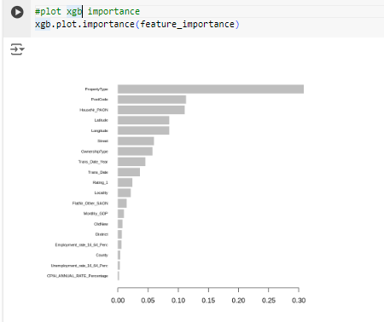
Fig. 9. A snippet showing the feature importance for Peterborough data

2.2.2 XGBoost model feature importance chart on London data

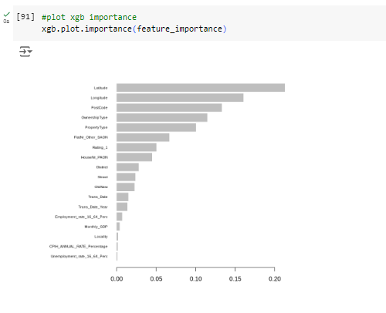
Fig. 10. A snippet of Feature importance for London data

2.2.3 The results

The following table shows our results based on the machine learning algorithms listed below. These results were confidently generated from the respective modules, again without generally going through each algorithm, it is clear that through our developed framework, our proposed XGBoost performed better than every other algorithm on the list, with these scores: RMSE:0.444, MAPE:1.94%, MAE:0.234.

Table 1. The results of the algorithms based on the validation metrics (Highlighted in bold are the best performed algorithms)
3 Conclusion
This research has demonstrated that property price prediction is a complex and dynamic process, influenced by multiple factors. However, machine learning offers a robust approach to addressing these challenges by exploiting large dataset and advanced algorithms. It can understand data patterns and correlation between features to predict the property prices, with near accuracy. The most ranked features are the property location, postcodes, geo location, property type, with huge potentials for further feature integration and engineering. Through the proposed framework XGBoost (Extreme Gradient Boosting): RMSE:0.444, MAPE:1.94%, MAE:0.234; is proposed as part of the wider contribution to the body of knowledge, which outperformed Bagging (Ensemble) RMSE:0.509, MAPE:3.76%, MAE:0.286; Neural Network: RMSE:0.523, MAPE:2.61%, MAE:0.324, refer to (Table 1.), ARIMA, Holt Winters, Support Vector Machine (SVM), KNN, Decision Tree (DT), Principal Component Analysis algorithms, given its lesser RMSE, MAPE, MAE scores and high MAPE accuracy prediction of 1.94% on the processed fed data in the framework.
Another factor to note about the proposed algorithm lies on its efficiency and effectiveness in implementation and handling huge datasets efficiently, as identified gap. This study deeply and extensively assessed various machine learning models, as shown in the framework methodology. The selection criteria for the best-performed model were made possible using these metrics: RMSE, MAPE and MAE. This ensured consistency across the selection criteria of the various models.
The model that showed a consistent positive results in the prediction when consolidated was the XGBoost across the 48 ran modules over other models, which adopted supervised and unsupervised methods of learning respectively; we equally looked at the Ensemble model in the process; which consisted of Random Forest, Tree, OLS, Bagging algorithms: Bootstrap aggregation which is also known as Bagging, and as part of the ensemble learning method; used in this instance for its capability of reducing variance in a noisy dataset; K-Nearest Neighbours (KNN), which is a ML method that uses proximity to predict or classify a data points grouping; and this is supervised learning method; and Ordinary Least Squares (OLS).
The essence of running these ML models was to collectively assess and chose the best performing models for this research; and for the developed framework SFMLAF; in view to aid and influence the decision-making process in property price prediction with the readily available UK online datasets, which allows the user of the framework the opportunity of real-life experience through the proposed process.
The futuristic outlook would look like a process where the required data is downloaded or through API (Application Programming Interface) as part of automation process; the data would then be saved in a cloud-based database, from where the framework will run and feed into a dashboard created for the required machine learning analysis and prediction. The initial phase of such dashboard visualization could be possible with R-Shinny, which could allow parameterized property price prediction. In the part of expanding the scope of the data collection, using the information about the property, further characteristics of the property could be collected to enrich the dataset.
Dummy variables or attributes of the property could be created to enable the data collection for further feature engineering as necessary, alongside future continuous revaluation of latest algorithms including hybridization of algorithms, that can fit into the machine learning scope with ultimate accurate prediction and speed, data science is continuing to expand and new knowledge found daily, so I am optimistic that the future is promising for a 100% accuracy that can be done in a lightening speed and on huge datasets that is resource efficient, given the cloud technologies at our disposals.

References
- Price Paid Data Download, 2024. Price Paid Data Download. Available at: https://www.gov.uk/government/statistical-data-sets/price-paid-data-downloads (Accessed: March 2024).
- Tchuente, Dieudonné and Nyawa, Serge. (2022) 'Real estate price estimation in French cities using geocoding and machine learning', Annals of Operations Research, 308, 571–608 (2022). Available at: https://doi.org/10.1007/s10479-021-03932-5. (Accessed: 03 March 2024).
- Kang et al., (2021) 'Understanding house price appreciation using multi-source big geo-data and machine learning’, LandUse Policy,Volume 111,2021,104919,ISSN 0264-8377,https://doi.org/10.1016/j.landusepol.2020.104919. Available at: (https://www.sciencedirect.com/science/article/pii/S0264837719316746).Price Paid Data Guidance (2024) Available at: https://www.gov.uk/guidance/about-the-price-paid-data (Accessed: 30 April 2024).

- Mostofi et al., (2022) 'Real-estate price prediction with deep neural network and principal component analysis', Organization, Technology and Management in Construction: an International Journal. 14. 2741-2759. 10.2478/otmcj-2022-0016. Available at: https://www.researchgate.net/publication/366979465_Real-estate_price_prediction_with_deep_neural_network_and_principal_component_analysis (Accessed: 03 March 2024).
- Saya Sapakovaa and Askar Sapakov (2024) 'Features of modeling the online real estate market in Almaty',Procedia Computer Science,Volume 231,2024, Pages 409-414, Available at:https://doi.org/10.1016/j.procs.2023.12.226. And (https://www.sciencedirect.com/science/article/pii/S187705092302238X) (Accessed : 03 March 2024).
- Zhao,Y. et al. (2019) ‘Deep Learning with XGBoost for Real Estate Appraisal’. 2019 IEEE Symposium Series on Computational Intelligence (SSCI), Xiamen, China: 2019, pp. 1396-1401, doi: 10.1109/SSCI44817.2019.9002790: Available at: https://ieeexplore.ieee.org/abstract/document/9002790
(Accessed 16 November 2022).
- Sehgal, S. and Agarwal, M. (2018) ‘Analogous Examination of Various Machine Learning Algorithm Applied to Big Data’. 2018 International Conference on Advances in Computing, Communication Control and Networking (ICACCCN), Greater Noida (UP), India: 2018, pp. 121-123, doi: 10.1109/ICACCCN.2018.8748855: Available at: https://ieeexplore.ieee.org/document/8473231 (Accessed 10 November 2020).
- Trawiński, B. et al. (2017) ‘Comparison of expert algorithms with machine learning models for real estate appraisal’. 2017 IEEE International Conference on INnovations in Intelligent SysTems and Applications (INISTA), Gdynia: 2017, pp. 51-54, doi: 10.1109/INISTA.2017.8001131:Availableat: https://ieeexplore.ieee.org/document/8001131 (Accessed: 15 October 2022).
- Renigier-Biłozor, M. et al. (2020) ‘Hybridization of valuation procedures as a medicine supporting the real estate market and sustainable land use development during the covid-19 pandemic and afterwards, Land Use Policy’. Volume 99,2020,105070,ISSN 0264-8377,https://doi.org/10.1016/j.landusepol.2020.105070: Available at: https://www.sciencedirect.com/science/article/pii/S0264837720315702 (Accessed : 09 November 2022).
- Xiaolong, H. and Ming Z. (2010) ‘Applied research on real estate price prediction by the neural network’. The 2nd Conference on Environmental Science and Information Application Technology, Wuhan :2010, pp. 384-386, doi:10.1109/ESIAT.2010.5567321: Available at: https://ieeexplore.ieee.org/document/5567321 (Accessed: 14 November 2022).
- Liu, G. and Zong, X. (2017) ‘Research of second-hand real estate price forecasting based on data mining’. 2017 IEEE 2nd Information Technology, Networking, Electronic and Automation Control Conference (ITNEC), Chengdu: pp. 1675-1679, doi:10.1109/ITNEC.2017.8285080: Available at: https://ieeexplore.ieee.org/document/8285080 (Accessed: 12 October 2022)
- Dambon, J.A. et al. (2021) ‘Maximum likelihood estimation of spatially varying coefficient models for large data with an application to real estate price prediction’. Spatial Statistics: Volume 41,2021,100470,ISSN 2211-6753,https://doi.org/10.1016/j.spasta.2020.100470: Available at : https://www.sciencedirect.com/science/article/pii/S2211675320300646 (Accessed : 11 November 2020)
- Bin, J. et al. (2017) ‘Regression model for appraisal of real estate using recurrent neural network and boosting tree’. 2017 2nd IEEE International Conference on Computational Intelligence and Applications (ICCIA), Beijing, 2017, pp. 209-213, doi:10.1109/CIAPP.2017.8167209: Available at : https://ieeexplore.ieee.org/xpl/conhome/8115600/proceeding (Accessed :08 November 2022)
- Varma, A. et al. (2018) ‘House Price Prediction Using Machine Learning and Neural Networks’. 2018 Second International Conference on Inventive Communication and Computational Technologies (ICICCT), Coimbatore: 2018, pp. 1936-1939, doi: 10.1109/ICICCT.2018.8473231: Available at: https://ieeexplore.ieee.org/document/8473231 (Accessed 05 November 2022).
- Xu, H. and Gade, A. (2017) ‘Smart real estate assessments using structured deep neural networks’. 2017 IEEE SmartWorld, Ubiquitous Intelligence & Computing, Advanced & Trusted Computed, Scalable Computing & Communications, Cloud & Big Data Computing, Internet of People and Smart City Innovation (SmartWorld/SCALCOM/UIC/ATC/CBDCom/IOP/SCI), San Francisco, CA: 2017, pp. 1-7, doi: 10.1109/UIC-ATC.2017.8397560: Available at : https://ieeexplore.ieee.org/document/8473231 (Accessed 02 November 2022).
- Shi, H. (2009) ‘Determination of Real Estate Price Based on Principal Component Analysis and Artificial Neural Networks’. 2009 Second International Conference on Intelligent Computation Technology and Automation, Changsha, Hunan: 2009, pp. 314-317, doi: 10.1109/ICICTA.2009.83: Available at : https://ieeexplore.ieee.org/document/5287649 ( Accessed 05 November 2022).
- Mohammad Tamim Kashifi et al., (2023) 'Deep hybrid learning framework for spatiotemporal crash prediction using big traffic data', International Journal of Transportation Science and Technology, ScienceDirect, Volume 12, Issue 3,2023,Pages 793-808,ISSN 2046-0430, Available at: https://doi.org/10.1016/j.ijtst.2022.07.003. (https://www.sciencedirect.com/science/article/pii/S2046043022000648).
- Sheng Huang (2024) 'Big Data Processing and Analysis Platform Based on Deep Neural NetworkModel', Soft Computing Letters (2024), doi: https://doi.org/10.1016/j.sasc.2024.200107 (Accessed: 03 March 2024).
- Tan, M.J and Guan,C. (2021) ‘Are people happier in locations of high property value? Spatial temporal analytics of activity frequency, public sentiment and housing price using twitter data’. 2021 Science Direct Volume 132,2021,102474,ISSN 0143-6228, https://doi.org/10.1016/j.apgeog.2021.102474:
(https://www.sciencedirect.com/science/article/pii/S0143622821000904). (Accessed: 02 March 2023).
- Safieddine, F, (2021) Student’s guide for final year project thesis, ed. K Lomidze, New York: CreateSpace Publishing.
- Gomez, J. (2022) ‘8 critical factors that influence a home's value’. Opendoor, California, USA: 2022.; published 6/4/2020. Available at: https://www.opendoor.com/articles/factors-that-influence-home-value (Accessed: 02 March 2023).
- Rahman, M. F. et al. (2017) ‘Density Based Clustering over Location Based Services’. 2017 IEEE 33rd International Conference on Data Engineering (ICDE), San Diego, CA, USA: 2017, pp. 461-472, doi: 10.1109/ICDE.2017.103. (Accessed: 14 April 2021).
- Enver, N. and Issac, D. (2002) ‘The Valuation of Property Investments’ WS Bookwell, Juva, Estates Gazette, London, 2002.

