Man Science

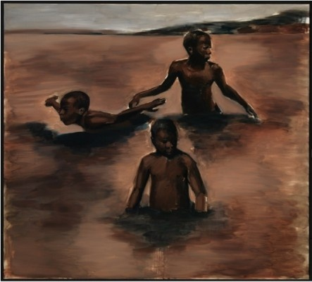

I first saw Lynette Yiadom-Boakye’s work in early 2012 at the New Museum in New York. I remember the darkness of the paint: a smallish, square oil painting, and the gleam of a grin. The brushstrokes were sometimes rough, sometimes elegant; they reminded me of Manet, except that there was something forced about the grin that struck me as strange. The exhibition was called ‘The Ungovernables,’ the London riots had happened the previous summer, and it seemed to me that these dark paintings contained a political message. In time, however, I came to see them differently.
That spring, I saw ‘Man Science’ in Yiadom-Boakye’s solo show at the Chisenhale Gallery, London. It’s a large-format work, a size that often indicates a ‘history painting’, but its subject is three young boys in the shallows of a body of water. There is something provisional about it, and the figures could be three studies of a single boy. The drawing reminds me of Joshua Reynold’s portrait ‘Portrait of a Black Man,’ except that, here, anonymity is not a reduction to type; it is a defence of the imagination. Yiadom-Boakye paints people who don’t exist, or who exist as figments of her own imagination. This painting, in turn, represents three boys involved in imaginative play: one runs his hands in the water; another skulks; and the last holds his arms back, as if becoming a bird.
Later that year, I wrote an essay about her work that, I think, ended up imposing a politics on it. In 2013, Yiadom-Boakye won the Turner Prize, and I was asked to write another essay about her and then to interview her. But the more time I spent thinking about her work, the less confident I felt that I understood it. Her 2014 exhibition at Jack Shainman Gallery in New York was accompanied by a poem that referred secretively to ‘What the Owl Knows.’ When I interviewed her, at her home in South London, the artist spoke about her relationship with the figures of her imagination, which seemed to come and go of their own volition. I began to see the wisdom of protecting the privacy of her own imagination. I noticed that the artist’s glasses were a little owlish.
Yiadom-Boakye’s retrospective at Tate Britain, in 2020, included a reading list, where I learned that she had been inspired by Macbeth, Shakespeare’s wintry revenge tragedy. This helped me to see a connection between her work and the poetry I love. Keats called it ‘negative capability’ – the ability of a poet to stay with the mystery without demanding hard scientific facts. This is what makes the reader want to understand it and ensures that they will never definitively pin it down. Something similar is true of the viewer of Yiadom-Boakye’s work, and we should meet her respect for the mystery with our own. This, perhaps, is the wisdom of the owl, which is said to only fly at dusk.
These days, what I notice in her work is more formal: the red robe of one sitter that looks like the red of a cardinal in a painting by Velazquez; her interest in necks, and roughs and necklaces that cut across them; the presence of certain animals as ornaments; the dancer; the uncle; more than anything, the relaxed elegance of her young men. Her backgrounds are often dark, rendering her figures outside of context, time and place. The diffuse brown background in ‘Man Science’ reminds me of the old-fashioned idiom ‘in a brown study,’ meaning a state of deep thought. That’s what we are seeing: three children consumed by their own inner lives. There is something brooding about it, but I don’t know what is meant about to happen. The flatness of the represented space makes the scene vertiginous, as if the water could break down over us.
I now think of her titles as short poems, red herrings, and Rorschach tests. ‘Man Science’ sounds to my ears like a critique of Enlightenment science and all its mistaken ideas about race. But who knows? Maybe it’s about learning how to swim. The painting always makes me think of the ancient adage: ‘Everything is in shallow waters.’ And the heaving Atlantic Ocean in the film ‘Moonlight,’ where a father teaches his son to swim. And William Wordsworth’s couplet: ‘see the children sport upon the shore/ And hear the mighty waters rolling ever more.’ If we can resist the wish to explain, we finally begin see the children in the swelling water, and all our associations become merely private ways to make sense of the pleasure that the painting gives.

