Birth, death, and persuasive analogies: the Nativity at Eğri Taş¸ Kilisesi, Cappadocia
Niamh Bhalla
Life was unpredictable, and often precarious, for the people of medieval Byzantium. Life expectancies were low and mortality rates high, particularly for young children and women. Securing divine protection was imperative for medieval families, particularly in the face of childbearing, illness, death, and judgement. Very often, all that remains of the cycles of existential threat, fear, and trust in God experienced by medieval people are the objects of material culture through which they sought God’s protection, and often merely fragments thereof. Here, I explore what remains of the image of Christ’s nativity in the tenth-century, rock-hewn church of Eğri Taş in the Peristrema Valley of Cappadocia in rural Turkey as an indexical trace of the community that once came to secure God’s protection assisted by the potent imagery there. The palpable emphasis on Christ’s infancy in this funerary church which hosted many graves, including those of women and children, through a highly unusual and extended cycle concerning his birth, along with the inclusion of powerful written elements such the elusive Sator palindrome within the Nativity, will be interpreted as the employment of persuasive analogies in response to the struggles families faced in the community.

Art history: loss, longing, and indexical fragments

Underpinning the discussion is an exploration of the role that imagery—even the damaged traces that survive at Eğri Taş Kilisesi—can play in viscerally connecting us to past communities that have otherwise left no mark on the historical record. The programme is incomplete: parts have been lost irrevocably through rock fall, human activity, and the vicissitudes of time. The irreparable loss stretches beyond the visual to the lack of an original liturgical/performative context for the programme and a dearth of information concerning the community who created the imagery and buried their loved ones in the graves around the church. Gaping voids continue beyond the group of four churches to which Eğri Taş¸ belongs, across the material record, since comparisons for most of the unfamiliar motifs included are found flung across the Byzantine Empire and outside of it, particularly in Coptic Egypt, with no demonstrable connections. The art historian working with premodern material is faced with the familiar task of creatively reconstructing a surmised whole from the visual, material, textual, and performative traces that can be reasonably collected and connected. The decisions concerning whether the fragments remaining are sufficient to attempt the creation of that whole vary across the periodical and geographical divisions that have shaped art history and from scholar to scholar. So too does the hierarchy of pieces that determine the imagined whole. Very often textual fragments are given authority in determining not only the shape of the vignette offered, but also its credibility.

The increasingly global and inclusive scope of art history—the expansion of the parameters concerning what is deemed worthy of inclusion therein, stimulated in large part by the rise of visual studies—and the diversification of the questions that art historians have been willing to ask of art under the influence of new historicism since the 1970s have prompted the attempt here to journey beyond (often implicit) assertions of textual and archival primacy, to think about imagery and its relationship to undocumented past people groups, when image fragments are essentially all that remain. The performative agency of the pictorial in one (necessarily vaguely defined) community’s navigation of birth and death is explored, providing an argument for the integration of materials and approaches from the margins of scholarship. Venturing beyond the textual paradigms previously used to interpret this imagery, which tracked its unusual scenes and motifs to apocryphal literature, thus assigning a generative and explanatory role to text, I explore the powerful synchronicity of image and inscription in the face of the medieval life cycle. Powerful words within the imagery that wielded immediate agency raise a contentious debate concerning the relationship of ‘magic’ and religious experience. Recent focus on material agency within the humanities makes it an opportune moment to discuss this potent imagery aside from polarized dichotomies between religion and magic, and high and low cultures. The direct performance of this community’s inscribed imagery is reframed as giving a glimpse into past religious experience, but only if the value of the fragment is accepted and visual epistemics are prioritized.

The discipline of art history has been marked by a sense of loss since its inception. Johann Joachim Winckelmann’s (1717–68) famous analogy for the task and predicament of those who would seek to recreate the totality of the lost Greek ideal in art is often cited in this regard—his farewell scene between a lover and her beloved in his formative History of the Art of Antiquity (1764), arguably the founding text of the modern discipline:
Just as a beloved stands on the seashore and follows with tearful eyes her departing sweetheart, with no hope of seeing him again, and believes she can glimpse even in the distant sail the image of her lover—so we, like the beloved, have as it were only a shadowy outline of the subject of our desires remaining.
Historians of Byzantine art have responded differently over time to the substratum of loss upon which the discipline has inevitably been built—from the fantasy of creating genetic recensions, a pseudo-science aimed at restoring the countless works that no longer exist, to a delimiting empiricism willing only to comment upon what is present, to the anchoring of art historical assertions in the authority of text, treated as a bastion of truth from beyond the ravages of time, rather than as a fragment itself. Alex Potts describes succinctly the quandary at the heart of Winckelmann’s longing that continues to this day; that in ‘the impulse that produces history, the projective power that animates the surviving bits and pieces that otherwise would be mere dead fragments, is equally the creation of delusions’; what Jaś Elsner says can become in an art history which is necessarily more ‘archaeologically inflected’, ‘a process of reparation through fantasy that is considerably more optimistic than the shadowy outlines over which the founder of the discipline shed his tears’. Whilst mindful of the risk, I aim to work the material remains hard and to be satisfied with what I perceive to be a glimpse into the past based on the patching together of fragments, without trying to construct any detailed imaginary whole; in the words of Winckelmann, I seek to draw ‘inferences from many tiny details’ and to ‘arrive at a probable assertion’.

Funerary churches in the Peristrema Valley

there seems to have been something of an obsession throughout Cappadocia with death and its commemoration …
From the seventh to the second half of the ninth century CE, Cappadocia was an embattled border province of the Eastern Roman Empire, now known as Byzantium. Raids from the Arab emirates of northern Syria were frequent, but a series of successful expeditions against the Arab offensive in the ninth century culminated in the establishment of Cappadocia as a secure and prosperous province in the middle of the empire by the mid-tenth century, thanks to the retaking of eastern Anatolia. As a result, the mid-tenth to late eleventh centuries saw a burgeoning of towns, rock-cut churches, monastic settlements, and artistic patronage in Cappadocia. The built environment of the region was rupestrian, because carving structures from the soft volcanic rock there was practical and economical, and over seven hundred rock-cut churches and chapels survive from this period. There is a dearth of information regarding who used these ecclesiastical structures, but recent scholarship has generally refuted the ‘monastic paradigm’ prevailing since the first antiquarian travellers passed through the region in the nineteenth century, which maintained that these spaces belonged to ascetic monastic communities who sought refuge in these cave-like spaces. This romantic notion seemed apt given the fantastical, breathtakingly stark landscape, the fact that Basil of Caesarea (330–397 CE)—the Father of eastern monasticism—hailed from there, and wider stereotypes of Byzantium as excessively religious.

The interpretation of the sites as primarily monastic, even those now identified as aristocratic οἶκοι/houses, was reinforced through Guillaume de Jerphanion’s (1877–1948) authoritative scholarship on the painted rock-cut churches between 1925 and 1942, which perpetuated the paradigm. The theory has been challenged in recent years, however, with architectural historians such as Robert Ousterhout, Veronica Kalas, and Fatma Gül Öztürk demonstrating that many Cappadocian settlements once identified as monasteries were towns, villages, or aristocratic houses. Lay inscriptions and graves abound in Cappadocian churches, far outnumbering monastic ones, testifying to vibrant communities of men, women, and children living in the region; and lay patrons of high social and military rank can also be identified. Although it appears isolated, barren, and uninhabited today, Cappadocia once sat on some of the most travelled trade, pilgrimage, and military routes of the medieval period between Syria, Palestine, and Constantinople, with powerful landowners there considered a threat in Constantinople. Recent thought has sought to explain the disproportionate number of churches in Cappadocia, which far exceed the normal liturgical needs of the region’s population, as burial chapels for the laity used primarily for commemorative purposes.

The understanding of the rupestrian structures within the Peristrema Valley in the northern foothills of the Hasan Dağı massif in the province of Aksaray, western Cappadocia—also previously characterized as a bustling monastic milieu—has shifted similarly. The deep river gorge, cutting through solidified volcanic ash for about six miles, contains an impressive concentration, now hard to quantify, of rock-cut churches, rooms, tombs, and settlements carved into the steep cliffs on either side of the Melendiz Suyu River, particularly between the modern Turkish villages of Ihlara and Belisirma. The four churches of the so-called Ihlara group to which Eğri Taş belongs (with Pürenli Seki Kilise, Yılanlı Kilise, and Kokar Kilise)—dated to the tenth century on stylistic and epigraphical grounds and so named because of their proximity to the modern Turkish village (located two kilometres to the south of the valley)—forms an explicit cluster there. The unusual iconographies and stylistic traits of the Ihlara group churches—first published by Nicole and Michel Thierry (1916–2011) in Nouvelles Églises Rupestres de Cappadoce (1963), which remains the only monograph on them—suggest that a distinct community was responsible for them. Many of the churches found near Ihlara are greatly damaged because the pinkish-grey rock in this part of the valley erodes in large chunks. More habitations, including large residences, are consequently found to the northern end of the valley where the yellowish-grey rock is softer to carve and less prone to fall near the modern villages of Selime and Yaprakhisar. Despite the nature of the rock near the Ihlara end, at least twelve rock-cut churches have been carved into the cliff faces. We do not have information about liturgical practices in Cappadocia, but it is clear that the number of churches in the valley far exceeded protean liturgical needs. The proliferation of burial churches suggests that many were separate spaces existing primarily for funerary and commemorative services.

The variety in the size, nature, and disposition of the burials in the Ihlara churches, and their varied funerary portraits and inscriptions, point firmly towards the close involvement of a lay community. The unusual style of the Ihlara paintings with their schematic black outlines and bright arresting colours, along with their unusual features found mostly in Coptic materials, and the connection of the Eğri Taş programme to Syriac writings, prompted Nicole Thierry to attach the group to a Syrian or Coptic diaspora community, whilst others have asserted a link to the significant Armenian community in Cappadocia. The flux and movement of groups across these regions, particularly as a result of the expansion of the Islamic world, makes any of these suggestions possible, but I suggest, based on the sheer number of comparisons with Coptic material—which seems to go beyond mere coincidence based on what has been preserved in the arid Egyptian climate—and the close connections between Syriac and Coptic Christianity, that a link to Egypt is most probable, though there are multiple other cultural influences and connections evidenced throughout these churches that cannot be disentangled further here. A connection to Egypt might also be perceived in the extended representation of the flight of the holy family into Egypt which takes up a disproportionate amount of space on the vault, with inscriptions that repeatedly mention Egypt such as ‘Joseph on his way to Egypt’ and an unusual and ornate personification of ‘The Queen of Egypt’ who welcomes the holy family to ‘the town of Egypt’. Regardless, it seems that the community was well established and assimilated given the continued use of the church over time, the content of the painted programmes and funerary inscriptions, and the prominent levels of patronage evidenced therein, so that it seems improbable, that a non-Chalcedonian group was operative in the church.

The painted programme of Eğri Taş Kilisesi (The Church of the Crooked Stone)

Taking its name from the fall of the cliff that caused the obliteration of its western wall, Eğri Taş is a single-nave church with a barrel vault, which is relatively large in comparison with the other churches of the Ihlara group (figures 1 and 2). It is dated by a painted dedicatory text, on the eastern wall to the right of the apse, to 921–27 CE. This badly damaged dipinto commemorates the donor, giving his name and titles (figure 3). The Thierrys provided the original transcription, but Nikolaos Oikonomides (1934–2000), has provided a different reconstruction and reading:
The church of the Holy Virgin was decorated in the year six thousand four hundred thirty […] under the reign of Romanos, Constantine and Christopher, at the expense of the servant of God and of the Holy Virgin, the spatharokandidatos and tourmarches Padiates; all of you pray for him, amen.
One Padiates (the Thierrys identified the patron as Christopher)—identified with the mid-level title of spatharokandidatos and the military office of tourmarches (τουρμάρχης)—is said to have decorated the church of the Theotokos. The church is now exposed, and one enters through the large funerary chamber previously underneath the nave, once separated by a now vanished wooden floor. The distance between the original floor level and the apex of the vault is around four-and-a-half metres; the nave at its widest is almost six metres; and the length may have been up to ten metres. Underneath the church and well beyond it one encounters a suite of successive rooms that the Thierrys refer to as a ‘vast necropolis’, hosting mostly lay but also monastic burials.

There is the possibility that the church of Eğri Taş¸ at the heart of this cemetery was connected to, or serviced by, a monastic community. A earlier funerary inscription on the eastern wall of the main funerary chamber dated to the seventh century belongs to the hieromonk Peter buried there, described as a priest of the Theotokos. The inclusion of Gregory (probably of Nazianzus) and Basil of Caesarea on the upper part of the eastern wall of the church to the left and right of the sanctuary, respectively, may further suggest a monastic link; but this could also merely relate to their popularity because of their connection to the region. Other donor imagery and burials are decidedly lay in nature, and we must assume close relationship with the wider community. There appears, for example, to have been a special connection between the church’s dedication to the Virgin and female patrons. In the northern funerary chapel, a woman is represented with a fragmentary inscription indicating that she was buried in one of the floor graves. She kneels before the image of the enthroned Virgin and Child there, grasping the foot of the Theotokos, with an intimate and protective relationship implied. A later image of what may be a female donor is represented at the feet of a female saint on the eastern wall of the church to the right of the sanctuary underneath the earlier lay donor inscription, suggesting the continued involvement of lay females with the church over time (figure 3). Infants and females were buried throughout, evidenced by means of inscriptions and the size of some of the burial plots, such as the three small graves directly underneath the sanctuary in the funerary chapel.

The main church is covered in a unique cycle of paintings—now greatly damaged—that must be understood in relation to the better-known Cappadocian narrative programmes from the first half of the tenth century, first termed ‘archaic’ by Jerphanion. Following Iconoclasm, dense narrative renderings of Christ’s life were painted on the walls of mostly single-nave, barrel-vaulted churches in Cappadocia, with standing saints on the lower walls, whilst images of Christ in glory often occupied the apse. Abbreviated yet busy Christological cycles of ‘continuous narration’ ran, often in chronological order but with no real separation of the scenes, on the upper parts of tenth-century churches such as the Old Church at Tokalı Kilise, Göreme. Generally, these archaic cycles prioritized the Infancy, Passion, and Resurrection of Christ, which has been related to the eucharistic function of the spaces. The churches of the Ihlara group are similar to these programmes in this regard.

The decoration of Eğri Taş is restored in places but, overall, the original Christological cycle of the naos may be discerned, save for what has disappeared completely. A large cross occupies the length of the barrel vault at its apex (figure 4). The unique form and size of this decorated cross dominate the space, declaring a protective function for the imagery that surrounds it: prominent post-iconoclastic crosses in Cappadocia were generally apotropaic, and burial inscriptions in the church celebrate the power of the cross in the face of death. The cross is flanked by three superimposed registers of painted scenes on the north and south sides of the vault. The programme reads from east to west, or right to left, like Syriac writing, starting on the south side of the vault with the Annunciation and Visitation: beyond this point the rock has fallen. On the register underneath is the Nativity, comprising the Adoration of the Magi, the Nativity proper, Christ’s First Bath by the Midwives, and the Visit of the Shepherds, named after the terms of the elusive ‘magic’ word square known as the Sator palindrome (an acrostic comprising the words Sator, Arepo, Tenet, Opera, Rotas arranged in a grid so that each word could be read horizontally and vertically), written here in Greek script. The lowest level hosts the Dream of Joseph, the Flight into Egypt, and Herod Ordering the Massacre of the Innocents, though the part of the scene depicting the soldiers killing the infants has disappeared. On the south wall below are the Baptism of Christ and the Entry into Jerusalem. Everything else has vanished.

The narrative sequence continues on the lowest register of the north side of the vault with the Denial of Peter, the Washing of the Feet, the Garden of Gethsemane and, at the centre of the north wall, the Women at the Tomb. Beyond this to the west, rock fall has again destroyed the paintings. The upper registers of the north side of the vault return, with a disregard for narrative continuity, to the theme of Christ’s birth. A prominent tableau of the Virgin enthroned with the Christ child flanked by angels holding textiles is included immediately under the cross, and underneath this, again running from east to west, are apocryphal scenes: a second Annunciation, this time the apocryphal version at the well— found in the Protevangelion of James—and the apocryphal Three Visions of the Magi. The Thierrys thought that perhaps there was an intentional theme here that escapes us: however, the thrust of this article is that particular concerns and purposes may be discerned through the idiosyncrasies evident in what survives, all of which stemmed from the desire for a protective encounter with the divine in the face of existential threat.

The programmes of the four Ihlara churches are dominated by two main themes: Christ’s birth and death, seen at Eğri Taş in the unusually extensive, repetitive, and eclectic representation of Christ’s infancy, in the Passion cycle which is now mostly destroyed, and in the Last Judgement, of which only fallen fragments have been found. Throughout the Ihlara programmes there is also a noticeable inclusion of unique powerful features—angelic and demonic names, talismanic symbols like the ‘holy rider’ spearing a demon, repeated use of the cross in unusual forms, and the Sator formula—that have often been labelled as ‘magic’ in Byzantine studies. In this powerful mixture of Christological imagery and potent motifs, the needs of the people using these images are palpable: the creation of compelling imagery pertaining to the birth and death of Christ stemmed from what it meant for their own births and deaths. The reasons why birth and death would have dominated the minds of those creating these churches are not difficult to discern. The individuals and communities frequenting these foundations lived in a harsh and unpredictable climate, dominated by subsistence farming which was affected regularly by animal and plant disease, high infant mortality rates, and short life expectancies. Life in rural Cappadocia would have been as Eric Cooper and Michael Decker put it ‘precarious, often miserable, and usually brief’.

These monuments are the sole surviving testimony to the real medieval people who created and interacted with them, and they are almost palpable in the striking, visceral imagery that they left behind. The unusual nature of the painted programmes has meant that these churches and what they may be able to tell us about a rural Cappadocian community have largely been overlooked. An iconographic mode of interpretation has been employed to interpret the imagery, based primarily on finding its motifs in texts, but here I appeal also to other ‘everyday’ forms of visual and amuletic culture, particularly from Coptic Egypt, to which I believe the community was connected in some way, to understand the inscribed imagery more fully. My focus is on the unusual treatment of the extended nativity cycle that dominates the church—a fragment of the fragments—but this must be expanded in future endeavours to consider the representations of the Passion and death of Christ as forming part of this protective cycle.

Beyond textual paradigms

A dogmatic paradigm—premised on the idea of the image as a visual theological commentary—has informed the interpretation of the archaic programmes since Jerphanion first described them as ‘dogmatic’. Nicole Thierry nuanced this approach, describing Christological narrative cycles as ‘theophanic’, comprising divine manifestations that were both illustrative of texts and didactic concerning Christ’s person. Catherine Jolivet-Lévy has similarly unpacked narrative imagery in tenth-century Cappadocia as didactic in purpose and tone: ‘visual apologetics’ were made palatable to the people through these visual ‘stories’. The prioritization of the infancy cycle across tenth-century programmes in particular has been simultaneously related to the eucharistic sacrifice performed in these spaces which was made possible by the Incarnation and to a complex visual commentary on the fully human and divine nature of Christ affirmed at the Council of Chalcedon and through the iconoclastic controversies. Jolivet-Lévy has demonstrated that the Orthodox understanding of Christ’s person was ‘still being proclaimed here in the face of ongoing heresies’. The theological importance of visual representations of Christ’s birth and death, and the didactic nature of the imagery and its connection to its liturgical context in the churches of Cappadocia, are of course irrefutable, but the extension and non-chronological repetition of scenes at Eğri Taş, along with the inclusion of unusual apocryphal materials and the addition of ‘magical’ inscriptions, are indicative of a fervent desire to experience and harness the power of these seminal Christian events.

Apocryphal texts have been used to explicate the Ihlara cycles, particularly in relation to the infancy cycle at Eğri Taş. The Thierrys emphasized deviancy from Orthodoxy in Nouvelles Églises through the reliance of these four churches on extra-canonical texts. They indicate at the beginning of their ground-breaking publication—intended as a mere starting point—that the direction for further research on these churches should be the interrogation of Syriac texts they had been unable to consult. A textual understanding of the images predominates to the extent that their descriptions of the Eğri Taş scenes are given in narrative order, rather than in the non-chronological order in which they appear in the church, which belies a purely narrative intent or diachronic approach, as does the reduplication of themes. Their invaluable work can be expanded upon through consideration of why such scenes were used to expand Orthodox image cycles; of the formative role played by oral traditions and smaller works of material culture in the creation of these churches; and of innovation based on what the community wanted and needed to encounter.

Christ’s infancy was not treated at any length in the canonical scriptures and the desire to supplement the laconic account (and to document the Virgin’s life as it pertained to inherently Christological considerations), gave rise to the popular apocryphal traditions that surface in Cappadocian images. Texts such as the mid-second-century Protevangelion of James circulated widely in the East, the Protevangelion weaving itself into the lives of medieval Christians. Achieving an almost canonical status, stories and details from it were found in narrative Christological programmes from the fifth century onwards. The appearance of stories from the Protevangelion was symptomatic of its wide diffusion across the Christian East to the point that it was incorporated into liturgical works by the mid-sixth century such as Byzantine hymnographer Romanos the Melode’s famous Kontakion. The stories became part of the Christian Roman empire’s ‘large and complex web of intersecting stories which informed the actions and perceptions of its people’. In the Ihlara churches, elements from the Protevangelion and other apocryphal texts naturally formed part of the potent mixture of scriptural and apocryphal imagery, divine names, scriptural quotations, and ‘magical’ names and symbols that could help to guide the faithful through a precarious existence.

Building on architectural historian Spiro Kostof’s (1936–2001) astute observation that ‘a Christological ensemble of magic potency’ was desired at Eğri Taş rather than a linear narrative, I argue that the infancy imagery had a protective function in relation to the medieval life cycle. Kostof too identified various texts behind the potent imagery, concluding that the Ihlara cycles differed from the archaic churches because of reliance on different sources, notably the Gospel of Pseudo Matthew and the Armenian Book of the Infancy over the Protevangelion. Beyond the apocryphal scenes included to extend the infancy cycle such as the Visions of the Magi, small details— spread by oral and visual means—were also added to stimulate viewers to make affective analogous connections between their experiences and the imagery. Inscriptions added to the Christological imagery, especially those such as the Sator formula, draw us into what this imagery may have meant for the lives of its creators and viewers. Those frequenting these funerary sites were primarily interested in Christ’s incarnation because of what it meant for their own lives and deaths, with the experience of each viewer nuanced or heightened to a greater or lesser extent by the intricacies of theology and related texts. All faced the same pressing realities, but each brought a different horizon of expectation and understanding to the imagery.

The extended nativity cycle, powerful names, and the dynamic of incongruity

Although a greater number of Passion scenes probably once existed, it seems that the miracles and ministry of Christ were omitted, and it is clear that the unusual infancy cycle received greatest prominence in being placed in the upper parts of the church dominated by both the striking apotropaic cross and the large composition of the Theotokos and Child which extends the full length of the cross leg, becoming an overwhelming presence in the space (figure 5). The Theotokos, dressed in a grey marphorion over a dark purple robe, holds her son and blesses with her left hand, making a powerful connection with viewers through eye contact, gesture, and scale. Flanking the Theotokos are two imposing archangels in red tunics whose inscriptions identify them as Michael and Gabriel. They advance in profile, knees bent slightly in subordination, but they look out towards the viewer, each with a massive wing extending upwards. Unusually, they hold in their hands a square green cloth adorned with a purple cross surrounded by four pearl-like circles. Two angels follow, dressed in white and carrying red textiles that cover their hands in a more familiar gesture of adoration; they are both named Raphael, but presumably one should have been Uriel. These powerful figures, frequently represented across Byzantine art, and whose names were abundantly common in amuletic materials across cultures and religious traditions, protectively surround the Mother and Child. They were regularly invoked for protection, particularly in relation to childbirth and death, from the earliest times and right through the Middle Ages: framing the mother and child in this way, surmounted by the large cross, they appear as a protective and powerful presence.

The paintings in the apse are now almost destroyed, but there seems to have been another enthroned Virgin and Child flanked by archangels painted there in the semi-dome, surmounted by a bust of Christ blessing with his right hand and holding a closed book in his left (figure 6). Below are the apostles, now greatly damaged. The Virgin and Child are barely visible, but the lower half of the archangels’ imperial attire appears to be in a later style to the rest of the church’s programme, and similar in style to the later female donor image. The Thierrys suggest that the original apse programme may have been comparable with the apse painting in room six of the Monastery of Apa Apollo at Bawit, Egypt (sixth–seventh century), with its Vision of Ezekiel above and seated Virgin and Child flanked by the apostles below. Stars seem to be strewn across the conch in an earlier layer of paint at Eğri Taş, as at Bawit, which would support this suggestion, but it cannot be proven because of the extent of the loss. It seems probable that there was some sort of repetition of the Virgin and Child in the powerful theophanic imagery of the apse.

The Nativity, occupying the second register on the opposite side of the vault, is similar to other Byzantine iterations (figures 7 and 8). Joseph faces away despondently, while Mary reclines looking towards Christ swaddled in the manger to the right, blessing him with her right hand. The midwives bathe the infant Christ to the right. The magi who were not present at Christ’s birth are included anachronistically to the left. They were probably all originally labelled with their apocryphal names—Gaspar, Melchior, and Balthasar—as they were in Kokar Kilise and Pürenli Seki Kilise, but only Melchion (MEKXEON) now remains. The arrival of the three magi to adore the infant was one of the earliest narrative Christological scenes to develop, being found in the catacombs of Rome from the early fourth century, and the image as it appears here belongs to what has been termed the asymmetrical version whereby they arrive dynamically from the left, as opposed to flanking the Virgin and Child. The magi are given prominence at Eğri Taş through their naming and their inclusion at the moment of the nativity. They are also named and given prominence at Kokar Kilise and at Pürenli Seki, but in the latter, they approach an older infant seated on the Virgin’s lap in a separate composition underneath the Nativity (figures 11–13). It seems from their prominence, particularly at Eğri Taş—where at least five scenes are devoted to the magi, which is greatly disproportionate to the verses they receive in Matthew’s Gospel (2:1–12)—that there may have been a special devotion to them in the local community.

Corresponding to the position of the Nativity on the other side of the vault, the highly esoteric apocryphal Visions of the Magi take up a considerable amount of space, elongating the nativity cycle (figures 9 and 10). According to the Armenian Book of the Infancy (IX,17–21), a sixth-century translation of a now lost Syriac apocryphal text, each of the three magi came into the cave to adore the infant in the manger and give their gift, but each of them received a different vision: Gaspar, King of India, saw the ‘Son of God embodied, seated on the throne in glory’; Balthasar, King of Arabia, saw the ‘Son of Man, son of a king, seated on the highest of the thrones, countless armies before him’ in human form; and Melkon, King of Persia, saw ‘him bodily tortured and dead, and risen from the dead’. The three different visions represented at Eğri Taş¸ do not neatly reflect the details of this particular text but seem to come from a wider tradition. In a fourth scene, now mostly destroyed, they seem to confer and decide that this polymorphic manifestation confirms Christ’s divinity, also recounted in the text. Each of the magi is named above their vision in the church. Balthasar’s vision most notably diverges from the text: interestingly, his vision of Christ’s humanity is represented here through an image of the infant Christ in his crib. Furthermore, their order is different to the narrative, with Melchion entering first. Their appearances strangely differ from those in the Nativity proper on the other side of the vault: for example, Melchion is a beardless youth there whilst in his vision he has a dark beard. Reading from right to left there is an age progression in these visions for both Christ and the magi which may form an early expression of later understandings of the magi as representing the three ages of man. Christ develops from an infant to an adult with a dark, longer beard, whilst the magi range from youthful and unbearded to an older bearded type. The esoteric visions seem to support an interest in the human life cycle at Eğri Taş.

The disproportionate space given to the magi at Eğri Taş probably stemmed from what they meant for the community. The magi were intimately connected to ideas of protection. They were found on children’s sarcophagi in this capacity from an early date: such as the front of the small, early fourth-century marble sarcophagus, now in the Vatican Museums, Rome, which hosts an unusual combination of Ezekiel’s vision of the resurrection of the dry bones (37:1–10) with the magi’s visit to the enthroned Virgin and Child, known as the Epiphany: they were invoked here in the context of the child’s hoped for resurrection. They were also included in a personal and protective fashion on worn items, perhaps most prominently on pilgrimage paraphernalia. Where Christological scenes survive on Coptic textiles, the magi’s visit is one of the most popular scenes and their repeated appearance even on the same garment betrays an apotropaic significance. A linen tunic, from sixth–eighth century Egypt, now in the British Museum, London, is decorated with several images of the magi, some abbreviated, which clearly held protective significance. Most of these garments survive from Egyptian burials: buried either with their original wearer or as strips created specifically for burial and sewn onto garments for posthumous protection. The scene also appears on smaller worn items such as an amuletic bronze bracelet now in the Kelsey Museum of Archaeology, Ann Arbor, which shows the Virgin and Child with a kneeling magus (abbreviated due to space constraints) with other motifs often used for protection in relation to childbearing, such as a holy rider figure spearing a female figure on the ground. The unusual prominence and additional scenes of the magi at Eğri Taş which extend and lend mystical presence and potency to the infancy cycle, add to the cumulative effect of the imagery, along with the cross, the Virgin and Child, and esoteric details within the Nativity proper, particularly the Sator square, suggesting that their inclusion related to the protective purpose of the infancy cycle as a whole within this funerary context.

In their dynamic advancement from the left, the magi correspond to the visiting shepherds who advance from the far right, providing a frame for the central tableau. The structure of the Nativity at Eğri Taş, shared with Kokar Kilise, is somewhat atypical, with the central scene very prominently and protectively framed by the advancing shepherds and magi (figure 11). The Nativity flanked by these visitors was found intermittently in later Byzantine images, for example, in the mosaics from the early eleventh century at Hosios Loukas in Greece, but there the visitors were incorporated more organically into the scene, rather than used as a frame, and they were not prominently named in this way. The Nativity was often singled out in Cappadocian churches even in cycles of ‘continuous narration’, where scenes run into one another, either by placing it prominently on its own architectural surface or near the sanctuary. However, in the Ihlara churches, the Nativity is singled out even more through this buttressing of the mother in incubation with child by these flanking groups with potent names.

Framing the Virgin and Child with the shepherds and magi related to an ancient and hallowed type, reproduced most closely at Pürenli Seki, where the seated Virgin and older infant form the centre of the composition rather than the Nativity (figures 12 and 13). The type can be seen in an eighth-century painting at Dayr al-Suryan (Monastery of the Syrians) in the Wadi al-Natrun (figure 14). In the northern half dome of the main church, the three magi (an adolescent, an adult, and an old man) approach an enthroned Virgin holding Christ in an oval (now lost) with the star of Bethlehem overhead. The magi are named, with only ‘Dikastia’ and ‘Melchior’ remaining. The Virgin is flanked by the archangels Michael and Gabriel, and the shepherds are placed symmetrically on the other side of the Virgin in a composition that reflects the design of four of the Monza ampullae—pilgrimage flasks from the Holy Land—which themselves probably emulated the Justinianic apse image from the Church of the Nativity in Bethlehem. At Eğri Taş it is as if they have separated the type, placing the Virgin and Child flanked by archangels on one side of the vault and the magi and shepherds as a protective frame for the Nativity on the other.

The names ascribed to the shepherds were derived from the so-called magic square. The scene is now greatly damaged and only traces of the first two names remain—CATOP (Sator) and what appears to be APEPO (Arepo)—but all five terms from the square were probably once included as they were in Kokar Kilise and Pürenli Seki Kilise.Although the mystical assignment of the terms to Christian elements is found elsewhere such as in North African amuletic materials—where they designate the nails of the Crucifixion— the attribution of the words from the square to the shepherds is only found in Cappadocia. Jerphanion wrote comprehensively on this in relation to archaic churches such as St Eustathius (Göreme no. 11): however, in these buildings only the first three terms are used to name three shepherds. The use of five in the Ihlara group appears to prioritize the formula over the habitual iconography of three shepherds.

The ordering of the square’s terms in the Ihlara churches, beginning with Sator, is the inverse of their order in the Roman world (which commonly began with Rotas). This Latin palindrome, written here in Greek, may have originated in the Roman world, but it diffused widely. In 1868, a possibly third- or fourth-century rotas version was found scratched into a piece of wall plaster from a Roman house in Cirencester, England, demonstrating the spread of the motif throughout the empire. Excavations in 1931–32 revealed examples, possibly from the third century, on the walls of a Roman military office in Dura Europos, Syria, that had once been a Temple of Artemis Azzanathkona (figure 15). A short time later, excavations at Pompeii revealed an earlier version on a column near the amphitheatre, dating the earliest known instance to the first century. Following these early instances, it can be found widely, from the fourth to the nineteenth century, from Cappadocia to Egypt, and across Europe to other continents, including the Americas. The square has received a plethora of interpretations since the nineteenth century, which have sought to make it Stoic, Orphic, Pythagorean, Jewish, Mithraic, and Christian in origin. Linear interpretations of the terms have been attempted which make Arepo a masculine proper noun/name to create literal renderings—such as ‘Arepo the sower/farmer (sator) guides (tenet) the wheels (rotas) with skill, or by his work, (opera)’—which have been greatly contested. It is very unclear whether this cryptogram did have any agreed meaning: indeed, one of the earliest attempts to decipher a translation is found in a later Byzantine manuscript now held in the Bibliotheque nationale, Paris, suggesting that there was no agreed use across traditions.

Its popularity by the end of the Middle Ages and thereafter in Western Europe seems to have resulted from its perceived protective uses against a range of conditions and evils, but this is evident from an earlier date in the East. The terms were often used in an apotropaic manner: for example, in funerary contexts within Nubian Christianity. In a crypt at Old Dongola, Sudan, dedicated to one Archbishop Georgios (d. 1113 CE), there were multiple burials and inscriptions in both Greek and Coptic. The inscriptions, which were discovered by Stefan Jakobielski from Warsaw University and his colleagues of the Polish Archaeological Expedition, included a potent mixture of Gospel texts and powerful names, including a list of the twenty-four elders from the Book of Revelation (represented and named in Yılanlı Kilise), a Sator square, and cryptograms. An earlier eighth-century anchorite’s grotto from Nubia in the desert to the west of Faras, Sudan, hosts Coptic texts which include gospel incipits; the letter of Christ to King Abgar of Edessa in Coptic (widely used in Coptic contexts against illness); the names of the forty martyrs of Sebaste (also represented and named at Yılanlı Kilise); the Sator formula; the names of the magi; the names of the seven sleepers of Ephesus; and a prayer for the soul of one Theophilus, in what amounts to a potent assemblage of scriptural excerpts, powerful names, and symbols. The inclusion of the Nicene Creed with the anathema against the Arians with these talismanic inscriptions evidences a comparable combination of perceived Orthodoxy and apotropaic elements. The Sator formula was used there in its linear form preceded by the words ‘These are the names of the nails of Christ’, evidencing a similar and enduring desire across various times and places to use these powerful terms to name aspects of Christian tradition and use them in an apotropaic manner.

Such usage of the square in an apotropaic manner appears also to have been connected at times to the names of the magi and the Nativity. A small amulet written on papyrus from the late sixth or seventh century from Coptic Egypt, although intended for protection against venomous creatures, demonstrates a grouping comparable with the representation at Eğri Taş (figure 16). Here the Sator formula, rendered in Greek letters, is grouped with another palindrome (the alpha-leôn square), the names of the three magi (Melchior, Thaddias, and Bethezora in this case), and a reference to the power of the Nativity (here for snake bites). The connection between the names of the magi and the Sator square on this amulet and on the walls of Eğri Taş does not seem to have been coincidental: there seems to have been a wide tradition associating the magi’s names with protective power, derived from their connection to the Nativity, but also an ancient and enduring connection between their names and the magic square. At times, names derived from the square—Ator, Sator, and Peratoras—were even attributed to the magi themselves. At Eğri Taş¸, the magi’s more traditional names were used, and the square’s terms were used for the shepherds, so that they appear separately but together as part of a powerful apotropaic frame for the Nativity.

Interestingly, the Sator formula was also used in charms for successful childbirth. A tenth-century amulet from Coptic Egypt, intended to heal and protect a woman named Kiraheu, includes the Sator formula both before and after the request for protection—its use as a powerful frame echoes its employment around Christ’s birth in the Ihlara group. Another Coptic spell to drive evil forces from pregnant women calls on names included either prominently or repeatedly across these churches such as those of the archangels, the three youths in the furnace (Kokar Kilise), the twenty-four elders, the forty martyrs of Sebaste (Yılanlı Kilise), and the Sator formula. The decision to use these terms for the shepherds who derived their significance from their attendance at the most sacred of births may have been connected to this wider tradition. The palindrome continued to be used in this way in later European charms, where the terms appeared with adjurations of the angels and iterations of sacred mothers as a potent ensemble in the context of childbirth.

This enigmatic formula, reproduced around the world for almost two thousand years, seems to have owed its popularity precisely to its endless ingenuity and lack of determinative meaning: the mysterious open-ended nature of its signification. Its power resided perhaps in its perceived self-sufficiency and ability to elude interpretation. The strange names derived from a square shared across traditions seem not to relate in any meaningful way to the shepherds of the Nativity, but this incongruity may have been where the performative power of the composition resided. Influential anthropologist Bronisław Malinowski (1884–1942) identified in his consideration of Trobriand ritual speech two verbal components that create a powerful and authoritative force in a dialectic: the ‘coefficient of intelligibility’ and, its counterpart, ‘the coefficient of weirdness’. Within the latter, meaningless words indicated a surpassing of the mundane world to the magical or spiritual. The coexistence here of recognizable Christian iconographies in a dialectic with mysterious names may have served in a similar way to heighten the potency of the image and create a powerful word–image entity that could bring reassurance in the face of life’s inevitabilities. The efficacy of these inscriptions that surpassed the mundane world formed a catalyst in applying the power of the image to the present, mediating between the sacred and profane worlds and heightening the protective nature of the Nativity itself as a persuasive analogy in the face of the needs of the community.

Everyday religion versus magic

Magic does not exist, nor does religion. What do exist are our definitions of these concepts.
How the incorporation of this mysterious square into a Christological scene should be understood touches upon the polarized debate concerning magic and religion because, as has become clear, its terms survive most frequently in amuletic materials where they seem to have wielded some form of direct agency. Powerful symbols and inscriptions that fell on the margins of official Orthodox belief structures, termed ‘alternative traditions’ by Richard Greenfield, or more recently ‘unauthorised, heterodox ones’ by Jacquelyn Tuerk, have received intermittent attention within Byzantine studies. However, the heterogenous materials covered within ‘magical studies’ have recently assumed greater importance because of increased interest in the agency of material culture across the humanities, most notably within the field of material religion, as part of a push towards ontological democratization—the dismantling of hierarchies between humans, animals, and objects (a protest against the Anthropocene), and also between ‘high’ and ‘low’ cultures—alongside the ongoing postcolonial interrogation of dichotomies between pure religion and ‘primitivism’. The result has been a gradual erosion of both the nomenclature and sense of a distinct area of enquiry—a departure from isolating ‘magical materials’ within their own esoteric category. Indeed, as religion has been increasingly understood as mediated through materials and experienced through an embodied response, David Frankfurter and others have concluded that magic as a heuristic category has been
surpassed.

The Ihlara churches have certainly been subjected to the, often ethnocentric, bias entailed in the term ‘magic’, with all its implications of alterity, primitivism, superstition, exoticism, and illegitimacy. They have been both romanticized and orientalized since Hans Rott first travelled there and characterized this ‘valley of death’ as exuding a savage and unspoilt grandeur. The treatment of the style of the Ihlara churches has been marginalizing; errors in inscriptions, their ‘brutal’ palette, and the unrefined draughtsmanship are seen as belonging to another world, simultaneously pushed eastward and associated with the provincial—an undocumented community, worlds apart from the refinement of Constantinople. The churches have been distanced from the mainstream of Byzantine art—in keeping with the treatment of Cappadocian monuments more generally, but even more so—through the interpretation of their style as an indication of inferiority and the categorization of their iconographies as belonging to what Nicole Thierry supposes might even be a heterodox sect with gnostic and dualist leanings Interpretations of their use of powerful names and unusual iconographies have been determined by both Western rationalism and Romanticism, but in recent years it has become increasingly apparent that it is our understanding of the expression of religion that should be more expansive, moving on from distancing widespread practices to the margins as ‘magic’.

Magic has persisted as a discrete area of academic enquiry, since its birth within the nascent discipline of anthropology in the nineteenth century, because of the perceived need to describe words, symbols, images, and practices that wielded an immediate and quasi-autonomous agency. The second half of the twentieth century saw efforts to integrate such phenomena into theological and philosophical studies through diversifying the terminology used to describe them—as ‘popular’, ‘folklorised’, ‘ordinary’, or ‘ritually powerful’—but they still belonged to a binary, placed in opposition to the religious expression of the highly literate elite. What we find in the Ihlara churches might not have endeared them to the Patriarch of Constantinople, and the proliferation of churches in the region, many of which appear to have been private funerary foundations, means that tight episcopal regulation of ritual and imagery was not feasible, even though they probably came nominally under the bishopric of Nigde. The small idiosyncrasies that we find there betray aspects of everyday Christian practices in this community. It is hard to escape the sense of a high/low binary, but the term ‘everyday’ is used here to characterize the expression rather than the conceptualization of religion, to challenge the prioritization of elite written sources in the creation of historical narratives, and thus the experience of the few rather than the many, whose epistemological structures were primarily oral, material, and visual. The imagery in these churches provides a glimpse into one community’s expression of Christianity.

The everyday religion of a broader swathe of the population of the Eastern Roman Empire with its material and oral entanglements is accessible through less expensive, often portable, forms of material culture, particularly the large quantities of amulets that survive from across the Greco-Roman, Jewish, and Christian worlds, from as early as the fifth century BCE. John Gager highlights their marginalization in scholarship because of the ‘danger’ they pose to the reputation of Classical Antiquity and Christianity ‘as bastions of pure philosophy and true religion’, consigned to the periphery as magic because not worthy of the label of religion. The ability to know and utter the names of relevant spiritual parties to counter the unremitting threat to one’s family and livelihood was prominent across cultures, so that parchment, paper, and metal amulets hosting names proliferated. Christian amuletic practices developed from both Jewish and Greco-Roman traditions in this regard, and names and motifs used across the Ihlara churches can be found transcending cultural and religious boundaries in Jewish amulets of the Genizah (the over four hundred thousand documents dated from the sixth to the nineteenth centuries from the storeroom of the Ben Ezra Synagogue in Old Cairo); Coptic materials; and across the Greek Magical Papyri (a compendium of ritual compositions, spells, recipes, and hymns which give insight into the pluralistic environment of Greco-Roman Egypt from the second century BCE to the fifth century CE).

Tension between legitimate and illegitimate practices predated Christianity but heightened within the faith. Admonitions against the use of amulets by ecclesiastical authorities emerged from the fourth century, revealing conflict between elite theology and vernacular expressions, even though the incantations in much amuletic material reworked doxological traditions and liturgical acclamations. Canon 36 of the Council of Laodicea in Phrygia (c.363–64) provided official condemnation of the use of amuletic materials, reiterated again at the Council of Constantinople (692). Such resistance was probably informed by the continuity and transgression of terms and motifs across regions and religions. Indeed, Joseph Sanzo has recently argued that where Early Church fathers such as John Chrysostom (d. 407) did speak vehemently against amulets, it may have been to reassert ‘communal boundaries’. Such shared amuletic practices that endured over many centuries and communities resulted from people’s needs, often in the face of sickness and infertility: they most likely did not perceive themselves as sitting outside of sanctioned religion and, indeed, they were not limited to the laity: for example, there is now consensus that monks were largely responsible for the Christian amuletic materials from Egypt. Shared needs across different groups in the ancient and medieval worlds led to the spread of powerful names, motifs, and palindromes across smaller objects of material and oral culture, and the powerful terms at Eğri Taş¸ most probably derived from such traditions and held protective significance for those frequenting the space. Their inclusion within the nativity cycle may evidence a particular interest in the protection of families.

The perils of the present and persuasive analogy

As a function of mind, analogizing is as universal as a human trait can be, yet it also has a history and is minutely inflected in different cultural contexts.
The trials faced by Byzantine families may have informed the extension and elaboration of the Nativity scene with protective elements from amuletic culture at Eğri Taş. The primary purpose of marriage in Byzantium was procreation, and in order to ensure the survival of two or three children into adulthood to provide for their parents in old age, a woman needed to give birth at least six times. A woman, who became eligible for marriage at puberty, but generally married in her mid-teens, also had a high chance of dying in the process. Childbirth was a perilous but crucial process in ancient and medieval societies, necessary for the survival of families and communities, and divine intervention was key, explaining why it produced so many amuletic materials across traditions. Hostile written accounts imply how commonly accepted the use of apotropaic materials was for the protection of infants in Byzantium. The odds were stacked against the family unit in Byzantium, which was also the primary unit of economic reproduction, and so apotropaic materials were abundant in relation to the spheres of marriage, family, and childbearing across many centuries.

The survival of children was both a personal and community affair. Childbearing was not only the concern of women: a husband’s impotence provided grounds for divorce in the Ecloga, the compilation of Byzantine law issued in 726 CE, such was the value of a productive family unit. Barrenness, childbirth, and lactation issues correspondingly recur across hagiographical literature, demonstrating their pervasiveness and seriousness, and the normalcy of appealing for divine help. In the tenth-century Life of Thomaïs of Lesbos, the parents of the saint were sterile, affecting them like ‘iron collars laid upon them and binding them all around’. The terminology of binding speaks to the prevalent worldview which saw the cosmos as populated by hostile demonic forces that sought to bind and frustrate the ideal divine blueprint for human life. Such was the perceived threat to the family that a whole industry grew up around their protection. Many related written amulets on ephemeral materials have disappeared, save for in Egypt, but they are referred to in texts. For example, Vicky Foskolou discusses the case of St Anthony the Younger, who in the ninth century helped a barren couple to conceive by writing prayers from the scriptures and invocations of holy personages on a roll of parchment: the wife was instructed to wear this when next sleeping with her husband and the couple conceived a son.

Byzantine amulets made from metal, glass, clay, and stone, along with amuletic rings, belts, and armbands, survive mostly from the sixth and seventh centuries: they are often thought to have originated in Syria–Palestine, though their provenance as portable items is difficult. Many comprise Christological images focused on the birth and death of Christ along with apotropaic motifs and inscriptions such as the Holy Rider, the Chnoubis (‘the master of the womb’), ring signs, the pentalpha, and scriptural excerpts with a known apotropaic value, such as Psalm 90. Many inscriptions on these objects demonstrate that they were intricately connected to the protection of the family. A silver armband, perhaps from eastern Anatolia, now in the Royal Ontario Museum (D: 7.7 centimetres), has an inscription from Psalm 90, and calls for ‘Health’ and ‘Grace’, with the plea ‘Theotoke, help Anna’ beside a Virgin and Child enthroned, along with other narrative Christological imagery, on its medallions. It is also highly significant that the main body of amuletic objects that survive from the Middle Byzantine period consists of those concerned with uterine problems (ὑστερικὰ φυλακτήρια) so that the continuation of personal, worn protective items was predominantly in the sphere of familial and reproductive health from early to middle Byzantium.

Uterine amulets, dated to the tenth–twelfth centuries and mostly from Asia Minor but also Egypt, include engraved gems and cameos, enamel pendants, and pendants of gold, silver, bronze, and lead, along with silver and bronze rings. Most have a face with Medusa-like radiating serpents, most often surrounded by an inscription which begins ‘womb, black, blackening [ …]’, demonstrating that these were to combat the perceived evils caused by the rogue womb. The protective emblem of the holy rider saint conquering a female figure is often included, connecting these amulets to the age-old belief spread through oral, written, and material culture in a female demon who brings harm to pregnant women and infants—Abyzou or Gylou in Byzantine texts, but with other harmful secret names, who is often foiled by the recitation of powerful names. In the apocryphal Testament of Solomon, this female demon tells the protagonist that her name is Obyzouth and that she is thwarted by the name of the angel Raphael written on a piece of papyrus at the time of birth. This practice of using powerful names for the protection of childbearing women and infants was of ancient foundation in both the Greco-Roman and Jewish worlds. Amulets with incantations against the similar child-killing female demon Lilith, like those found in the Genizah, were often placed in the birthing room or rolled and worn by Jewish women. Gylou received such prominence that she was even linked to attempted interference at Christ’s birth, but elsewhere it is the devil who attempts to thwart the beginning of God’s plan for salvation. At Eğri Taş the representation of the Massacre of the Innocents underneath the Nativity demonstrated that Satan would not passively accept defeat and that God’s children needed protection until the fulfilment of God’s plan at the final judgement.

Given the widespread connection of mysterious names to protection, the frequent employment of Byzantine amuletic materials to counter threats to the family, and the appearance of both the Sator square and the magi in amuletic materials, it is significant that Christ’s birth scene is framed by them. The successful protection of Christ’s birth from the demonic and its general sanctity as the ideal prototype also led to the employment of the image of the Nativity itself within amuletic materials. The Nativity heralded the beginning of the fulfilment of God’s plan for the salvation of humankind and so its apotropaic use is not surprising. The protective deployment of the image of the Nativity and the magi was sometimes made clear by accompanying motifs and inscriptions: a sixth-century octagonal gold pendant reliquary inscribed in niello with silver hosting these scenes on the obverse has on its reverse a protective inscription: ‘Secure salvation, and repulsion of all evil things’ and an apotropaic cross (figure 17). Indeed, the octagonal form itself was also deemed apotropaic in Byzantium, and the names of the healing saints Cosmas and Damian on the edge of the lid suggest that this protection was desired primarily in the context of reproductive health. Christ’s birth features prominently as the hallowed precedent upon which favour was requested, but the wearing of the representation and the inscriptions suggest a power inherent to the object and its analogous imagery in and of themselves.

Distinctly apotropaic images of the Nativity were not limited to personal worn items and may be discerned in monumental art too, such as a later wall painting from the Omorphi Ekklesia, Aegina (1289), discussed at length by Foskolou (figure 18). Here the Virgin and Child of the Nativity have been merged with the Galaktotrophousa type (the Virgin nursing Christ), rare in narrative scenes before the end of the thirteenth century. The apotropaic nature of the image becomes apparent through the six watching eyes that punctuate the cave of Bethlehem: they surround the nursing mother and child and clearly relate to belief in the evil eye and the damage it could unleash on one’s life. Foskolou also demonstrates that the unusual inclusion of a dog refers to the attempted interference of the devil. It is significant that again apotropaic elements have been merged with the protective framing of the Nativity by the shepherds and magi, as at Eğri Taş. The inclusion of the nursing type would have appealed to the somatic memory of mothers, quickening their emotional connection to the image as analogous to their own experience and thus to the protective properties of the image. Persuasive analogy was key to extending to viewers the protection embodied in the Nativity as a sacred prototype.

It is difficult to overestimate the role of analogy in human cognitive and social processes across almost all cultures as a way of organizing and processing human experience and conveying abstract ideas that are difficult to express directly though the granular elements of visual and verbal communication systems. John Pollack describes the thought categories created by means of analogy as ‘organs of perception’ that allow humans to engage conceptually with the world around them. The principle of ‘persuasive analogy’ specifically, the use of analogy not only to engage with the external world but also to effect change, was inherent to many amulets from the earliest times in terms of both content and materials. Ancient Greek spells inscribed on lead appealed to their medium, for example, ‘Just as this lead is cold and useless, so let them (my enemies) be cold and useless.’ The recollection and utterance of relevant mythological precedents in historiolae (narrative charms) were also common, stemming back to Ancient Egyptian practices, whereby the immediate problem could be likened to a comparable mythic instance for the purpose of healing. The appeal to the resolution implicit in the mythical antetype could bring change for the petitioner.

Short scriptural passages appealing to a sacred prototype, taken particularly from the Gospels, were used as powerful tools by Christians on a pars pro toto basis. Such uses of ideal biblical prototypes as ‘ancient and hallowed precedents’ upon which to request ‘divine favour towards the client’ were common also in Judaism, and the rhetorical link of a biblical personage with the fate of the user is a distinctive trait of Jewish amulets from the Genizah. Couching their requests in scriptural language, Jewish users asked God to grant them favour, just as he had granted favour to Old Testament patriarchs like Noah and Joseph. Frankfurter’s authoritative work, based on speech-act theory, on historiolae, and more broadly on the inherent potency of any narrative voiced in a ritual setting—‘the idea that the mere recounting of certain stories or situations directs their “narrative” power into this world’—provides an informative comparison with the nature of the imagery at Eğri Taş. Frankfurter discounts the idea that the term historiola can be applied to images because they are ‘unspoken’, but the performative nature of Byzantine imagery and its often vocalized inscriptions means that his observations on written and uttered narrative charms prove compelling for thinking about Byzantine visual materials.

Metonymic analogies were also performed through paradigmatic Christian imagery for the purpose of finding similarity in difference. Sacred analogy and the theology and practice of mimesis were central to Christian pilgrimage and its material culture, for example, and Gary Vikan interprets this as the use of persuasive analogy. The magi were by far among the most popular figures on the pewter and lead ampullae with which pilgrims returned from the Holy Land, which Vikan relates to a ‘protracted mimetic identification’ on the part of those emulating these archetypal pilgrims who made their way from afar to visit the Christ child. They manifested as a sacred paradigm by analogy for safe passage to and from the Holy Land; carrying their image helped the faithful to connect with and activate this paradigm.Analogies very often function in this way to connect humans to the world around them, not only noetically but also emotionally, providing a bridge to the known in the face of the unknown or perilous within human existence, and this is key to understanding the unusual image of the Nativity at Eğri Taş.

The widely understood analogous connection between sacred births and the births of ordinary women explains the popularity of representations of Elizabeth, mother of John the Baptist, who overcame infertility, and the Virgin—women who had both successfully conceived and given birth to sons—on objects that may have been used by women from an early date. Henry Maguire sees this as the motivation behind the reproduction of the Nativity on infant and female clothing and jewellery, like the pendant discussed. Sacred births also operated as the mythical antecedent on the basis of which the unborn child could be commanded to come out safely in amuletic materials, becoming effective in the present for those citing them. Coptic charms even drew on less closely related analogies such as the narrative of Christ calling Lazarus out of the tomb. A papyrus from the fifth or sixth century preserves instructions for an ostracon to be placed on a woman’s thigh during labour with the words written or pronounced: ‘Come out of your tomb, Christ is calling you’, suggesting the perceived intimate connection between the womb and the tomb, between birth and death, from Late Antiquity onwards, and the value of sacred analogy in the face of such danger. It seems that in this church at the heart of a burial ground populated with the graves of women and children, in this ‘valley of death’, this potent imagery of the nativity of Christ functioned as a persuasive and protective narrative analogy.

The Nativity at Eğri Taş was the ideal antecedent, but adding powerful names to it and extending the nativity cycle with mystical scenes concerning the magi increased its potency for the present. The Flight into Egypt—the escape of the holy family from danger—takes up a disproportionate amount of space underneath, indicating further emphasis on the family and its protection. Viewers’ interaction with the extended Nativity cycle, underpinned by the child’s escape from violent death at Herod’s hands, may be best understood in terms of the similia… similibus…/ ὡς … ὅυτω … (just as … so also) formula which activated persuasive analogies in narrative charms. This is the moment of the application of the sacred narrative to the present: just as the holy family was kept safe, so too keep us, Lord; the image and its powerful inscriptions which surrounded the viewer in this bright and bold design aided in bringing this sacred and powerful moment into the present. Egyptologist Thomas Schneider has argued that analogy with a mythic paradigm functioned to reinstate harmony in the face of chaos in the world, and here the precariousness of human life was offset through appeals to the most sacred of births and the paradigm of those who encountered it. At the heart of the narrative charm was often the theme of encounter—the power and possibility of meeting the supernatural and of circumstances changing. In this regard, the encounters between the shepherds and the magi—some of the first to recognize that God had come to earth—with the Virgin and Child of the Nativity seem to exude power and possibility for the present.

Between the sixth and eleventh centuries there was an increasing emphasis within the Byzantine liturgy on likening oneself to biblical archetypes in order to understand and participate in the grace and mercy of God. Bolstered no doubt by liturgical activities in the space, users became integrated into the mythic order to experience the power of these encounters with the Nativity through the imagery surrounding them—hoping to apply that protection to their own lives, whether in relation to family, illness, or other challenges. The Incarnation held boundless power. The imagery at Eğri Taş embodied a particularly immediate and potent connection for those frequenting the space, who hoped to be protected like the holy family, through its focus on Christ’s birth and infancy and the addition of protective devices. A powerful, sacred paradigm, flanked with figures given powerful names, formed for its viewers a very persuasive analogy activated, implicitly, by something akin to the ὡς … ὅυτω formula. The nativity imagery forms an indexical trace of the experiences, hopes, and fears of the community that created and used the space and who once hoped to apply the reality of the sacred image to their present circumstances. The image and its mysterious, protective names brought this powerful moment into the present for the viewer to feel and believe.

List of illustrations
Fig. 1. Plan of Eğri Taş Kilisesi (The Church of the Crooked Stone), 10th century, Peristrema Valley, near Ihlara, Cappadocia, Turkey. Nicole Thierry and Michel Thierry, Nouvelles Églises Rupestres de Cappadoce: région du Hasan Daǧi (Paris, Klincksieck, 1963), fig. 8.
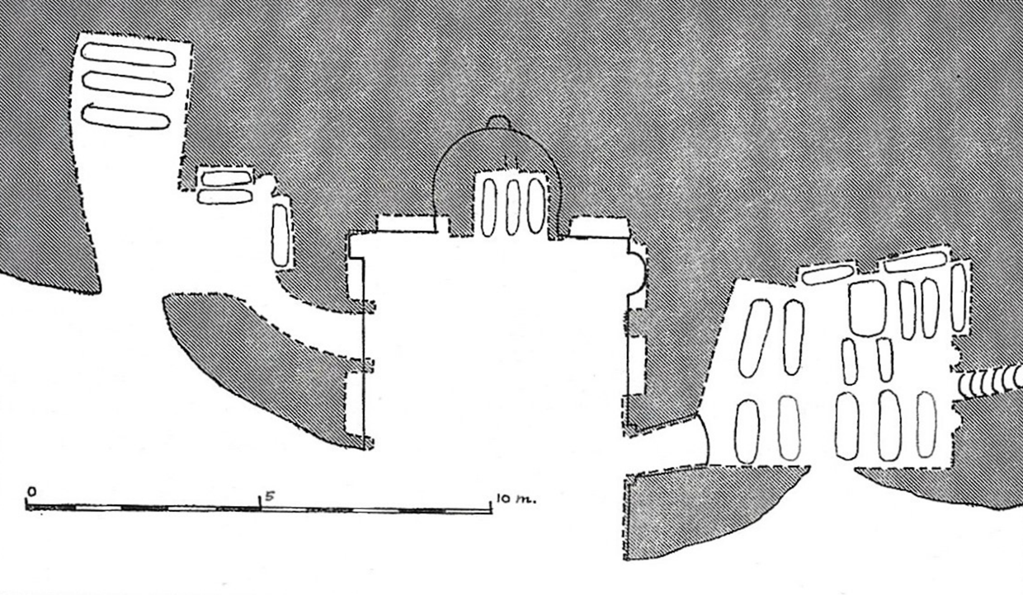
Fig. 2. Eğri Taş Kilisesi (The Church of the Crooked Stone), 10th century, Peristrema Valley, near Ihlara, Cappadocia, Turkey. © Juergen Ritterbach/Alamy Stock
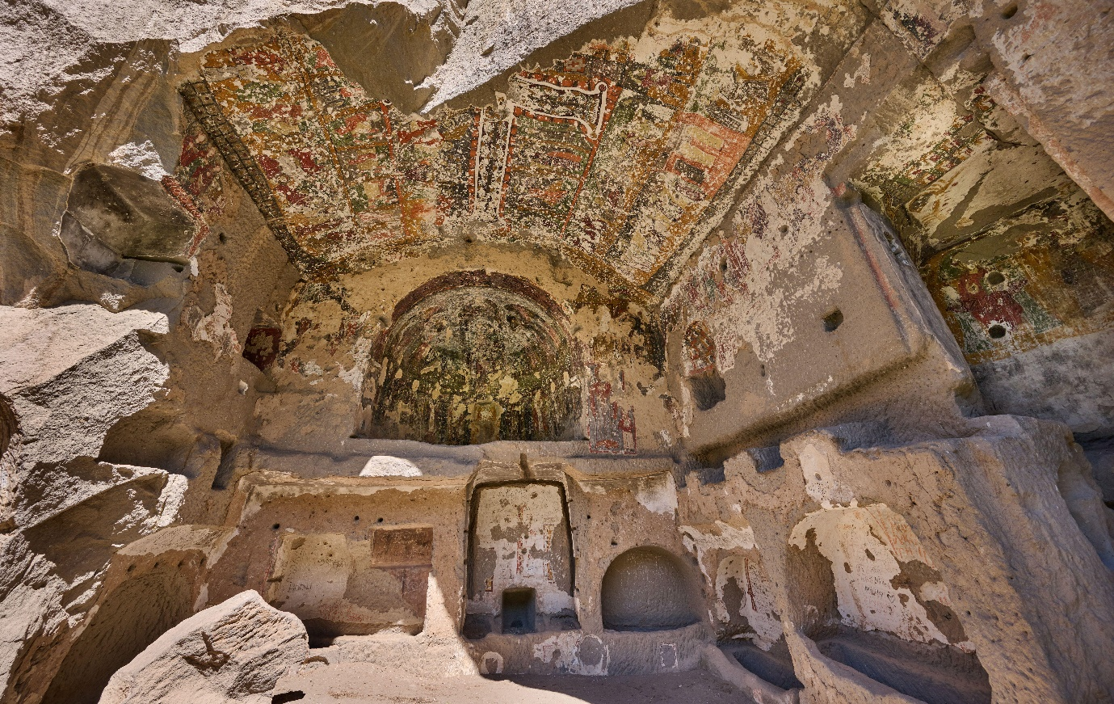
Fig. 3. Dedicatory inscription and later donor portrait. East wall of the naos. Eğri Taş Kilisesi. © the author
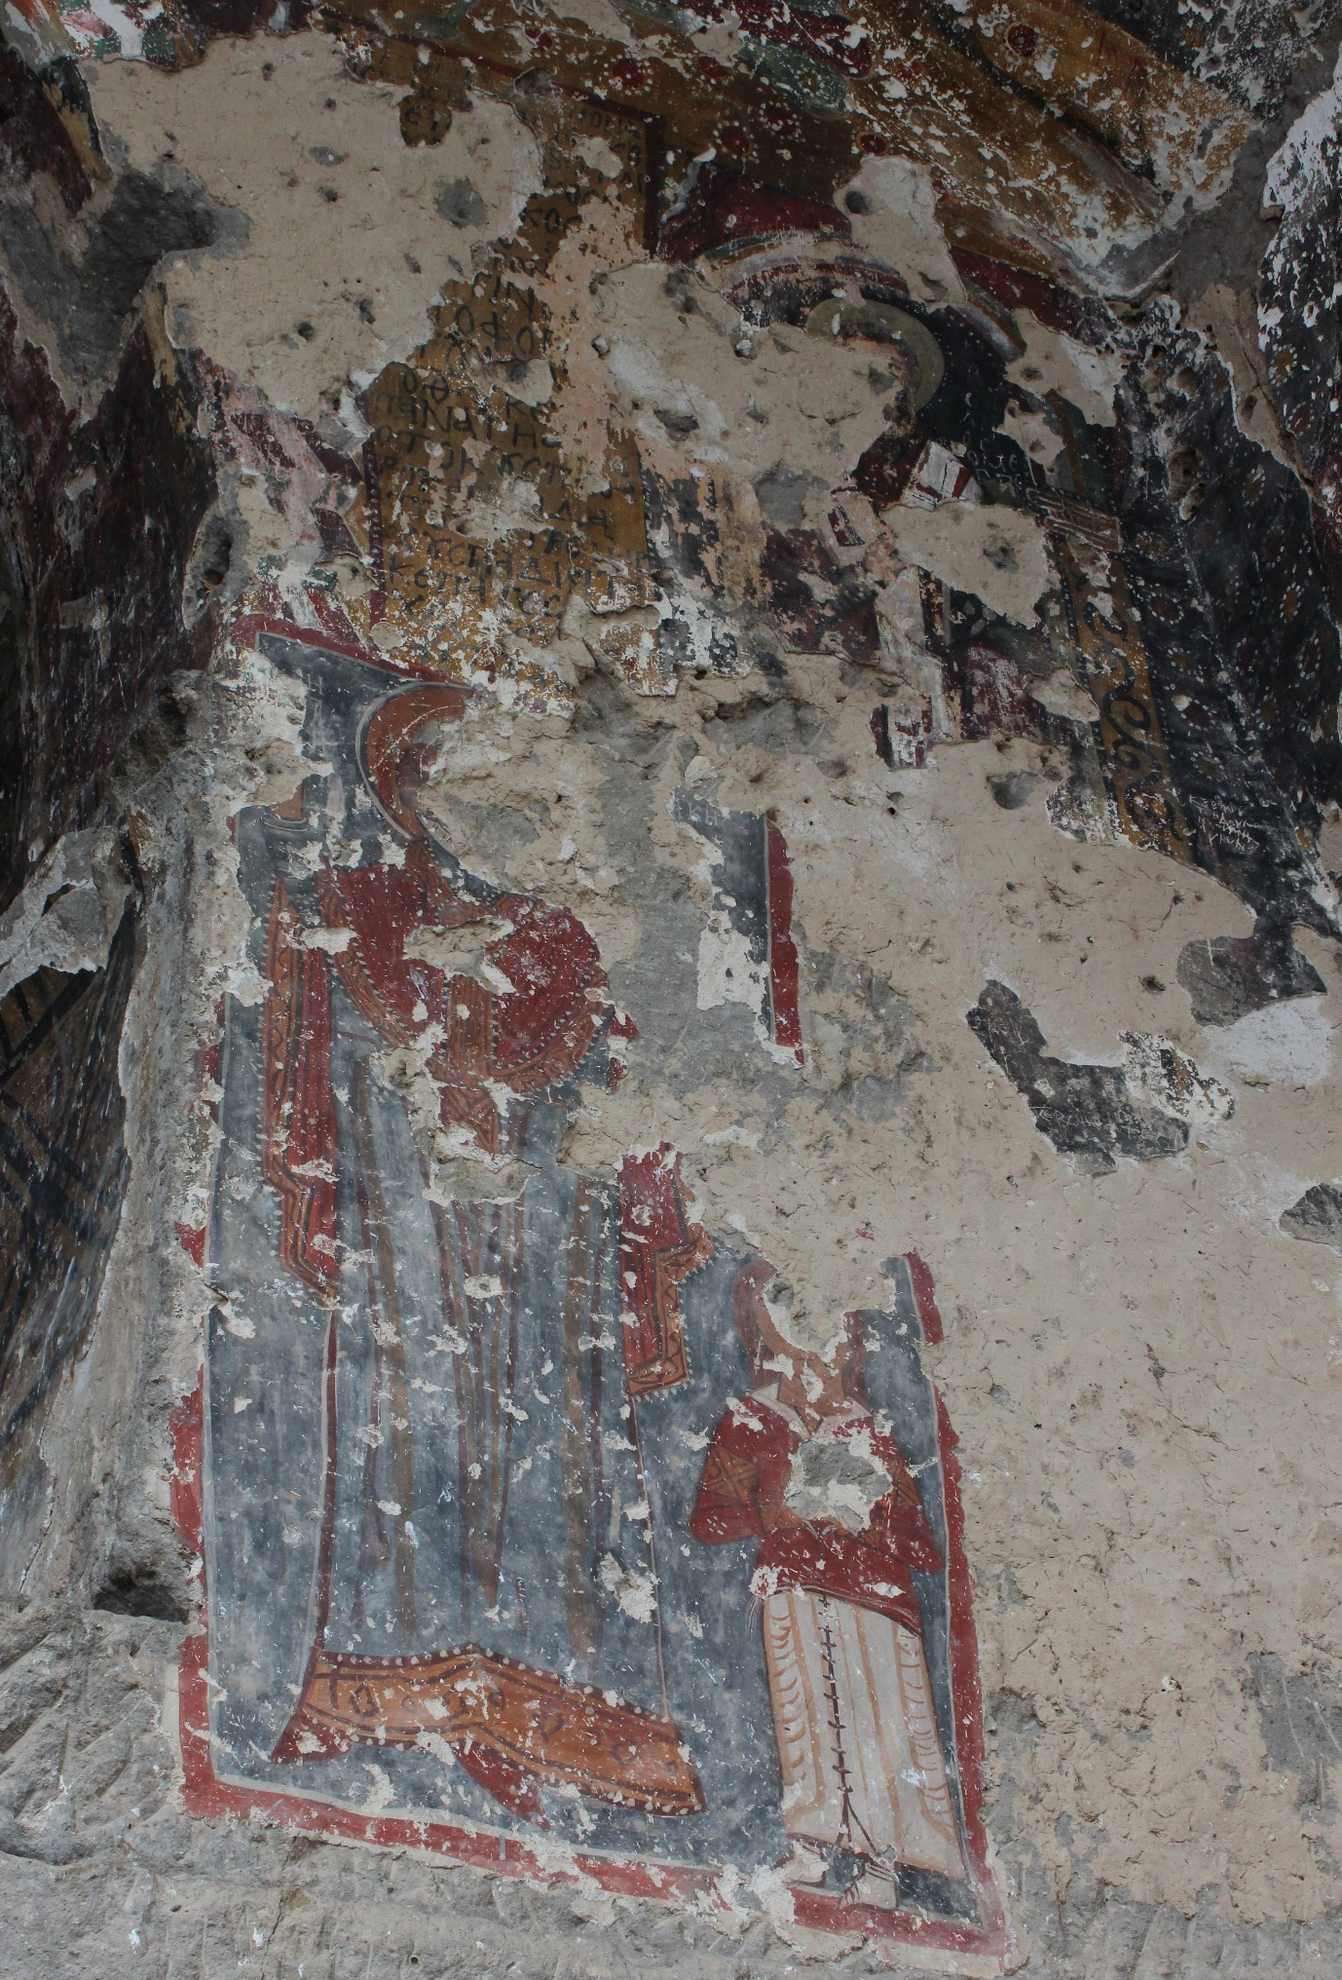
Fig. 4. The Christological cycle on the vault of the naos. Eğri Taş Kilisesi. © the author
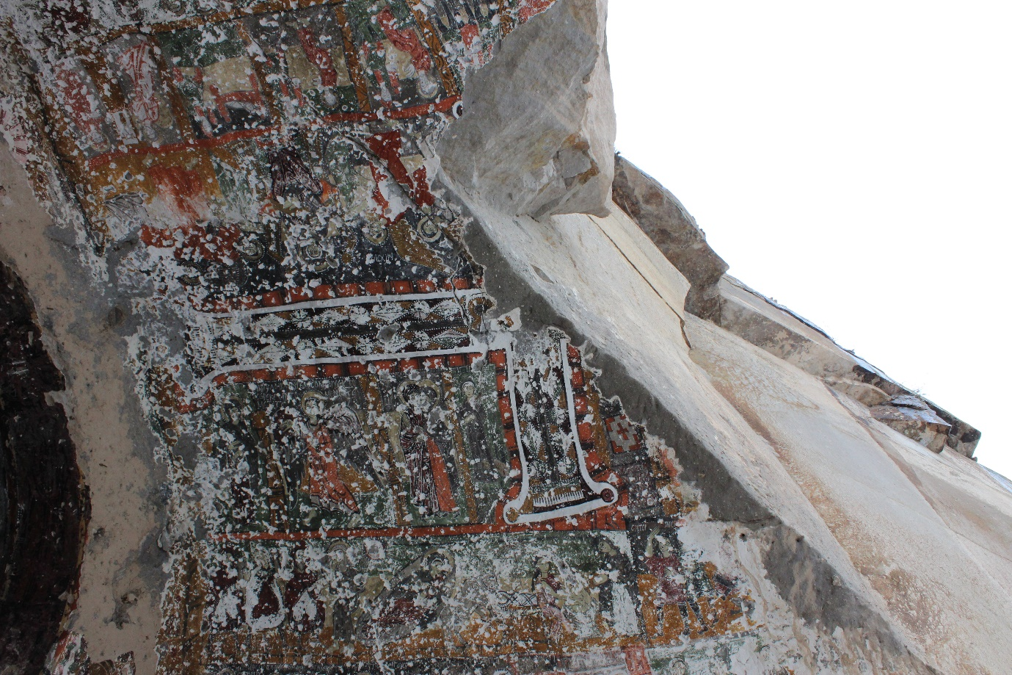
Fig. 5. The Virgin and Child Enthroned. Northern side of the barrel vault of the naos. Eğri Taş Kilisesi. © the author
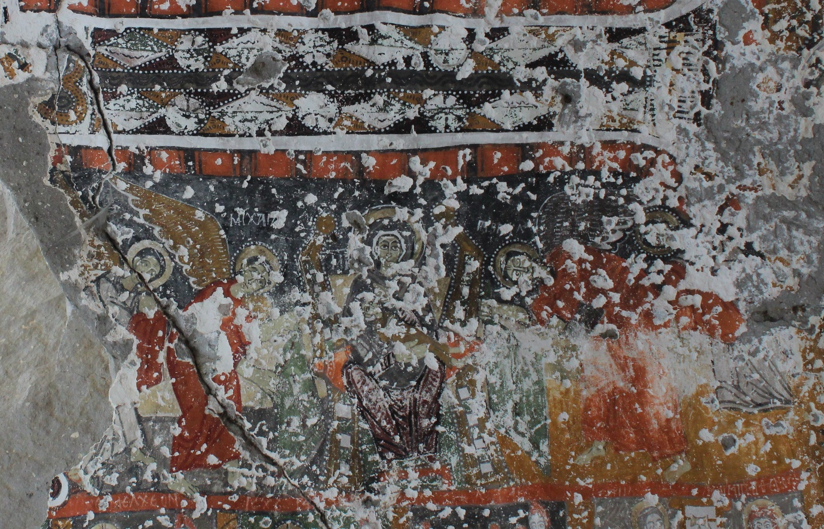
Fig. 6. The badly damaged conch of the apse at Eğri Taş Kilisesi. © the author
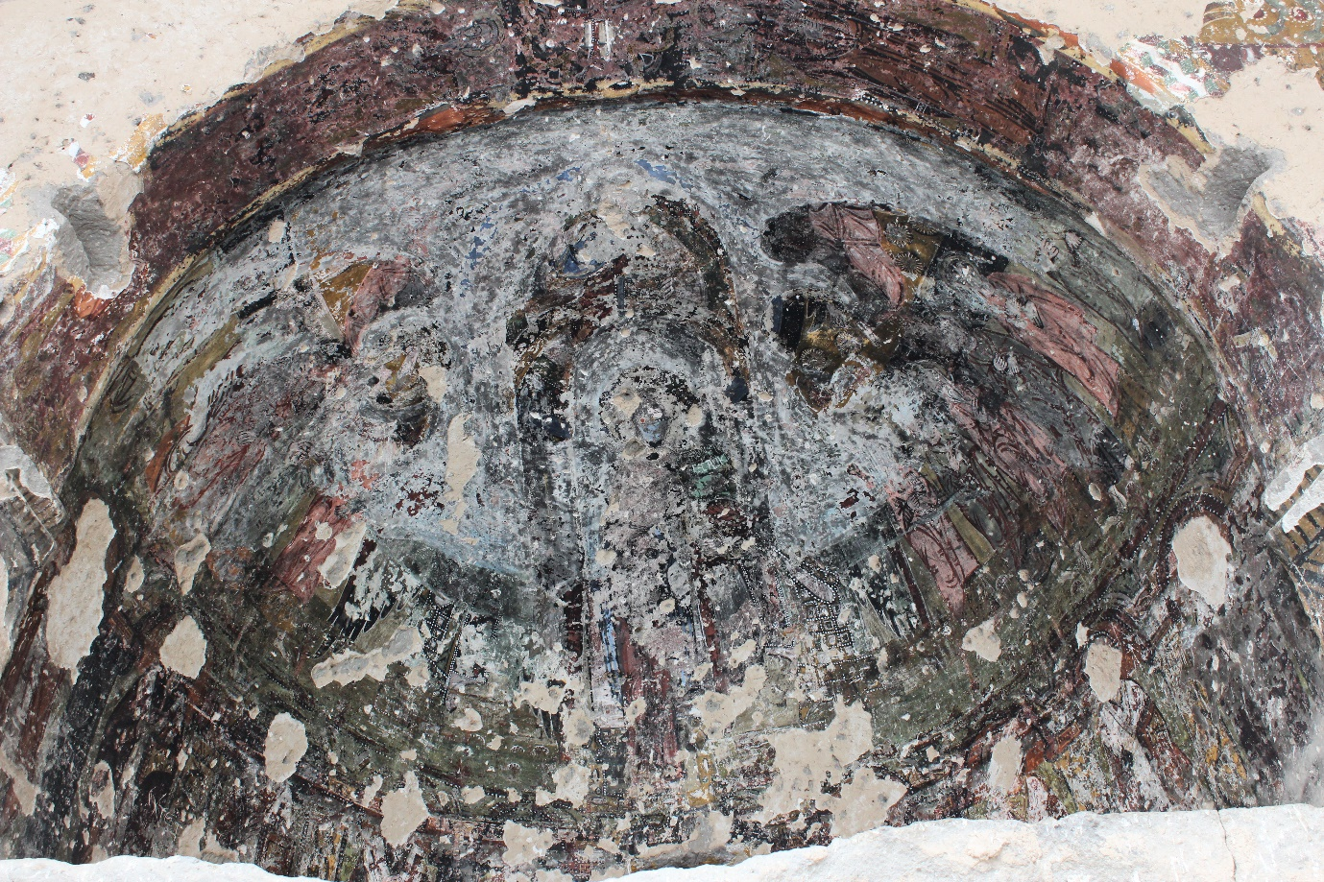
Fig. 7. The Nativity and Flight into Egypt. Southern side of the barrel vault of the naos. Eğri Taş Kilisesi. © the author
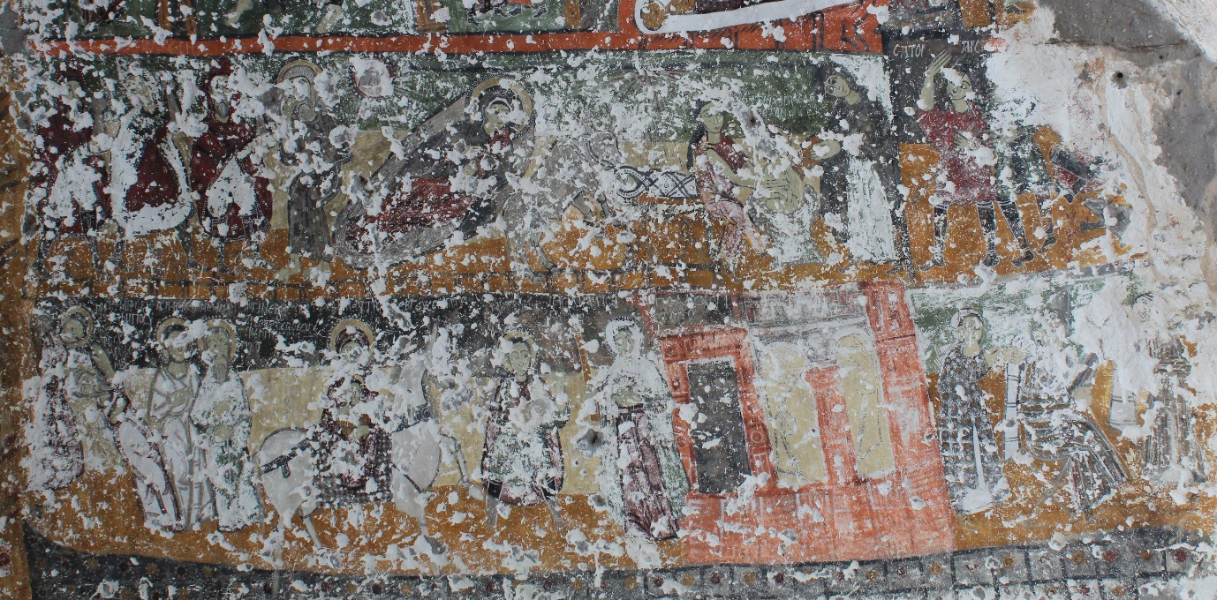
Fig. 8. Line drawing of the Nativity and Flight into Egypt. Nicole Thierry and Michel Thierry, Nouvelles Églises Rupestres de Cappadoce: région du Hasan Daǧi (Paris, Klincksieck, 1963), fig. 11.
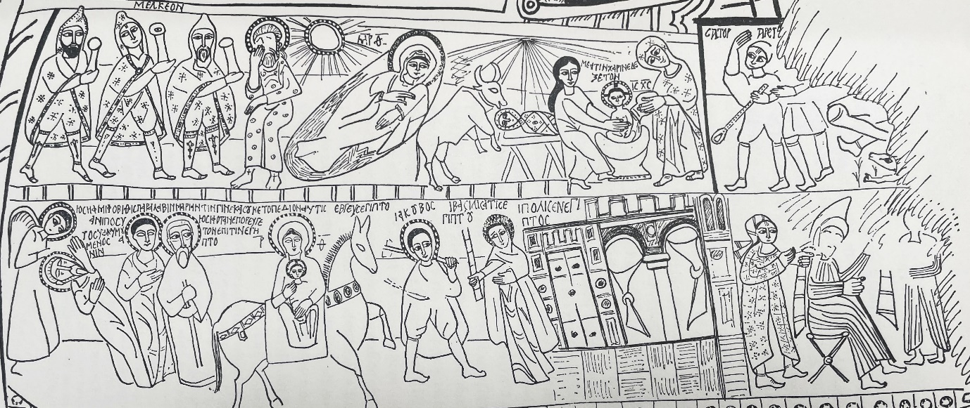
Fig. 9. The Visions of the Magi and the Annunciation at the Well. Northern side of the barrel vault of the naos. Eğri Taş Kilisesi. © the author
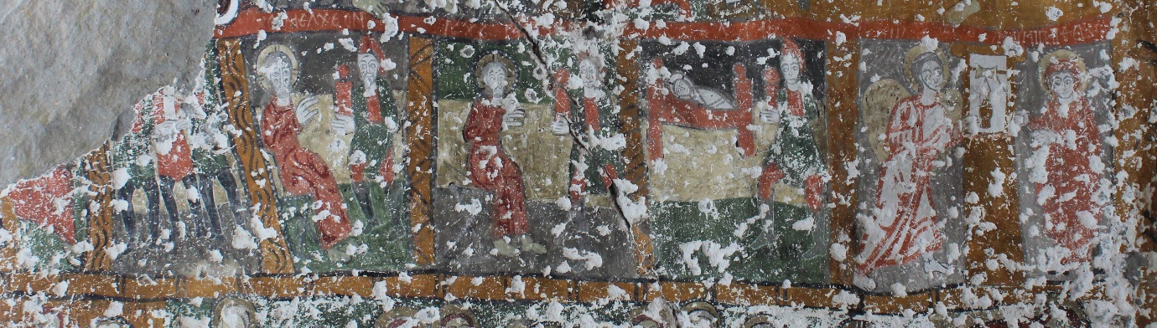
Fig. 10. Line drawing of the Visions of the Magi at Eğri Taş Kilisesi. Nicole and Michel Thierry, Nouvelles Églises Rupestres de Cappadoce, fig. 12.
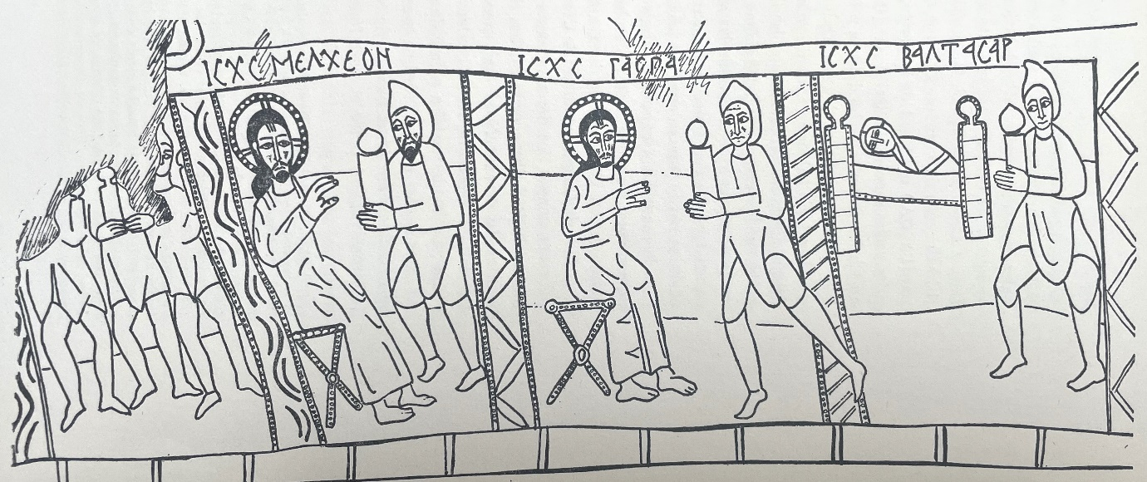
Fig. 11. Line drawing of the Nativity at Kokar Kilise, 10th century, Peristrema Valley, near Ihlara, Cappadocia, Turkey. Nicole and Michel Thierry, Nouvelles Églises Rupestres de Cappadoce, fig. 27.
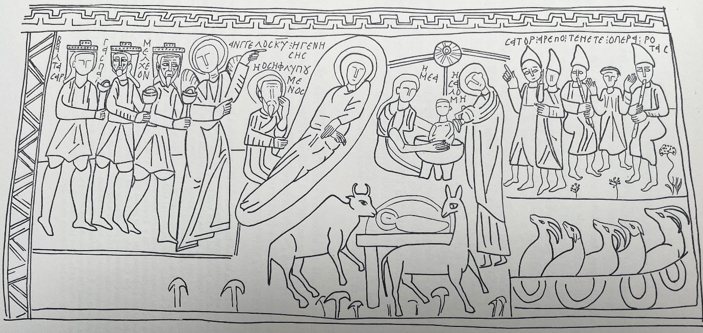
Fig. 12. The Nativity with the Epiphany and Adoration of the Shepherds, Pürenli Seki Kilise, 10th century, Peristrema Valley, near Ihlara, Cappadocia, Turkey. © the author
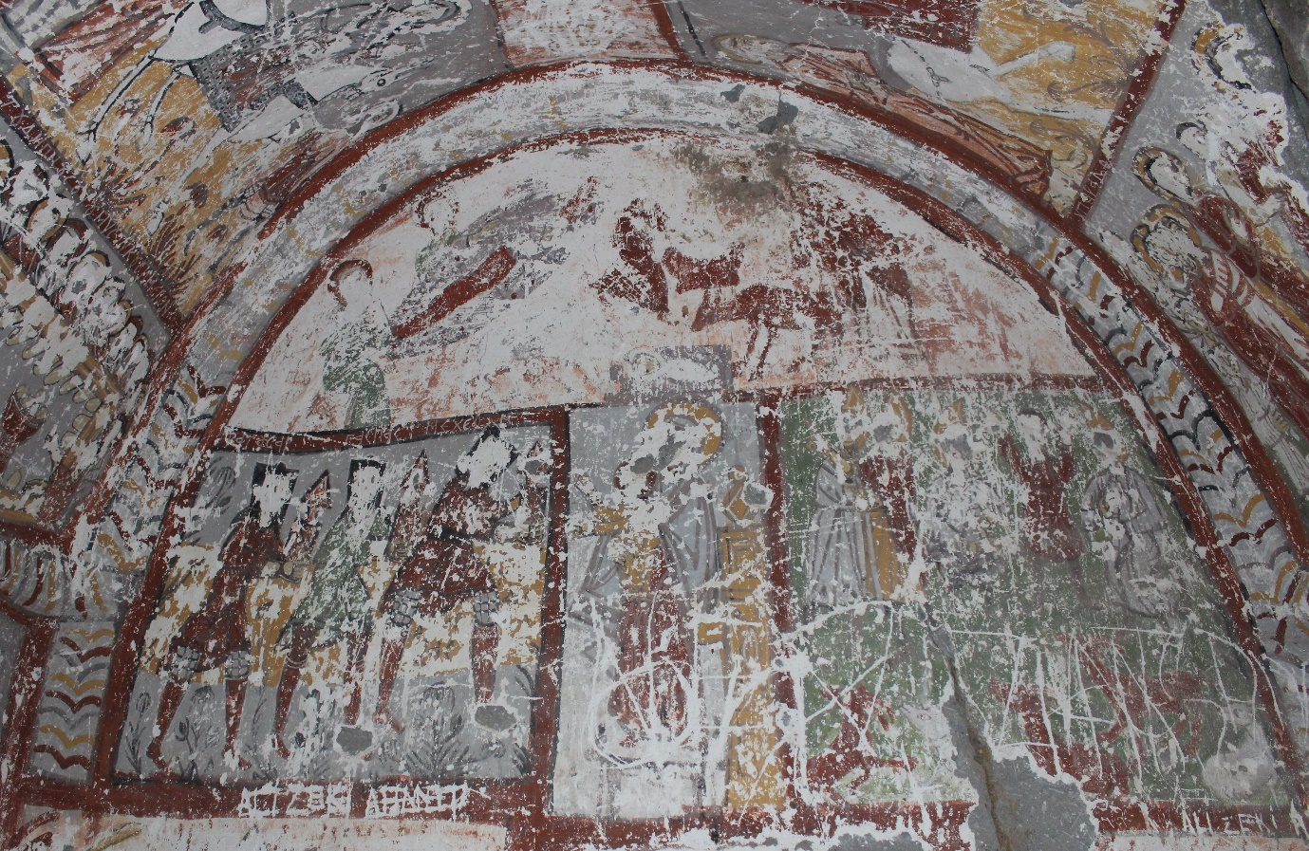
Fig. 13. Line drawing of the nativity from Pürenli Seki Kilise. Nicole and Michel Thierry, Nouvelles Églises Rupestres de Cappadoce, fig. 32.
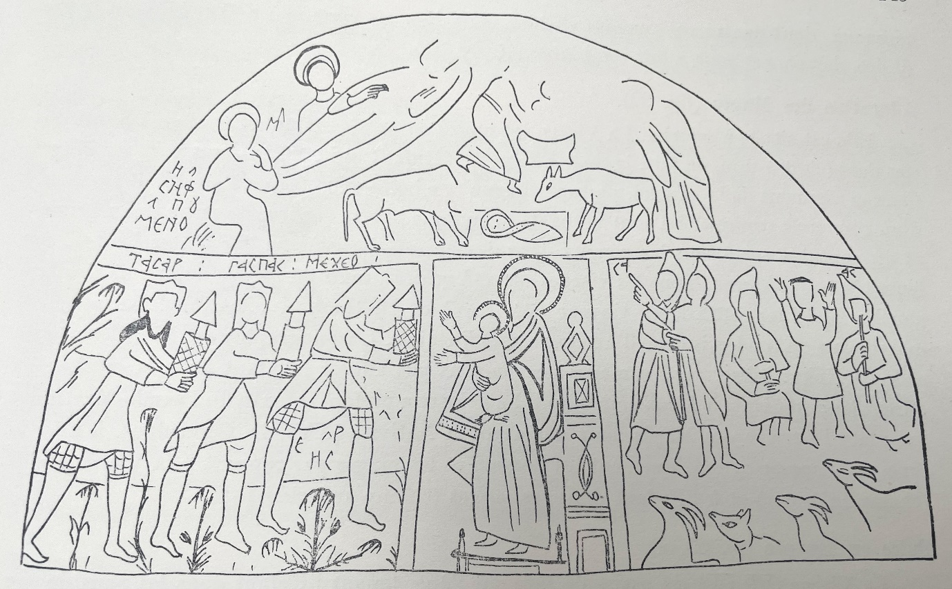
Fig. 14. Epiphany with the Shepherds, eighth century, northern half-dome of the main church. Dayr al-Suryan (Monastery of the Syrians) in the Wadi al-Natrun, Egypt © B.O'Kane/Alamy Stock Photo
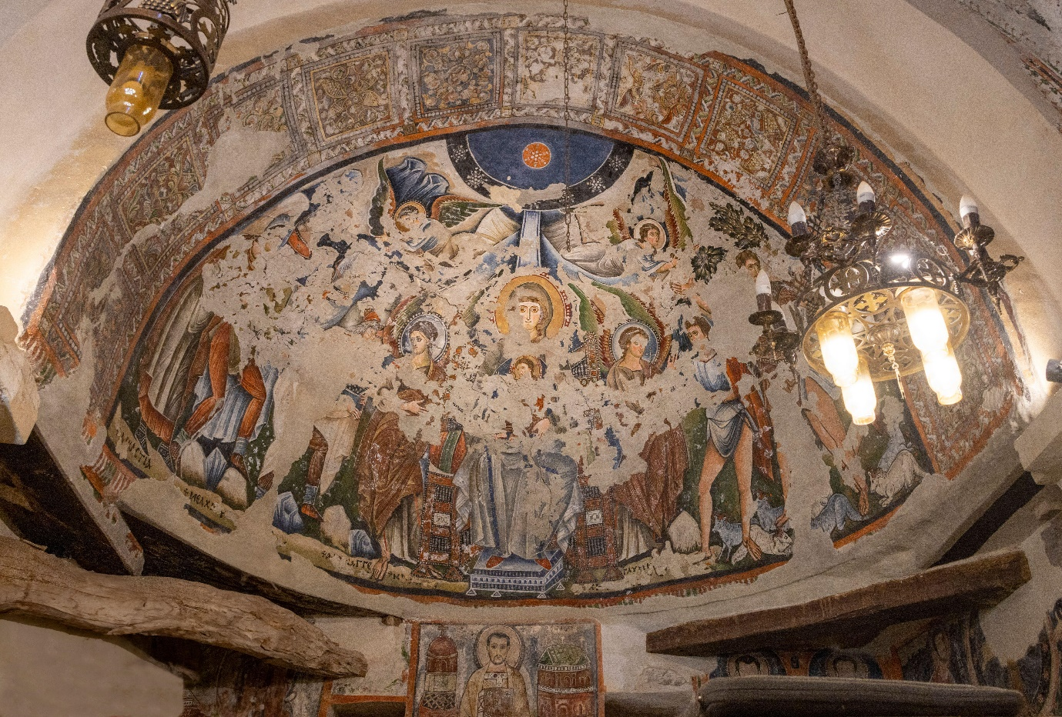
Fig. 15. Acrostic Rotas-Sator Square, Paint on plaster, c. 165–256 CE, 9 1/4 × 8 1/4 in. (23.5 × 21 cm), Excavated in Dura-Europos, Syria. Yale University Art Gallery, 1933.298
Photograph courtesy of Yale University Art Gallery. No known US copyright restrictions. CC0 1.0 Universal. 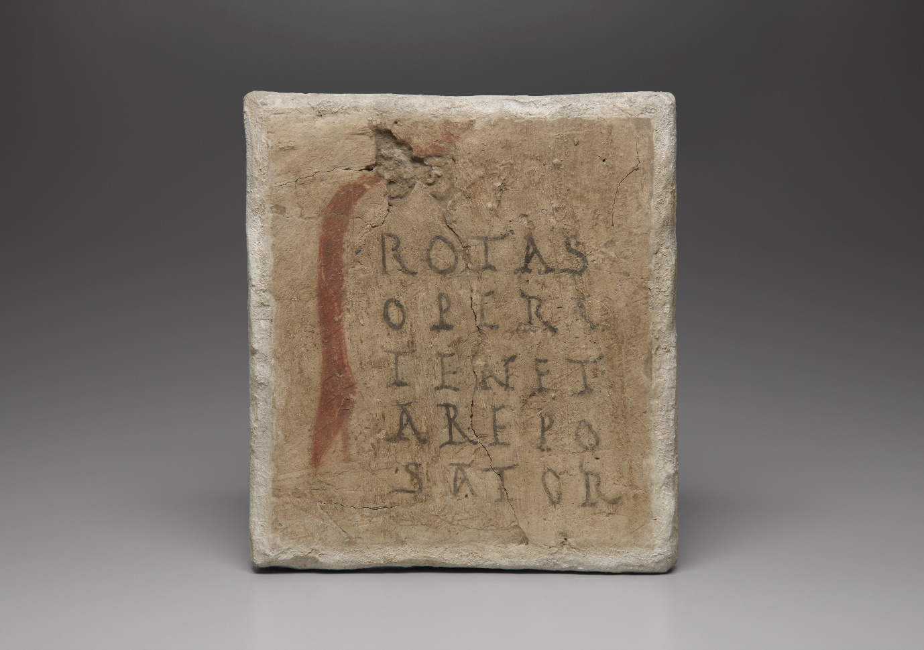
Fig. 16. Amulet against venomous creatures. Papyrus, 6th/7th century CE, 242 x 229 mm. Egyptian/Coptic. Yale University, Beinecke Library, P.CyYBR inv. 1792 Photograph courtesy of Beinecke Rare Book and Manuscript Library, Yale University. No known US copyright restrictions. CC BY-NC 3.0.
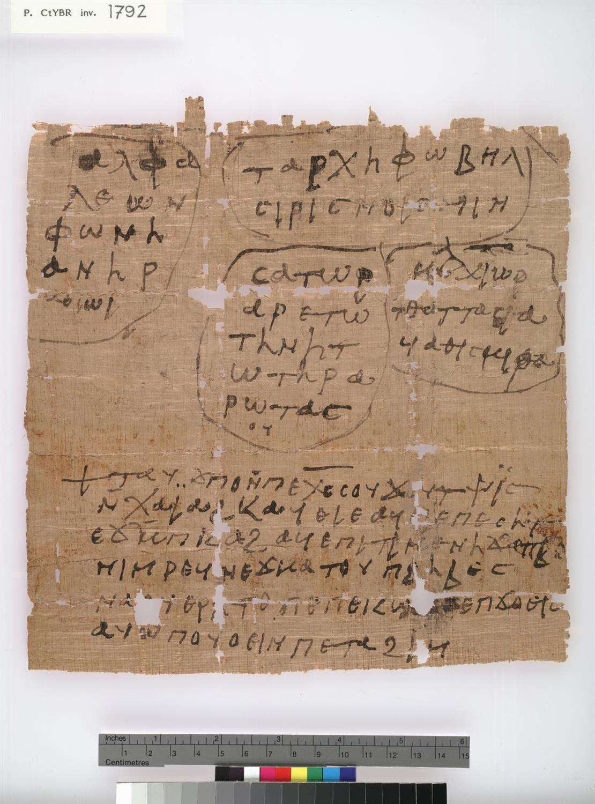
Fig. 17. Reliquary Pendant with the Nativity and the Epiphany, engraved gold with niello and silver, 6th century, Constantinople. British Museum AF.354 © The Trustees of the British Museum. CC BY-NC-SA 4.0.
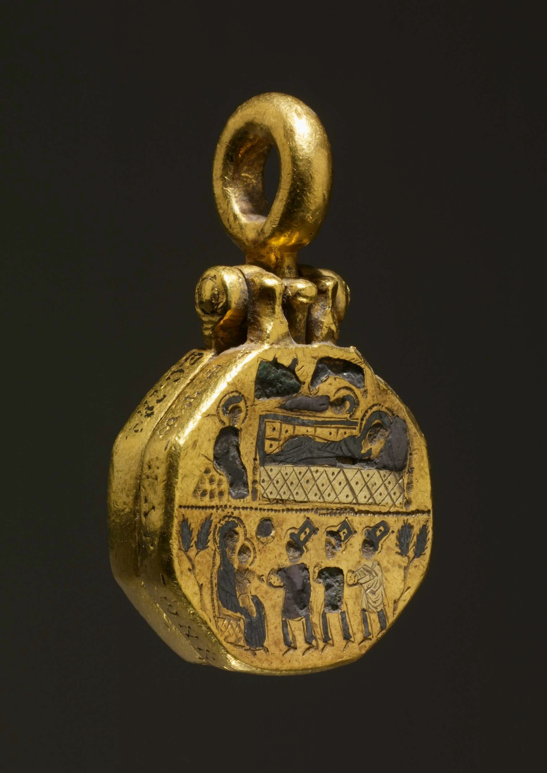
Fig. 18. Wall painting of the nativity, Omorphi Ekklesia, Aigina, 1289 CE. © ΕΦΑ Δυτικής Αττικής, Πειραιώς & Νήσων. Wikimedia Commons, CC BY 2.0. Available at https://upload.wikimedia.org/wikipedia/commons/a/a0/Λεπτομέρεια_από_την_τοιχογραφία_της_Γεννήσεως_του_Χριστού_στην_οροφή_του_ναού_Αγίων_Θεοδώρων_%28Όμορφη_Εκκλησία%29.jpg
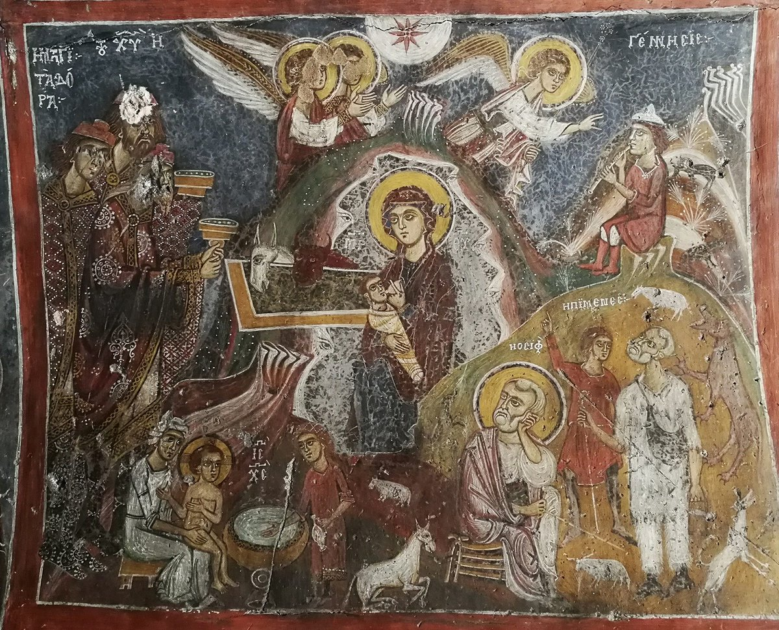

On art history and the fragment, see, in particular, the excellent introduction and essays in Beate Fricke and Aden Kumler, eds. Destroyed—Disappeared—Lost—Never Were (Penn State University Press, 2022); William Tronzo, ed. The Fragment: An Incomplete History (Los Angeles: Getty Research Institute, 2009); S. Rebecca Martin and Stephanie Langin-Hooper, “In/Complete: An Introduction to the Theories of Miniaturisation and Fragmentation”, The Tiny and the Fragmented. Miniature, Broken or Otherwise Incomplete Objects in the Ancient World (Oxford: Oxford University Press, 2018), 1–23.
On global art history as still determined by the paradigms and conventions of the western discipline, see James Elkins, Chinese Landscape Painting as Western Art History (Hong Kong: Hong Kong University Press, 2010).
See the recent special volume of Word and Image 29:1 (2023) on Iconographiae or ‘word image’ entities that undermine the primacy of either in many medieval visual systems. The performative function of inscriptions in Cappadocian churches has been highlighted in recent scholarship. Catherine Jolivet-Lévy, “Inscriptions et images dans les églises byzantines de Cappadoce: Visibilité/lisibilité, interactions et fonctions,” Visibilité et présence de l’image dans l’espace ecclésial. Byzance et Moyen Âge occidental, eds. Sulamith Brodbeck & Anne-Orange Poilpré (Paris: Éditions de la Sorbonne, 2019), 379–408.
Johann Joachim Winckelmann, History of the Art of Antiquity, trans. Harry Francis Mallgrave (Los Angeles: Getty Publications, 2006), 351. On this passage in relation to the fragment, see, in particular, Jaś Elsner, “The Dreamwork of Positivism: Archaeological Art History and the Imaginative Restoration of the Lost” and Peter Geimer, “Mourning the Loss of Works/Praising Their Absence: A Response” in Fricke and Kumler, Destroyed—Disappeared, 61–74, 143–52 See also Alex Potts, Flesh and the Ideal: Winckelmann and the Origins of Art History (New Haven: Yale University Press, 1994), 47–50.
Potts, Flesh and the Ideal, 49; Elsner, “The Dreamwork of Positivism”, 69.
Winckelmann, History, 351.
Robert Ousterhout, Visualizing Community: Art, Material Culture, and Settlement in Byzantine Cappadocia (Washington, D.C.: Dumbarton Oaks Research Library and Collection, 2017), 478.
Eric Cooper & Michael Decker, Life and Society in Byzantine Cappadocia (Basingstoke: Palgrave Macmillan, 2012), 23.
On Cappadocia and its structures, see Ousterhout, Visualizing Community; Catherine Jolivet-Lévy, La Cappadoce médiévale. Images et spiritualité (Saint-Léger-Vauban: Zodiaque, 2001), 23–28. Scholarship has focused mostly on extant wall paintings: Guillaume de Jerphanion, Une nouvelle province de l’art byzantin; les églises rupestres de Cappadoce. 2 vols. (Paris: P. Geuthner, 1925–42); Spiro Kostof, Caves of God: The Monastic Environment of Byzantine Cappadocia (Cambridge M.A.: MIT Press, 1972); Catherine Jolivet-Lévy, Les Églises Byzantines de Cappadoce: le programme iconographique de l’abside et de ses abords (Paris, CNRS, 1991).
The few written sources pertaining to the region do not support such claims, referring merely to the troglodytes who lived there, e.g. Leo the Deacon, History, Book III, 35.6–7. Alice-Mary Talbot and Denis Sullivan, trans. The History of Leo the Deacon: Military Expansion in the Tenth Century (Washington DC: Dumbarton Oaks, 2005): 87. Further discussion in Thomas Mathews, Annie-Christine Daskalakis Mathews, “Islamic-Style Mansions in Byzantine Cappadocia and the Development of the Inverted T-Plan,” Journal of the Society of Architectural Historians 56, no. 3 (1997): 294–315. On early exploration of the region, see, selectively, Charles Texier, Asie Mineure: Description géographique, historique et archéologique des provinces et des villes de la Chersonnèse d’Asie (Paris: Firmin-Didot, 1862); William Mitchell Ramsay and Gertrude Bell, The Thousand and One Churches (London: Hodder and Stoughton, 1909); Hans Rott, Kleinasiatische Denkmäler aus Pisidien, Pamphylien, Kappadokien, und Lykien (Leipzig: Weicher, 1908).
Jerphanion, Une nouvelle province.
See, for example, Veronica Kalas, “Early explorations of Cappadocia and the monastic myth,” Byzantine and Modern Greek Studies 28 (2004): 101–19; Veronica Kalas, “Challenging the Sacred Landscape of Byzantine Cappadocia,” in Negotiating Secular and Sacred in Medieval Art: Christianity, Islam, and Buddhism, eds. Amanda Luyster and Alicia Walker (Aldershot: Ashgate, 2009), 147–173; Mathews and Mathews, “Islamic Style Mansions”; Robert Ousterhout, A Byzantine Settlement in Cappadocia (Washington, DC: Dumbarton Oaks, 2005); Fatma Gül Oztürk, “Negotiating between the Independent and Groups of Courtyard Complexes in Cappadocia,” Proceedings of the Society of Architectural Historians, Australia and New Zealand 30, no. 2 (Queensland: SAHANZ, 2013): 837–49.
Lisa Bernardini, “Les donateurs des églises de Cappadoce,” Byzantion 62 (1992): 118–40; Kalas, “Challenging”, 160–62.
Cooper and Decker, Life and Society, 175–252; Michel Kaplan, “Les grands propriétaires de Cappadoce VIe-XIe siècles”, in Le aree omogenee della civiltà rupestre nell’ambito dell’Impero Bizantino: la Cappadocia, ed. Cosimo Fonseca (Galatina: Congedo editore, 1981), 125–58.
Ousterhout Visualizing Community, 175, suggests a monastic skeleton staff may have serviced them.
Rock-cut sites with elaborate façades at the opposite end of the valley are now known to have been domestic. Veronica Kalas, “The 2004 Survey of the Byzantine Settlement at Selime-Yaprakhisar in the Peristrema Valley, Cappadocia”, Dumbarton Oaks Papers 60 (2006): 271–93. No refectory has been identified but some churches have been identified as having a monastic presence by other means. See Veronica Kalas, “Middle Byzantine Art and Architecture in Cappadocia: The Ala Kilise in the Peristrema Valley,” in Anathemata eortika: Studies in Honor of Thomas F. Mathews, eds. Joseph Alchermes, Helen Evans and Thelma Thomas (Mainz: Philipp von Zabern, 2009), 181–90.
There may have been medieval villages at either end and midway through the valley, corresponding to the modern Turkish villages, but this cannot be confirmed. Ousterhout, Visualising Community, 147.
Nicole Thierry and Michel Thierry, Nouvelles Églises Rupestres de Cappadoce. Région du Hasan Daǧi (Paris, Klincksieck, 1963). Five churches were originally included, but Ağaç Altı Kilise is now omitted because of architectural and stylistic differences. Ousterhout, Visualizing Community, 74. Nicole Thierry had similarly changed her mind by the time she wrote Nicole Thierry, La Cappadoce de l'Antiquité au Moyen Âge (Turnhout: Brepols, 2002).
Kalas, “Middle Byzantine Art”, 185; Ousterhout, Visualising Community, 6.
On Cappadocian liturgies, see Robert Ousterhout, “Remembering the Dead in Byzantine Cappadocia: The Architectural Settings for Commemoration,” in Architecture of Byzantium and Kievan Rus from the 9th to the 12th Centuries, ed. Denis Ëlshin (St Petersburg: The State Hermitage Publishers, 2010), 89–100, at 87, n. 3.
Nicole Thierry, “Notes critiques à propos des peintures rupestres de Cappadoce,” Revue des études byzantines 26 (1968): 337–66, at 351. On an Armenian connection, see Jacqueline Lafontaine-Dosogne, “Nouvelles notes Cappadociennes,” Byzantion 33 (1963): 121–83.
Thierry and Thierry, Nouvelles Églises, 55–6, fig, 11, pl. 31b.
On the church in general, see Thierry and Thierry, Nouvelles Églises, 39–72; Nicole Thierry, “La peinture de Cappadoce au Xe siècle,” in Constantine VII Porphyrogenitus and His Age, ed. Athanasios Markopoulos (Athens: Europaiko Politistiko Kentro Delphōn, 1989), 217–46. For the date of the dedicatory inscription, see Nikolaos Oikonomides, “The Dedicatory Inscription of Eğri Taş Kilisesi (Cappadocia),” Harvard Ukrainian Studies 7 (1983), 501–6, at 503.
Thierry and Thierry, Nouvelles Églises, 44–45, suggest that it could commemorate a later repair.
Oikonomides’ proposed reconstruction of the Greek: Ἐκαλλιεργήθη ὁ ναὸς τῆς Παναγίας Θεοτόκου ἔτος κόσμου ς' χιλιοστὸν τετρακοσιοστὸν τριακοστὸν ......., ἐπὶ βασιλέων ʹΡωμανοῦ, Κωνσταντίνου καὶ Χριστοφόρου, διὰ συνδρομῆς τοῦ δούλου τοῦ Θεοῦ καὶ τῆς Παναγίας Θεοτόκου, σπαθαροκανδιδάτου καὶ τρουμάρχου Παδιάτη· καὶ πάντες εὔχεσθε ὑπὲρ αὐτοῦ, ἀμήν. Oikonomides, “The Dedicatory Inscription,” 506, transcription prior to reconstruction at 502. For a slightly different transcription, see Thierry and Thierry, Nouvelles Églises, 42.
Jolivet-Lévy, Les Églises, 300–2; Ousterhout, Visualising Community, 349. The role of tourmarches is discussed at length in the tenth-century military tract connected to Nikephoros Phocas (Περὶ Παραδρομῆς, On Skirmishing), analysed in Gustave Schlumberger, Un empereur byzantin au dixième siècle, Nicéphore Phocas (Paris: Firmin-Didot, 1890), 180–3. It disappears from use soon after this date. For more recent discussion, see The Oxford Dictionary of Byzantium, ed. Alexander Kazdhan [Tourmarches - Oxford Reference, 03/06/2024].
Thierry and Thierry, Nouvelles Églises, 40.
The large monastery of Karanlik Kale (tenth or eleventh century), situated around ten minutes on foot on the same bank of the river, was built probably after Eğri Taş but the church was used continuously over time so the two may have been connected.
“Tomb of the monk Peter, priest (of the church) of the Theotokos,” Thierry and Thierry, Nouvelles Églises, 67; Ousterhout, Visualizing, 376; Maria Xenaki, “Épitaphes paléochrétiennes et médiévales d’ Eğri Taş¸ Kilisesi a Ihlara en Cappadoce”, Gephyra 27 (2024): 109–170, no. 8.
Jolivet-Lévy, La Cappadoce médiévale, 70.
For these prominent and numerous female burials, see Xenaki, “Epitaphes paleochretiennes”, nos 1, 8, 9, 17, 21, 24.
Jolivet-Lévy, La Cappadoce médiévale, 179–181. On the dating of the archaic churches, see Robin Cormack, “Byzantine Cappadocia: The Archaic Group of Wall-Paintings,” Journal of the British Archaeological Association 30, no. 1 (1967): 19–36; Catherine Jolivet-Lévy, “La Cappadoce après Jerphanion: les monuments byzantins des Xe–XIIIe siècles,” Mélanges de l’École française de Rome – Moyen Âge 110, no. 2 (1998): 899–930.
Annabel Wharton, Tokalı Kilise: Tenth-century Metropolitan Art in Byzantine Cappadocia (Washington DC: Dumbarton Oaks, 1986). On the infancy cycles at Old Tokalı, for comparison, see Jerphanion, Une nouvelle province, I, 262–94; Jolivet-Lévy, La Cappadoce médiévale, 181–3; 187–88, 281. On continuous narration and the subsequent development of a narrative system comprised of individually framed icons, see Ousterhout, Visualizing Community, 213, 221.
Thierry, La Cappadoce, 155.
Ousterhout, Visualizing Community, 263–4; Cormack, “Byzantine Cappadocia,” 27, 34. See the dipinto around a painted cross that accompanies an arcosolium tomb in the crypt, recently reconstructed by Anne Sitz, “‘Great fear’: epigraphy and orality in a Byzantine apse in Cappadocia,” Gesta 56 (2017): 5–26.
Explored at length in Niamh Bhalla, Experiencing the Last Judgement (London & New York, Routledge, 2021), 80–113.
On mortality rates in Byzantium, see Angeliki Laiou, “Family, Byzantium,” in Dictionary of the Middle Ages, ed. Joseph Strayer, vol. 4 of 13, 1982–89 (New York: Charles Scribner’s Sons, 1984), 595.
Cooper and Decker, Life and Society, 49.
Jerphanion, Une nouvelle province, I, 147–70.
Thierry, La Cappadoce, 113.
Thierry, La Cappadoce, 113.
Jolivet-Lévy, La Cappadoce médiévale, 186.
On the connection of the infancy cycle to apocryphal texts more generally in Cappadocia, see Manuela Studer-Karlen, “Apocryphal Iconography in the Byzantine Churches of Cappadocia: Meaning and Visibility in Scenes of the Story of Mary and the Infancy of Christ,” in Mary, the Apostles, and the Last Judgment. Apocryphal Representations from Late Antiquity to the Middle Ages, eds. Stanislava Kuzmová, and Andrea-Bianka Znorovszky, (Budapest: Trivent, 2020), 83–115, influenced heavily by Nicole Thierry, “L’illustration des apocryphes dans les églises de Cappadoce,” Apocrypha 2 (1991): 217–48.
Thierry & Thierry, Nouvelles Églises, xiv.
The earliest extant Greek text dates to the second century. See Émile de Strycker, La forme la plus ancienne du Protévangile de Jacques (Brussels: Société des Bollandistes, 1961). However, since the early church fathers Clement of Alexandria and Origen quote it, portions of it at least must have been written before 200 CE. On a first century date, see George Zevros, The Protevangelium of James; Greek Text, English Translation, Critical Introduction (London: T&T Clark, 2019).
On the quasi-canonical status of the text, see Mary Cunningham, “The Use of the Protevangelion of James in Eighth-Century Homilies on the Mother of God,” in The Cult of the Mother of God in Byzantium. Text and Images, eds. Lesley Brubaker and Mary Cunningham (London: Routledge, 2011), 163–78, at 165; Évelyne Patlagean, “Remarques sur la diffusion et la production des apocryphes dans le monde byzantin,” Apocrypha 2 (1991): 155–63, at 166–67. On the range of languages that it was translated into, see James Elliott, ed. The Apocryphal New Testament: A Collection of Apocryphal Christian Literature in an English Translation (Oxford: Oxford University Press, 1993), 51–55.
Emmanuel Bourbouhakis and Ingela Nilsson, “Byzantine Narrative: The Form of Storytelling Byzantium,” in Companion to Byzantium, ed. Liz James (Chichester: Wiley-Blackwell, 2010), 263–74, at 263.
Kostof, Caves, 198.
The Protevangelion, along with the Infancy Gospel of Thomas, influenced the later Gospel of Pseudo Matthew from the sixth or seventh century which was mostly popular in the Latin-speaking world. See Elliot, Christian Apocrypha, 272.
See, for example, the haematite gem with a donkey-headed figure, magical Ἀβλαναθαναλβα palindrome and uterus, accompanied by Uriel and variants of the names Gabriel, Raphael and Michael. Armand Delatte and Philippe Derchain, Les intailles magiques gréco-égyptiennes (Paris: Bibliothèque nationale, 1964), no. 362. On the use of the archangels’ names on Jewish amulets, see Campell Bonner, Studies in magical amulets, chiefly Graeco-Egyptian (Ann Arbor: University of Michigan Press, 1950), 31–32, 170–1; Richard Greenfield, Traditions of Belief in Late Byzantine Demonology (Amsterdam: Adolf M. Hakkert, 1988), 272–73.
Coptic Museum, Cairo, inv. 7118.
The earliest textual reference to their names comes from the Excerpta Latina Barbari – a poor Latin translation of an original Greek chronicle from Alexandria (probably sixth century). See Johann Hoeveler, “Die Excerpta Latini Barbari,” Festschrift der dreiundvierzigsten Versammlung Deutscher Philologen und Schulmänner (Bonn: Universitäts-Buchdruckerei von C. Georgi, 1895), 193–214.
Felicity Harley, “Visual Apocrypha: The Case of Mary and the Magi in Early Christian Rome,” in Apocryphal and Esoteric Sources in the Development of Christianity and Judaism, ed. Igor Dorfmann-Lazarev (Leiden and Boston: Brill, 2021), 383–410, at 391.
The magi were at times included at the nativity. See the lid of the fourth-century Adelphia sarcophagus from the Catacomb of St John, Syracuse, now in the Archaeological Museum there.
Thierry and Thierry, Nouvelles Églises, 119–20, 144–5.
Abraham Terian, The Armenian Gospel of the Infancy: with three early versions of the Protevangelium of James (Oxford: OUP, 2008); Thierry and Thierry, Nouvelles Églises, 50–54, fig. 12, pl. 32; Ousterhout, Visualizing Community, 219–20, fig 2.5; Studer-Karlen, “Apocryphal Iconography,” 101–2.
Their named representations corresponding to different ages represented by unbearded, dark beard and grey/white beard is found in the sixth-century mosaic at San Apollinare Nuovo, which may also be an early indication of their connection to the three ages of man.
Cat. No. 31450. Fragment of sarcophagus with the Epiphany and the vision of Ezekiel (museivaticani.va) [08/06/23]
Gary Vikan, “Pilgrims in Magi's Clothing: The Impact of Mimesis on Early Byzantine Pilgrimage Art,” in The Blessings of Pilgrimage, ed. Robert Ousterhout (Urbana: University of Illinois Press, 1990), 97–107.
British Museum, London, 1901,0314.1. Henry Maguire, “Garments Pleasing to God: The Significance of Domestic Textile Designs in the Early Byzantine Period,” Dumbarton Oaks Papers 44 (1990): 215–24, at 221, fig. 29; Stephen Davis, “Fashioning a Divine Body: Coptic Christology and Ritualized Dress”, The Harvard Theological Review 98, no. 3 (2005): 335–62, at 341–5, fig. 5a–b.
Eunice Dauterman Maguire, ed. Weavings from Roman, Byzantine and Islamic Egypt: The Rich Life and the Dance (Urbana: Krannert Art Museum, 1999): 168–69.
The beginning of the protective verse from Psalm 90/1 is also inscribed and a scene of either Christ or Lazarus’s resurrection. Bonner, Studies, D.321. On the holy rider and this female demon, see 208–21.
Karel Innemée, “A Newly Discovered Painting of the Epiphany in Deir Al-Surian,” Hugoye: Journal of Syriac Studies 14, no. 1 (2011): 63–85; Jules Leroy, Les peintures des couvents du Ouadi Natroun (Cairo, Institut Français d'Archéologie Orientale, 1982), 68.
André Grabar, Les ampoules de Terre Sainte (Paris: Klincksieck, 1958), 16, 18, 20, pls. I, II, IV, VIII; Innemée, “A newly discovered,” 224–26.
Thierry and Thierry, Nouvelles Églises, 120 and 145, respectively.
J. Schwartz, “À propos du carré Sator chez les Éthiopiens,” Annales d’Éthiopie 2 (1957): 219–23.
Guillaume de Jerphanion, “La formule magique: ‘Sator Arepo’ ou ‘Rotas Opera’. Vieilles théories et faits nouveaux,” Recherches de science religieuse 25 (1935): 188–225.
Scholarly study began in earnest after this with Reinhold Köhler, “Sator-Arepo-Formel,” Zeitschrift für Ethnologie 13 (1881): 301–306. See also Francis Haverfield, “A Roman Charm from Cirencester,” Archaeological Journal 56 (1889): 319–23, who argued it was an original Roman inscription though this was discounted at the time, and Donald Atkinson, “The Sator-Formula and the Beginnings of Christianity,” Bulletin of the John Rylands Library 22 (1938): 419–34.
Michael Rostovtzeff, ed. The Excavations at Dura-Europos Conducted by Yale University and the French Academy of Inscriptions and Letters, Preliminary Report of the Fifth Season of Work (New Haven: Yale University Press, 1934), 159–161; Michael Rostovtzeff, “Il rebus Sator,” Annali della Reale Scuola Normale Superiore di Pisa, Lettere, Storia e Filosofia 2, no. 3 (1934): 103–5.
John Sundwall, “L'enigmatica iscrizione ROTAS in Pompeii,” Acta Academiae Aboensis Humaniora 15, no. 5 (1945): 3–17. This inscription was used to reconstruct another example found in 1929 from the house of Publius Paquius Proculus. See Guillaume de Jerphanion, “À propos des nouveaux exemplaires, trouvés à Pompéi, du carré magique ‘Sator’,” Comptes rendus des séances de l'Académie des Inscriptions et Belles-Lettres (1937): 84–93.
Felix Grosser, “Ein neuer Vorschlag zur Deutung der Sator-Formel,” Archiv für Religionswissenschaft 24 (1926): 165–69 caused a stir in first suggesting that the rebus had been invented by Christians during their persecution in the Roman world. The Pompeii discoveries rendered Christian origins improbable. See, particularly, Jerphanion, “À propos” and Fishwick, “On the origins” on the argument for a Jewish origin instead. For an annotated version of the extensive bibliography which explains the historiography and nuances of the debate, see Mary Sheldon, “The Sator Rebus: An unsolved cryptogram?” Cryptologia 27, no. 3 (2003): 233–87.
Such literal readings are refuted, for example, in Duncan Fishwick, “An Early Christian Cryptogram?” Canadian Catholic Historical Association 1 (1959): 29–41.
S. Seligman, “Die Satorformel,” Hessische Blätter fur Volkskunde 13 (1914): 154–183, at 174. Arsenio Frugoni, “Sator Arepo Tenet Opera Rotas,” Rivista di Storia e Letteratura Religiosa 1 (1965): 433–39 argues reasonably that it meant different things in different contexts.
On the apotropaic use of the formula against evil and illness, Richard-Ernst Bader, “Sator arepo: Magie in der Volksmedizin,” Medizinhistorisches Journal 22 (1987): 115–34; Duncan Fishwick, “On the Origins of the Rotas-Sator Square,” Harvard Theological Review 57 (1964): 39–54.
Stefan Jakobielski, “Monastery of the Holy Trinity at Old Dongola-A Short Archaeological Report,” The Spirituality of Ancient Monasticism (Kraków: Wydawnictwo Benedyktynow, 1995), 35–45.
Francis Llewellyn Griffith, “Oxford Excavations in Nubia,” Annals of Archaeology and Anthropology (1921–3): 57–116, pls. XL-LXXX.
P. CtYBR inv. 1792. Marvin Meyer and Richard Smith, Ancient Christian Magic: Coptic Texts of Ritual Power (San Francisco: Harper, 1994), 101–2, no. 55; George Parássoglou, “A Christian Amulet against Snakebite,” Studia Papyrologica 13 (1974): 107–10. On the magi in Coptic religion and ‘magic’, see William Brashear, “The Coptic Three Wise Men,” Chronique d’Égypte 58 (1983): 297–310.
For a discussion of the early Byzantine bible, see Isaaci Casauboni, De rebus sacris et ecclesiasticis exercitationes VXI. Ad Cardinalis Baronii Prolegomena in Annales, et primam eorum partem, de Domini Nostri Iesu Christi Navitate, Vita, Passione, Assumtione (London: Billium, 1614), 137; Jerphanion, ‘Formule magique’, 204; and Bruce Manning Metzger, ‘Names for the Nameless in the New Testament’, in New Testament Studies: Philological, Versional, and Patristic (Leiden: Brill, 1980), 23–43, at 25. Studies: Philological, Versional, and Patristic (Leiden: Brill, 1980), 23–43, at 25..
Vienna K 7093 (Rainer); paper, late tenth century. Smith and Meyer, Ancient Christian Magic, 97–98.
Smith and Meyer, Ancient Christian Magic, 120.
A charm for childbirth in a collection of medical remedies of c.1400, includes utterances of holy mothers and the Sator formula. Cambridge University Library, Additional 9308, no. 11, fol. 49r–50r. Midwives were also instructed to place the formula on a piece of cheese or butter for a woman to eat. Monica Green, The Trotula: A Medieval Compendium of Women’s Medicine (Philadelphia: University of Pennsylvania Press, 2001), 100, no. 98. On the Sator square and late medieval English charms for childbirth, see Lea Olsan, “Charms in Medieval Memory,” Charms and Charming in Europe, ed. Jonathan Roper (Hampshire: Palgrave Macmillan, 2004), 59–88.
Bronisław Malinowski, Coral Gardens and their Magic, 2 of 2 vols. (New York: American Book Co. 1978), 213–31. On unintelligible speech forms in Late Antiquity as signifying transitions to a higher spiritual order, see Patricia Cox Miller, “In Praise of Nonsense,” in Classical Mediterranean Spirituality, ed. Arthur Hilary Armstrong (New York: Alban Books, 1986), 489–505. Anthropological work on ritual language, particularly that of Stanley J. Tambiah has recently been brought to bear on Byzantine amulets by Foskolou, “On Magic” cf. n.98 with full ref.; Tuerk-Stonberg, “Magical Amulets” n.85 for full ref.. Tambiah’s work brought the speech-act theory developed in J. L. Austin’s category of performative utterance and J. R. Searle’s understanding of the agency of declarative speech to the study of religion. J.L. Austin, How to do things with Words (Cambridge, M.A.: Harvard University Press, 1975); John R. Searle, “A Taxonomy of Illocutionary acts”, in Language, Mind, and Knowledge, ed. Keith Gunderson (Minneapolis: University of Minnesota Press, 1975), 344–69; Stanley Tambiah, “The Magical Power of Words”, Man 3 (1968): 175–208; Tambiah, “Form and Meaning of Magical Acts: A Point of View”, in Modes of Thought, eds. Robin Horton and Ruth Finnegan (London: Faber & Faber, 1973), 199-229. David Frankfurter, “Narrating Power: The Theory and Practice of Magic Historiola in Ritual Spells”, in Meyer and Smith, Ancient Magic, 455–76 brought insights from this body of work to ancient religion. See also David Frankfurter, “Spell and Speech Act” in David Frankfurter, Guide to the Study of Ancient Magic (Leiden: Brill, 2019), 608–25.
Henk Versnel, “Some Reflections on the Relationship Magic-Religion”, Numen 38:2 (1991): 177–97, 177.
The lively anthropological debate which reached its apogee in the mid-twentieth century was built on the foundational work of figures such as Marcel Mauss, Henri Hubert, Bronisław Malinowski, Emile Durkheim, Gerardus van der Leeuw and others. The bibliographic material is extensive, but for a good introduction, see David Frankfurter, Guide to the Study of Ancient Magic (Leiden: Brill, 2019).
Greenfield, Traditions, 153–64; Jacquelyn Tuerk, “Hierotopy, Narrative, and Magical Amulets”, in Comparative Hierotopy, vol. 2, Alexei Lidov, ed. (Moscow: Research Centre for Eastern Christian Culture, 2008), 79–104. Still definitive are Henry Maguire, ed. Essays in Byzantine Magic, (Washington D.C.: Dumbarton Oaks, 1995); Bonner, Studies in Magical Amulets; Meyer and Smith, Ancient Christian Magic; Gary Vikan, “Art, medicine, and magic in early Byzantium”, Dumbarton Oaks Papers 38 (1984): 65–86. For an excellent summation of the field as it stands in relation to Byzantine art see Jacquelyn Tuerk-Stonberg, “Magic and Byzantine Art”, in The Oxford Handbook of Byzantine Art and Architecture, Ellen Schwartz, ed. (Oxford: OUP, 2022), ch. 6. For a fuller bibliography, see Jacquelyn Tuerk-Stonberg, “Magical Amulets, Magical Thinking, and Semiotics in Early Byzantium”, Old world: Journal of Ancient Africa and Eurasia (2021): 1–23.
For a good introduction, see Kimberly Stratton, Naming the Witch: Magic, Ideology, and Stereotype in the Ancient World (Columbia University Press, 2007): 4–18. On James Frazer’s influential framing of magic as opposed to religion, see Radcliffe Edmonds, Drawing Down the Moon: Defining Magic in the Ancient Greco-Roman World (Princeton: Princeton University Press, 2019), 1–34, esp. 15. On the problematic entanglements of magic and colonialism, the development of anthropology and the dichotomy between tribalistic magical societies and civilised ones, see Meyer and Smith, Ancient Christian Magic, 2–4, 13–14.
David Frankfurter “Afterword”, in Ritual Matters: Material Residues and Ancient Religions, Claudia Mose and Jennifer Knust (University of Michigan Press, 2017); 145–50.
See Rott, Kleinasiatische, 269.
Thierry, “L'Antiquité”, 157.
On maintaining a “cross-cultural notion of an illegitimate or ambivalent sphere of ritual” and the prospect of discontinuing use of the term “magic”, see Frankfurter, Guide, 6. Tuerk, “Hierotopy” uses the idea of the orthodox vs the unorthodox. She discusses the problems of their differentiation in Jacquelyn Tuerk-Stonberg, “Early Byzantine Amulets: Unorthodox, yes; Incorrect, no”, Journal of Modern Hellenism 27 (2009): 103–29, 104.
For example, David Elton Gay, “On the Christianity of Incantations”, in Charms and Charming in Europe, ed. Jonathan Roper (Hampshire: Palgrave Macmillan, 2004), 32–46, argues that the “folklorised portion of religion” is no less important than that endorsed in elite theological texts. Ritual power is used as a qualifying term in the title of seminal publications such as Marvin Meyer and Paul Mirecki, eds. Ancient Magic and Ritual Power (Leiden: Brill, 1995).
Mathews and Mathews, “Islamic Style”, 294, considers this in relation to the trouble that domestic chapels caused for ecclesiastical discipline.
Michael Richter, The Formation of the Medieval West: Studies in the Oral Culture of the Barbarians (Dublin: Four Courts Press, 1994); cf. Mathew Innes, “Memory, Orality and Literacy in an Early Medieval Society”, Past & Present 158, no. 1 (1998): 3–36, 8, who criticises his artificial separation of written, Church and oral, secular culture.
John Gager, Curse Tablets and Binding Spells from the Ancient World (Oxford: Oxford University Press, 1999), 3–24; Olof Petersson, “Magic— Religion. Some Marginal Notes to an Old Problem”, Ethnos 3–4 (1957): 109–19, 119. For an analysis of the association of religion with the cognitive purity of the church and temple, and magic with the personal, selfish and superstitious, see also Esther Eidinow, “Networks and Narratives: A Model for Ancient Greek Religion”, Kernos 24 (2011): 21–23. See also E. A. Budge, Amulets and Magic (London and New York: Routledge, 2011).
Jewish paper and parchment amulets survive from Egypt, but metal amulets have been found in Palestine. Theurgic names were also prevalent in Merkavah mysticism and visionary literature in the first and second centuries. Gideon Bohak, Ancient Jewish Magic: a history (Cambridge: CUP, 2008).
On early Christian demonological beliefs, see esp. David Aune, Magic in Early Christianity (Berlin: De Gruyter, 1980); Meyer and Smith, Ancient Christian Magic.
First published in Karl Preisendanz, Papyri Graecae Magicae, 2 vols. (Stuttgart: Verlag: 1928–31). English translations and some additional texts: Hanz Dieter Betz, ed. The Greek and Demotic Papyri in Translation (Chicago: University of Chicago Press, 1986). The first major collection and analysis of Coptic materials was Angelicus Kropp, Ausgewählte koptische Zaubertexte, 3 vols. (Brussels: Edition de la Fondation égyptologique reine Elisabeth, 1930–1). Lamellae – thin sheets of folded or rolled metal often worn in small cylindrical metal cases, dating to the same period but surviving from across the Greco-Roman world – demonstrate close affinity with amuletic content on papyri, and it is possible that the former were modelled on the latter. Roy Kotansky, Greek Magical Amulets. The Inscribed Gold, Silver, Copper, and Bronze Lamellae (Opladen: Westdeutscher Verlag, 1994.
See Vicky Foskolou,“The Magic of the Written Word: The Evidence of Inscriptions on Byzantine Magical Amulets”, Deltion tēs Christianikēs archaiologikēs hetaireias 35 (2014): 329–482, 330; Tuerk-Stonberg, “Magical Amulets”; Henry Maguire, “Magic and the Christian Image,” in Maguire, Byzantine Magic, 60–66.
Theodore de Bruyn, Making Amulets Christian: Artefacts, Scribes, and Contexts (Oxford: OUP, 2017), 18–24; 185–6; Hennie Stander, “Amulets and the Church Fathers”, Ekklesiastikos Pharos 75 (1993): 55–66; Matthew Dickie, “The Fathers of the Church and the Evil Eye”, in Maguire, Byzantine Magic, 9–34.
Karl Joseph von Hefele, Histoire des conciles d’après les documents originaux (Paris: Letouzey et Ané, Éditeurs, 1907), I:2, 1018–19.
Don Skemer, Binding Words: Textual Amulets in the Middle Ages (Pennsylvania: Penn State University Press), 279.
Joseph Sanzo, “Magic and Communal Boundaries: The Problems with Amulets in Chrysostom, Adv. Iud. 8, and Augustine, In Io. tra. 7”, Henoch 38, no. 2 (2017): 227–46; Raʻanan Boustan and Joseph Sanzo, “Christian Magicians, Jewish Magical Idioms, and the Shared Magical Culture of Late Antiquity”, Harvard Theological Review 110, no. 2 (2017): 217–24. The cultural pluralism at the heart of ancient magical practices is gaining increasing attention, see Ljuba Merlina Bortolani, William Furley, Svenja Nagel, and Joachim Friedrich Quack, eds, Cultural Plurality in Ancient Magical Texts and Practices (Tubingen: Mohr Siebeck, 2019); Radcliffe G. Edmonds, Carolina Lopez-Ruiz, and Sofia Torallas-Tovar, eds, Magic and Religion in the Ancient Mediterranean World (London: Routledge, 2024).
In Meyer and Smith, Ancient Christian. The fifth-century Egyptian archimandrite Shenoute of Atripe attacks protective amulets and the monks in his monastery distributing them. Tito Orlandi, ed. Shenute: Contra Origenistas (Rome: C.I.M., 1985): 19. See also Jacques van der Vliet, “Tradition and Innovation: Writing Magic in Christian Egypt”, Rituals in Early Christianity: New Perspectives on Tradition and Transformation, eds. Albert Geljon and Nienke Vos (Leiden: Brill, 2020), 259–81; David Frankfurter, Christianizing Egypt: Syncretism and Local Worlds in Late Antiquity (Princeton: 2018), 192–211; David Brakke, Demons and the Making of the Monk (Cambridge: CUP, 2006), 226–39; De Bruyn, “Making Amulets”, 7, 29.
See the excellent special volume of Word and Image 39:3 (2023) on Analogical Practices in the Global Art World, particularly Mark Cheetham & Hana Nikčević, “Image/text/cliché/insight: analogical practices in the global art world”, 283-290, 283. On visual analogy, see Barbara Stafford, Visual Analogy: Consciousness as the Art of Connecting (MIT Press, 1999).
Angeliki Laiou demonstrates a roughly 50% mortality rate for peasant classes in the fourteenth century. Angeliki. Laiou, “The Role of Women in Byzantine Society”, JÖB 31:1 (1981): 233–60, 236. There is no reason to assume statistics were vastly different in the Middle Byzantine period. On marriage in Byzantium, see Alicia Walker, “Marriage: wife and husband; ‘a golden team’”, in Byzantine Women and Their World, ed. Ioli Kalavrezou (Cambridge: Harvard University Art Museums, 2003): 215–31.
Life of Theoktiste of Constantinople [PG99:844b-45a] cited in Peter Hatlie, “The Religious Lives of Children and Adolescents”, in Byzantine Christianity ed. Derek Krueger (Minneapolis: Fortress Press, 2006), 182–200, 184.
Edwin. H. Freshfield, A manual of Roman law, the Ecloga published by the emperors Leo III and Constantine V of Isauria at Constantinople A.D. 726 (Cambridge: CUP, 1926), 78–9.
Paul Halsall, trans. “Life of St. Thomaïs of Lesbos”, in Holy Women of Byzantium: Ten Saints’ Lives in English Translation, ed. Alice-Mary Talbot (Washington, D.C.: Dumbarton Oaks, 1996), 291–322, 300.
On the private devotional practices of women related to phylacteries and childbearing, see Brigitte Pitarakis, “Female piety in context: understanding developments in private devotional practices”, in Images of the Mother of God: Perceptions of the Theotokos in Byzantium, Maria Vassilaki, ed. (Aldershot: Ashgate, 2005), 153–66.
Foskolou, “The Magic”, 331.
Copper alloy amulets survive from the fourth century. The principal studies are Bonner, Studies, 309–12; Jeffrey Spier, “Medieval Byzantine Magical Amulets and Their Tradition”, Journal of the Warburg and Courtauld Institutes 56 (1993): 25–62; Foskolou,“The Magic”; Vikan, “Art, Medicine”; Gary Vikan. “Two Amuletic Armbands and the Group to which They Belong”, The Journal of the Walters Art Gallery 49/50 (1991 –1992): 33-51.
The original study was Jean Maspero, “Bracelets-amulettes d’époque byzantine”, Annales du service des antiquités d’Égypte 9 (1908): 246–58, now Vikan, “Two Amuletic”; “Art, Medicine”. On later amuletic, personal historiated phylacteries with Christological images, evolved from these earlier jewellery types, see Anna Kartsonis, “Protection against All Evil: Function, Use and Operation of Byzantine Historiated Phylacteries”, Byzantinische Forschungen 20 (1994): 73–102.
Vikan, “Amuletic Armbands”, fig. 5a–d.
Spier, “Medieval Byzantine Magical”.
ὑστέρα μελάνη μελανωμένη. Spier, “Medieval Byzantine Magical”, 25.
Spier, “Medieval Byzantine Magical”, 27, 33–34. For the primary texts that recount St Sissinios’ triumph over Gylou, see Greenfield, Traditions, 83–141; Richard Greenfield, “Saint Sisinnios, the Archangel Michael and the Female Demon Gylou: The Typology of the Greek Literary Stories”, Byzantina 15 (1989): 83–141.
In the Testament of Solomon, the Old Testament figure is master of all demons due to a magic seal ring given to him by the archangel Michael. Chester McCown, The Testament of Solomon (Leipzig: Hinrichs, 1922); James Charlesworth, ed. The Old Testament Pseudepigrapha, (London 1983) I: 935–87. Early fragments of this text, which merges ancient demonological beliefs and Jewish legends, survive from the fifth and sixth century. Greenfield, Traditions.
Bohak, Ancient Jewish Magic, 32. Historiolae based on encounters between the archangels Raphael, Gabriel and Michael with Lilith are also recorded. TS K1.18/30 in Bohak, Ancient Jewish, 61, see also 69–75; Edina Bozoky, ‘Medieval Narrative Charms’, in The Power of Words: Studies on Charms and Charming in Europe, ed. James Kapalo, Eva Pocs, and William Ryan (Berlin: De Gruyter, 2013), 101–15, at 102–03.
E.g. John Chrysostom, Homilia in Natalem Christi Diem, Patrologia Graeca 56:391.
Greenfield, Traditions, 133–4.
Ἡ βεβαία σωτηρία καὶ ἀποστροφὴ πάντων τῶν κακῶν. British Museum AF.354. Previously dated to the tenth century. Brigitte Pitarakis, “Objects of Devotion and Protection”, in Krueger, Byzantine, III: 164–181, 170.
Gary Vikan, “Art and Marriage in Early Byzantium”, Dumbarton Oaks Papers 44 (1990): 145–63, 161.
Vicky Foskolou, “The Virgin, the Christ child and the evil eye”, in Vassiliki, Images of the Mother, 251–62.
Foskolou, “The Virgin”, 251–3.
John Pollack, Shortcut: How Analogies Reveal Connections, Spark Innovation, and Sell Our Greatest Ideas (New York: Gotham, 2014), 257.
Developed most fully initially by social anthropologist Stanley J. Tambiah (1929–2014) in “Form and Meaning”. See also Gagner, Curse Tablets and Binding Spells from the Ancient World (Oxford: OUP, 1999), 9. Most recently applied to Byzantine amulets in relation to reproductive health in Tuerk-Stonberg, “Magical Amulets”.
Gagner, Curse Tablets, 4; nos. 105–7.
On the mythic precedent for present circumstances, see Bronisław Malinowski, Magic, Science and Religion and other essays (Illinois: The Free Press, 1948), 63–4. For discussion, see Frankfurter, “Narrating Power”, 464–8.
Meyer and Smith, Ancient Christian Magic, 80.
Joseph Sanzo, Scriptural Incipits on Amulets from Late Antique Egypt: Text, Typology, and Theory (Tubingen: Mohr Siebeck, 2014); de Bruyn, Making Amulets Christian, 146–53; Brakke, Demons and the Making of the Monk, 29.
Bohak, Ancient Jewish, , 31, 40.
TS K1.127.22-28 in Bohak, Ancient Jewish, 38.
Principally Frankfurter, “Narrating Power”, but also “Spell and Speech”; David Frankfurter, “Narratives that Do Things in Religion”, in Narrating Religion, ed. Sarah Johnson (Farmington: Macmillan, 2017): 95–106. See also Brian Sowers, “Historiolae: Narrative Charms in Magical Texts and Literature in Late Antiquity”, History of Religions 56, no. 4 (2017): 426-48; Bozóky, “Narrative Charms”, 101–106. On the power of precedent and paradigm in relation to historiola, see also Joseph Sanzo, Scriptural Incipits on Amulets from Late Antique Egypt: Text, Typology, and Theory (Tübingen: Mohr Siebeck, 2014), 65–9.
Frankfurter, “Spell and Speech”, 611, n. 16.
Vikan, “Pilgrims”, 27; Gary Vikan, ‘Whence Agency’, Byzantine Materiality, eds. Roland Betancourt and Evan Freeman (Berlin/Boston: De Gruyter, 2024): 103–20.
Vikan, “Pilgrims”, 59.
See, for example, the three magi on an amuletic bronze ring from the fifth or sixth century, now in The Menil Collection (x 490.741). Vikan, “Pilgrims”, fig. 38.
Pollack, Shortcut, 93.
Henry Maguire, “The Cult of the Mother of God in Private” in Mother of God: representations of the Virgin in Byzantine art, Maria Vassilaki, ed. (Athens, Skira, 2000), 279–89.
Maguire, “The Cult”, 284.
This widespread and persistent tradition can be found even in late medieval and modern Greek codices. Cod Neap. II, C, 33, from 1495 in Armand Delatte, ed. Anecdota Atheniensa, vol. 1: textes grecs inédits relatifs à l’histoire des religions (Liège, 1929), 619.
ἤξερθε ἠκ τοῦ μνεμίου σου· Χριστός σ̣ε̣ καλῖ Suppl.Mag. ii 96, lines 48–51. See PGM CXXIIIa-f, line 50, Pisa, Universita di Pisa, fifth century, in Betz, The Greek and Demotic Papyri, 319.
Thierry and Thierry, Nouvelles Églises, 55–6, fig. 11, pl. 31b.
See Roy Kotansky, “A Silver Phylactery for Pain”, J Paul Getty Museum Journal 11 (1983): 169–78, 174.
Thomas Schneider, “Die Waffe der Analogie: Altägyptische Magie als System”, in Analogiedenke: Vorstöße in ein neues Gebiet der Rationalitätstheorie, ed. Manuel Bachmann and Karen Gloy (Munich: Verlag Karl Alber Freiburg, 2000), 37–85.
Bozóky, “Narrative Charms”, 105; erdinand Ohrt, “Über Alter und Ursprung der Begegnungssegen,” Hessische Blätter für Volkskunde 35: 49–58..
On Byzantine subjects’ self-understanding through the liturgy, see Derek Krueger, Liturgical Subjects: Christian Ritual, Biblical Narrative, and the Formation of the Self in Byzantium. (Philadelphia: University of Pennsylvania Press, 2014).

