TEMPO and a co-reductant mediated aerobic epoxidation of olefins using a new magnetically recoverable iron(III) bis(phenol)diamine complex: Experimental and computational studies
Pegah Mohammadpour¹, Elham Safaei^{1,}* Elham Mazarei² and Constantinos D. Zeinalipour-Yazdi³
¹Department of Chemistry, College of Sciences, Shiraz University, Shiraz, 7194684795, Iran
²Theoretical Chemistry, Institute of Chemistry, University of Potsdam, Karl-Liebknecht-Str. 24-25, 14476 Potsdam, Germany
³Department of Natural Sciences, Middlesex University, Hendon Campus, the Burroughs, London NW4 4BT, UK

Abstract
A magnetically recoverable catalyst of iron(III) bis(phenol) diamine complex immobilized onto amine functionalized silica-coated magnetic nanoparticles has been synthesized. The catalyst was characterized using FESEM, TEM and XRD which confirmed the nano structure of catalyst. The physico-chemical techniques of ICP, FT-IR, XPS, EDS and TGA proved the loading of ligand and metal complex on silica-coated magnetic nanoparticles. Using the prepared heterogeneous catalyst, aerobic epoxidation reactions of different alkenes have been investigated in the presence of SO₃²⁻ as a reducing agent. Moreover, using TEMPO (2,2,6,6-tetramethyl-1-piperidinyloxy) to discover the aerobic epoxidation of olefins mechanism, a new TEMPO-assisted route has been explored. Both of the reaction pathways led to the moderate to high percentage yield of epoxides in water at room temperature. For further consideration of mechanistic aspects, Density Functional Theory (DFT) computational studies have been performed. The DFT calculation confirms the suggested mechanism for title reaction and shows the electron density in the vicinity of Fe(II) in the presence of TEMPO as co catalyst was more than SO₃²⁻.

Keywords: Aerobic epoxidation, Bis(phenol) diamine, TEMPO, iron(III) complex

Introduction
The improvement of active and sustainable catalysts for the economic synthesis of functionalized compounds from simple hydrocarbons for various industrial targets remains an important challenge.¹ Among these research areas, the catalytic selective oxidation reactions of organic substrates are very noticeable.² Lately, epoxidation reaction of alkenes have received prominent attention due to the remarkable role of epoxides as key intermediates in various key organic transformations.³
For large-scale production of oxygenated hydrocarbons from alkanes or olefins which are obtained from petroleum industry, choosing a green and economical oxygen source is a key consideration, and consequently, most research studies have concentrated on aerobic oxidation developments in recent years.
However, regarding triplet spin-state of oxygen and singlet spin-state of organic substrates, direct oxidation of organic compounds with molecular O₂ is spin-forbidden⁴ and transition metal catalysts are required to facilitate the oxidation process.⁵ Hence, there have been limited reports on hydrocarbons oxidation reactions using a heterogeneous catalyst comprising non-noble metal and molecular oxygen as the most cost-effective and environmentally friendly oxidant.⁶ On the other hand, although the stronger oxidants such as peroxides are known as waste-producing reagents, they are usually employed. ⁷ Among them, hydrogen peroxide is one of the most common oxidant which is employed widely in oxidation reactions due to water being produced as byproduct; but according to its synthesis route, using H₂ and CO gas is not considered as a totally green oxygen source. Therefore, considerable effort has been oriented towards the use of molecular oxygen toward designing catalytic complexes especially late-transition-metal complexes in recent years.⁸
In nature, metalloenzymes selectively oxidize hydrocarbons through dioxygen activation process in the presence of NADH as an electron and proton source.⁹ Non-heme and heme iron dependent oxygenases are one of the most significant groups of these metalloenzymes which show a desire to incorporate molecular oxygen into a variety of biomolecules.¹⁰ Actually, iron due to the availability of different redox states, has good potential to activate dioxygen and facilitate the reaction of molecular oxygen incorporation into biomolecules which is often challenging with synthetic approaches. In metalloenzymes such as cytochrome P450, these reactions regularly proceed via high valent Fe(IV) oxo (ferryl) [Fe(IV)=O] or, Fe (V) oxo (perferryl) [Fe(V)=O] intermediates in the presence of molecular oxygen and a reducing agent but in synthetic and artificial models, high valent iron-oxo species usually arise via strong oxidants (Figure 1).¹¹
Alternatively, sulfite (SO₃⁻) is one of the known reducing agents that has recently considered for oxidation reaction using O₂ and iron-based catalysts.¹²
One of the most popular radical scavenging antioxidants is nitroxyl radicals. Among these compounds, TEMPO (2,2,6,6-tetramethyl-piperidinoxyl) is the most well-known nitroxyl radical. This stable radical in combination with metal complexes has been studied for many chemical transformations such as oxidation of alcohols to aldehyde.¹³ However, to the best of our knowledge, there is not any report containing TEMPO/metal (complex) system for the oxidation of alkenes using molecular oxygen or air under mild conditions.
Scientists have performed widespread investigations to achieve the oxygenase enzymes performance in vitro. One of the most popular strategies is bio inspiration of these macromolecules. Most of the attempts that have been made to reach this goal are focused on designing N, O and S ligands comprising pyridyl ¹⁴, imidazole moieties ¹⁵, porphyrins ¹⁶ and amine phenol ¹⁷, O,N,O or ONNO multi-dentate ligands ¹⁸ which are able to provide a coordination sphere around the metal center with tunable properties such as Lewis acidity and catalytic activities. Amine phenols through substituted benzyl group of phenols could easily make complexes with hard metal ions in relatively high oxidation state. On the other hand, CH₂ bridges between amine and phenol groups not only let the ligand accept metals with different radii owing to the structural flexibility, but also improve structural performance in various catalytic processes.¹⁹
Scientists have developed some strategies for supporting these ligands on stable supports such as SBA-15 ²⁰ and nanomagnets ²¹ to prepare highly active, recoverable, reusable and selective catalysts to overcome the problems such as separation of catalysts from the reaction mixture. In the past decades, immobilization of metal complexes on magnetic nanoparticles has been investigated due to their easy isolation by applying a magnetic field and because they benefit from both homogeneous and heterogeneous catalysts.²²
In this study, we have introduced a homogeneously heterogeneous catalyst which contains FeL^{AE} complex [in which L^{AE} (four dentate N₂O₂ donor) is the anion of a bis(phenol) di amine H₂L^{AE} ligand^{20a} that covalently bonded to n-propylamine functionalized silica coated Fe₃O₄ magnetic nanoparticles through the ligand side arm which allows the catalyst a homogenous performance and possesses heterogeneous advantages simultaneously. Herein, we have explored aerobic epoxidation of the scope of olefins in the presence of inexpensive sodium sulfite as reducing agent using the mentioned iron(III)-based complex magnetic catalyst at room temperature.
Additionally, the mechanistic studies have directed the inquiries to another novel and unpredictable catalytic TEMPO-assisted aerobic epoxidation reaction procedure. Furthermore, the observations and hypothesizes were investigated using DFT calculations.

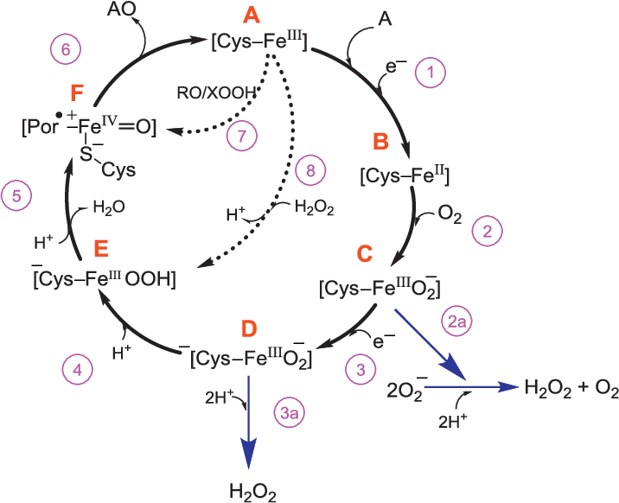
Figure 1. The cytochrome P450 catalytic cycle. Figure reproduced from Ref. 11c

Result and discussion
Preparation and characterization of catalyst
The preparation and modification of catalyst was followed through the synthetic stepwise procedures (Scheme 1). The iron oxide nanoparticles were formed via co-precipitation of Iron(II) and Iron(III) salts in alkaline media and tetraethylorthosilicate (TEOS) was introduced to form silica-shell on the surface of nanoparticles to protect them. The presence of -OH groups on silica-coated magnetic nanoparticles was functionalized with (3-aminopropyl)triethoxysilane (APTES) to prepare n-propylamine functionalized nanoparticles Fe₃O₄@SiO₂-APTES. A bis(phenol) diamine ligand containing a brominated alkyl side arm immobilized on amine functionalized magnetic nanoparticles through the reaction of Br with –NH₂ groups to form Fe₃O₄@SiO₂-APTES-H₂L^{AE}. Afterwards, the ligand was metalated with FeCl₃ to obtain the recoverable magnetically heterogeneous catalyst with an efficient catalytic active site (Fe₃O₄@SiO₂-APTES-FeL^{AE}).
The synthesized Fe₃O₄@SiO₂-APTES-FeL^{AE} nanoparticles were characterized by several techniques comprising Fourier-Transform Infrared Spectroscopy (FTIR), Transmission Electron Microscopy (TEM), Scanning electron microscopy (SEM), Thermal Gravimetric Analysis (TGA), X-Ray Diffraction (XRD), X-ray Photoelectron Spectroscopy (XPS), Vibrating-Sample Magnetometer (VSM) and Inductively Coupled Plasma Optical Emission Spectroscopy (ICP-OES).

Scheme 1: The schematic preparation steps of catalyst.

FTIR spectroscopy was applied to investigate the different preparation steps of functionalized particles. The signals near 500 cm⁻¹ were assigned to Fe-O stretching modes. The absorption bands around 800-1400 cm⁻¹ refer to asymmetric and symmetric stretching vibrations of Si-O-Si and Si-OH (Figure 2-A). Moreover, peaks at 1620 cm⁻¹ and 3400 cm⁻¹ appeared due to the bending and stretching vibration of O-H bond of adsorbed water and silica surface. Successful immobilization of propyl amine groups onto silica surface has been proven by symmetric and asymmetric stretching modes of –CH₂ at 2890 and 2936 cm⁻¹, stretching mode of N-H at 3430 cm⁻¹ and bending modes of –NH₂ and –CH₂ groups at 1450 cm⁻¹ (Figure 2-B). Furthermore, the observed decreasing and a slight shift in O-H bond confirm the effective graft of the complex on amine groups.²³
The morphological quality of catalyst nanoparticles was examined by transmission electron microscopy (TEM) and scanning electron microscopy (SEM) techniques (Figure 3). In different magnitudes, TEM images exhibit the nanoparticles spherically and uniformly. Similarly, SEM images clearly display uniform spreading of nanoparticles after metalation and the nanoparticle average diameters are approximately 33 ± 3 nm (Figure 3 E-G). Additionally, the SEM image of catalyst after 8 catalytic cycles shows an insignificant aggregation (Figure 3-H).

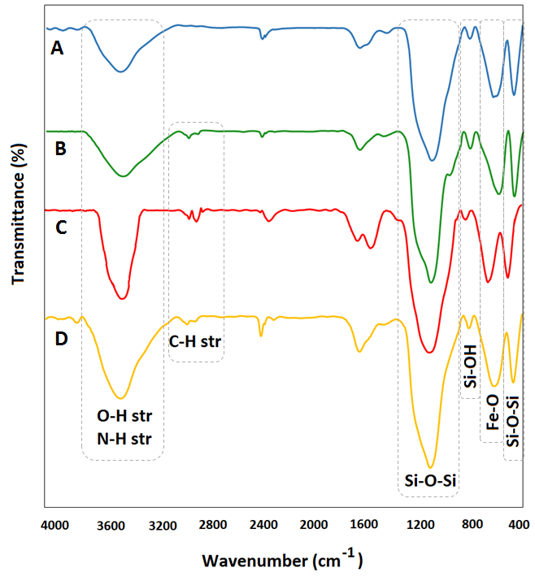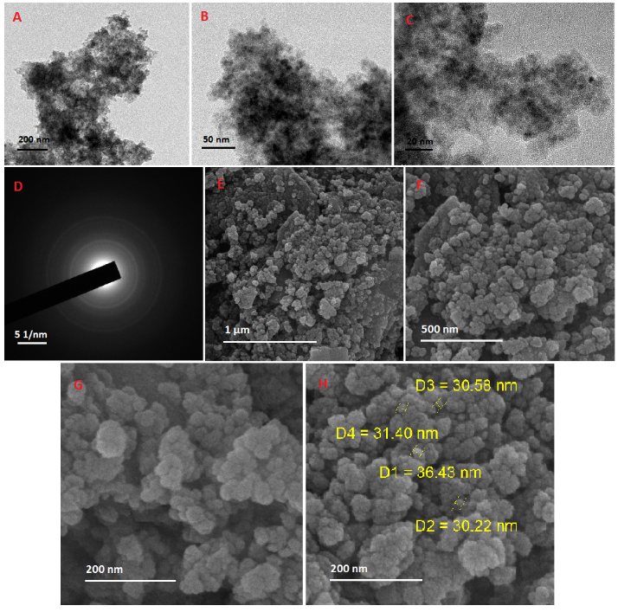

Figure 2: FT-IR spectra of A) Fe₃O₄@SiO₂, B) Fe₃O₄@SiO₂-APTES, C) Fe₃O₄@SiO₂-APTES-H₂L^{AE}, and D) Fe₃O₄@SiO₂-APTES-FeL^{AE}.
Figure 3: TEM images of Fe₃O₄@SiO₂-APTES-FeL^{AE}: A) 200 nm, B) 50 nm, C) 20 nm. D) SAED pattern, and SEM images of Fe₃O₄@SiO₂-APTES-FeL^{AE}: E) 1 µm, F) 500 nm, G) 200 nm, H) after recycling.

Immobilization of propylamine groups on silica surface, and afterwards bond formation between ligand and amine groups were verified by Thermogravimetric analysis (TGA) studies. The slight weight loss below 200 ᴼC usually relates to the loss of water, while the main weight loss in higher temperatures refers to loss of aminopropyl group and L^{AE} ligand. Remarkable decrease in weight of Fe₃O₄@SiO₂-APTES (0.8719 mg) obviously confirms the presence of functional groups on silica surface (Figure 4-A) and more weight reduction in Fe₃O₄@SiO₂-APTES-Fe^{AE} (1.990 mg) approves the successful ligand bonding onto anchored amines (Figure 4-B). In addition, the metal loading in the synthesized catalyst was determined by using Inductively Coupled Plasma (ICP) analysis. The mol percentage of Fe was measured approximately by calculating the difference between the quantity of Fe in Fe₃O₄@SiO₂-APTES-H₂L^{AE} and Fe₃O₄@SiO₂-APTES-FeL^{AE} (0.59 mmolg⁻¹).
The crystal structure of catalyst was considered by X-Ray diffraction (XRD) and according to the position and intensity of diffraction peaks, the cubic structure of Fe₃O₄ nanoparticles has been confirmed (Figure 5).
In addition, the superparamagnetic activity of prepared catalyst was explored by vibrating sample magnetometer (VSM) at room temperature (Figure S1). The magnetization curve of catalyst showed the field-dependent magnetization behavior of catalyst and high amount of saturation magnetization (M_{s}) of about 20 emu g⁻¹ confirmed the easy separation of catalyst from reaction using an external magnet.

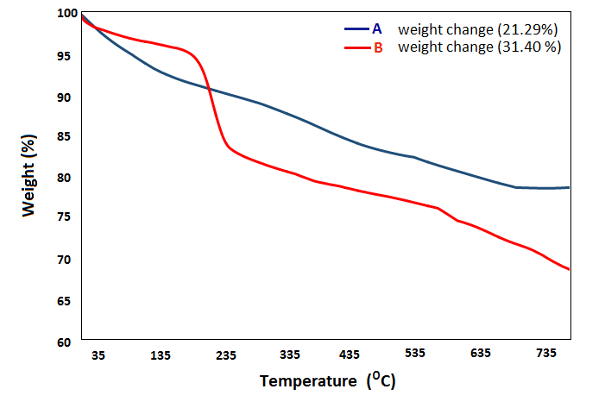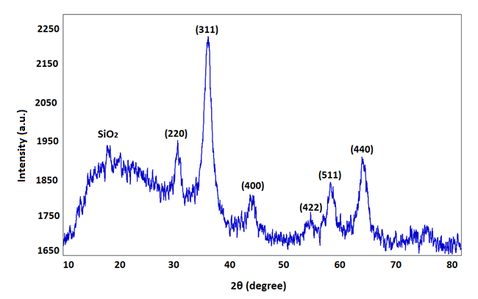

Figure 4: TG plots of A) Fe₃O₄@SiO₂-APTES, B) Fe₃O₄@SiO₂-APTES-FeL^{AE}.
Figure 5: XRD pattern of Fe₃O₄@SiO₂-APTES-FeL^{AE}.

Further exploration of catalyst has been performed by using X-ray photoelectron spectroscopy (XPS) which is a powerful technique to measure the elemental composition, chemical state and electronic state of the elements in materials (Figure 6-A). Regarding the representative XPS scan of the Fe 2p lines (Figure 6-B), the binding energies (BE) 710.75 eV and 724.28 eV are respectively correlated to Fe 2p_{3/2} and Fe 2p_{1/2} which indicates that Fe²⁺ and Fe³⁺ peaks are not separated from each other, but are located between these two binding energies as a mixed peak (Figure 6-B).²⁴ Moreover, the silica binding energies appeared at 103.08 eV (Si 2p) and 154.08 eV (Si 2s), and the peaks at 284.7 eV (C 1s), 399.95 eV (N 1s) and 531.77 eV (O 1s) are good evidence of the effective grafting of ligand (Figure 6-A).

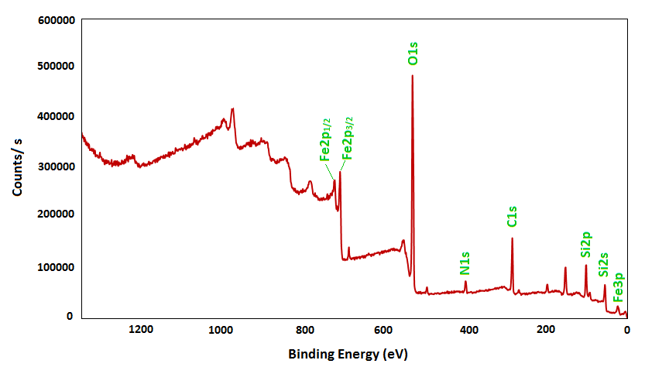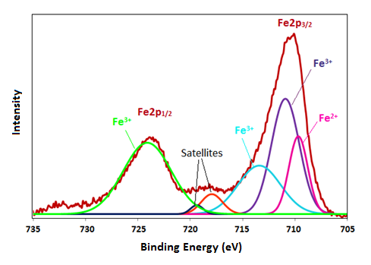
A
B
Figure 6. XPS spectrum: A) Survey of Fe₃O₄@SiO₂-APTES-FeL^{AE} and B) Fine spectrum of Fe2p.
Catalytic epoxidation reaction evaluation
The initial studies were concentrated on optimization of additive and catalyst loading in cyclopentene epoxidation reaction at room temperature in water (Table 1) and the conversion of cyclopentene and selectivity to cyclopentene oxide was analyzed by Gas chromatography (GC) method (Figure S2). Sulfite ion as reducing agent is necessary for the aerobic epoxidation reaction to convert Fe(III) to Fe(II).²⁵ The changes of Na₂SO₃ equivalent investigations proved that the catalytic epoxidation performance is directly dependent on the presence of sulfite and the system does not work if there is a lack of reducing agent source (Table 1, entry 1).
The optimized equivalent of sulfite was shown in Table 1, entry 4 which led to the 97% conversion of cyclopentene to 1,2-epoxycyclopentane and excellent selectivity. Alternatively, increasing the amount of catalyst to 60 mg not only impairs efficiency but also reduces selectivity. Moreover, using a variety of reducing agents including ascorbic acid, tri-sodium citrate, NaHCO₃ and Na₂CO₃ did not affect the aerobic epoxidation reaction. On the other hand, to explore the role of Iron(III) catalytic center and the catalyst components of Fe₃O₄@SiO₂-APTES-FeL^{AE}, in a separate test, Fe₃O₄@SiO₂, Fe₃O₄@SiO₂-APTES and Fe₃O₄@SiO₂-APTES-H₂L^{AE} have been used instead of catalyst and the obtained conversions were negligible.
Table 1: The optimization of catalytic epoxidation of cyclopentene
Entry |  | Catalyst (mg) |  | Reducing Agent (eq) | Time (h) | T | Solvent  (0.6 mL) | Conversion % | Selectivity %
1 | 60 |  | - |  | 10 | R.T. | H₂O | 4 | >99
2 | 40 |  | Na₂SO₃ (0.5 eq) |  | 6 | R.T. | H₂O | 48 | 92
3 | 40 |  | Na₂SO₃ (1 eq) |  | 6 | R.T. | H₂O | 56 | 90
4 | 40 |  | Na₂SO₃ (3 eq) |  | 6 | R.T. | H₂O | 97 | 97
5 | 60 |  | Na₂SO₃ (3 eq) |  | 6 | R.T. | H₂O | 94 | 88
6 | 40 |  | Ascorbic acid  (3 eq) |  | 6 | R.T. | H₂O | 21 | 99
7 | 40 |  | Tri-sodium citrate  (3 eq) |  | 6 | R.T. | H₂O | 29 | 97
8 | 40 |  | NaHCO₃ (3 eq) |  | 6 | R.T. | H₂O | 39 | 86
9 | 40 |  | Na₂CO₃ (3 eq) |  | 6 | R.T. | H₂O | 94 | 52

The chemical oxidation of sodium sulfite, as reducing agent, using radicals ²⁶ such as OH• and NH₂•, or with oxidizing transition metals, for instance Mn(III)²⁷, Ce(IV)²⁸ and Fe(III)²⁹ to generate sulfite radical anion, has been reported. The free produced sulfite radical anion is able to quickly combine with oxygen (Eq. 1) ³⁰ to yield peroxomonosulfate radical anion, SO₅^{•-}, which is known as a good oxidant according to its redox potential (E⁰ = 0.86 V versus SCE).²⁶
SO₃^{•-} + O₂ SO₅^{•-} k = 1.5 × 10⁹ M⁻¹ s⁻¹ (Eq. 1)
The product of one-electron reduction of SO₅^{•-} is SO₅²⁻ with two-electron redox potential of E⁰ = 1.58 V versus SCE which obviously confirms its capability in oxidation reactions (Eq. 2).³¹
HSO₅⁻ + 2 H⁺ + 2 e⁻ HSO₄⁻ + H₂O (Eq. 2)
There are only a few reports on the use of in situ formation of HSO₅⁻ from SO₃²⁻ and O₂, which has been particularly focused on the iron and manganese porphyrins, and polyoxometalates. ³²
Regarding these studies, it could be assumed that the Fe₃O₄@SiO₂-APTES-FeL^{AE} catalyze the one-electron oxidation of sulfite anion to yield SO₅^{•-}, which undergoes fast reaction with O₂ to in situ formation of peroxosulphate species for efficient epoxidation of alkene.
To verify this assumption, we carried out the reaction in the presence of a radical scavenger agent (TEMPO, 1 eq) under standard conditions. However, it was expected that the TEMPO radicals would be able to trap the SO₅^{•-} species and interrupt the radical chain, but surprisingly, the efficiency of alkene epoxidation was enhanced considerably (total conversion in 4 h but lower selectivity) which rejected our hypothesis about the radical reaction route and producing SO₅^{•-}. Consequently, the non-radical procedure theory via high valent [Fe(IV)=O] or [Fe(V)=O] intermediates production, would be more feasible.
On the other hand, it seems that TEMPO could accomplish the epoxidation reaction in another parallel orientation which was confirmed by running a test reaction with TEMPO in the absence of sodium sulfite. Therefore, the new optimized conditions for aerobic epoxidation reaction of cyclopentene using TEMPO was inspected (Table 2). The conversion was enhanced along with increasing TEMPO equivalents but selectivity was decreased remarkably which was probably caused by radical chain propagation. Increasing catalyst amount up to 60 mg did not affect the conversion and selectivity (Table 2, entry 8), while decreasing it to 20 mg caused lower conversion (Table 2, entry 9), which proved that the ideal catalyst content per 1 mmol alkene in epoxidation reaction was 0.023 mmol (Table 2, entry 7). Correspondingly, a blank reaction was performed without catalyst in the presence of TEMPO (0.5 equivalent) and the resulted conversion was only 11% which proved the importance of catalyst role (Table 2, entry 10).

Table 2: The optimization of catalytic epoxidation of cyclopentene in the presence of TEMPO
Entry | Catalyst (mg) | TEMPO (mmol) |  | Time (h) | T | Solvent (0.6 mL) | % Conversion | % Selectivity
1 | 40 |  | 2 mmol | 6 | R.T. | H₂O | >99 | 33
2 | 40 |  | 1 mmol | 6 | R.T. | H₂O | >99 | 40
3 | 40 |  | 0.5 mmol | 6 | R.T. | H₂O | 92 | 60
4 | 40 |  | 0.25 mmol | 6 | R.T. | H₂O | 79 | 64
5 | 40 |  | 0.1 mmol | 6 | R.T. | H₂O | 84 | 75
6 | 40 |  | 0.075 mmol | 6 | R.T. | H₂O | 75 | 95
7 | 40 |  | 0.05 mmol | 6 | R.T. | H₂O | 82 | >99
8 | 60 |  | 0.05 mmol | 6 | R.T. | H₂O | 80 | >99
9 | 20 |  | 0.05 mmol | 6 | R.T. | H₂O | 55 | 95
10 | - |  | 0.5 mmol | 6 | R.T. | H₂O | 11 | 90

Suggested mechanisms
According to the evidence, the catalytic aerobic epoxidation reaction of alkenes using Fe₃O₄@SiO₂-APTES-FeL^{AE} and Na₂SO₃ has been followed through a non-radical procedure and generation of high-valent iron-oxo intermediates very similar to the enzymatic behavior. In keeping with Scheme 2, SO₃²⁻ is able to reduce Fe(III) to Fe(II) which is highly motivated to react (in 2 equivalent) with molecular oxygen to form dinuclear µ-peroxo complex, (L^{AE})Fe^{III}-O-O-Fe^{III}(L^{AE}).³³ The Fe(II)-involved complex may persuade the dinuclear intermediate to homolytic cleavage of O-O bond which leads to the 2 equivalents of active high-valent [Fe(IV)=O] intermediates as the main oxygen-transfer agent to the alkene and regenerates the Fe(II) complex which is unstable enough to easily reduce oxygen and recover the Fe(III)-based catalyst. In fact, the one-electron reduction of 1/2O₂ to 1/2H₂O₂ in aqueous media catalyzed by Fe(II) component is suggested due to the high midpoint redox potential of O₂/O₂²⁻ (E⁰ = +695 V at pH=7).³⁴
On the other hand, the produced SO₃^{-•} could rapidly react with oxygen to form superoxide and SO₅^{-•} which are reactive enough to be consumed in the catalytic cycle through a synergistic effect by reduction of Fe(III) to Fe(II) and producing high-valent iron-oxo intermediate, respectively (Eq. 3, 4).³⁵
SO₃^{-•} + O₂ SO₃ + O₂^{-•} (Eq. 3)
SO₃^{-•} + O₂ SO₅^{-•} (Eq. 4)
Moreover, SO₃^{-•} radical can probably undergo dimerization (Eq. 5) and/or propagation (Eq. 6).³⁶
2 SO₃^{-•} S₂O₆⁻ (Eq. 5)
2 SO₃^{-•} SO₃ + SO₃⁻ (Eq. 6)

Scheme 2: Catalytic epoxidation mechanism in the presence of Na₂SO₃. Grey spheres show Fe₃O₄@SiO₂ nanoparticles.

The TEMPO-promoted aerobic alkene epoxidation mechanism has been depicted in Scheme 3. In fact, TEMPO bonds to iron center in Fe₃O₄@SiO₂-APTES-Fe^{III}L^{AE} to form TEMPO-coordinated intermediate (2) which could be considered as a model for [Fe-O-O] unit, the intermediate in O₂ activation reactions by iron-containing metalloenzymes.³⁷ Then, it is recognized that the O-O bond cleavage leads to the formation of the high-valent iron-oxo intermediate (3), which is species known as two-electron oxygen atom transfer mediator.³⁸ Since, TEMPO may be evaluated as an analogue of the peroxide ligand, this proposed path is predictable.³⁹ Last of all, the produced Fe(II) complex (4) oxidizes to form the primary Fe(III) catalyst (1) in the vicinity of oxygen saturated water.
In addition, to ensure that all the catalytic occurrences happen in catalytic metal-center, we applied the standard conditions for epoxidation reaction of cyclopentene using Fe₃O₄@SiO₂-APTES and Fe₃O₄@SiO₂-APTES-H₂L^{AE} and no remarkable conversion of cyclopentene to epoxide was obtained neither in the presence of sulfite nor TEMPO.

Scheme 3: Catalytic epoxidation mechanism in the presence of TEMPO. Grey spheres show Fe₃O₄@SiO₂ nanoparticles.

Catalytic epoxidation reaction of various olefins in the presence of Na₂SO₃ and TEMPO
To investigate the scope of catalytic epoxidation reactions, a range of alkenes including cyclic, straight-chain and aromatic alkenes, were subjected to the optimized catalytic condition using sulfite anion (Table 3). As shown in Table 3, the efficiency of catalytic performances is strongly related to the steric conformation of alkenes. For example, the lowest conversions were obtained with the most difficult alkenes (1-cyclohexene, cyclooctene, cis-stillbene) in slightly longer reaction time. However, the best results were achieved with 5 to 7-membered cyclic alkenes and terminal alkenes such as 1-hexene and 1-octene. On the other hand, 4-methylstyrene showed the weakest performance. Unpredictably, the styrene and 4-methylstyrene were converted to the related epoxides only at high temperatures. Alternatively, the selectivity for epoxide products was relatively excellent for most of the reactions which may be attributed to the absence of strong oxidant.

Table 3: The scope of catalytic epoxidation reaction in the presence of Na₂SO₃
Entry | Substrate | Na₂SO₃ (mmol) | Time (h) | Conversion (%) | Selectivity to epoxide (%)
1 |  | 3 | 6 | 80 | 92
2 |  | 3 | 6 | 87 | 90
3 |  | 3 | 8 | 60 | 78
4 |  | 5 | 15 | 30 | >99
5 |  | 3 | 15 | 41 | 93
6 |  | 3 | 6 | 80 | 92
7 |  | 3 | 7 | 60 | 87
8 |  | 3 | 6 | 9 | >99
9ª |  | 3 | 6 | 94 | >99
10ª |  | 3 | 6 | 71 | >99
11^{b} |  | 4 | 10 | 12 | >99
Reaction conditions: Catalyst (40 mg), Alkene (1 mmol), Na₂SO₃, water (0.5 mL), oxygen balloon, T=R.T.. [a] Catalyst (40 mg), Alkene (1 mmol), Na₂SO₃, water (0.5 mL), acetic acid (1.5 eq), oxygen balloon, T=60 ᴼC. [b] Catalyst (60 mg), Alkene (1 mmol), Na₂SO₃, water (0.5 mL), acetic acid (1.5 eq), oxygen balloon, T= 60 ᴼC.
The mentioned conversions percentages and selectivity percentages are the average results of 3 reactions and are obtained by GC analysis.
The scope of different alkene epoxidation reactions in the presence of TEMPO under optimized conditions were studied (Table 4). Herein, similar to the alkenes activities in the presence of sulfite, the behavior of alkenes strongly depended on the steric rather than the electronic effects of the substituents around the double bond. The best conversions belonged to the 5 and 6-membered cyclic and final chained alkenes (Table 4, entries 1, 2 and 6) while the other entries including larger size cyclic and chain alkenes were more difficult to convert. Likewise, the aromatic alkenes epoxidation (entries 9-11) did proceed in the presence of higher TEMPO quantities, higher temperatures (50 ᴼC) and weak acidic media.
Consequently, the similar performances of different alkenes and efficiency with both sulfite and TEMPO-assisted catalytic mechanisms, strongly confirmed that the oxygen atom transfer agents in both mechanisms is the same, i.e., a Fe(IV)=O species. Besides, the observation of similar reactivity of some olefins, especially aromatic alkenes, in the presence of acid suggested the identical role played by H⁺ in the two catalytic systems. Accordingly, further experiments including epoxidation reaction of styrene under optimized catalyst quantity and solvent, in the absence of the main additives (sulfite and TEMPO) and in the presence of acetic acid (1.5 eq), at 60 ᴼC were carried out and no significant conversion appeared. This result rejected the role of H⁺ in directing a parallel mechanism and approved its effective function to promote the both mentioned sulfite and TEMPO mechanisms indirectly. The most probable suggestion for the role of H⁺ is assumed with considering cytochrome P450 cycle (Figure 1, peroxide shunt pathway, shortcut 8). Based on this pathway, H₂O₂ obtained from the reaction of peroxide molecule with proton is potentially reactive to combine with Fe(III) species to generate a hydroperoxo intermediate, Fe^{III}-O-O-H, which is highly reactive to heterolytic splitting of O-O bond, forming the super active high-valent oxoiron(V) intermediate and accelerating the epoxidation process (Scheme 4).

Scheme 4: The role of acid in catalytic epoxidation reaction. Grey spheres are Fe₃O₄@SiO₂ nanoparticles.

Table 4: The scope of catalytic epoxidation reaction in the presence of TEMPO
Entry | Substrate | TEMPO (mmol) | Time (h) | Conversion (%) | Selectivity to epoxide (%)
1 |  | 0.05 | 8 | 85 | >99
2 |  | 0.05 | 8 | 85 | 93
3 |  | 0.05 | 8 | 59 | 95
4 |  | 0.1 | 9 | 36 | >99
5 |  | 0.1 | 12 | 47 | 88
6 |  | 0.05 | 8 | 83 | 84
7 |  | 0.1 | 8 | 14 | 88
8ª |  | 0.1 | 10 | 60 | 87
9ª |  | 0.07 | 8 | 100 | 89
10^{b} |  | 0.07 | 8 | 96 | 93
11^{b} |  | 0.1 | 10 | 10 | >99
Reaction conditions: Catalyst (40 mg), Alkene (1 mmol), TEMPO, water (0.5 mL), oxygen balloon, T=R.T.. [a] Catalyst (40 mg), Alkene (1 mmol), TEMPO, water (0.5 mL), acetic acid (1.5 eq), oxygen balloon, T=50 ᴼC. [b] Catalyst (60 mg), Alkene (1 mmol), TEMPO, water (0.5 mL), acetic acid (2 eq), oxygen balloon, T= 60 ᴼC.
The mentioned conversions percentages and selectivity percentages results of 3 reactions run, obtained by GC analysis.

Computational results
The present computational study is divided into the following two sections: (1) exploring the mechanism of the reaction and the related PES of co-reductant SO₃²⁻ reaction and (2) with the TEMPO mediated reaction. Analysis of the corresponding thermodynamics and kinetics parameters in presence of two catalysts is also performed. The same calculations were performed in the presence of SO₃²⁻ as a reducing agent. Figure 7 shows the PES (relative Gibbs free energy) for this reaction at Wb97xd/6-311g (d,p) level of theory and thermodynamics parameters for this mechanism are listed in Table 5.
The mentioned mechanism starts with electron transfer reaction from SO₃²⁻ to the structure 1 to form SO₃^{•-} and structure 2. It is noteworthy to mention that the conversion of the structure 1 to 2 depends on the reduction of Fe(III) to Fe(II) in structure 2. As shown in Figure 7 and Table 5, this reaction is exothermic (ΔH = -2.8 kJ mol⁻¹) and endergonic (ΔG = 4.1 kJ mol⁻¹). It can be said that this is a nonspontaneous reaction with equilibrium constant (K_{eq}) of 0.19. It is worthy to mention that the structure 2 is unstable than 1 in the presence of SO₃²⁻ unlike the TEMPO mechanism (we will discuss this in more detail later on).
The structure 2 reacts (in 2 equivalent) with molecular oxygen to form the structure 3 (dinuclear µ-peroxo complex, (L^{AE})Fe^{III}-O-O-Fe^{III}(L^{AE})). The values of ΔG and ΔH for this reaction is -8.0 and -5.5 kJ mol⁻¹, respectively. The distance of Fe-O and O-O in the structure 3 are 1.97 and 1.61 Å, respectively. It is considered that the bond lengths in the structure 3 have been increased due to the steric effects. Then, the O-O bond in structure 3 cleaves and forms two equivalents of oxo ferryl ([Fe(IV)=O]) species. Conversion reaction of the structure 3 to 4 is exothermic (ΔH = -0.02 kJ mol⁻¹) and endergonic (ΔG = 2.0 kJ mol⁻¹), with equilibrium constant (K_{eq}) of 0.45 M.
The structure 4 in the presence of alkenes (Fe(IV) and alkenes) convert to Fe(II) and epoxide. The conversion reaction is exothermic and endergonic with the values of ΔH and ΔG of -2.0 and 0.1 kJ mol⁻¹, respectively. Structure 5 at the aerobic condition converts to structure 1 and indeed, Fe(II) oxides to Fe(III).

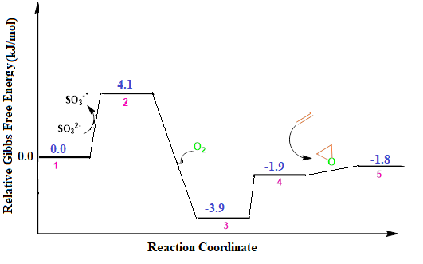
Figure 7: PES at the wb97xd/6-311g (d,p) level of theory in the presence of SO₃²⁻.

Table 5. Relative enthalpies, ΔH in kJ mol⁻¹, entropies, ΔS in kJ mol⁻¹K⁻¹, and Gibbs free energies, ΔG in kJ mol⁻¹, computed at 298.15 K in water at the Wb97xd/6-311g (d, p) level of theory in the presence of SO₃²⁻.
K_{eq} | ΔS | ΔH | ΔG | Reaction
0.19 | -0.0231 | -2.8 | 4.1 | 1 → 2
25.21 | 0.0083 | -5.5 | -8.0 | 2 → 3
0.45 | -0.0067 | -0.02 | 2.0 | 3 → 4
0.96 | -0.0070 | -2.0 | 0.1 | 4 → 5

Figure 8 shows a schematic representation of the calculated frontier molecular orbitals (FMOs) of the species involved in this reaction in the presence of SO₃²⁻ as reducing agent. The HOMO and LUMO energy differences in structures 1 and 2 are 1.0 and 2.9 eV, respectively. Investigation of HOMO in the structure of 2 shows a high electron density at the center of the molecule (adjacent to the Fe(II) atom). Thus, the electron transfer of SO₃²⁻ to the structure 1 takes place and the structure 2 is formed. In the structure 3, the electron density in the vicinity of two Fe(III) atoms in binuclear intermediate is more than that of the O-O bond, so O-O bond cleaves homolytically, leading to the formation of two active high-valent [Fe(IV)=O] intermediates (structure 4). The energy band gap of the structure 4 is 3.9 eV. The electron density in the structure 4 in the vicinity of Fe(IV) is higher than the structure 3. In fact, the removal of one dimer from intermediates increases the electron density in the vicinity of HOMO orbital of atom Fe(IV) in the structure 4.

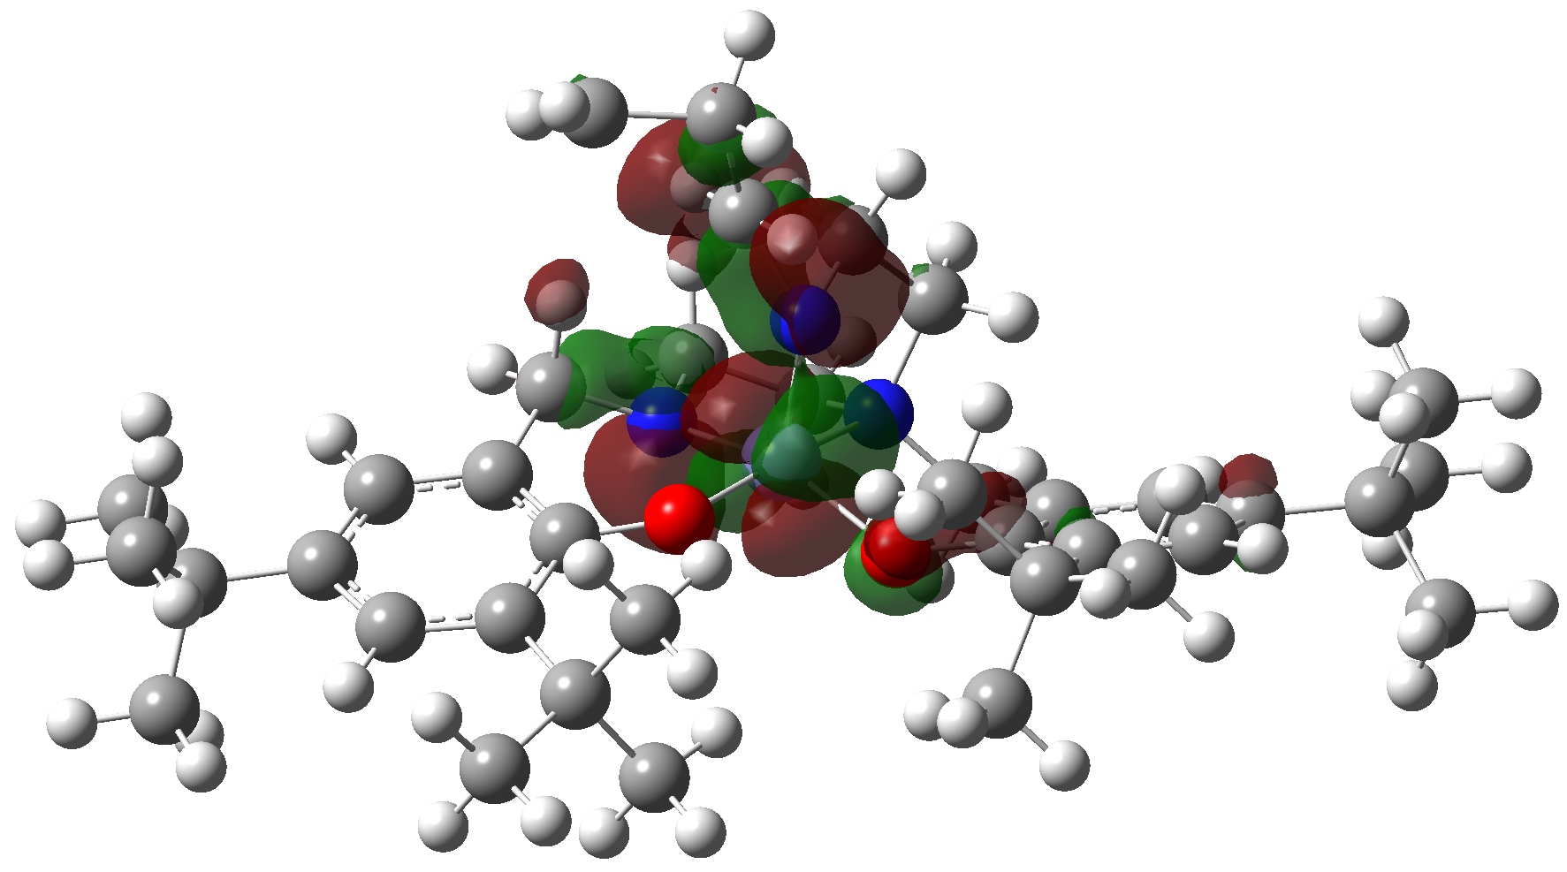  HOMO of structure 1 | 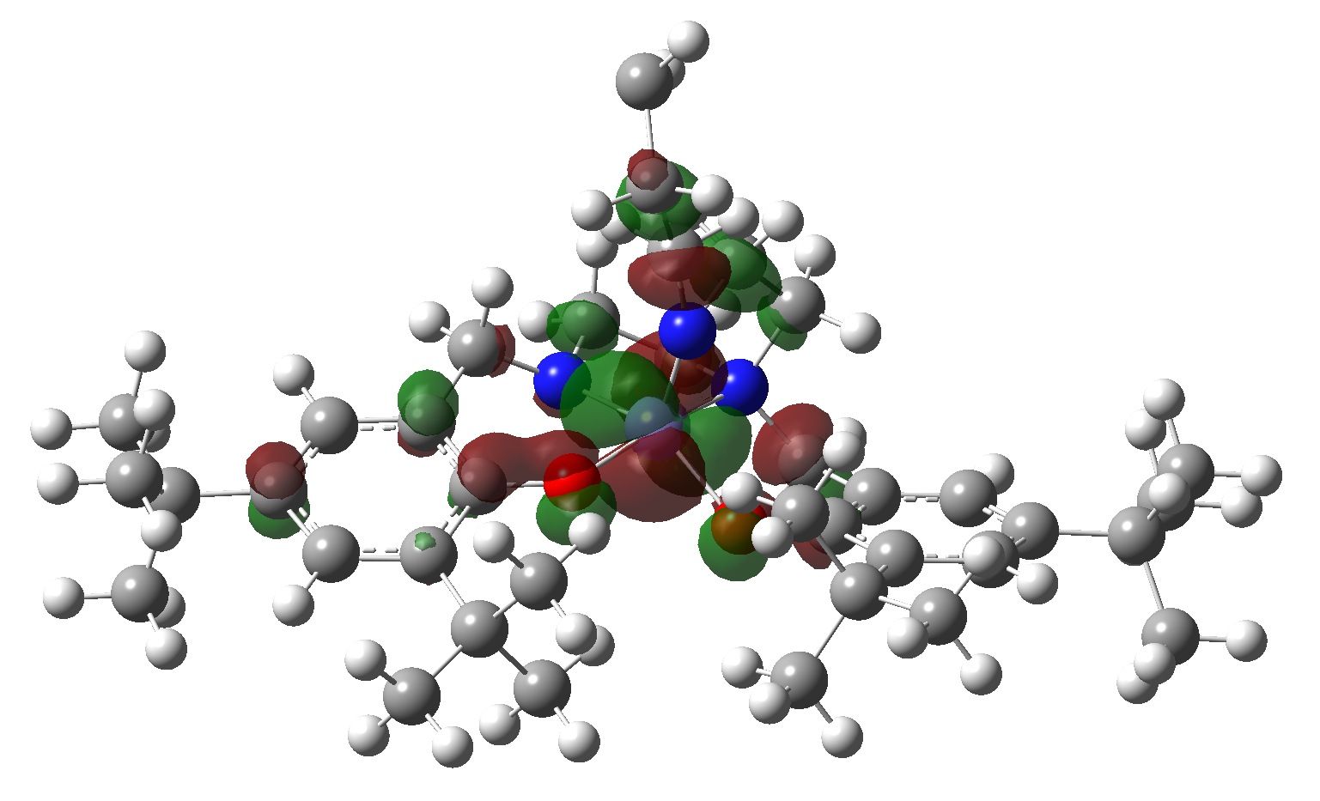LUMO of structure 1 | 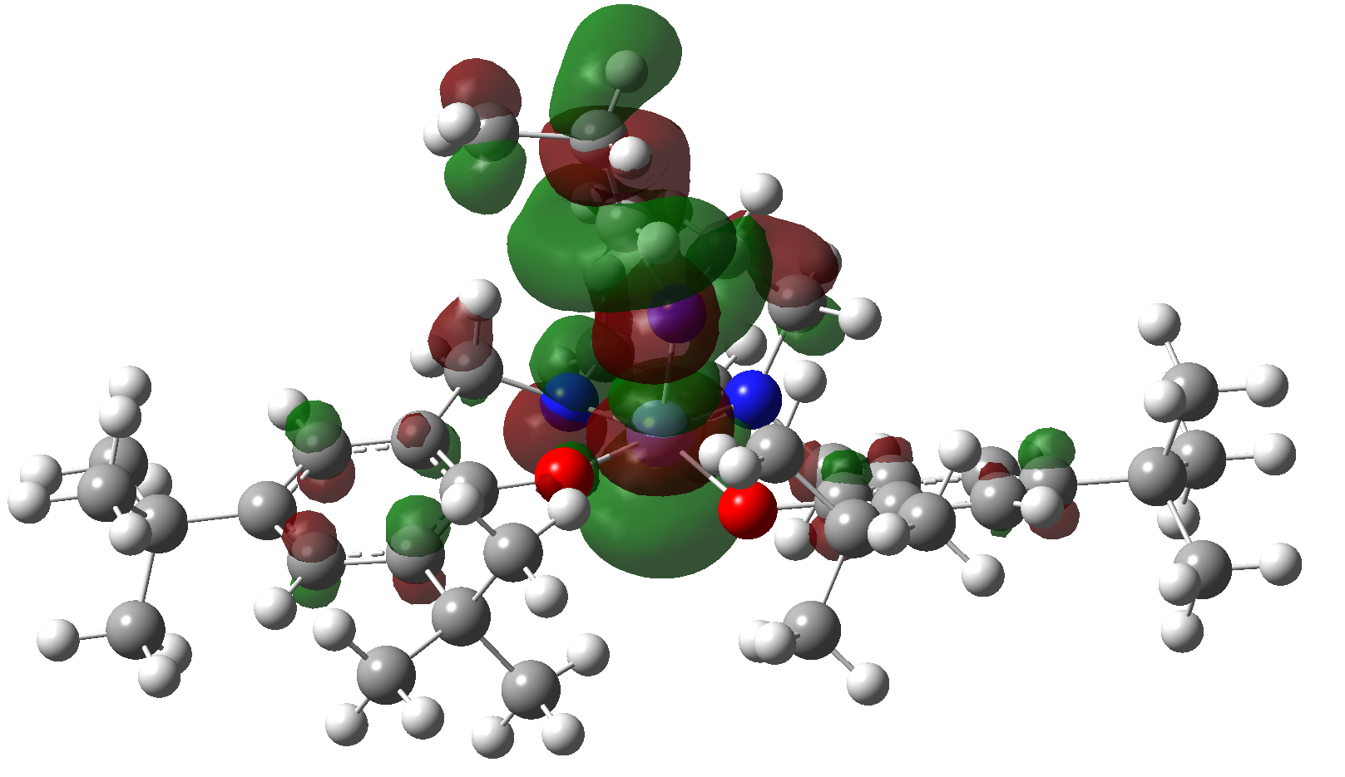  HOMO of structure 2
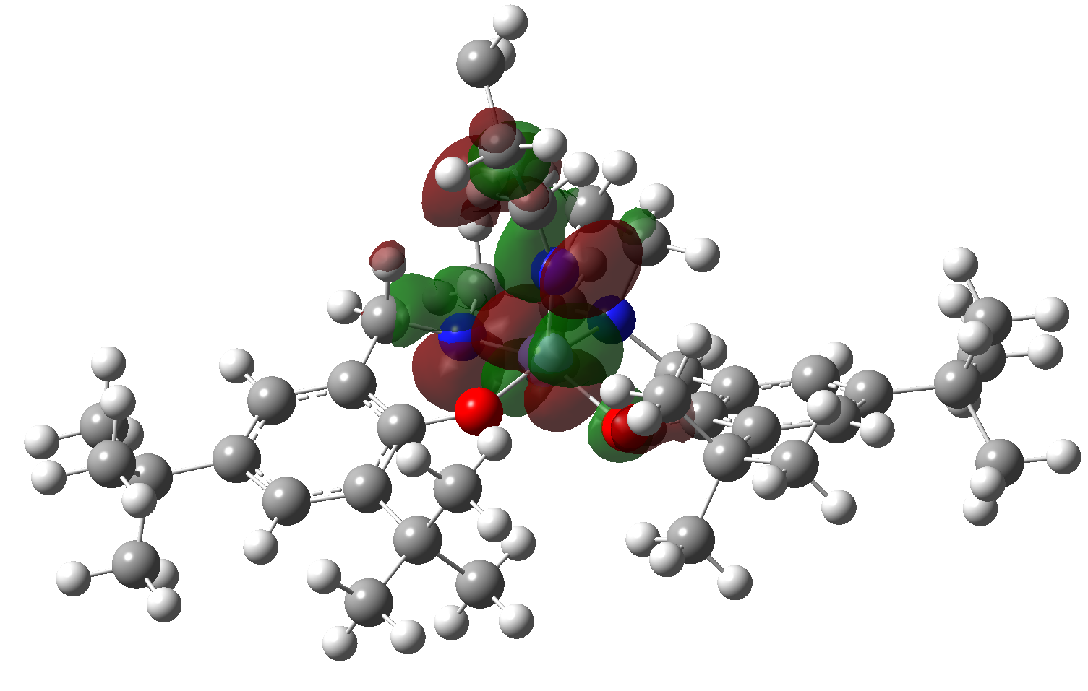  LUMO of structure 2 | 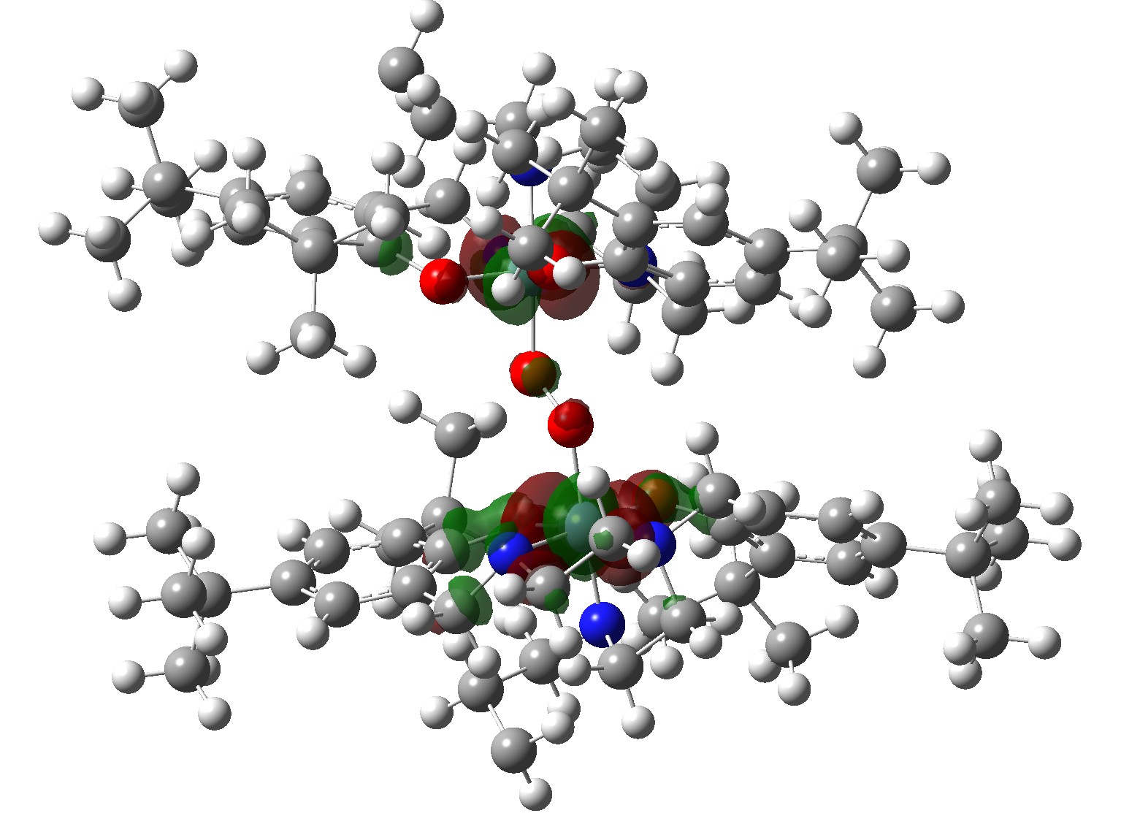HOMO of structure 3 | 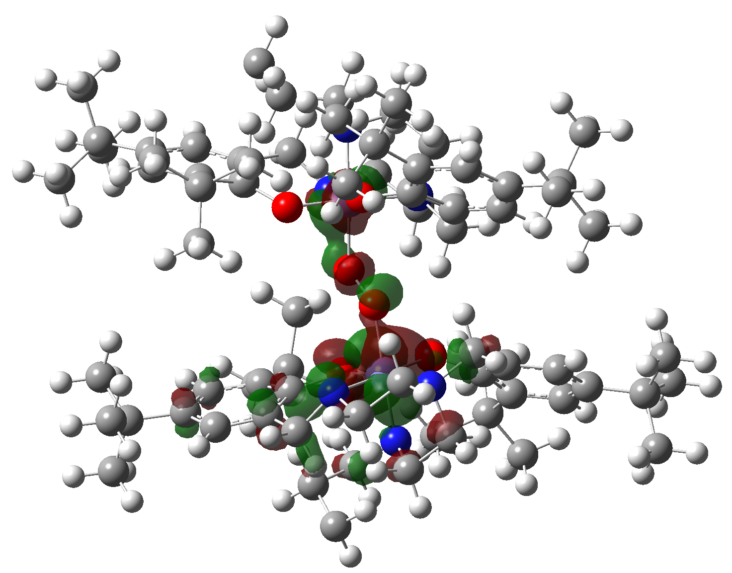  LUMO of structure 3
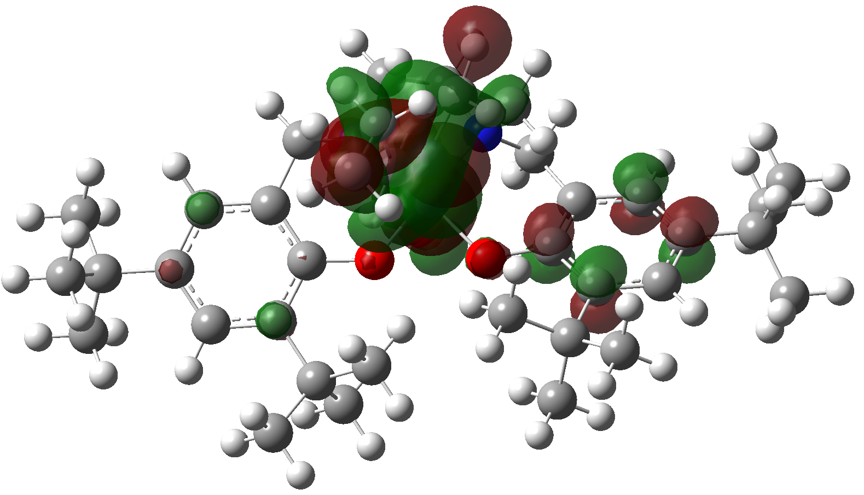HOMO of structure 4 | 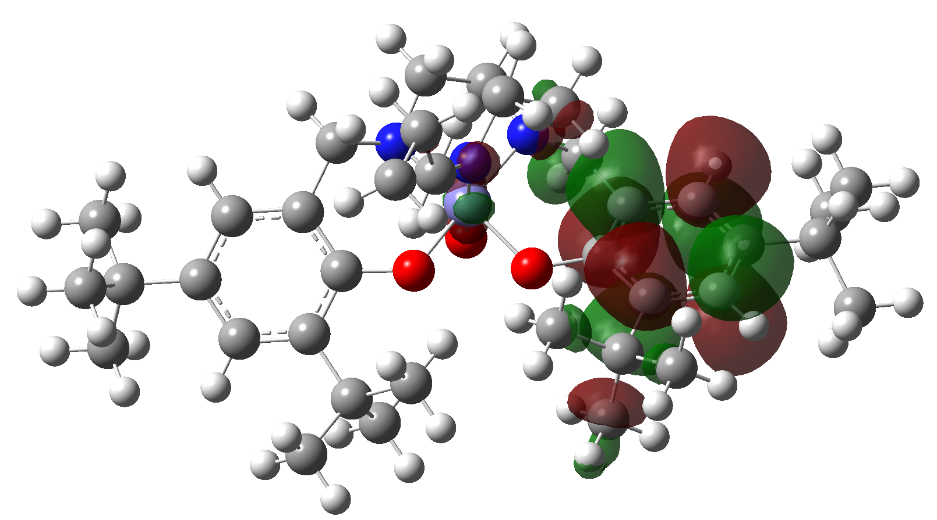LUMO of structure 4
Figure 8: Schematic representation of the calculated FMOs of the species involved in the proposed catalytic cycle in the presence of SO₃²⁻ in solution (water). Circles with light and dark gray, red, blue and medium purple color are H, C, O, N and Fe atoms.

Figure 9 shows the PES (relative Gibbs free energy) at the wb97xd/6-311g (d,p) level of theory in presence of TEMPO. This reaction begins with the attack of TEMPO to structure 1 and generates a structure 2 (TEMPO-coordinated intermediate) with C1 symmetry. It is worthy to mention that the structure 2 is more stable than 1 in the presence of the TEMPO unlike the SO₃²⁻ mechanism. These criteria can perhaps be attributed to the steric effects of the propyl group near the reaction active site, and also, with the connection of the TEMPO molecule, the number of hydrogen bonds in the system increases. As shown in Figure 9 and Table 6, this reaction is barrier less and exothermic (ΔH = -242.4 kJ mol⁻¹) and exergonic (ΔG = -103.7 kJ mol⁻¹), so this reaction in the presence of TEMPO is spontaneous and the high value of equilibrium constant (K_{eq}= 1.5×10¹⁸ M⁻¹) confirms this statement. The distance of O-atom of TEMPO and the Fe-atom of structure 1 is 1.80 Å which is in fair agreement with the experimental value (1.66 Å). From this, it is concluded that Fe(II) is more stable than Fe(III) in the presence of TEMPO as co catalyst.
In the presence of O₂, the conversion reaction of structure 2 to structure 3 (iron-oxo intermediate) and TEMPO takes place. The conversion reaction of the structure 2 to 3 is exothermic (ΔH = -0.8 kJ mol⁻¹) but endergonic (ΔG = 1.0 kJ mol⁻¹) because entropy changes (ΔS) during this formation is negative. Structure 3 in the presence of alkenes reduces to structure 4. This means that Fe(IV) and alkenes convert to Fe(II) and epoxides respectively during this reaction. This reaction is endothermic (ΔH = 2.2 kJ mol⁻¹) and endergonic (ΔG = 2.1 kJ mol⁻¹).

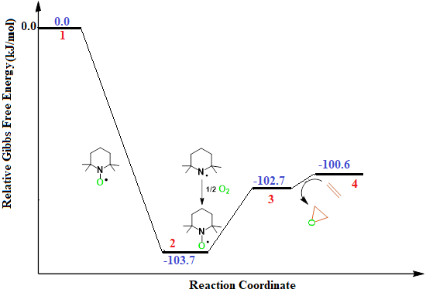
Figure 9: PES at the wb97xd/6-311g (d,p) level of theory in presence of TEMPO.

Table 6. Relative enthalpies, ΔH in kJ mol⁻¹, entropies, ΔS in kJ mol⁻¹K⁻¹, and Gibbs free energies, ΔG in kJ mol⁻¹, computed at 298.15 K in water at the Wb97xd/6-311g (d,p) level of theory in the presence of TEMPO.
K_{eq} | ΔS | ΔH | ΔG | Reaction
1.5×10¹⁸ | -0.0631 | -242.4 | -103.7 | 1 → 2
0.67 | -0.0060 | -0.8 | 1.0 | 2 → 3
0.42 | 0.00008 | 2.2 | 2.1 | 3 → 4

A schematic representation of the calculated FMOs of the species involved in this reaction has been shown in Figure 10. The HOMO and LUMO energy differences in structures 1 and 2 are 1.1 and 3.1 ev, respectively. Therefore, it is concluded that the electron is transferred from TEMPO to structure 1 and the formation of structure 2 is desirable path. Likewise, Figure 10 shows that TEMPO group increases the electron density in the vicinity of the center of structure 2 (Fe(II)).
Investigation of HOMO from the structure 3 shows that the removal of the TEMPO group reduces the electron density in the vicinity of the Fe(IV) atom. The difference between the HOMO and LUMO energies in the structure 3 is 4.01 eV, which is greater than in the structure 2. Because, the electron density of HOMO in structure 3 decreases and the band gap increases, so this structure converts to structure 4 in the presence of alkene, as HOMO orbital in structure 4 shows, high electron density at the center of the molecule. The energy gap in structure 4 is 3.4 eV.

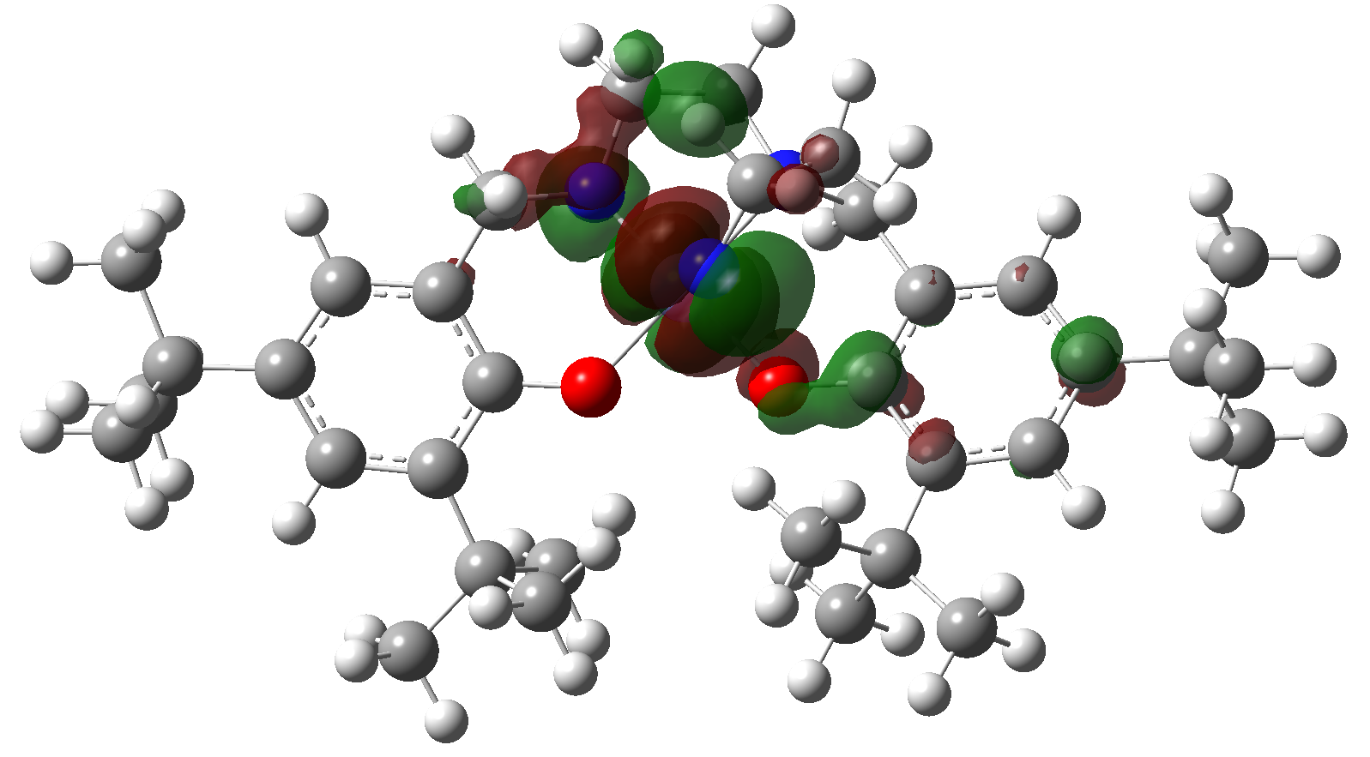HOMO of structure 1 | 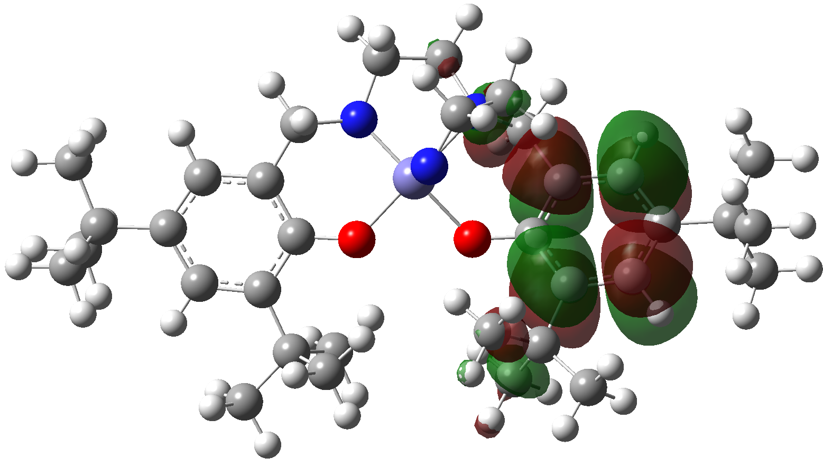LUMO of structure 1 | 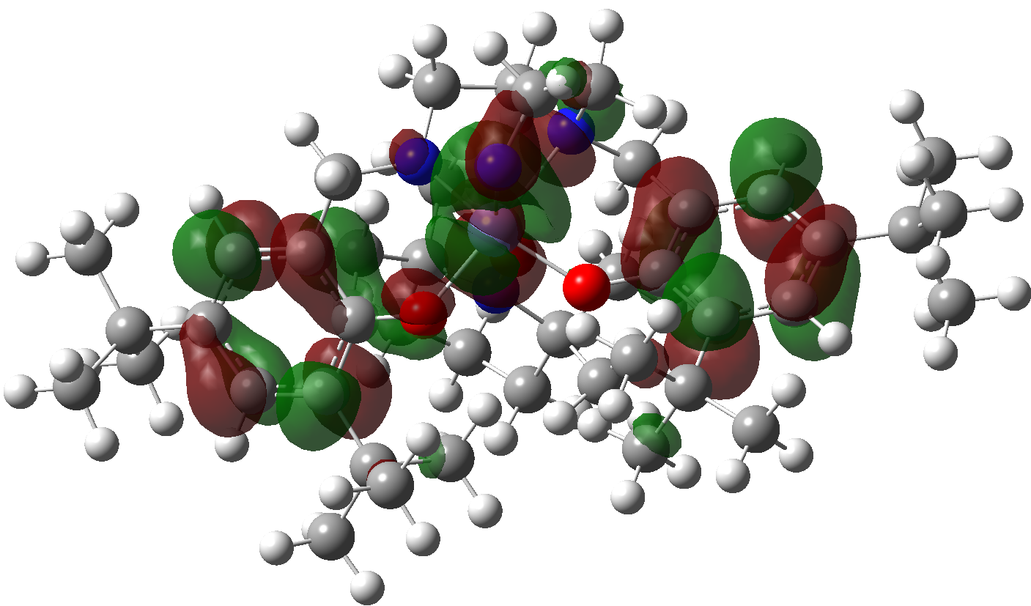  HOMO of structure 2
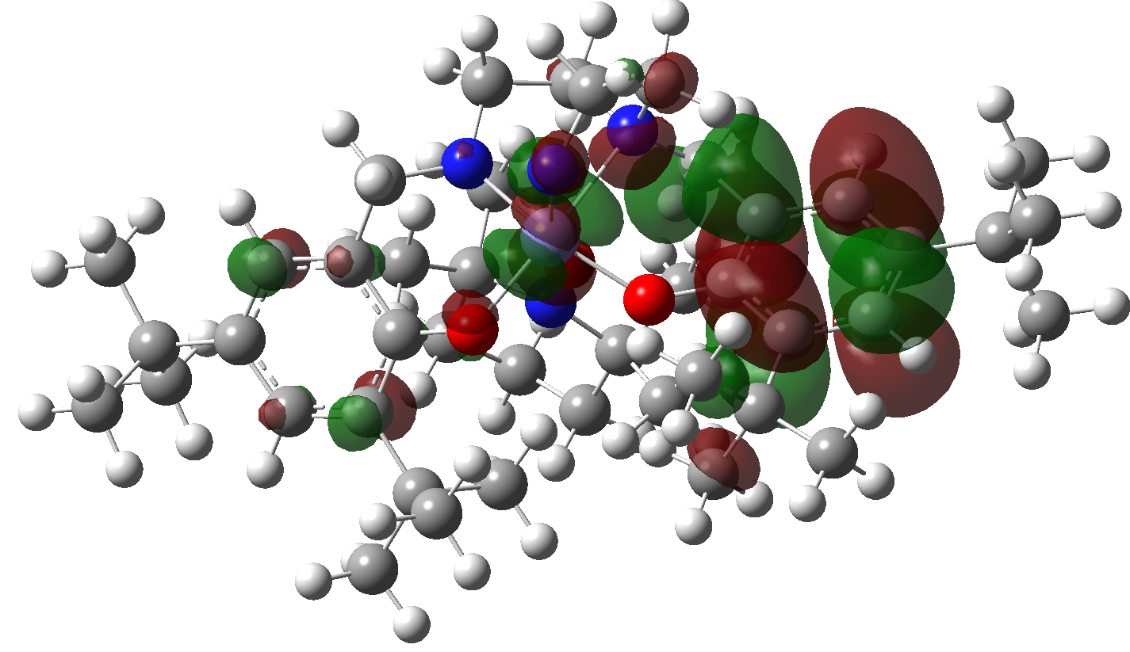LUMO of structure 2 | 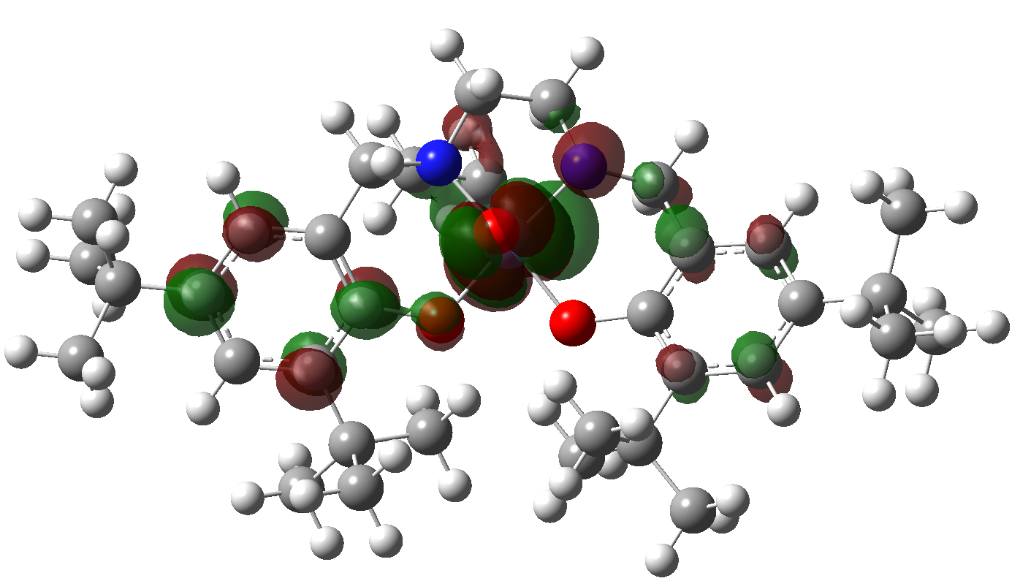HOMO of structure 3 | 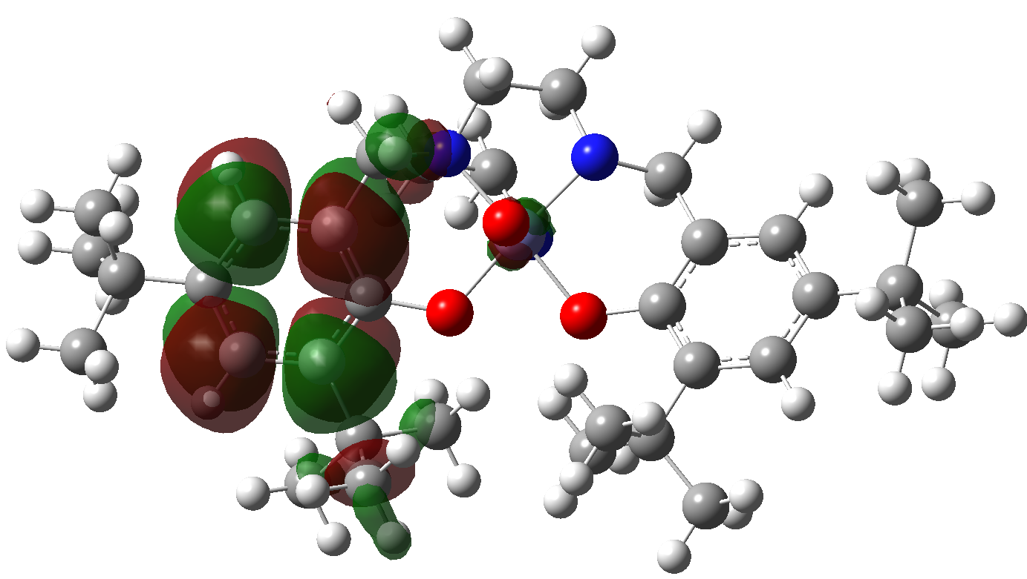  LUMO of structure 3
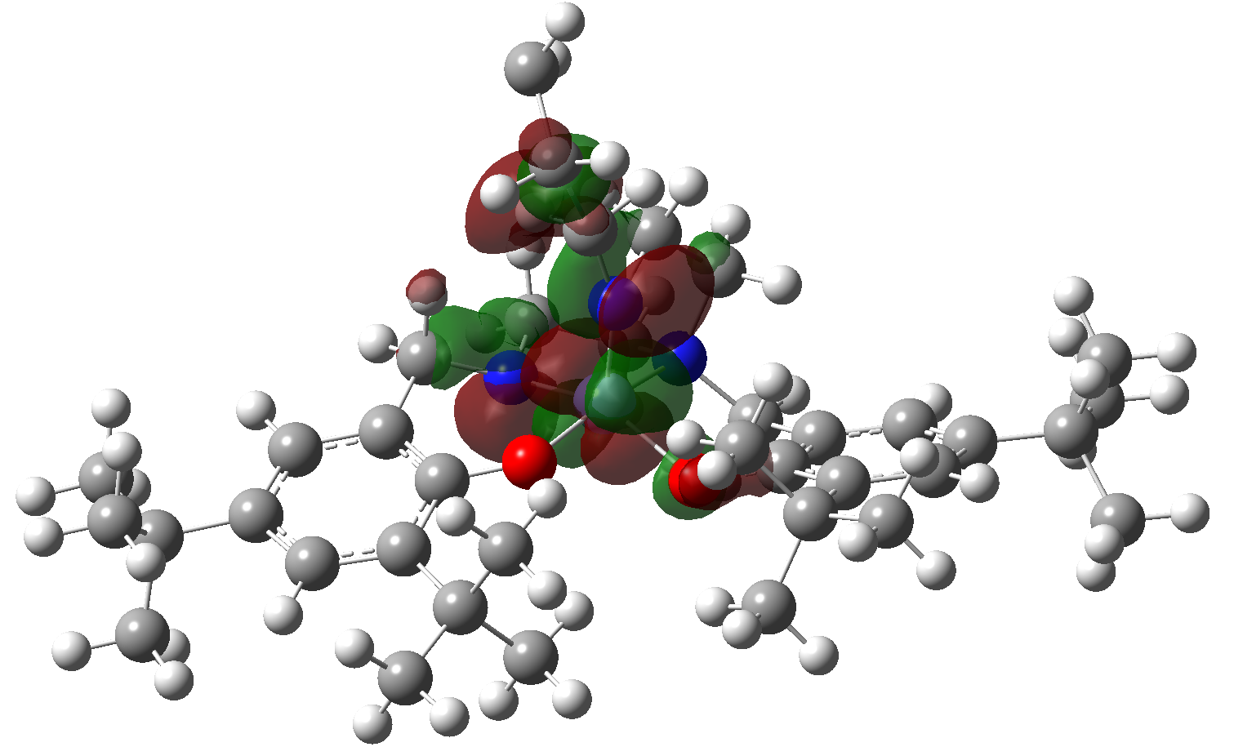HOMO of structure 4 | 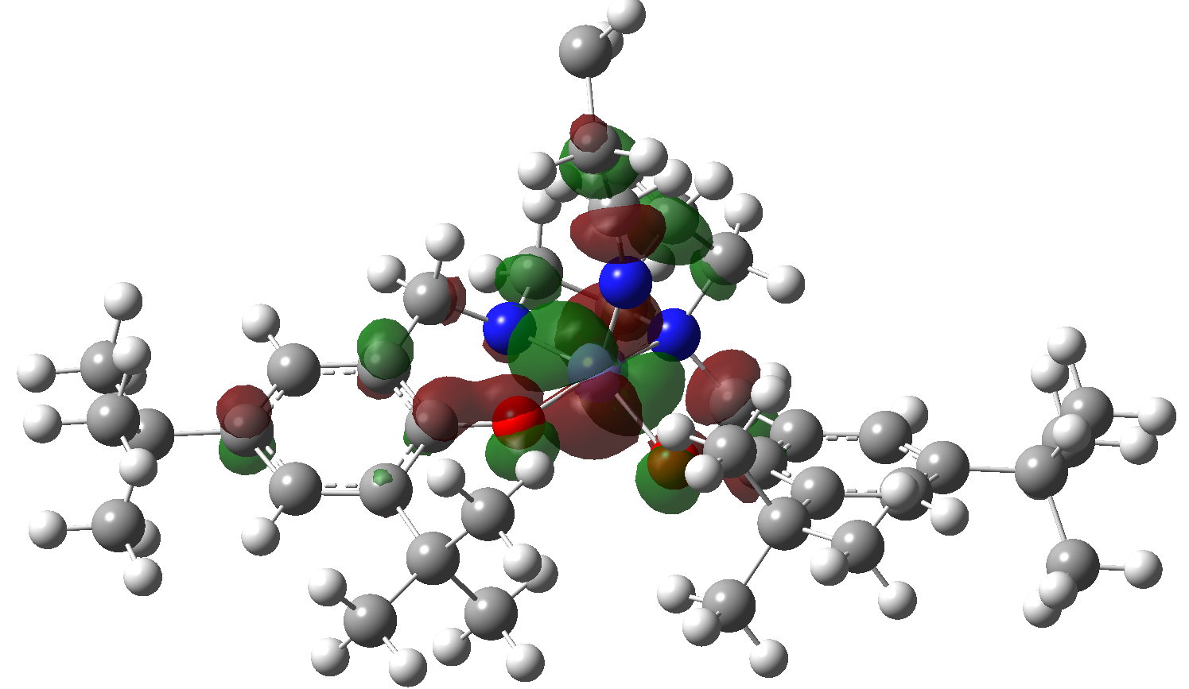  LUMO of structure 4

Figure 10: Schematic representation of the calculated frontier molecular orbitals (FMOs) of the species involved in the proposed catalytic cycle in the presence of TEMPO in solution (water). Circles with light and dark gray, red, blue and medium purple color are H, C, O, N and Fe atoms.

Leaching test and re-usability of catalyst
To ensure whether the catalytic progress was followed heterogeneously or not, the catalyst has been magnetically separated in the middle of reaction time and the conversion monitored. The results have clearly shown that the conversion of alkene to epoxide has been paused without catalyst which established that the catalyst covalently anchored on amine-functionalized nanomagnetic core-shell through the sulfite and TEMPO-mediated catalytic cycles (Figure S5). The insignificant conversion of progress in TEMPO mechanism could refer to the TEMPO radical reactivity.
Moreover, the ICP-OES analysis was performed to measure the leached catalyst and the obtained values were negligible (0.013 mmol g⁻¹ for sulfite and 0.016 mmol g⁻¹ for TEMPO mechanisms).
On the other hand, the catalyst was recovered, washed and after drying, re-used for new catalytic run and the efficiency has been maintained for 7 runs in the presence of both sulfite and TEMPO (Figure S6).
Conclusion
In summary, a novel and efficient catalytic system has been introduced which is able to carry out epoxidation of olefins under oxygen atmosphere and room temperature using an iron-based homogenously heterogenized catalyst assisted in two separate reactions, first by using sodium sulfite as a reducing agent and second by TEMPO co-catalyst. The mechanistic studies by using TEMPO as radical scavenger not only lead to interrupting the radical chain and reaction process, but also accelerated the process, which is accordant with non-radical sulfite-iron redox mechanism. In addition, the results confirmed the TEMPO capability to continue the epoxidation reaction through another pathway. Furthermore, the similar behaviors of the scope of alkenes with sulfite and TEMPO mechanisms, verified the active high-valent [Fe(IV)=O] intermediate as main oxygen-transfer agent to the alkene intermediate in both routes.
It is worthy to mention that, in spite of several publications for aerobic oxidation of alkenes, there are limited reports that address the issue of this process using heterogeneous catalyst in water in the presence of oxygen.
Lastly, the proposed mechanisms were evaluated and confirmed with Density Functional Theory (DFT) computational method. The computational results show that the mechanisms goes through the active species of Fe(IV)=O which transfer oxygen to epoxide. In addition, based on the computational calculations, electron transfer and formation of structure 2 (Fe(II)) in the presence of TEMPO is very favorable due to the increase in electron density in the vicinity of Fe(II) in structure 2. Moreover, structure 4 (Fe(IV)) is unstable in the presence of TEMPO and SO₃²⁻ because of decreasing in electron density.

Experimental
1. Materials and Methods
All reagents and solvents were procured from commercial sources and used without purification. FTIR spectra from KBR pellets were documented by using Shimadzu FT-IR-8300 spectrophotometer. The morphological appearance of nanoparticles was evaluated by using TEM (JEOL, JEM-2100F, 200KV). Scanning electron microscopy (FESEM) analysis was performed with Tescan Mira (II) at an acceleration voltage of 15 kV. The X-ray powder patterns were recorded using a PHILIPS PW1730 (step size: 0.05, time per step: 1s). The magnetic possessions of the catalyst were examined by using VSM by homemade vibrating sample magnetometer apparatus (Meghnatis Daghigh Kavir Company, Iran) at RT from -10000 to +10000 Oe. The electronic states of the powders were accomplished by using XPS (Multilab 2000, Thermo Scientific, Alka Radiation). Additionally, the reactions were followed using gas chromatography (GC, Aligent gas chromatograph model 7890A) with an HP-1 methyl siloxane column (30 m in length ×320 μm ×0.25 μm) attached to a Flame Ionization Detector (FID).

Computational details
All quantum chemical calculations in the solvent phase have been performed at wb97xd/6-311g(d,p) level of theory with the Gaussian 16 suite of programs.⁴⁰ The optimization of all species structures at the solvent phase and calculation of their harmonic vibrational frequencies were carried out at wb97xd/6-311g(d,p) level of theory. Implicit solvent effects of water were considered using the polarizable continuum model (PCM) in the framework of the self-consistent reaction field (SCRF).
KiSThelP package ⁴¹ has been used to perform statistical mechanics calculations from ab initio quantum chemistry data, without the necessity of an analytical potential energy function. Quantities using the canonical and microcanonical ensembles are calculated and thermodynamic properties of molecular species such as enthalpy, entropy and Gibbs free energy are produced through partition function calculations.
The vibrational contribution to entropy was calculated using a quasi-rigid-rotor-harmonic-oscillator (quasi-RRHO) approximation by means of the Grimme method implemented in the GoodVibes program ⁴², which applies a free-rotor model for modes with frequencies smaller than a threshold (i.e. below to 100 cm⁻¹). ⁴³ Subsequently, relative Gibbs free energies were corrected with the quasi-RRHO method and relative Gibbs free energies corrected with the quasi-RRHO method used to obtain the equilibrium constant (K_{eq}) for the title reaction by KiSThelP package.
2. Preparation of Ligand
2.1. Synthesis of Bis(phenol) Diamine Ligand (H₂L^{AE})

The ligand was produced according to the adjusted reported method.⁴⁴ To a round-bottom flask, 2,4-di-tert-butylphenol (11.25 g, 55.00 mmol), 2-(2-aminoethylamino)ethanol (3 mL, 27.00 mmol) and formaldehyde 37% (4.58 mL, 55.00 mmol) was added and stirred under refluxed condition for 48h. The reaction crude was cooled to obtain the large amounts of solid. As a final point, the solvent was decanted, and the residue was washed with cold methanol to achieve a pure white powder (67% yield).

2.2. Bromination of Bis(phenol) Diamine Ligand (H₂L^{AE-Br})
The yielded H₂L^{AE} precursor (1; 2.25 g, 4 mmol) was dissolved in CHCl₃ (4 ml) and cooled in an ice bath to 20 ᴼC. A solution of PBr3 (0.2 g, 2 mmol) in CHCl₃ (4 ml) was introduced dropwise and then, the solution was stirred for 1 h and at 20 °C. To end, the reaction was quenched with the slow and steady addition of water (10 ml). The organic phase was extracted and rinsed three times with water and dried over MgSO₄. After evaporation of solvent, the yielded viscous oil, crystallized at 0°C over a few days and the resulted pale-yellow solid material was dried over air (87% yield). ⁴⁵
3. Preparation of heterogeneous catalyst
3.1. Synthesis of Fe₃O₄@SiO₂
Synthesis of iron oxide nanoparticles proceeded using a reported co-precipitation method.⁴⁶ A solution of 25 ml deionized water, 5.2 g of FeCl₃.6H₂O and 2.8 g of FeSO₄ was prepared and 0.85 mL of HCl 37% was added. The resulting solution was dropped into 250 mL solution of 1.5 mol L⁻¹ NaOH at 80 ᴼC continuously and mechanically stirred under the argon atmosphere. The produced Fe₃O₄ nanoparticles were isolated using an external magnetic field and washed three times using water and ethanol.
With the purpose of protecting the prepared magnetic nanoparticles using silica shell, 0.5 g of Fe₃O₄ nanoparticles were dispersed in a mixture of ethanol (50 mL), water (5 mL), and tetraethoxysilane (TEOS) (0.20 mL). Afterwards, 5 mL NaOH (10 wt %) was added in 15 minutes and the reaction was permitted to carry on under mechanical stirring at R.T. for 30 min. Then, the SiO₂@Fe₃O₄ particles were separated magnetically and rinsed with ethanol and water three times and dried in vacuum oven at 80 °C for 7 h. ⁴⁷
3.2. Synthesis of Fe₃O₄@SiO₂-APTES
Silica-coated Fe₃O₄ nanoparticles (1 g) were diffused in dry toluene (70 mL) and 5 mL 3-Triethoxysilylpropylamine (APTES) was added dropwise. The reaction temperature was slowly increased to 110 ᴼC under argon atmosphere and refluxed for 36 h. The resulted Fe₃O₄@SiO₂-APTES nanoparticles were separated magnetically, washed 3 times with ethanol and acetone and dried at 80 ᴼC for 24 h.
3.3. Immobilization of H₂L^{AE-Br} on Fe₃O₄@SiO₂-APTES
The brominated ligand H₂L^{AE-Br} (1 mmol, 0.602 g) was added to disperse Fe₃O₄@SiO₂-APTES (1 g) in dry THF (15 mL) and the suspension was stirred for 48h at room temperature. The obtained anchored ligand (Fe₃O₄@SiO₂-APTES-H₂L^{AE}) was magnetically separated and washed with THF, diethyl ether and dichloromethane three times to eliminate the unreacted ligand. The modified nanoparticles were dried at 80 ᴼC for 24 h.
3.4. Synthesis of Fe₃O₄@SiO₂-APTES- FeL^{AE}
Triethylamine (2 mmol, 0.2 g) was added to a stirred mixture of Fe₃O₄@SiO₂-APTES-H₂L^{AE} (1 g) and FeCl₃ anhydrous (1 mmol, 0.162 g) in ethanol (80 mL), and the reaction mixture was stirred for 3 days at room temperature. The product was separated using external magnet and washed with ethanol and acetone several times. The synthesized Fe₃O₄@SiO₂-APTES-FeL^{AE} was dried at 80 ᴼC overnight and the Fe-doped amount was analyzed using ICP-OES.
4. General procedure for catalytic epoxidation of alkenes in the presence of Na₂SO₃ and TEMPO
Catalyst (0.004 g), alkene (1 mmol) and oxygen saturated water (0.6 mL) were added to a 5 mL round-bottom flask. The oxidation reaction was followed by addition of specific equivalents of Na₂SO₃ or TEMPO and the mixture was stirred at room temperature under filled-oxygen balloon. At the finishing point, the catalyst was separated using an external field the reaction solution was washed with 1.5 mL water to remove the sulfite salt and some TEMPO, and the organic phase was analyzed using GC. The reported conversions and selectivities are the average of 3 runs.

References
1. a) D. Munz, D. Wang, M.M. Moyer, M.S. Webster-Gardiner, P. Kunal, D. Watts, B.G. Trewyn, A.N. Vedernikov, and T.B .Gunnoe, Aerobic epoxidation of olefin by platinum catalysts supported on mesoporous silica nanoparticles, ACS Catalysis, 2016, 6, 4584-4593. b) T. V. Andrushkevich, and E. V. Ovchinnikova, The role of water in selective heterogeneous catalytic oxidation of hydrocarbons, Molecular Catalysis, 2020, 484, 110734. c) J. R. Webb, T. Bolaño, T. B. Gunnoe, Catalytic oxy‐functionalization of methane and other hydrocarbons: fundamental advancements and new strategies, ChemSusChem, 2011, 4, 37−49.
2. S. Tanase, E. Bouwman, Selective conversion of hydrocarbons with H₂O₂ using biomimetic non-heme iron and manganese oxidation catalysts. Adv. Inorg. Chem., 2006, 58, 29-75.
3. AC05726672 A, editor. Ullmann's encyclopedia of industrial chemistry. Wiley-VCH, 2000.
4. E. M. Pliss, M. Aleksey Grobov, K. Anton Kuzaev, and A. L. Buchachenko, Magnetic field effect on the oxidation of organic substances by molecular oxygen, Journal of Physical Organic Chemistry, 2019, 32, e3915.
5. C. Parmeggiani, C. Matassini and F. Cardona, A step forward towards sustainable aerobic alcohol oxidation: new and revised catalysts based on transition metals on solid supports, Green Chem, 2017, 19, 2030-2050.
6. a) D. Munz, T. Strassner, Propane activation by palladium complexes with chelating bis (NHC) ligands and aerobic cooxidation, Angew.Chem., Int. Ed. 2014, 53, 2485−2488. b) L. Qian, and G. Zheng, Recent advances of metal nanoclusters for aerobic oxidation, Materials Today Nano., 2020, 11 100080. c) W. Chen, J. A. Kocal, T. A. Brandvold, M. L. Bricker, S. R. Bare, R. W. Broach, N. Greenlay, K. Popp, J. T. Walenga, S. S. Yang, J. Low, Manganese oxide catalyzed methane partial oxidation in trifluoroacetic acid: Catalysis and kinetic analysis, Catalysis Today, 2009, 140, 157−161.
7. Z. Chen, X. Li, S. Zhang, J. Jin, X. Song, X. Wang, and P. G. Tratnyek, Overlooked role of peroxides as free radical precursors in advanced oxidation processes, Environmental science & technology, 2019, 53, 2054-2062.
8. a) A.M. Wright, D.R. Pahls, J.B. Gary, T. Warner, J. Z. Williams, S. M. M. Knapp, K. E. Allen, C. R. Landis, T.R. Cundari, and K. I. Goldberg, Experimental and Computational Investigation of the Aerobic Oxidation of a Late Transition Metal-Hydride, J. Am. Chem. Soc., 2019, 141, 10830-10843. b) L. Boisvert, K. I. Goldberg, Reactions of late transition metal complexes with molecular oxygen, Acc. Chem. Res., 2012, 45, 899−910. c) D. Munz, T. Strassner, Alkane C–H functionalization and oxidation with molecular oxygen, Inorg. Chem., 2015, 54, 5043−5052.
9. a) V. C.-C. Wang, S. Maji, P. P.-Y. Chen, H. K. Lee, S. S.-F. Yu and S. I. Chan, Alkane oxidation: methane monooxygenases, related enzymes, and their biomimetics, Chem. Rev., 2017, 117, 8574-8621. b) A. D. Ryabov, Green challenges of catalysis via iron (IV) oxo and iron (V) oxo species. Adv. Inorg. Chem., 2013, 65, 117-163.
10. a) M. Costas, M. P. Mehn, M. P. Jensen,L. Que, Jr., Dioxygen activation at mononuclear nonheme iron active sites: enzymes, models, and intermediates. Chem. Rev. 2004, 104, 939-986. b) H. Ito, H. Kurokawa, and H. Matsui, Mitochondrial reactive oxygen species and heme, non-heme iron metabolism. Archives of Biochemistry and Biophysics, 2020, 108695.
11. a) C. Krebs, D. Galonic Fujimori, C. T. Walsh, J. M. Jr. Bollinger, Non-heme Fe(IV)-oxo intermediates. Acc Chem Res, 2007, 40, 484-492. b) E.G. Hrycay, and S.M. Bandiera, Monooxygenase, peroxidase and peroxygenase properties and reaction mechanisms of cytochrome P450 enzymes. Adv Exp Med Biol, 2015, 851, 1-61.
12. a) L. Chen, X. Peng, J. Liu, J. Li, F. Wu, Decolorization of orange II in aqueous solution by an Fe(II)/sulfite system: replacement of persulfate, Ind. Eng. Chem. Res., 2012, 51, 13632–13638. b) J. Xu, W. Ding, F. Wu, G. Mailhot, D. Zhou, K. Hanna, Rapid catalytic oxidation of arsenite to arsenate in an iron(III)/sulfite system under visible light, App. Catal. B-Environ. 2016, 186, 56–61.
13. a) J. E. Nutting, K. Mao, and S. S. Stahl, Iron (III) Nitrate/TEMPO-Catalyzed Aerobic Alcohol Oxidation: Distinguishing between Serial versus Integrated Redox Cooperativity. J. Am. Chem. Soc., 2021, 143, 10565-10570. b) G. Szczepaniak, J. Piątkowski, W. Nogaś, F. Lorandi, S. S. Yerneni, Marco. Fantin, A. Ruszczyńska, A. E. Enciso, E. Bulska, K. Grela and K. Matyjaszewski, An isocyanide ligand for the rapid quenching and efficient removal of copper residues after Cu/TEMPO-catalyzed aerobic alcohol oxidation and atom transfer radical polymerization. Chemical Science, 2020, 11, 4251-4262.
14. a) R. Peng, A. Offenhäusser, Y. Ermolenko, and Y. Mourzina, Biomimetic sensor based on Mn (III) meso-tetra (N-methyl-4-pyridyl) porphyrin for non-enzymatic electrocatalytic determination of hydrogen peroxide and as an electrochemical transducer in oxidase biosensor for analysis of biological media. Sensors and Actuators B: Chemical, 2020, 321, 128437. b) H. Ohi, Y. Tachi, S. Itoh, Supramolecular and Coordination Polymer Complexes Supported by a Tripodal Tripyridine Ligand Containing a 1,3,5-Triethylbenzene Spacer, Inorg Chem, 2004, 43, 4561-4563.
15. L. Santagostini, M. Gullotti, R. Pagliarin, E. Bianchi, L. Casella, E. Monzani, Functional Mimics of Copper Enzymes. Synthesis and Stereochemical Properties of the Copper (II) Complexes of a Trinucleating Ligand Derived from L-Histidine, Tetrahedron: Asymmetry, 1999, 10, 281−295.
16. a) K. Cho, P. Leeladee, A. J. McGown, S. DeBeer, D. P. Goldberg, A high-valent iron-oxo corrolazine activates C–H bonds via hydrogen-atom transfer, J. Am. Chem. Soc., 2012, 134, 7392-7399. b) K. A. Prokop, H. Neu, S. P. de Visser, D. P. Goldberg, A Manganese (V)-Oxo π-Cation Radical Complex: Influence of One-Electron Oxidation on Oxygen-Atom Transfer, J. Am. Chem. Soc., 2011, 133, 15874-15877. c) J. A. A. W. Elemans and R. J. M. Nolte, Porphyrin cage compounds based on glycoluril–from enzyme mimics to functional molecular machines. Chemical Communications 2019, 55, 9590-9605.
17. a) G. Zhan, W. Zhong, Z. Wei, Z. Liu, X. Liu, Roles of phenol groups and auxiliary ligand of copper (II) complexes with tetradentate ligands in the aerobic oxidation of benzyl alcohol, Dalton Transactions, 2017, 46, 8286-8297. b) S. Indira, G. Vinoth, M. Bharathi, S. Bharathi, A. Kalilur Rahiman, and K. Shanmuga Bharathi, Catechol oxidase and phenoxazinone synthase mimicking activities of mononuclear Fe (III) and Co (III) complexes of amino-bis (phenolate)-based mixed ligands: Synthesis, spectral and electrochemical studies. Inorganica Chimica Acta., 2019, 495, 118988.
18. a) E. C Monkcom, P. Ghosh, E. Folkertsma, H. A. Negenman, M. Lutz, and R. J. M. Klein Gebbink, Bioinspired Non-Heme Iron Complexes: The Evolution of Facial N, N, O Ligand Design. CHIMIA International Journal for Chemistry, 2020, 74, 450-466. b) L. Hajikhanmirzaei, E. Safaei, A. Wojtczak, Z. Jagličić, New mixed-ligand salicylaldehyde complexes of Mn(III) bis (phenol) di-amine: Synthesis, electronic and magnetic properties. Inorganica Chimica Acta, 2015, 430, 125-131.
19. a) B. Meunier, Metalloporphyrins as versatile catalysts for oxidation reactions and oxidative DNA cleavage, Chem. Rev., 1992, 92, 1411. b) B. M. Choudary, M. L. Kantam, B. Bharathi, C. R. V. Reddy, Mn(III) salen complex: an efficient reusable acylation catalyst, J. Mol. Catal. A: Chem, 2001, 168, 69-73. c) J. Balsells, P. J. Carroll, P. J. Walsh, Achiral tetrahydrosalen ligands for the synthesis of C2-symmetric titanium complexes: a structure and diastereoselectivity study, Inorg. Chem., 2001, 40, 5568-5574. d) L. Cavallo, H. Jacobsen, Electronic effects in (salen) Mn-based epoxidation catalysts, J. Org. Chem. 2003, 68, 6202.
20. a) I. Saberikia, E. Safaei, B. Karimi, Y. I. Lee, Oxygenation of sulfides catalysed by SBA‐15‐immobilized molybdenum(VI) complex of a bis (phenol) diamine ligand using aqueous hydrogen peroxide as a green oxidant. Applied Organometallic Chemistry, 2018, 32, e4304. b) M. T. P. da Silva, J. Villarroel-Rocha, C. F. Toncón-Leal, F. Fernandes Barbosa, M. Oliveira Miranda, M. A. Morales Torres, K. Sapag, S. BC Pergher, and T. Pinheiro Braga, Textural and photocatalytic characteristics of iron-cobalt based nanocomposites supported on SBA-15: Synergistic effect between Fe²⁺ and Fe⁰ on photoactivity. Microporous and Mesoporous Materials, 2021, 310, 110582.
21. a) T. Karimpour, E. Safaei, B. Karimi, Y. I. Lee, Iron (III) Amine Bis (phenolate) Complex Immobilized on Silica‐Coated Magnetic Nanoparticles: A Highly Efficient Catalyst for the Oxidation of Alcohols and Sulfides. ChemCatChem, 2018, 10, 1889-1899. (Highlighted, Yasuhiro Uozumi, Anggi Eka Putra, Synfacts 01082019, 15(08), 0918). b) T. Karimpour, E. Safaei, B. Karimi, A supported manganese complex with amine-bis (phenol) ligand for catalytic benzylic C (sp 3)–H bond oxidation. RSC advances, 2019, 9,14343-14351. c) M. Ghobadi, M. Kargar Razi, R. Javahershenas, and M. Kazemi, Nanomagnetic reusable catalysts in organic synthesis, Synthetic Communications, 2021, 51, 647-669.
22. a) Q. Zhang, X. Yang, J. Guan, Applications of Magnetic Nanomaterials in Heterogeneous Catalysis, ACS Applied Nano Materials, 2019, 2, 4681-4697. b) P. Mohammadpour, E. Safaei, Catalytic C–H aerobic and oxidant-induced oxidation of alkylbenzenes (including toluene derivatives) over VO²⁺ immobilized on core–shell Fe₃O₄@SiO₂ at room temperature in water. RSC Advances, 2020, 10, 23543-23553. (This manuscript selected as highlighted paper in the field of Polymer-Supported Synthesis: SYNFACTS Contributors: Yasuhiro Uozumi, Shota Mizuno SYNFACTS 01092020, 16(09), 1088 Published online: 18.08.20201861-19581861-194X DOI: 10.1055/s-0040-1706755; Reg-No.: Y07820SF Georg T).
23. Y. Liu, W. Zhang, X. Li, X. Le, J. Ma, Catalysis of the hydro-dechlorination of 4-chlorophenol and the reduction of 4-nitrophenol by Pd/Fe₃O₄@ SiO₂@ m-SiO₂, New J. Chem., 2015, 39, 6474–6481.
24. A. P. Grosvenor, B. A. Kobe, M.C. Biesinger, N. S. McIntyre, Investigation of multiplet splitting of Fe 2p XPS spectra and bonding in iron compounds. Surface and Interface Analysis: An International Journal devoted to the development and application of techniques for the analysis of surfaces, interfaces and thin films, 2004, 36, 1564-1574.
25. L. Chen, X. Peng, J. Liu, J. Li, F. Wu, Decolorization of orange II in aqueous solution by an Fe(II)/sulfite system: replacement of persulfate, Ind. Eng. Chem. Res. 2012, 51, 13632–13638.
26. R. O. C. Norman and P. M. Storey, Electron spin resonance studies. Part XXXI. The generation, and some reactions, of the radicals SO₃–·, S₂O₃–·, S–·, and SH in aqueous solution, J. Chem. Soc. B, 1971, 1009-1013.
27. a) T. Ozawa, M. Setaka, T. Kwan, ESR studies of the sulfite radical anion, Bull. Chem. Soc. Jpn., 1971, 44, 3473–3474; b) T. Ozawa, M. Setaka, H. Yamamoto and T. Kwan, On the Reaction of the Sulfite Radical Anions with Thioureas, Chem. Pharm. Bull., 1974, 22, 962–964. c) T. Ozawa, T. Kwan, Esr evidence for the formation of new vinyl radicals in solution, J. Chem. Soc., Chem. Commun., 1983, 2, 80–81.
28. P. A. Siskos, N. C. Peterson, R. E. Huie, Kinetics of the manganese (III)-sulfur (IV) reaction in aqueous perchloric acid solutions, Inorg. Chem., 1984, 23, 1134–1137.
29. a) R. S. Murray, Reinvestigation of the reaction between hexacyanoferrate(III) and sulphite ions, J. Chem. Soc., Dalton Trans., 1974, 2381–2383. b) D. W. Carlyle, Electron transfer between sulfur (IV) and tris (1, 10-phenanthroline) iron (III) ion in aqueous solution, J. Am. Chem. Soc., 1972, 94, 4525–4529.
30. R. E. Huie, P. Neta, Oxidation of ascorbate and a tocopherol analogue by the sulfite-derived radicals O₃⁻ and O₃⁻, Chem. Biol. Interact., 1985, 53, 233–238.
31. H. Hussain, I. R. Green and I. Ahmed, Journey describing applications of oxone in synthetic chemistry, Chem. Rev., 2013, 113, 3329–3371.
32. a) Y. Song, C.-H. Yang, R. Kluger, Monooxygenase-like activity of methemoglobin with sodium sulfite as an efficient reductant, J. Am. Chem. Soc., 1993, 115, 4365–4366. b) K. Wietzerbin, J. G. Muller, R. A. Jameton, G. Pratviel, J. Bernadou, B. Meunier, C. J. Burrows, Hydroxylation, Epoxidation, and DNA Cleavage Reactions Mediated by the Biomimetic Mn-TMPyP/O₂/Sulfite Oxidation System, Inorg. Chem., 1999, 38, 4123–4127. c) A. Rubinstein, R. Carmelib, R. Neumann, Formation of persulphate from sodium sulphite and molecular oxygen catalysed by H₅PV₂Mo₁₀O₄₀–aerobic epoxidation and hydrolysis, Chem. Commun., 2014, 50, 13247-13249.
33. A. L. Balch, Y.-W. Chan, R.-J. Cheng, G. N. La Mar, L. Latos-Grazynski, M. W. Renner, Oxygenation patterns for iron(II) porphyrins. Peroxo and ferryl (Fe^{IV}O) intermediates detected by proton nuclear magnetic resonance spectroscopy during the oxygenation of (tetramesitylporphyrin) iron (II), J. Am. Chem. Soc., 1984, 106, 7779-7785.
34. P.M. Wood, The potential diagram for oxygen at pH7, Biochemical Journal, 1988, 253, 287-289.
35. a) I. Fridovich, P. Handler, Detection of free radicals in illuminated dye solutions by the initiation of sulfite oxidation, J. Biol. Chem., 1960, 235, 1835-1838. b) E. Hayon, A. Treinin, J. Waf, J. Am. Chem. Soc., 1972, 94, 47-57.
36. T. E. Eriksen, pH Effects on the pulse radiolysis of deoxygenated aqueous solutions of sulphur dioxide, J. Chem. Soc. Faraday Trans, 1974, 70, 208-215.
37. a) G. Katona, P. Carpentier, V. Nivière, P. Amara, V. Adam, J. Ohana, N. Tsanov, D. Bourgeois, Raman-assisted crystallography reveals end-on peroxide intermediates in a nonheme iron enzyme, Science, 2007, 316, 449-453. b) E. G. Kovaleva, J. D. Lipscomb, Crystal structures of Fe²⁺ dioxygenase superoxo, alkylperoxo, and bound product intermediates, Science, 2007, 316, 453-457.
38. a) M. Costas, M. P. Mehn, M. P. Jensen, L. Que, Dioxygen activation at mononuclear nonheme iron active sites: enzymes, models, and intermediates, L. Chem. Rev., 2004, 104, 939-986. (b) L. Que, The road to non-heme oxoferryls and beyond, Acc. Chem. Res., 2007, 40, 493.
39. J. M. Smith, D. E. Mayberry, C. G. Margarit, J. Sutter, H. Wang, K. Meyer, R. P. Bontchev, N-O Bond Homolysis of an Iron(II) TEMPO Complex Yields an Iron(III) Oxo Intermediate, J. Am. Chem. Soc., 2012, 134, 6516−6519.
40. Gaussian 16, Revision B.01, M. J. Frisch, et al. Gaussian, Inc., Wallington CT, 2016.
41. S. Canneaux, F. Bohr, E. Henon, A program to predict thermodynamic properties and rate constants from quantum chemistry results, KiSThelP: J. Comput. Chem. 2013, 35, 82-93.
42. S. Grimme, Supramolecular binding thermodynamics by dispersion‐corrected density functional theory. Chem. Eur. J., 2012, 18, 9955-9964.
43. GoodVibes v2.0.1, I. Funes-Adois and R. Paton, 2017, https://github.com/bobbypaton/GoodVibes.
44. E. Safaei, A. Wojtczak, E. Bill, H. Hamidi, Synthesis, crystal structure, magnetic and redox properties of Cu(II)–Cu(II) binuclear complexes of bis (phenol) amine ligands, Polyhedron, 2010, 29, 2769-2775.
45. A. Sokolowski, J. Müller, T. Weyhermüller, R. Schnepf, P. Hildebrandt, K. Hildenbrand, E. Bothe, K. Wieghardt, Phenoxyl radical complexes of zinc(II), J. Am. Chem. Soc., 1997, 119, 8889-8900.
46. X. Zheng, L. He, Y. Duan, X. Jiang, G. Xiang, W. Zhao, S. Zhang, Poly (ionic liquid) immobilized magnetic nanoparticles as new adsorbent for extraction and enrichment of organophosphorus pesticides from tea drinks. J Chromatogr A. 2014, 1358, 39-45.
47. J. Javidi, M. Esmaeilpour, M. Rajabnia Khansari, Synthesis, characterization and application of core-shell magnetic molecularly imprinted polymers for selective recognition of clozapine from human serum, RSC Adv, 2015, 5, 73268-73278.

Graphical Abstract

