On Revolutionary Waves and the Dynamics of Landslides
Sebastian Ille

Abstract: This paper argues that revolutionary waves, such as the Black Lives Matter and the metoo movements, or the Arab Spring share similar dynamics to sand sliding down the edges of a pile. On this basis, the paper develops a theoretical model in which contention arises endogenously through discontent and social imitation as the social system self-organises into a state of criticality over time. Revolts and collective actions are thus understood as subsequent reorganising cascades after the system reached such a critical state. Although, taken by themselves, the properties and timings of these cascades are entirely chaotic, at the aggregate level, the cascades’ properties follow regularities that are impervious to the individual characteristics of individuals but are affected by the structure of social networks.

Introduction
In late May 2020, African American George Floyd was killed during an arrest. The incident caused major outrage not only in the US but worldwide. Within less than three weeks, the killing of Floyd provoked over 450 protests in the US (Wu et al., 2020). Meanwhile. the Black Lives Matter movement (BLM) has spread across the world leading to demonstration in Europe, Japan, and New Zealand. Yet, the killing of Floyd has not been the first of its kind. BLM began as a Twitter hashtag in 2013 and was used during street demonstrations in Ferguson, Missouri, and New York. Until 2020, BLM has initiated numerous demonstrations. During the first half of July 2016, the movement organised protests in at least 88 cities across the US (Lee et al., 2016), while the movement had been less active in 2018 and 2019.
In its wake, BLM has encouraged people to question, criticise and repudiate established practices related to racism, slavery, and discrimination. Starting in the American National Football League, players across various US sports leagues have publicly expressed their support for people of colour by defying the tradition of standing during the national anthem (which came to be known as the National Anthem protests). An increasing number of lecturers have spoken out in favour of a decolonisation of curricula in higher education, deepened awareness of institutional racism and thus emphasised the need for a balanced ethnic composition of students and faculty. After the protests in 2020, part of 16th Street NW in Washington was renamed to Black Lives Matter Plaza. Activists are calling for defunding the police, and statues of proponents of racism, colonialism and slavery are taken down in the US and UK. The movement has brought the prevalence of institutionalised racism to attention and initiated a shift in people’s mind-set. Similarly, and despite operating in a different context, the Arab Spring after 2010 and the metoo movement after it gained momentum 2017 have followed similar dynamics and have set in motion a process of cultural transformation.
These are examples of dynamics that have been described as revolutionary waves or cycles (Beck, 2011, 2014; Katz, 1999; Tarrow, 1993, 1998; Tilly, 1993). Beck defines revolutionary waves as “profoundly cultural events, as they involve alternative ideals of political order” (Beck, 2001, p. 168). Tarrow (1993) identifies several characteristics of protest cycles. Collective actions are correlated with social tensions and an increased rate of violence. Cycles of protest start in one sector and diffuse into adjacent sectors. They are also initiated by unpredictable events and new cycles partially occur among established movement organisations that have been active in older cycles.
Contrary to the existing literature on revolutionary waves that mainly focuses on the changing repertoire of revolutionaries (Tarrow, 1993, 1998) or the underlying ideological motivations (such as the changing and expanding world culture, see Beck, 2011), this paper provides a framework to better understand the particular dynamics of revolutionary waves. Movements, like BLM and metoo, show patterns of protests and demonstrations that are not monotonic, i.e. the size of protests does not constantly increase over time but the movements are characterised by trigger events that cause uprisings of various magnitude. Over time, the magnitude of protests of a revolutionary wave follows a rather chaotic sequence.
Given their chaotic nature, the dynamics of revolutionary waves are modelled here using an agent-based model (ABM). Such computational simulations recreate autonomous agents that do not only choose actions from an individual repertoire but base these actions on an evolving environment and the actions chosen by other agents. Consequently, ABM simulates the strategic interaction of members within a large population to study the aggregate dynamics at a system’s level. ABM have been used by social scientists to better understand questions related to coordination, organisation, and cooperation (for examples, see Axelrod, 1997; Bonabeau, 2002; Ille, 2017; Tesfatsion, 2006).
The simplest versions of ABM are cellular automata. In the most basic version, agents are represented as fixed individual cells of a regular grid. Agents switch between a finite number of states based on the states of their adjacent neighbours. Conway's Game of Life (Gardner, 1970), a simple model of population dynamics, is probably the best-known example of a cellular automaton. Schelling (1971, 1978) used these simple models to show that ethnic segregation is an emergent property and even occurs if individuals illustrate a preference for a mixed neighbourhood. This paper builds on the cellular automata of Bak et al. (1987, 1988) and Bak (1996) which replicate the dynamics of sand piles and study the evolution of self-organized criticality.
Given the simplicity in design of the underlying approach, the aim here is not to develop a realistic model of revolutionary waves, but a simplified representation of the underlying social dynamics. Therefore, I do not argue that such an abstract model can be even remotely considered a realistic portrayal of a social system, let alone of individual decision-making. However, I show that the model’s results are robust to further sophistication and I, thus, argue that a more realistic model will add little to our comprehensive understanding of the driving forces. Thus, albeit being overly simplified, the model presented in this paper provides us with a tractable description of the fundamental dynamics that govern revolutionary actions and waves.
In this model, agents, if viewed individually, do not illustrate any genuine level of sophistication. Their actions and understanding of their environment are strictly limited. Yet, individual actions lead to complex behaviour at the collective level that is consistent with the empirical data. As is frequently the case in complex evolving systems, the simple behavioural rules that drive the system, generate complex global dynamics which are caused by the number of interacting parts. It is important to note that in this system, occurrences of larger social contention are not directly built into the individual decision-making, but the sudden and unexpected propagation of violent reactions is an emergent property of the system.
The model
A simple model of a cellular automaton from mechanical physics (Bak et al., 1987) will serve as a starting point for the model. Probably most of us spent some time during their childhood building simple sand sculptures on the beach. If you lacked the adequate motor skills like me, the sandcastle probably never looked as you planned in your mind requiring contenting yourself with a simple sand pile or drip castle. As you trickle small amounts of sand onto the same area of the beach, the pile grows but at a certain height, small amounts of sand slide a few centimetres down the pile’s edges. As you keep on adding more and more sand, the pile eventually reaches a critical height. At this moment, the sand slides turn into cascades that travel down the entire length of the pile’s edge. The amount that slides down is eventually more than what you initially added, and the pile does not longer increase in height, but on the contrary, becomes smaller. These large cascades after the system made of sand grains has become critical, are analogous to the events we have witnessed after the self-immolation of Mohamed Bouazizi, the killing of George Floyd, the arrest of Rosa Parks or the tweets by Alyssa Milano in 2017.
As explained before, a cellular automaton is a system in which cells interact with neighbouring cells based on simple decision rules. Instead of a sophisticated representation of sand, the sandpile model thus assumes that the surface to which sand is added is a plain surface subdivided into square cells of equal size forming a regular grid corresponding to a chessboard-like structure. In each period, we add a grain of sand to one of the cells (this can be a randomly chosen, new cell or always the same cell). We might then think of sand grains as small cubic toy blocks that are neatly stacked on top of each other. Figure 1 illustrates the theoretical setup.

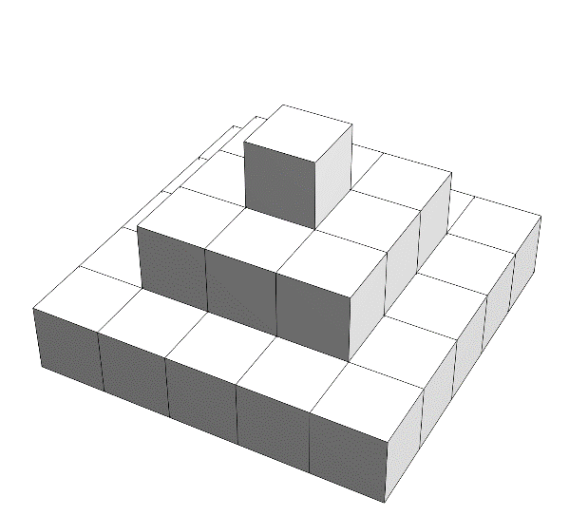
Figure 1: Abstract representation of a pile of sand.

Each cell is characterised by the number of cubes that are stacked on the cell, i.e. its height. The state of our system is then defined by the distribution of heights on the plain. The dynamics of the sandpile model, i.e. the transition from one state to the next, are determined by a set of simple rules:
- In each period, the height of a single cell is increased by one. This represents the event of a single grain of sand dropping on the plain.
- If a cell reaches a height beyond its critical height, sand topples from it to its neighbours or off the boundaries of the plain. This can be any amount of sand / cubes but for the moment, let us assume that this amount equals the number of neighbours.
- The height of each neighbour is increased by the number of toppled sand divided by the number of the neighbours. Given our previous assumptions, the increment is equal to one unit.
- If one of the neighbours reaches a critical height, step 3) and 4) are repeated for this cell.
To get a better grasp of these dynamics, we assume, for the moment, that cells are positioned in a row and sand can only fall to the right. The state of such a one-dimensional system as given by a string of heights. For the system represented in Figure 2, the state is given by 12321.
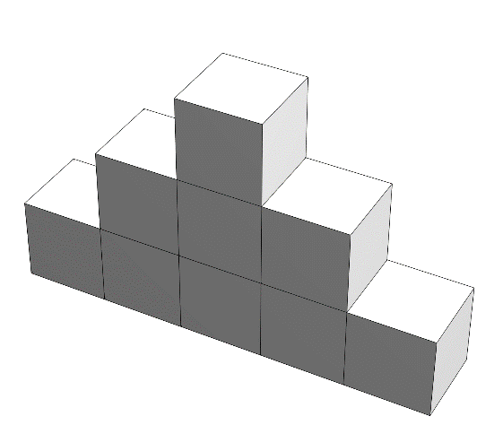
Figure 2: one and two-dimensional representation of a pile of sand.

This vastly simplified one-dimension version of the model will help us understand the reasons for the system’s complex behaviour. The higher-dimensional version of the model does not only illustrate a domino effect in which one element knocks on to the next, but it does so in a complex manner. This simplest, one-dimensional version of the model, on the other hand, illustrates a domino effect but no complex behaviour. To see this, assume that all cells reached a critical height of 4 and let the system be defined by four cells. If we illustrate the state of the system by the current height of the 4 cells, we have the following dynamics after a unit of sand drops on the leftmost cell in period 1:
Period 0: | 4444
Period 1: | 5444
Period 2: | 4544
Period 3: | 4445
Period 4: | 4444

This is obviously nothing spectacular, but a two-dimensional system reveals already a more sophisticated behaviour. Assume that the system is now defined by 7 cells and that the central cell has three neighbours to its right and three neighbours to its left. Once a cell reaches critical height, one unit of sand falls off to the left and another to the right, the critical cell hence loses two grains of sand. The dynamics are then
Period 0: | 4444444
Period 1: | 4445444
Period 2: | 4453544
Period 3: | 4535354
Period 4: | 5353535
Period 5: | 3535353
Period 6: | 4353534
Period 7: | 4435344
Period 8: | 4444444

We observe that the leap to two dimensions creates a lot of back and forth movement. At three dimensions, this cross-fertilisation generates complex patterns since cells do not only affect their left and right neighbour but also their upper and lower neighbour. To render the representation of each state of a three-dimensional system more accessible, we can represent each state as a matrix. Each element of the matrix represents a cell and the number the respective height. Figure 1 can then be represented by
$$\left(\begin{matrix}1 & 1 & 1 & 1 & 1 \\ 1 & 2 & 2 & 2 & 1 \\ 1 & 2 & 3 & 2 & 1 \\ 1 & 2 & 2 & 2 & 1 \\ 1 & 1 & 1 & 1 & 1\end{matrix}\right)$$

Figure 3 shows the evolution of a 3x3 cell system, starting with a random distribution in which some of the cells have reached a critical height. Note that for simplicity, we assume that an individual interacts only with her neighbours along the horizontal and vertical axis, i.e. her von Neumann neighbourhood (or 4-neighbourhood). For illustrative simplicity, the plain is only subdivided into 9 cells and sand falls off the edges of the plain. We observe that the system reaches a critical state in period 1, but then reorganises itself into a stable structure and reaches a stable distribution in period 5.
$$\begin{matrix}\left(\begin{matrix}4 & 3 & 3 \\ 3 & 4 & 4 \\ 3 & 3 & 4\end{matrix}\right) \\ Period 0\end{matrix}⇒\begin{matrix}\left(\begin{matrix}4 & 3 & 3 \\ 3 & 5 & 4 \\ 3 & 3 & 4\end{matrix}\right) \\ Period 1\end{matrix}⇒\begin{matrix}\left(\begin{matrix}4 & 4 & 3 \\ 4 & 1 & 5 \\ 3 & 4 & 4\end{matrix}\right) \\ Period 2\end{matrix}⇒\begin{matrix}\left(\begin{matrix}4 & 4 & 4 \\ 4 & 2 & 1 \\ 3 & 4 & 5\end{matrix}\right) \\ Period 3\end{matrix}⇒\begin{matrix}\left(\begin{matrix}4 & 4 & 4 \\ 4 & 2 & 2 \\ 3 & 5 & 1\end{matrix}\right) \\ Period 4\end{matrix}⇒\begin{matrix}\left(\begin{matrix}4 & 4 & 4 \\ 4 & 3 & 2 \\ 4 & 1 & 2\end{matrix}\right) \\ Period 5\end{matrix}$$
Figure 3: Sequence of self-organised criticality of a three-dimensional pile of sand.

In an abstract manner, this simple model echoes the central dynamics of the social transformation we observe in times of revolutionary waves. The grains of sand represent specific events, such as racial discrimination, violent actions against minorities, or individual grievances due to economic, social, or demographic pressure. Cells represent individual members of society. Once such members reach a critical level, they protest and revolt against established practices. Yet, in its current version, the model lacks three essential elements. First, the interaction structure which defines the same number of neighbours for each interior cell is not even remotely representative of what we find in the real world. Social networks are not regular but follow particular patterns. We will study this network topology in more detail later, but in simple terms, the vast majority of network members are only connected to a very small number of other members while very few members form a substantial number of connections. This characteristic is mainly due to the Matthew effect (i.e. the rich are becoming richer, in other words, we tend to connect ourselves more with people that are connectors) and implies that social networks form numerous small closely knit communities that are interlinked by highly connected hubs. In some other types of randomly formed social networks, few members are either weakly or highly connected and most members are connected to an average number of other members (i.e. the connections follow a normal distribution). Secondly, not all members of society have the same critical threshold level, some react more strongly to events than others. Similarly, not all events have the same social impact. The killing of George Floyd is more impactful than other occurrences of racial assault.
I have demonstrated elsewhere (Ille, forthcoming) that heterogeneous critical levels (and thus, also events of random size) do not influence results. Similarly, positioning cells in more realistic networks is, overall, only of marginal significance in smaller networks and has negligible impact in larger networks. The cascades still follow the pattern we have discussed before. The critical behaviour in a sandpile model is largely independent of the chosen parameter values (such as the critical height, the initial height distribution, the amount of sand that falls per period onto the plain, and the network topology and degree of connectivity between agents). System-wide critical behaviour is therefore a persistent emergent property of the sandpile model. This behaviour does not require an exogenous intervention in the form of an external parameter change like other models of criticality (for an example of the latter, refer again to Ille, forthcoming). Yet, the system in the sandpile model is not closed, but needs to be exogenously and continuously stressed. A new grain of sand drops randomly on an individual or on a pre-defined agent in each period. Our application to a social system, however, requires that we partially endogenise such a process to at least offer a motif for how individuals are selected and what builds their discontent.
Yet, completely endogenising the process by which individual actors become increasingly discontent would require a model of individual incentives which exceeds the scope and complexity of this paper. To maintain the simplicity of the sandpile model and the character of a cellular automaton, I will assume a straightforward process of social imitation. As a first step, we assume the following:
- Individuals are situated on a plain in a lattice structure identical to the original sandpile model.
- Each individual agent interacts with the 8 surrounding neighbours (i.e. her Moore neighbourhood).
- Individuals are in one of two states: content or discontent.
- Initially all individuals are content.

Based on these assumptions, the model runs the following code in each period:
- An individual agent is chosen at random. With a small probability ε, the individual idiosyncratically shifts her state from content to discontent or from discontent to content. With a probability of 1-e, the individual adopts a state based on the distribution of states in her neighbourhood.
- If the randomly picked agent is discontent, the individual contention value increases by one unit.
- If the contention value of this agent reaches a critical value, the contention value spills over to her eight neighbours. The latter’s contention value is increased by one unit and the former’s contention value is reduced by eight units.
- In this case, we study two options: I) A neighbour’s state changes to discontent or II) her state changes to discontent only if the neighbour’s contention value reaches a critical value.
- If a neighbour has reached their critical height, steps 3) to 5) are repeated for this agent.
This is essentially the sandpile model. The main differences are assumption c) and step 1), but these small changes bring the process closer to the context of social waves. A state of discontent in assumption c) reflects a situation in which an individual calls traditional practice into question. Step 1) introduces a stochastic element in the form of the ε term to the deterministic sandpile model. The ε term is not simply a random event. It represents the sudden rise of new ideas that are in contrast with traditional practice (Beck, 2011). These ideas are discussed in philosophical circles or on social networks (Collins, 1998). They are then adopted by peers who question established norms and practices. Consequently, our simple model does not show how novel ideas evolve but how these new ideas lead to contention that propagates through society and turn into revolutionary ideologies. The spontaneous occurrence of a new idea in the form of a random change of an individual’s state is considered to be rare. In the simulations, we will set ε = 0.0001, in other words, new ideas arise with a probability of one hundredth of a percent. Consequently, the dynamics are predominantly driven by social learning and most fundamentally by the deterministic sandpile dynamics.
Social learning is modelled as imitating peers where the latter are defined by an individual’s neighbourhood. The probability of being in a dissatisfied state is given by the number of dissatisfied neighbours divided by the total number of neighbours. Consequently, the likelihood of an individual to be satisfied in the simplest case of a regular grid with eight neighbours, is simply the number of satisfied neighbours over eight. In this drastically simplified version of social learning, the likelihood of being in a particular state increases linearly with the number of peers who are currently in that state ignoring that individuals have different peer group sizes and might be affected by some peers more strongly than others. Simulations show that integrating these latter assumptions into the model does not affect results as long as the individual sizes of peer groups and the individual impacts on others follow a normal or uniform distribution. We will see later that a peer group structure not following these distributions but one that is more common in social networks, slightly biases results but does not affect the fundamental conclusions of the model.
a) | b) | c) | d)
On its own, this process of social learning generates small clusters of discontent individuals. Figure 4 shows the evolution of the simple social system over time with ε = 0.0001. Content individuals are shown in blue, discontent individuals in yellow. We can see that occurrence of discontent is initially very rare and only increases at a constant but low rate over time. Discontent individuals form very small clusters that only slowly increase over time. After two hundred thousand periods, the share of discontent individuals is still at 0.06 percent. After roughly two million periods, this share reaches one percent.
Figure 4: Diffusion of discontent under social learning in steps of four hundred thousand periods. Starting at our hundred thousand.

It is, however, important to remember the meaning of an interaction period. Interactions do not occur simultaneously but in each period, one individual is chosen and determines her state based on her neighbourhood. The regular grid in Figure 4 is made up of 161 x 161 individuals. If we went through each individual one-by-one, we would require 25,921 periods. In reality, a vast number of individuals act concurrently. Furthermore, some individuals question their social customs considerably more frequently than others. Consequently, two million interaction periods might only imply a period of several months. For our purposes, the relative duration of the transition is of importance. While discontent from social imitation represents a shifting zeitgeist among the intellectual circles, the sandpile element of the model (i.e. steps 2 to 5) represents a more active form of instilled discontent in peers. The latter characterises a situation in which an individual reaches a critical state and decides to take active actions beyond theoretical debates and in a manner that passes on frustration to peers. Once an individual’s contention value exceeds a critical level, the individual unleashes her frustration in the form of civil disobedience and protest, probably even violent acts. We will see that populations look vastly different from Figure 4 after one million simulation periods under the full model that includes the sandpile dynamics.
Once the contention value is critical, several options exist to model the subsequent reaction of peers. We might assume that being discontent is contagious and any neighbour turns discontent after having observed an act of frustration among her peers. This situation is captured by option 4.I). In this case, already observing a peer reaching a level of individual criticality is enough to extrinsically cause a peer to feel discontent with established practices. But this is not necessarily the case. Imagine a friend of yours decides to join a protest. You will be affected, your contention rises but it might not be enough to completely oppose existing practices. In contrast to option 4.I) we can also assume that only an individual who already reached critical contention value is extrinsically rendered discontent. Obviously, once an individual reaches a critical level, she must be discontent. It is difficult to imagine somebody joining protests without feeling in conflict with established practices. This situation is modelled as option 4.II). These are the two extreme versions on the spectrum of peer-motivated discontent, and reality is somewhere in between. However, simulation results are largely identical for both assumptions with some differences at the micro level dynamics. Consequently, the details of how frustration is passed on to peers is of little relevance for the macro-dynamics of revolutionary waves.
a) | b) |  | c)
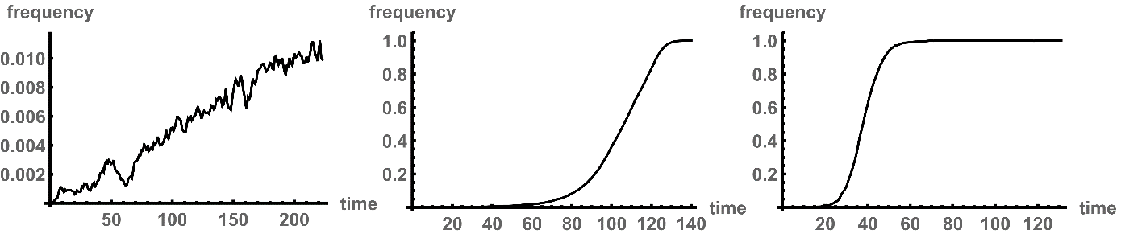
Figure 5: The evolution of discontent – time is given in ten thousand periods: a) only social imitation, b) sandpile model with option 4.I), c) sandpile model with option 4.II). Time is indicated in steps of 10,000 periods.
Figure 5 contrasts the different percentages of discontent individuals over time. Figure 5a) presents the dynamics based on the model of Figure 4 in which discontent is only spread by social imitation while Figures 5b) and 5c) show the evolution of discontent for the whole model for option 4.I) and 4.II), respectively. Comparing the “only-imitation” model to the full models shows two interesting results. While discontent has spread to all individuals after approximately one million/half a million interaction periods in the full models, idiosyncratic discontent, and social imitation only account for 0.5 percent. In addition, the sandpile dynamics trigger an exponential spread of discontent. After half a million/ a quarter million interaction periods, only an insignificant share of the population is discontent. Thereafter, we observe an ever-steeper increase of discontent members of society.
This behaviour is due to two components. Figure 6 shows the interplay between the distribution of discontent members, following the representation in Figure 4, and the corresponding distribution of the frequency at which individuals reached a critical height. As in Figure 4, the first row of Figure 6 shows discontent individuals in yellow, content individuals in blue after 25 thousand to one hundred thousand periods. The second row of Figure 6 visualises the corresponding frequency at which individuals reached a critical contention value. Individuals whose contention value has never exceeded a critical level are shown in black. As the individual frequency of reaching the critical height increases, i.e. individuals are repeatedly incited to protest, their colour changes from a dark red to a lighter red and eventually into a white. The agent with the highest frequency is shown in white and the colour grading of all other agents is proportional to the former’s frequency.
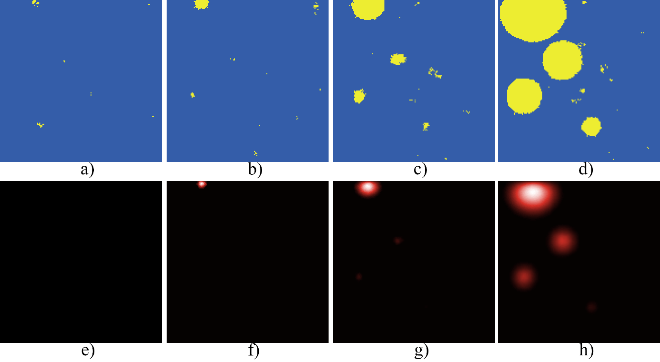
Figure 6: The evolution of discontent vs. criticality in steps of twenty-five thousand periods. e.g., a) and e) show period twenty-five thousand.

By comparing the first and second row, we can see that discontent and criticality are strongly correlated. Idiosyncratic choice and social imitation initially determine not only where discontent arises but the areas in which we will observe growing civil disobedience and unrest. This is a straight-forward relation: discontent with social practices initiates contention. After the initial spark, the causal relation is reversed. Contention and subsequent spillover create discontent. At 250 thousand periods, we only observe several small clusters of discontent individuals, but no individual has reached a critical contention value. At half a million interaction periods, contention is concentrated in a single area of a small cluster of discontent individuals. Other clusters of discontent individuals do not show signs of contention. This situation changes at 750 thousand interaction periods. The latter clusters now also transform into centres of contention. The first cluster shows higher levels since the contentious dynamics have persisted for a longer time and discontent is spreading from this cluster. This behaviour corresponds to our observations in the introductory discussion of this paper. For example, after demonstrations erupted against Ben Ali in Tunisia in December 2010, Egyptian activists initiated protests against Hosni Mubarak one months later. Demonstrations eventually occurred in Bahrain, Yemen, Libya, and Syria.
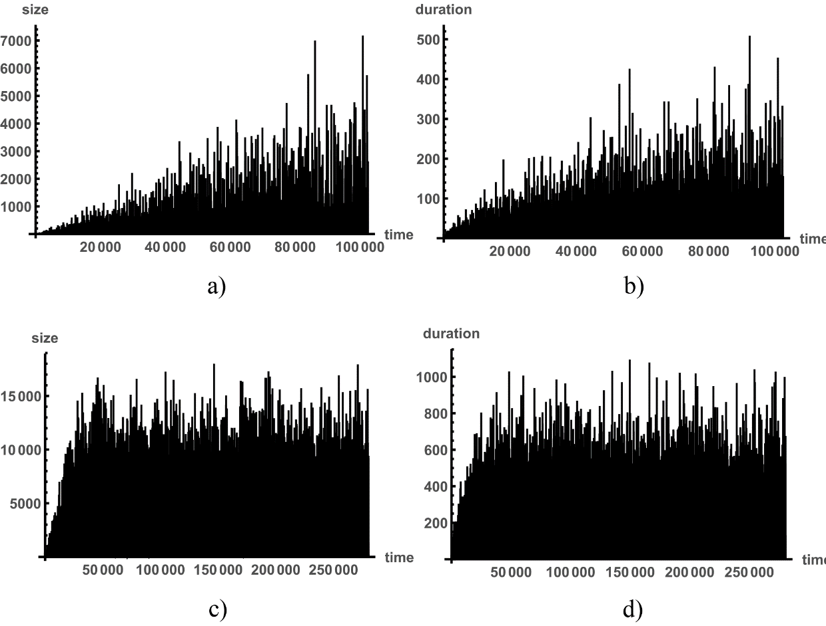
Figure 7: Size and duration of cascade sequences. a) and b) show results for first hundred thousand periods with zero occurrences. c) and d) show results for two million periods excluding zero occurrences.

Furthermore, the sandpile dynamics create cascade sequences of contention in which an individual reaches a critical contention value, spills over, and thereby affects peers. These peers, in return go through the same process and contention continuous to spread. The size and duration of these sequences is chaotic. Yet, interestingly, sequences demonstrate persistent characteristics at the aggregate level. Figures 7a) and 7b) show the size and duration of these cascade sequences over the first one hundred thousand periods of the simulation. We can see a general upward trend for both size and duration for the first 70 to 80 thousand periods. Figure 7c) and 7d) show the results for the entire duration of two million periods, excluding the zero occurrences (i.e. only if an individual reached a critical contention value, was the size and duration registered). In approximate 85 percent of the periods, size and duration is equal to zero, in other words, nothing happens. Intuitively, one might assume that the proportion of these zero events changes with the number of periods we consider. However, looking closer at the data shows that the share of these events is consistent if we take ten thousand periods or 70 thousand periods or longer periods, i.e. the chance of a zero events is independent of the span of a simulation. The same holds for any size and duration.
As a result, larger cascade sequences do not only materialise more sporadically than smaller sequences, but the likelihood of a cascade sequence is proportional to its size and duration. We can see this if we plot the number of occurrences, i.e. the frequency, based on the size and duration of a cascade sequence. Figures 8a) and 8b) show the relation for sizes and durations, respectively. These figures are plotted at a logarithmic scale. If we take the x-axis or y-axis, the distance between 1 and 10 is the same as the distance between 10 and 100 or 100 and 1,000. At this scale, we can see that up to a certain value, sizes and durations are ordered along a straight line of constant slope. This slope is roughly equal to -1.2 (+-0.15). In other words, a cascade sequence of twice the size and duration is less than half as likely (i.e. about $1/{r^{1.2}}$, with r being the ratio of the two sizes or durations). In the data presented in 7c and 8c, a sequence of size 50 occurred with a likelihood of 0.16 percent and a sequence of size 300 arose with a probability of 0.0188 percent which is consistent with our estimate that the smaller sequence is $6^{1.2}=8.5$ times more likely. The data follows a power law.
As indicated before, the power law distribution in Figure 8 is scale-invariant. If we increase the span of the simulation, we observe more occurrences of a particular sequence but on average, the relative frequency of such a sequence remains identical. In other words, if we run the simulation for ten million periods, a sequence of size 300 still arises with a probability of 0.0188 percent. Similarly, an increase in the population size has again little effect on the relative probability of the occurrence of a sequence of particular size and duration.

a) | b)
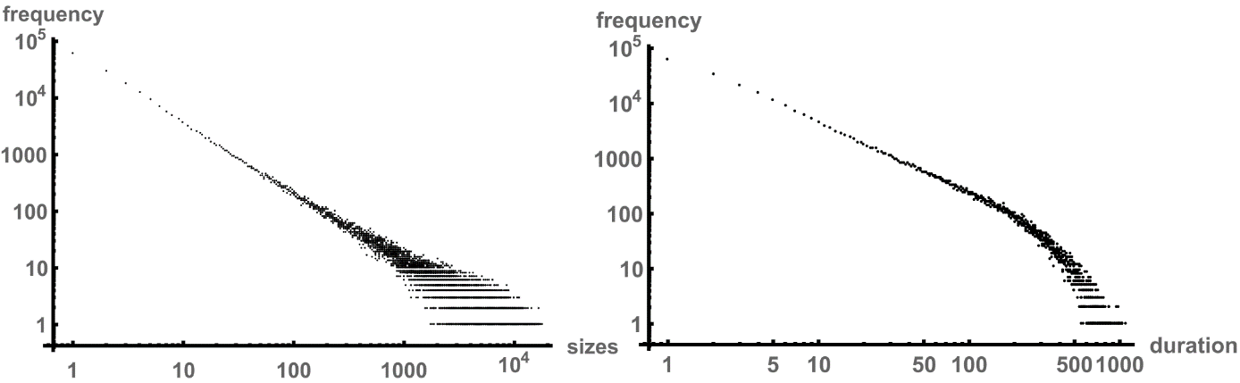
Figure 8: Distribution of cascade sizes and durations in log-log scale.

In addition, if we adopt option 4.II) of the simulation, instead of option 4.I), the results of Figures 5 to 8 remain essentially identical. It therefore does not matter whether we assume that a neighbour’s state is directly affected by a peer who reached a critical contention value or the neighbour only extrinsically changes her state to discontent if she reached a critical value herself. Nonetheless, the qualitative implication is more important than the exact quantitative results of the simulation. The model demonstrates unpredictable cascades whose size and duration are determined by chaotic dynamics (now frequently associated to the occurrence of black swans). Despite their underlying chaotic properties, sequences follow a regularity which allows us to make general statements about the aggregate dynamics.
Like the original version of the sandpile model, the dynamics are also robust to further generalisations of the extended model in this paper. Introducing individual weights (i.e. some individuals affect their peers more than others) and heterogeneous critical levels (i.e. some individuals display contentious behaviour earlier than others) has no impact on the increase and distribution of discontent or contentious behaviour nor on the distributions of revolutionary cascades. Since social imitation and idiosyncratic shifts of individual states are only of relevance for the initial periods of the simulation, the value of ε does not affect the transitions in Figure 5, but only when the transition is initiated. If we increase ε tenfold from 0.01 percent to 0.1 percent, the transition is initiated roughly two hundred thousand periods earlier. Yet, the value of ε has an impact on the number of clusters that form initially and spark contention. At higher levels, we therefore observe a more dispersed increase in contention while at lower levels only one or two clusters emerge at which contention is concentrated and which then expand in size. In other words, the frequency, at which new ideas appear and contest established practice, pressure exercised by economic depression, demographic challenges or war, influences the initial pattern of contention and spark more local uprisings (as they affect ε) but it is not correlated with the dynamics of the actual revolutionary wave.
a) | b)
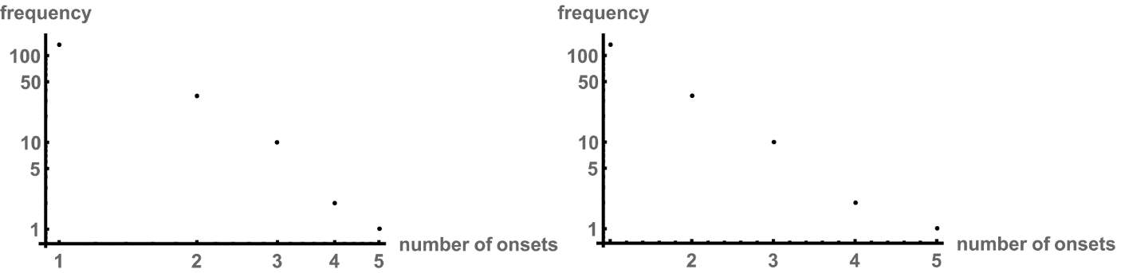
Figure 9: Frequency of revolutionary onsets per year from 1492 -1992, based on Tilly (1993).

How realistic are these results if we compare them to empirical data? Power law distributions are ubiquitous in social systems. We can find them if we compare the population size of cities, individual income or the frequency of words found in literature (Zipf, 1994). Yet, conflict related data shows a less distinct power law distribution. Figure 9 plots the frequencies as a function of the number of onsets of revolutionary situations based on data by Tilly (1993). Tilly identified 256 revolutionary onsets in the French and Russian states as well as Hungary, the Balkans, Iberia, the Low Countries, and the British Isles during the years 1492 to 1992. Figure 9.a) uses a log-log scale as in Figure 8 to plot the frequencies of these onsets, while 9.b) uses a log-linear scale. We need to acknowledge that data points are sparse, Central Europe is missing in the analysis and the number of onsets is not entirely equivalent to the scale of cascades in our model, and therefore, we need to be careful to not over-interpret the results. However, the data seems to indicate that the medium frequency of onsets occur at a higher frequency than what would have been predicted by a power law distribution. Therefore, the distribution bulges outwards if plotted in log-log scale. We can observe similar distributions if we analyse the duration of conflicts (e.g. using data from Wilkinson, 1980, p.22) or the casualties of war (see Ille, forthcoming).
These deviations from a standard power law distribution can be explained by the particular interaction structures of individuals. So far, we have assumed that individuals are structured along a regular lattice. Consequently, each member of society has the same number of peers. This is not the case for most social systems. The topology of a social network frequently demonstrates by itself a power law distribution. Consequently, those individuals who are highly connected influence their peers to a lesser degree compared to those who are connected to only a few. At the same time, the former have an impact on a significantly larger number of members of society than the latter. We might think here of the former as celebrities or politicians, and of the latter as parents and friends. Highly connected individuals then operate as both amplifiers and gatekeepers. If the contention value of a highly connected individual reaches a critical level, spill-over increases the contention value of numerous peers. Since the cascade dynamics are not uni-directional, cross-fertilisation occurs over a larger part of the network. Through the ensuing back-and-forth (which we have seen in the simplified 3x3 example before) between a larger section of the network, a highly connected individual amplifies the contentious effect. At the same time, large parts of a network are only indirectly connected through a highly connected individual. If the latter does not turn critical, the cascade dynamics stop at this point and contention is not spreading further across the social network.
An individual’s degree is defined by the numbers of peers or neighbours to whom an individual is connected. Figure 10 shows the degree distribution of a sample network of ten thousand individuals which has been generated via preferential attachment. Under preferential attachment, the likelihood of becoming connected to another individual increases proportionally with the latter’s degree. In other words, the more an individual is connected, the more likely she is to form further connections. This leads to the degree distribution in Figure 10 which is exemplary for social networks.
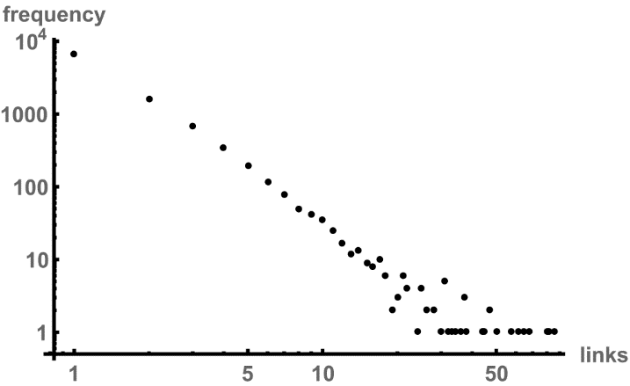
Figure 10: Link distribution of preferential attachment network in log-log scale.

The power-law distribution in Figure 10 has a slope of -2.4. Individuals with three connections (i.e. a degree of three) are roughly twenty times as frequent as individuals with 10 connections. The most highly connected individual has a degree of 263, the second highest individual has a degree of 85 and only 8 individuals have a degree larger than fifty. These individuals act as the strongest gatekeepers and amplifiers, depending on their current contention value. Figure 11 plots the results of a simulation over one million periods. Comparing Figure 11a) and Figure 11b), we can see that the sizes of the cascades do not perfectly follow the linear relation in the log-log scale of a power-law distribution but are slightly hump-shaped (i.e. concave). Yet, the distribution is also not linear in log-linear scale but slightly convex. In comparison, the durations show a more pronounced concave distribution in log-log scale and are therefore more linear in log-linear scale. Transforming the population structure from a regular network in which each member has the same number of peers into a network which more closely resembles existing social networks generates results that are comparable to the empirical results in Figure 10 as well as Wilkinson (1980) and Ille (forthcoming).
a) | b)
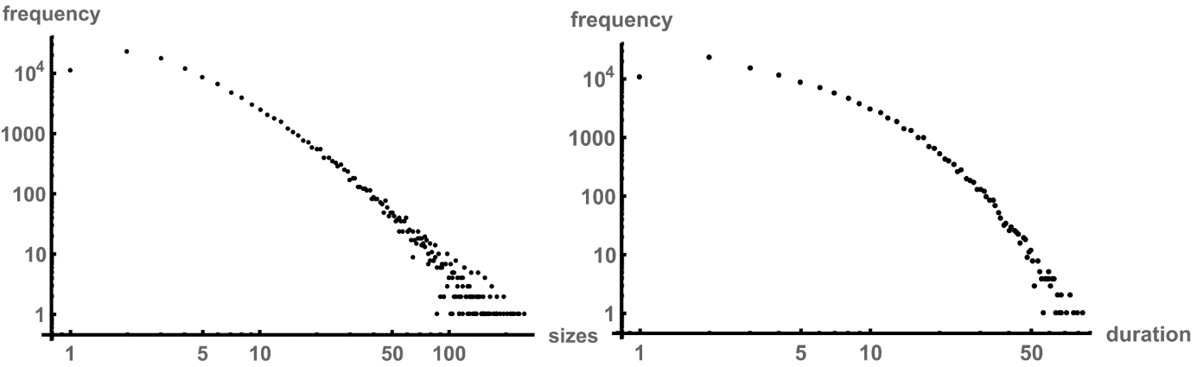
Figure 11: Distribution of cascade sizes and durations of preferential network in log-log scale.

Figure 12 supports the hypothesis that members of higher degree are crucially important for the propagation of cascades since an individual’s degree is directly correlated with the frequency at which she becomes critical. Highly connected individuals are more likely to become critical, and at the same time, these members of a social network cause larger cascades.

Discussion and Conclusion
This paper developed a simplified model of social contention and revolutionary waves. Individuals are represented as cellular automata. These cellular automata, despite having a limited number of actions at their disposal, create complex behaviour at the system’s level that is consistent with empirical results. The paper claims that revolutionary waves can be fundamentally understood as a process analogous to grains of sand sliding down the slopes of a pile of sand. Here, the stylised sandpile model of Bak et al. (1987) is extended to take account of the social nature of revolutionary waves. Instead of fictitious grains of sand falling onto a plain, the social system is stressed on the basis of a simple social imitation process in which individuals change their state of mind between being content or discontent based on their observation of peers. Discontent individuals become increasingly in conflict with existing social practices, which is represented by their contention value. Once the latter reaches a critical level, the individual incites discontent and contention in their peers. Based on this plain process, the system self-organises into a critical state and generates sophisticated cascade dynamics in which individuals are motivated by their peers to challenge practices and initiate collective actions. Collective action can then be understood as a reorganisation of the system into a stable state after it reached a state of criticality. Although these dynamics are chaotic and thus, unpredictable, the probabilistic characteristics of the process follow a consistent pattern. The frequency of a revolutionary wave is proportional to its size and duration. It is shown that the distributions of the latter follow a bulged power law distribution. The bulge in the distribution is caused by the topology of preferential social networks in which the degree distribution follows a power law.
The results demonstrate an interesting aspect that questions how we should analyse the social process of revolutionary waves and contention. While the model does not leave much room for individual autonomy beyond simple decision rules, the system shows complex dynamics. Additionally, the aggregate dynamics of the model are robust to individual idiosyncrasies and heterogeneous characteristics. Heterogeneous contention values and randomly distributed weights do not affect overall results. We have seen that the interaction structure slightly biases results, but overall, the power law distribution of the size and duration of revolutionary waves, and thus, the fundamental characteristics of the dynamics remain in place. These results indicate that firstly, individual attributes are of little relevance for the dynamics at the system’s level and we might suffice with a simplified study that relies on the average or representative individual. Secondly, results show that the model generates dynamics that cannot be inferred from a reductionist perspective that extrapolates individual actions to infer the dynamics of the system as a whole.
In this model, social contention is an emergent property of the social system which is born out of the complex interdependency between individuals but is not due to individuals being complex themselves. The model therefore raises doubt that aggregate statistics or individual case studies are suitable to understand the underlying dynamics. On the contrary, results stress the greater need to study the interaction structure and feedback effects in social networks, instead.
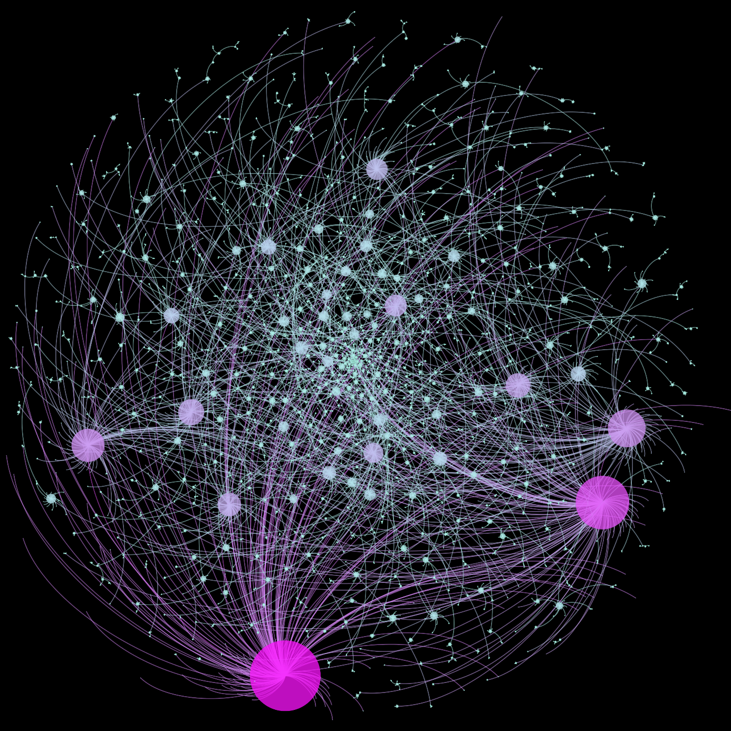
Figure 12: Preferential attachment network. Size of an individual/node shows its relative degree, a darker shade indicates relative higher frequency of criticality.

References:
- Axelrod, Robert (1997). The Complexity of Cooperation: Agent-Based Models of Competition and Collaboration. Princeton: Princeton University Press.
- Bak, Per (1996). How Nature Works: The Science of Self-Organized Criticality. New York: Copernicus.
- Bak, Per; Tang, Chao; Wiesenfeld, Kurt (1987). Self-organized criticality: an explanation of 1/ƒ noise. Physical Review Letters, Vol. 59, pp. 381–384.
- Bak, Per; Tang, Chao; Wiesenfeld, Kurt (1988). Self-organized criticality. Physical review A, Vol. 38(1), pp. 364–374.
- Beck, Colin J. (2011). The World-Cultural Origins of Revolutionary Waves: Five Centuries of European Contention. Social Science History, Vol. 35(2), pp. 167-207
- Beck, Colin j. (2014). Reflections on the Revolutionary Wave in 2011. Theory and Society, Vol. 43, pp. 197-223
- Bonabeau, Eric (2002). Agent-based modeling: Methods and techniques for simulating human systems. Proceedings of the National Academy of Sciences of the United States of America, Vol. 99, pp. 7280–7287
- Collins, Randall (1998). The Sociology of Philosophies: A Global Theory of Intellectual Change. Cambridge: Harvard University Press.
- Gardner, Martin (1970). Mathematical Games: The fantastic combinations of John Conway's new solitaire game ‘life’. Scientific American, Vol. 223, pp. 120-123.
- Ille (forthcoming)
- Ille, Sebastian (2017). Towards better economic models of social behaviour? identity economics. Studies in Ethnicity and Nationalism, Vol. 17(1), pp. 5-24.
- Katz, Mark (1999). Revolutions and Revolutionary Waves. New York: St. Martin’s
- Lee, Jasmine C., Iaryna Mykhyalshyn, Rudy Omri and Anjali Singhvi (2016). At Least 88 Cities Have Had Protests in the Past 13 Days Over Police Killings of Blacks. The New York Times. July 16, 2016. https://www.nytimes.com/interactive/2016/07/16/us/protesting-police-shootings-of-blacks.html, accessed 10 August 2020
- Schelling, Thomas C. (1971). Dynamic models of segregation. Journal of Mathematical Sociology Vol. 1, 143–186.
- Schelling, Thomas C. (1978). Micromotives and Macrobehavior. W. W. Norton & Company.
- Tarrow, Sidney (1993). Cycles of collective action: Between Moments of Madness and the Repertoire of Contention. Social Science History, Vol. 17(2), pp. 281-307
- Tarrow, Sidney (1998). Power in Movement: Social Movements and Contentious Politics. Cambridge: Cambridge University Press
- Testfatsion, Leigh; Judd, Kenneth, eds. (2006). Handbook of Computational Economics 2. Elsevier
- Tilly, Charles (1993). European Revolutions, 1492-1992. Cambridge: Blackwell.
- Wilkinson, David (1980). Deadly Quarrels: Lewis F. Richardson and the Statistical Study of War. Berkeley: University of California Press.
- Wu, Jiachuan; Chiwaya, Nigel; Smith, Savannah (2020). Map: Protests and rallies for George Floyd spread across the country. NBC News. accessed 10 August 2020.
- Zipf, George K. (1994). Human Behavior and the Principles of Least Effort: An Introduction to Human Ecology. Cambridge: Addison-Wesley Press, Inc.

