Strategic Narratives of Russia’s War in Ukraine: Perspectives from China
Angela Pennisi di Floristella, Xuechen Chen

Abstract

Strategic narratives have become an important tool with which states define their geopolitical reality and shape the types of foreign policy decisions that emerge. In order to build a more favourable international environment, China has deployed substantial resources to disseminate its strategic narratives and communicate its role, identity and vision and legitimise Chinese Communist Party (CCP) rule. Despite the obvious importance of narratives on conflict and global security, remarkably few studies have examined China’s strategic narratives on security-related issues. This article marks the first systematic effort to map out China’s strategic narratives in the context of the ongoing conflict in Ukraine. Based on a corpus linguistics approach and qualitative content analysis, the findings reveal that China does not project itself as a neutral player and that its strategic narratives often echo Russia’s portrayal of the Ukrainian war. However, the analysis also highlights China’s efforts to maintain its distance from Russia while presenting itself against the backdrop of the US/West-Russian rivalry as an equidistant player belonging to the wider international community as well as the most suitable actor to manage a peaceful global order.

Introduction
Strategic narratives have become an important tool that nations employ to define their geopolitical reality and shape the types of foreign policy decisions that emerge (Hinck et al. 2018). In particular, states use narratives to construct their preferences, identities and social reality (Finnemore and Sikkink 1998). Strategic narratives are used to communicate who one is and what one thinks of others as well as to establish short- and long-term objectives and identify how to achieve them (Miskimmon, O’Loughlin and Roselle 2013; Ashworth 2016). Under the leadership of Xi Jinping, China has deployed substantial resources to disseminate its strategic narratives and communicate its role, identity and vision for world order (Lams 2018). For obvious reasons, Beijing’s effort to “tell the Chinese story and spread Chinese voice well” (Xinhua 2013) has not passed unobserved. Some researchers have scrutinised how China’s strategic narratives have served to craft a particular foreign policy, including furthering the Belt and Road Initiative (BRI) or advancing certain policy goals, such as peaceful rise and peaceful development (Hinck et al. 2018; Rosendal 2022; Harting 2015). Others have analysed China’s success in employing its strategic narratives with regard to the BRI and have sought to determine what makes some narratives more successful than others (Van Noort and Colley 2022). In addition, scholars have examined China’s attempts to acquire greater discourse power to lead global governance reforms in a number of topic areas, from human rights to climate (Zhang and Orbie 2021; Yang 2021). Research has also explored China’s increasing deployment of strategic narratives to redefine the existing norms of global governance under the leadership of Xi Jinping (Yang 2021; Brown 2021). Lastly, COVID-19 has spurred an intense debate on the narrative power struggle between the United States and China (Hagström and Gustafsson 2021).
However, despite the growing popularity of research on strategic narratives and the increasing awareness of the crucial role they play in understanding China’s behaviour, aspirations and objectives, little scholarly attention has been given to examining China’s narratives on security-related issues. Some exceptions include a study focussing on China’s portrayal of terrorism, which the author described as embedded in a Confucian-style approach to security (Ning 2019), and a contribution centred around the narratives deployed by the Chinese media about ontological security concerns and challenges related to global competition (Hinck et al. 2021). Thus, this article seeks to shed more light on China’s security understanding by exploring the role played by China’s strategic narratives in the ongoing conflict in Ukraine. Specifically, it asks the following questions: What strategic narratives have China’s official sources of foreign policy disseminated concerning the war in Ukraine? What do China’s strategic narratives reveal about China’s view of, identity in relation to and potential solutions for the conflict in Ukraine?
Due to their numerous ramifications for global security politics, China’s strategic narratives on the war in Ukraine require investigation to understand China’s view of contemporary international security politics. This study is also urgently needed in the context of the vigorous International Relations debate about China’s rise and that nation’s likely intentions, which has seen scholars divided on the possibility of China’s peaceful rise. Within the wide spectrum of studies, scholars like Mearsheimer (2010) and Allison (2017) express pessimism about China’s ability to rise peacefully, believing that the country will be willing to alter the international order according to its own preferences. Power transition theorists also tend to be wary about China’s rise, suggesting that when a rising power is dissatisfied with the status quo, it will attempt to undermine the existing order. Others emphasise that China’s rise will be different due to Beijing’s cultural distinctiveness, civilisational identity, historical legacy and continental features (Bijian 2005; Jacques 2009). Through this prism, China is regarded as a status quo power, integrated within the US-led economic order and increasingly participating in regional and global international institutions (Johnston 2003; Foot 2006). Amid the present widespread disagreement among China’s observers, this article empirically attempts to illuminate China’s possible course of action and role in response to current and future international security crises.
Thus, this discussion seeks to achieve these aims by elaborating on Miskimmon, O’Loughlin and Roselle’s (2013) analytic framework of China’s strategic narratives. In this endeavour, the article introduces an original corpus linguistic approach to official Chinese sources, combined with qualitative content analysis. Our results reveal that while voicing dissatisfaction with the US-led international order and security practises, China has not projected itself as a neutral player. To some extent, China’s strategic narratives have sided with pro-Russian information campaigns in echoing Russia’s portrayal of the Ukrainian conflict. However, China also maintains a prudent distance from Russia and presents itself as an outsider to the rivalry between Russia and the US/Western camp. In other words, China’s attitude is one of belonging to the wider international community, assuming the role of the most suitable and just actor to solve the Ukraine conflict, as well as the best choice to manage a peaceful global order. This claim accompanies China’s call for the reform of global security governance, centred on a new, cooperative security vision, as laid down in the Global Security Initiative (GSI), and on non-confrontational conflict resolution tools.

Analytical framework: Strategic narratives
Drawing on social identity theory, narratives provide ways to make sense of the world, policies, events and interactions. Thus, they play an “important role in shaping and expressing political identity, perspective, and ideology” (Shenhav 2006: 245). Narratives are distinguished by chronological movement, linking different points in time through the stories actors tell about themselves, others, their history and their futures (Shenhav 2006: 247). Through narratives, people come to understand the international system. Narratives thus shape how the international order is imagined and constructed. At the same time, political actors draw on narratives to explain and justify their interests, roles and priorities.
While all narratives involve some underlying purpose (Ba 2019), strategic narratives, in addition to representing sequences of events and identities, are also used as important communicative tools by political actors to project their values and interests to manage expectations and to “change the discursive environments in which they operate” (Miskimmon, O’Loughlin and Roselle 2013: 3). Strategic narratives go beyond expressions of material interests; they shape an actor’s self-conception and set expectations about an actor’s role in the world and how it should be recognised (Miskimmon and O’Loughlin 2017). Strategic narratives provide a means of “linking together events according to a desired endpoint” (Zhang and Orbie 2021: 4). They are also employed to achieve political objectives and influence the behaviour of others towards particular outcomes (Miskimmon, O’Loughlin and Roselle 2013). Put differently, they are strategic because they project medium- and long-term goals based on representations of the situations, key actors and casual beliefs about social and political processes. Thus, in addition to helping make sense of the world, strategic narratives lead to certain pre-ordinated conclusions (Hinck et al. 2018). Against this backdrop, they are particularly important for emerging powers, such as China, whose values and interests stand in sharp contrast with those of the Western liberal tradition. Thus, China’s acquisition of more discourse power would increase its ability to reshape other nations’ values, interests and identities in ways more aligned to China’s ideas and principles (Yang 2021). Strategic narratives may also become particularly relevant in times of conflict and/or contestation (Ba 2019). Possessing discourse power can legitimate a new vision of global order and, in turn, “provide instructions” for novel ways forward in specific situations (Ba 2019).
According to Roselle, Miskimmon and O’Loughlin (2014), strategic narratives feature three main dimensions. First, system narratives establish common understandings about “how the world is structured, who the players are, and how it works” (Roselle, Miskimmon and O’Loughlin 2014: 76). System narratives help uncover a number of interrelated dimensions related to the global order by identifying the key attributes of the international (security) system, such as system polarity, the identification of great powers, alignment of interests and prospects for cooperation, integration or confrontation. They also indicate international actors’ desirability and possibility of collaboration, integration or confrontation in the international order. Furthermore, they make predictions about enemies and allies and outline the scope for the socialisation of political actors. By doing so, system narratives serve as a discursive effort through which international actors seek to produce, maintain or alter the international order (Zhang and Orbie 2021). System narratives are therefore particularly important because they contain important assumptions about whether a power is satisfied with the fundamental characteristics of the prevailing global order and power distribution or, contrariwise, is dissatisfied and wants to change the existing norms. They also contain important assumptions that will affect what foreign policies are seen as possible and desirable (Leslie and Roselle 2023: 308).
Second, identity narratives project who individuals are as political or national actors as well as their values, goals and agency. Identity narratives thus “seek to frame the identity of particular actors in international affairs” (Wellings et al. 2017). This type of narrative plays an important role in portraying the nature of an international actor’s self-imagination and the norms and values that it pursues in the international system (Roselle, Miskimmon and O’Loughlin 2014). Finally, policy-issue narratives outline how an actor views an appropriate response to a crisis and “set out why a policy is needed and (normatively) desirable” (Roselle, Miskimmon and O’Loughlin 2014: 76). Revolving around “topical and contextual problems” (Schmitt 2018: 490), policy-issue narratives establish “the terrain on which policies on particular issues are formulated” (Wellings et al. 2017: 24). While each dimension operates at different levels of analysis, system, identity and policy narratives are highly interconnected, interacting and intersecting with each other. In the subsequent section detailing the study’s empirical analysis, these three dimensions of China’s strategic narratives will be systematically evaluated.

Methodology and data analysis process
In its examination of China’s strategic narratives concerning Russia’s invasion of Ukraine, this study draws on an integrative combination of a quantitative corpus linguistic approach and qualitative content analysis. Corpus linguistics is used to carry out quantitative research on a large number of texts (Baker et al. 2007). This approach allows researchers to study collocations and other repeating patterns related to specific words. Specifically, corpus linguistics can be used to analyse semantic patterns, the way words are used in discourse and the environment in which specific words appear. These goals are achieved by examining keywords, word frequencies, collocations and contexts within a large quantity of language data (Baker et al. 2008). Corpus linguistics has been effectively applied in various social fields, such as media and politics, to analyse discourse (Freake et al. 2011). The use of corpus linguistic methods results in a high level of accuracy in data analysis, as it allows researchers to examine a larger sample size (McEnery 2019). In the context of this research, we adopt corpus linguistic techniques to investigate two aspects of China’s narratives: keyness and collocation. Keyness is used to understand the high frequency of particular words and can help identify important terms or themes that appear significantly more frequently in the texts. Collocation refers to the co-occurrence of two words when the frequency of the co-occurrence is greater than chance would dictate. Thus, collocation analysis offers information on the most salient characteristics associated with a word or a selected group of words (Baker 2007).
Gaining further knowledge and understanding of China’s strategic narratives was accomplished by using corpus linguistics in parallel with a qualitative content analysis, representing a widely adopted research technique in the social sciences (Ercan and Marsh 2016). Integrating qualitative content analysis into data analysis strengthens the rigour and reliability of research (Kohlbacher 2006). Meanwhile, the qualitative element ensures the interpretation of the results in the context (Kohlbacher 2006). Qualitative content analysis, which is underpinned by an interpretivist perspective, involves the process of analysing a selective number of texts in a rigorous, in-depth manner to uncover underlying patterns, themes and characteristics of the texts that remain underexplored by the quantitative process (Ercan and Marsh 2016). In specific terms, we first read through the entire corpus of articles before deriving emerging patterns of narratives. Statements and articles were inductively analysed in relation to the depiction of system, identity and policy narratives.
Regarding the data collection and analysis process, this research includes a corpora of English-language texts comprising 315,035 words. The corpus consists of 164,717 words from official statements and press releases from China’s Ministry of Foreign Affairs (MFA) and 150,318 words representing media reports from China Daily and Xinhua News. Each article in the corpus includes at least one of the following search terms: “Russia-Ukraine crisis”, “Ukraine conflict”, “Ukraine crisis”. In addition, the study focusses only on English-language discourse in order to target the broadest international audience.
The rationale behind the data selection was that both official discourses from the MFA and state-led media agencies have a significant level of representativeness in terms of China’s official narratives towards the Russia–Ukraine crisis and can be regarded as important authoritative sources to ascertain the Chinese government’s official position. Of no less importance, media and MFA sources, though often referenced by scholars, have seldom been compiled systematically in a structured dataset.
Scholars have recognised that MFA transcripts, including regular press conferences, are both illustrative of Chinese leaders’ intentions and beliefs as well as a unique source of Chinese strategic narratives used to attract, persuade and achieve broader Chinese foreign policy goals (Mochtak and Turcsanyi 2021). At the same time, research has suggested that media reports wield narratives to construct world views in pursuit of political goals at home and abroad (Miskimmon, O’Loughlin and Roselle, 2013), along with providing a sense of shared culture (Carey 2008 as quoted by Hinck et al. 2021). Furthermore, while “leaders play important roles in providing definitions and visions for state policy, these policies still rely on media for their dissemination and support within the public” (Hinck et al. 2021: 34). In fact, it has been noted that media narratives serve as an important multiplier of crisis perception and resolution (Cross 2017).
Finally, and of no less importance, retrieving data from both the MFA and the media helped increase the degree of representativeness of our empirical data. The analysis timeframe includes articles published between 1 February 2022 – a mere three weeks before Russia’s full-scale military invasion of Ukraine following the 2014 aggression that culminated in the annexation of Crimea – and 30 November 2022. This ten-month analysis allowed us to gather a large data corpus, making it possible to uncover the main thematic patterns of China’s strategic narratives. We then adopted the text analysis tool KH Coder – a software program that draws on computation linguistics for quantitative content analysis (Higuchi 2016) – to identify the top-frequency keywords and create co-occurrence networks of words to identify key terms with similar appearance patterns (i.e. with a high degree of co-occurrence, connected by lines). Before conducting the software analysis, we identified a list of stop words (e.g. common words occurring in all kinds of sentences, such as substantive verbs), which were removed from the KH Coder analysis.

China’s strategic narratives on the war in Ukraine

System narratives
As mentioned in the discussion of the theoretical framework, system narratives are concerned with the nature of the international relations structure. Specifically, political actors utilise system narratives to depict how global politics is structured, who the key players are and how international relations operate (Miskimmon, O’Loughlin and Roselle, 2013). A system narrative can reveal crucial dimensions of the international order, such as political actors’ interpretations of power relations and polarity. It may also contribute to describing expectations about the behaviours of different types of states, as well as assessing the possibility of collaboration and confrontation among different actors in the order (Miskimmon, O’Loughlin and Roselle, 2013; Zhang and Orbie 2021). In essence, the system narrative refers to “discursive attempt by actors to produce, maintain, and change the international order” (Zhang and Orbie 2021: 6). In line with this approach, the remainder of this section unpacks China’s system narratives concerning the war in Ukraine, focussing on China’s discursive attempts to construct and interpret the international order, as well as the key players, against the backdrop of the conflict.
Drawing on our empirical data led us to make the following four observations.
First, China’s system narratives view the US as the key international player that sits at the centre of the international system and bears the greatest responsibility for the conflict in Ukraine. As can be seen in Table 1’s listing of the key actors featured in the corpus and their respective frequencies, the “United States” is mentioned 1817 times, even surpassing the frequency of “Russia”, which appears 1498 times in the corpus.

Table 1. Key actors featured in China’s narratives and their frequencies
Key actors | Frequency
China | 3314
Ukraine | 2406
US | 1817
Russia | 1498
Taiwan | 561
NATO | 538
Europe | 381
EU | 349
International community | 359
United Nations | 142
Source: Authors’ own compilation based on corpus data

Figure 1. Word frequency (Top 50)

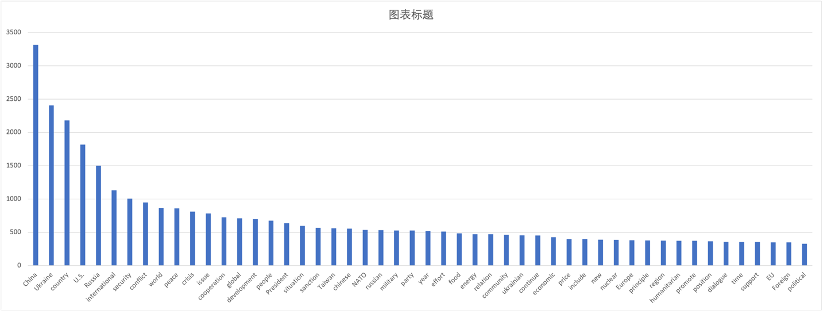

Source: Authors’ own compilation based on corpus data

Importantly, both the US and NATO, with their so-called “rules-based international order”, are seen as conflict initiators that systematically challenge world peace and security. This view is reiterated in various statements, such as the following examples: “Everybody knows that the United States shoulders major responsibility for Europe’s security” (MFA, 6 May 2022), “The US’ decision on NATO’s eastward expansion is directly linked to the Ukraine crisis now” (MFA, 17 March 2022), and “The history of NATO is one of creating conflicts and waging wars” (MFA, 6 July 2022). Contrariwise, Russia’s behaviour is portrayed as a rational defensive approach taken in response to the US and NATO’s efforts aimed at undermining Russia’s security, as highlighted, among other examples, by the following excerpt:

“While the West keeps blaming Russia for the conflict with Ukraine, NATO is responsible for the underlying conflict, the conflict over the right to feel secure around one’s border and not be encircled” (China Daily, 18 November 2022)

In this light, an essential point of convergence exists between China’s and Russia’s system narratives, displaying China’s effort to promote Russia’s view of the conflict, especially concerning accusations that NATO’s expansion threatens Russia’s security. This phenomenon is also demonstrated by the fact that Chinese official discourses do not present the conflict as a violation of the sovereignty and territorial integrity of Ukraine by Russia. On the contrary, they have consistently avoided the idea that Russia has violated the Ukrainian sovereignty by invading it, thereby lining up with and even amplifying the Kremlin’s disinformation campaign regarding the Ukrainian war. Although documents indicate that China maintains that the sovereignty and territorial integrity of all countries should be respected and protected in line with the purposes and principles of the UN Charter, Figure 2 demonstrates that the term “sovereignty” is primarily used to refer to the case of Taiwan, which is described “as purely China’s internal affair.” China’s system narratives have also significantly downplayed atrocities in the Ukrainian city of “Bucha”, mentioned only five times in the corpus, and have aligned with Russia’s rhetoric and description of the events. Indeed, when it came to attributing blame for the situation in Bucha, China refused to criticise Russia, claiming that “the relevant circumstances and specific causes of the incident should be verified and established” (MFA, 6 April 2022).
In line with these tenets, the Ukraine crisis has not been portrayed as a regional conflict between Russia and Ukraine. Instead, it has been framed as a conflict between Russia and the US/Western camp. The co-occurrence networks of words, as generated by KH Coder, illustrates that that the “US”, along with “Russia, Ukraine, crisis, conflict, sanction, Europe, world”, are close to each other and connected with lines, which means that these terms constitute a major linguistic cluster and thus represent a key discursive theme in China’s narratives (Figure 2). Based on a closer assessment of the concordance lines and sentences associated with the term “US”, the following excerpt further confirms that, instead of being framed as a regional conflict that is confined to Russia and Ukraine, this war is viewed as part of the geostrategic rivalry between Russia and the US (and its key allies):

The Russia–Ukraine conflict, which the US and its Western allies instigated, has had a huge impact on the global and regional security landscapes. The US-led NATO’s aggressive eastward expansion, ignoring Russia’s constant warnings not to do so, is the root cause of the conflict. And instead of trying to negotiate a peaceful end to the conflict, the US and its Western allies have been supplying weapons and other military equipment to Ukraine in order to weaken Russia by prolonging the conflict. (China Daily, 13 July 2022)

Figure 2. Co-occurrence network of words (Top 300 nouns)

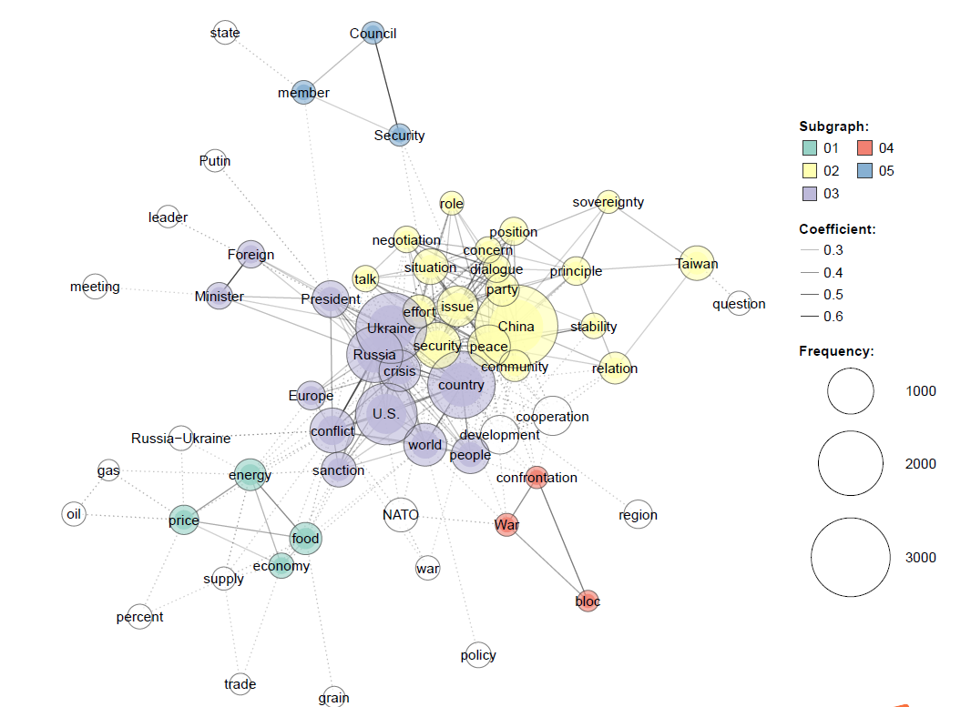

Our second observation has to do with how China’s system narratives highlight distrust and opposition to the US-led hegemonic order and preferences and China’s frustration at US efforts, which are constantly aiming at distorting and discarding China’s intentions (MFA, 1 November 2022) and creating exclusive groups against China. In this regard, China’s system narratives seek to depict the international order by constructing polarised images of China and the US (and its allies). Specifically, in line with Beijing’s approach aimed at telling China’s story well, China has attempted to project itself as a promoter of cooperation, peace and development, in contrast to the US and its Western allies, who are framed as adopting hegemonic attitudes and a Cold War mentality based on confrontation and the logic of domination, which “should be completely discarded” (MFA, 27 February 2022). An examination of the noun collocates associated with the term “China” suggests that “development, cooperation, effort, peace, and sovereignty” are among the top 10 high-frequency words that are closely linked to China (see Figure 1). MFA statements stress that “among the major countries, China has the best peace and security record” (MFA, 25 July 2022). It is frequently emphasised that “China will continue to promote peace talks on the Ukraine issue and always stand on the side of peace” and will “work with all parties to build a world of peace, development, cooperation” (MFA, 11 July 2022).
Third, by taking a more nuanced view of China’s system narratives, we observe that, apart from adopting a polarising positive self-image while portraying the US/West negatively, China’s official discourses also reveal Beijing’s intention to distance itself from both the US and Russia when narrating the conflict in Ukraine. By doing so, China regards itself as part of the wider international community and attempts to position itself as an outsider and impartial player in this conflict. When stating its position vis-à-vis the Russia–Ukraine war, China endeavours to align itself with the wider international community, as encapsulated by the following statements: “China stands ready to work with members of the international community to continue to play a constructive part in de-escalation efforts” (MFA, 30 September 2022), “China is committed to facilitating dialogue for peace, and believes that the international community should jointly support the pace talks between Russia and Ukraine for early substantive outcomes” (MFA, 15 March 2022). A closer look at China’s discourses also reveals China’s efforts to present itself as an advocate for small and medium countries, which are “bullied” and used by big powers “to fight proxy wars” (MFA, 19 March 2022). Several documents emphasise that “small countries should not be used as a pawn” (MFA, 19 March 2022). On the contrary, China depicts itself as a stanch support of the “legitimate right and interests” of small and medium countries “to decide their foreign policy independently” (MFA, 20 March 2023) and declares its firm opposition to placing them “on the front line of geopolitical games” (MFA, 1 April 2022).
While voicing dissatisfaction towards the US, along with concerns about an unstable and volatile security landscape, China’s system narratives thus manifest a greater confidence in China’s readiness to reshape and lead the wider international community, whose preferences have often been neglected in great power politics. China’s system narratives also highlight a closer alignment with Moscow on the basis of a shared vision of a post-Western, “more equitable and reasonable international order” (MFA, 15 September 2022). In this regard, Russia and China are both portrayed as committed “to developing a new model of major-country relations in line with the principles of non-alliance, non-confrontation and non-targeting of any third party” (MFA, 15 July 2022), signalling that China-Russia relationships are growing closer. Nevertheless, China’s system narratives are also contradictory and ambiguous vis-à-vis Russia, casting a shadow over the prospect of a Sino-Russian alliance. For example, reaffirming a traditional non-alliance stance, China’s discourses warn against a dangerous misinterpretation involving a “Beijing-Moscow Axis” (MFA, 18 April 2022) and maintain that China “has been and will remain an independent country that decides its position according to the merits of each matter, immune from external pressure or interference” (MFA, 18 April 2022).
According to our final observation, in such a volatile scenario, Europe is regarded as the focus of all pressures and has been framed as a marginalised actor and victim in the context of the Russia–Ukraine war. As can be seen from Table 1, the frequencies of the terms “Europe” and “EU” are 381 and 349, respectively, which are significantly lower than those of “China” (3314), “US” (1817), “Russia” (1498) and “NATO” (548). Additionally, a collocation analysis of the word “Europe” suggests that Europe or European countries have primarily been referred to as US “allies”, implying that China views Europe as subordinate to the US. While regarding these entities as key allies, China’s system narratives also highlight the divergent interests of Europe and the US in light of this conflict, contending that “the ongoing Russia-Ukraine conflict has taken a heavy toll on Europe politically, economically, and socially, while the US benefits from it, with arms-dealers popping champagne and American grain and energy industries making exorbitant profits” (MFA, 29 June 2022). At the same time, China regards Europe and European countries as victims of this conflict, as evidenced, inter alia, by the following statement: “Another 2.6 million refugees fleeing the Russia-Ukraine conflict have entered European countries, which are the real victims of the current situation” (MFA, 18 March 2022).

Identity narratives
Moving on to the analysis of China’s identity narratives, this sub-section unpacks how China seeks to frame its own role, norms and identity in international affairs (Miskimmon and O’Loughlin 2017) and how China projects its role in the context of the Ukraine crisis. Our analysis indicates that, above all, China’s strategic narratives at the identity level aim to establish China as a benign actor, a force for good as well as a responsible country that plays an active role in promoting peace, stability and dialogue (Figure 3). In the official discourses released by the MFA, China frequently refers to itself as a “responsible and major country” that “has always faithfully fulfilled its international obligations” as a permanent member of the UN Security Council (MFA, 26 February 2022). It establishes a self-image as a benign power that has “played a constructive role in maintaining world peace and stability” with “the best record among major countries” in terms of peace and security (MFA, 26 February 2022). China perceives its role as extremely positive in being most frequently and closely associated with “peace” and “stability” in the “international community”. According to several official sources, China stands on the side of “peace” and is able to play a “constructive” role in the “crisis” (MFA, 26 September 2022). China is also presented as “a force for world peace, a contributor to global development and a defender of international order” (MFA, 6 July 2022). In terms of the nation’s position in the Ukraine conflict, China is portrayed as “consistent” and “clear” (Figure 3) rather than affected by external pressures and self-interest. It is also repeatedly stated that China stands “on the right side of history”.

Figure 3. Co-occurrence network referencing the term “China”

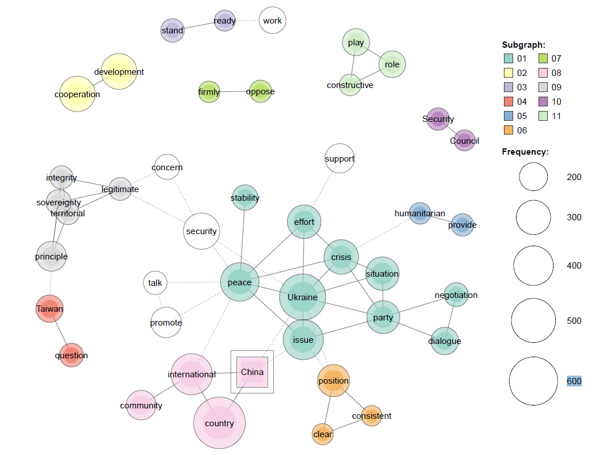

Closely related to its self-identification as a “responsible major power” and a benign actor is China’s depiction of itself as a “fair”, “just”, “objective” and “impartial” international player, unlike other major countries like the US, which are seen as hegemonic and coercive. This notion is illustrated, inter alia, in the following excerpt:

We have stood for fairness and justice, and made active efforts to encourage peace talks.… Some major country, in contrast, has contributed nothing to the peace talks but maneuvered to use the crisis to weaken Russia and fight Russia to the “last Ukrainian”. … They only want to use Ukraine as “cannon fodder” to wear Russia down and sacrifice Ukrainian lives to achieve their own hegemonic ambition and geostrategic goals. (MFA, 6 May 2022)

The fact that China perceives itself as a fair and just player is reflected in its self-image of an equidistant and inclusive actor, part of a shared “international community” and the “community” of mankind rather than of unilateral blocs (Figure 3). China rejects a “black-and-white, friend-or-foe approach” (MFA, 20 March 2022), taking sides “with anyone against anyone” (MFA, 22 April 2022) as well as resisting any efforts to coerce others to take sides.

Overall, China’s identity narratives highlight a set of traditional norms and principles that lie at the centre of China’s foreign policy rationale and actions, including the principles of “non-interference”, “respect for sovereignty” and the promotion of peace through “dialogue and negotiation”. The following excerpt provides a telling example of how China narrates its approach and principles:

As a responsible major country, China has explored workable Chinese approaches to solving hotspot issues. While adhering to the principle of non-interference in others’ domestic affairs and respecting the will and needs of the countries concerned, China has endeavoured to help settle hotspot issues in a constructive way. Our approach is one of promoting peace through negotiation, one that is both fair and pragmatic and that aims to address both the symptoms and root causes of hotspot issues. (MFA, 25 September 2022)

Notably, China also attaches strong importance to the norm of respect for sovereignty, which is a core theme in the overarching co-occurrence network. The term “sovereignty” is mentioned 241 times in the corpus and is frequently associated with “territorial integrity”, as evidenced in the following statement issued by the MFA:

China maintains that the sovereignty and territorial integrity of all countries should be respected and protected and the purposes and principles of the UN Charter abided by in real earnest. This position of China is consistent and clear cut and applies equally to the Ukraine issue. (MFA, 26 February 2022)

Nevertheless, as noted above, most Chinese sources refer to the concept of sovereignty in the context of Taiwan (see Figure 3). Instead, as will be discussed in the following section, with respect to the conflict in Ukraine, the defence of sovereignty is often juxtaposed with safeguarding the “legitimate security concerns” of countries, suggesting that China frames its identity as an honest, fair and just peace broker.

Policy-issue narratives
Policy narratives are informed by the system and identity narratives illustrated above (Ba 2019). As mentioned in the theoretical framework discussion, policy-issue narratives establish “the terrain on which policies on particular issues are formulated” (Wellings et al. 2017: 24), outlining how an actor views the appropriate response to a crisis and articulates a position based on material interest and/or what might be a normatively desirable outcome (Miskimmon and O’Loughlin 2017). Accordingly, this sub-section seeks to unpack what responses are regarded as appropriate and desirable in the context of the Russia-Ukraine crisis, based on which China’s policies and position on global security governance are formulated. Notably, China sees itself as the key player in terms of providing security, stability and peace in Ukraine (Figure 4). Historical accounts and Chinese culture and beliefs are often mentioned to legitimise China’s role. For instance, it is stated that “China has never invaded any country, never launched any proxy war, and never participated in or put together any military bloc” (MFA, 6 July 2022).

Figure 4. Co-occurrence network referencing the term “security”
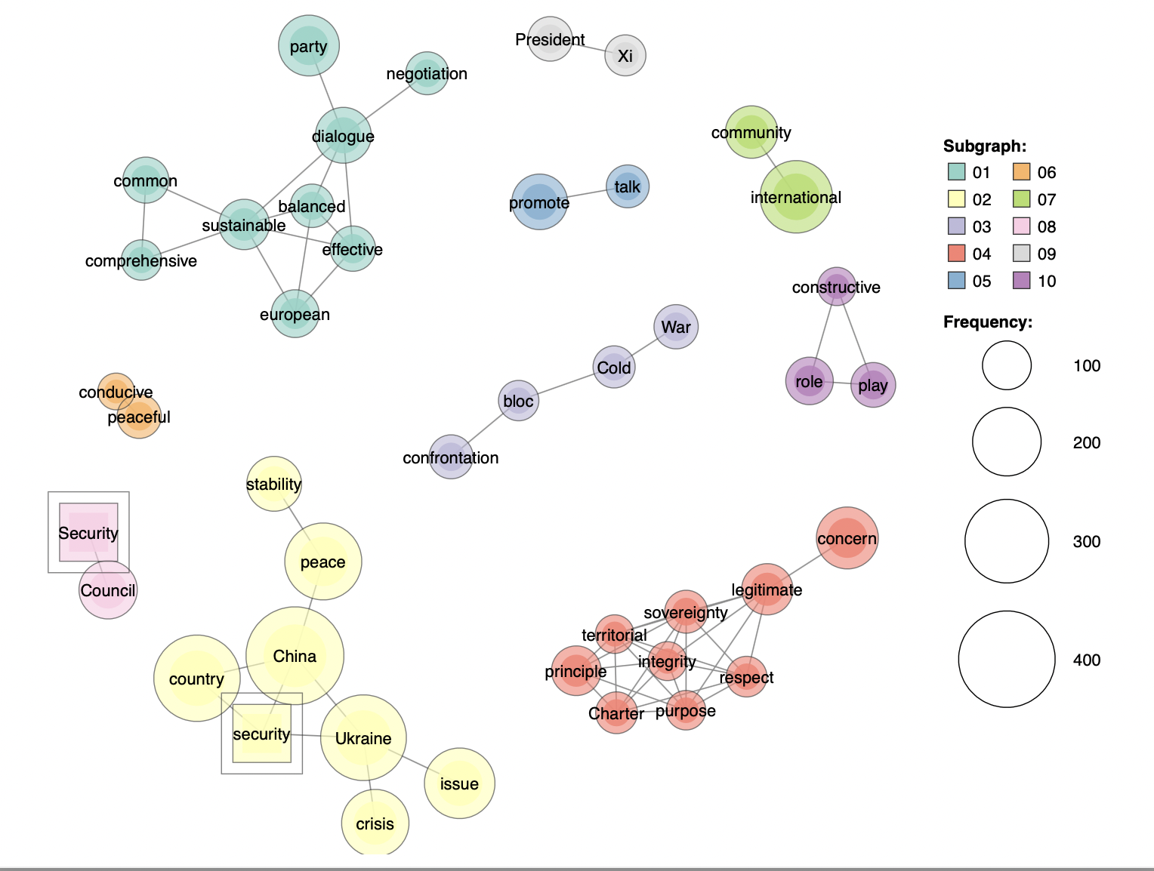

China’s policy narratives also suggest that reforming the global security governance system in line with a novel security vision based on the principles of “indivisible” and “absolute security” is one of China’s main desirable outcomes. These principles are laid down in the GSI, which outlines “a new type of security that replaces confrontation, alliance and a zero-sum approach with dialogue, partnership and win-win results” (MFA, 6 May 2022). China’s discourses describe the GSI as a fundamental solution for eliminating “the peace deficit” and emphasise “China’s input to meeting global security challenges” (MFA, 26 September 2022). As shown in Figure 4, which visualises China’s co-occurrence network for the term “security”, the Chinese discourse emphasises the following themes: “sustainable”, “common”, “balanced”, “comprehensive”, “constructive” and “dialogue”. This security vision also stresses the benefits of solidarity, in direct opposition to antagonistic “blocs”, “confrontation”, a “Cold War” mentality and unilateralism, while underscoring the need for “a new model of major country relationship” and a “community with a shared future of mankind”.
According to official Chinese sources, “an enduring solution would be for major countries to respect each other” (MFA, 9 March 19, 2022). China’s call for a new security vision aligns with its belief that the appropriate response to the crisis in Ukraine should consider that “the security of one country should not come at the expense of the security of other countries” and that the “legitimate security concerns of any country should be taken seriously” (MFA, 26 February 2022). As evidenced by Figures 3 and 4, this respect for countries’ territorial integrity, sovereignty and UN Chapter is associated with the need to address the “legitimate” security “concerns” of all parties. Both “legitimate” and “concern” are among the 150 most frequently cited words, being mentioned 191 and 179 times, respectively, in the corpus. Chinese sources frequently make statements resembling the following: “The final settlement of the Ukraine crisis requires abandoning the Cold War logic, abandoning the logic of ensuring one’s own security at the expense of others” (UN 2022). On the contrary, efforts to accommodate the “legitimate security concerns” of all parties are deemed to be the only way to achieve lasting peace and stability. By so stating, China thus backs Russia’s victimisation narrative, circumventing any request for withdrawal of the Russian army from occupied Ukrainian territories. At the same time, these contradictory and deliberately vague policy narratives, striving to find a middle ground of logic regarding the Ukrainian conflict, demonstrate China’s unwillingness to address the policy issue at the heart of the war itself. China is indeed not providing any practical suggestion on how it would be possible to reconcile the irreconcilable positions between Russia, wanting to annex Ukraine to secure itself, and Ukraine, willing to preserve its territorial sovereignty.
Significantly, sources also refer to the need to safeguard the legitimate rights and interests of China as well as those of the vast number of developing small and medium countries whose interests are threatened by the interests of hegemonic powers. In this way, China presents itself as a leader and voice defending the development of nations and promoting a more just and reasonable form of security governance.
Regarding China’s perception of what is appropriate for a state to do in the context of the Ukraine crisis, it is clear that China prioritises “dialogue and negotiation” (n=115) and diplomacy as the most effective and appropriate conflict resolution mechanisms, as well as the foundational elements for building a “sustainable security architecture” and as “the only means through which Europe can achieve lasting peace and stability” (MFA, 8 April 2022).
The following excerpt demonstrates how China places “dialogue and negotiation” at the centre of its vision and approach to mitigate the crisis:

It is China’s consistent belief that dialogue and negotiation is the only right way to resolve the Ukraine crisis. We call on both Russia and Ukraine to stick to the course of dialogue and negotiation, work in the same direction and reach consensus on a political resolution to avoid further escalation of the situation and restore peace at an early date. Under the current circumstances, the international community should speak and act in a way conducive to dialogue and negotiation, and support Russia and Ukraine in keeping the talks going to bring about outcomes for peace. It is important to stay wary of and prevent adding fuel to the fire and heightening tensions, which will only impede the diplomatic settlement of the issue. (MFA, 30 March 2022)

This is confirmed by the term solution–resolution in the co-occurrence network (Figure 5), which further demonstrates that China’s central theme concerning the appropriate response to the conflict in Ukraine is a new vision based on a sustainable, balanced security architecture and dialogue-centred and diplomatic tools, which respect the legitimate concerns of the parties.

Figure 5. Co-occurrence network referring to the term “solution–resolution”

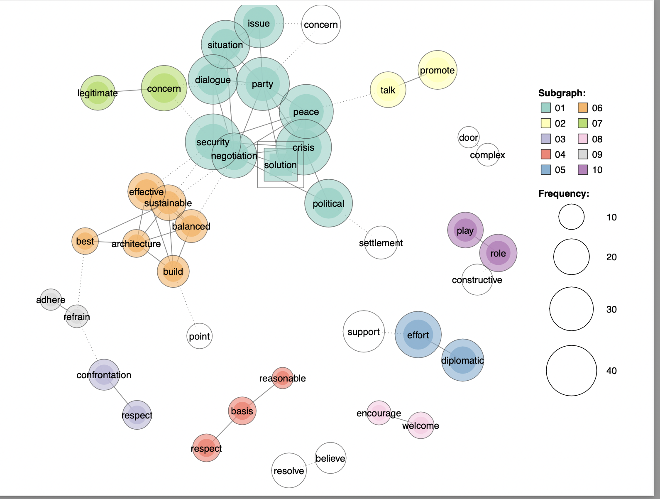

In contrast, China’s policy narratives illustrate its firm opposition to unilateral sanctions. “Sanctions”, one of the most frequent terms in the corpus linguistic data (566), are described as “illegal”, with “no basis in international law” and no Security Council mandate. They are portrayed with negative connotations as inadequate and even dangerous instruments, which instead of solving the conflict serve to fuel tensions, as indicated by the following statements:

Peace can never be achieved by imposing sanctions and pressure or sending weapon. (Permanent Mission of the People’s Republic of China to the United Nations, 24 August 2022)

History has shown time and again that instead of solving problems, imposing sanctions is like “putting out fire with firewood” and will only make things worse. (MFA, 19 March 2022)

The massive, indiscriminate sanctions imposed by a few countries on Russia have not helped the situation deescalate at all. (MFA, 6 June 2022)

Chinese sources also warn that many countries around the world are becoming “victims” of the sanctions imposed on Russia due to the spillover effects caused by severe financial, food and energy disruptions. Sanctions are connected to negative effects, especially with regard to the economies of vulnerable countries. Interestingly, “unlike the US which have the ability to ability to impose sanctions on any country it dislikes”, Europe is also presented as a victim of this approach: “[s]anctions have caused enormous hardship for ordinary Russian citizens as well as citizens across the EU member states” (China Daily, 19 August 2022). Closely related to this notion is the call for the EU to craft its “strategic autonomy” vis-à-vis the US. As reported by one source, “The EU should act more independently, rather than allow the US to dictate its policies” (China Daily, 29 September 2022).
Finally, while calling for a new vision for global security governance as well as dialogue-centred mechanisms, our data reveal that China’s identity narratives attach great importance to the UN and, in particular, to the United Nations Security Council’s role in solving the current crisis (Figure 5). According to sources, “China believes that to resolve the current crisis, we must uphold the purposes and principles of the Charter of the United Nations (UN)” (MFA, 3 July 2022). In particular, China attributes a leading role to the UN Security Council, which “should play a constructive role in resolving the Ukraine issue and give priority to regional peace and stability and the universal security of all countries” (MFA, 26 February 2022). Furthermore, “the Security Council, as the core of the international collective security mechanism, should make full use of the mediation tools given by the Charter, and stick to the right direction of ceasefire and peace talks” (Permanent Mission of the People’s Republic of China to the UN, 27 September 2022).

Conclusion

This paper is the first systematic effort to map out and examine China’s strategic narratives on the war in Ukraine. Our findings (Table 2), based on data collected over a ten-month period, show that China has refrained from condemning Russia’s invasion of Ukraine and has often aligned with and amplified Russia’s key strategic narratives, thereby not attaining a neutral stance. China has portrayed the conflict as a struggle over the future world order, with the US-centred bloc on one side and Russia on the other. China’s narratives on the Ukraine conflict also reflect China’s self-recognition as a benign power, a force for good and part of a wider international community, which rejects acts of hegemony, domination and bullying. From Beijing’s perspective, in contrast to the US, which is constrained by its Cold War and bloc mentality, and the EU, painted as dependent on and subordinate to the US sphere of influence, China positions itself as a just, fair, objective and equidistant player. This suggests China’s effort to engage those countries, likely including public opinion within EU countries, which are dissatisfied with the current management of security issues. Furthermore, the study demonstrates China’s growing confidence in its security role as well as its suitability for tackling the current crisis. This self-recognition goes hand in hand with China’s quest for a reform of global security governance, as evidenced in China’s vision of GSI.
Taken together, China’ strategic narratives bear witness to the fact that the current security governance in the case of the war in Ukraine is in flux and highly contested. Sino-US competition is intensifying while, at the same time, the international system is experiencing growing contestation and collision of preferences. Against this backdrop, the extent to which China will lean towards Russia remains open to debate in light of China’s seeming struggle to find a position that best serves its national interests and apparent inability to find a unified formula to deal with the erratic dynamics of Russia’s war in Ukraine (Zhenze 2023). Along these lines, our study demonstrates how China’s system narratives adopt a dual-track approach, juggling between a support of Russia’s position, as manifested in the convergent strategic narratives about the responsibilities imposed by the Ukrainian war, the calls for a new international order, and maintaining distance from Russia that is in line with China’s traditional non-alliance policy. This contradiction is also reflected in China’s policy narratives which target a balance between the various parties involved. This study also invites International Relations scholars to reconsider the longstanding debate concerning China’s role as a “revisionist power versus status quo power” in global politics. The ambivalent dual-track approach and China’s aspiration to reform the global security governance highlighted in its strategic narratives indicate that the current debate about China’s position in global politics should transcend the conventional understanding of revisionist and status quo power as a dichotomy.
Notably, this study does not include the consideration of the concepts of hard power and soft power as a dichotomy. Instead, following Rothman’s (2011) revised understanding of power, the concepts of hard and soft power are viewed as a continuum of power based on the tools available for implementing different degrees of soft or hard power.
Overall, this study provides a deeper understanding of China’s view of the conflict in Ukraine in the process of illustrating China’s attitude toward global security governance. In particular, it sheds light on China’s discomfort with the current security architecture, based on US hegemony, and supports the claim that although Beijing continues to advocate the centrality of the UN to some extent, it also aspires to reshape the existing order in line with the GSI vision and non-confrontational tools. In turn, China’s contradictory strategic narratives provide evidence that China’s foreign and security policy is a work in progress, raising the necessity to acknowledge some degree of uncertainty with respect to China’s future intentions. In the months to come, it will be interesting to investigate whether, almost two years after Russia embarked upon its recent full-scale invasion of Ukraine, China’s strategic narratives have reflected continuity or change. Likewise, future research should scrutinise whether China’s sources of foreign policy prioritise and project similar and/or different views, values and solutions to the current conflict and, more generally, to security governance issues. Such an endeavour could provide valuable insights into China’s potential actions and contributions within the realm of global security.

Table 2: Strategic Narratives of Russia’s war on Ukraine
China’s system narratives on the war in Ukraine | View of the conflict, key players and how the system works | - The US is the key international player that sits at the centre of the international system and, shoulders the greatest responsibility for the conflict in Ukraine.  The Ukraine crisis is not perceived as a regional conflict between Russia and Ukraine, but as a conflict between the US/West and Russia;  - China is a promoter of cooperation, peace, development versus the US/West which have hegemonic attitudes and adopt Cold War mentality based on confrontation;  - China tries to distance itself from both the US/West and Russia when narrating this conflict, and sees itself as belonging to the wider international community (an outsider position)  - Europe/EU has been marginalized and framed as a victim
China’s identity narratives | Actor’s identity, role, values and goals | - China is a benign actor and a force for good in the context of this conflict which makes great efforts and plays an active/constructive role in promoting peace, stability, and dialogue  - China is a fair and just actor  - China’s identity is based on China’s norms and principles, including those traditional norms such as non-interference, sovereignty, consultation, mutual respect, but also some newly developed ideas such as community of common destiny
China’s policy narratives | What the post-crisis landscape should be | - China supports a shift towards a new security vision and approach to solve current security challenges. This vision is laid down in the Global Security Initiative as well as in China’s concepts of A new model of Major Country relations and Shared future of mankind  - China’s policy narratives also support the continuous centrality of the UN system to solve the current crisis
Source: Authors’ own compilation adapted from Miskimmon, O’ Loughlin & Roselle 2013.

References

Allison, G. (2017). Destined for War: Can America and China Escape Thucydides’s Trap? Boston: Houghton Mifflin Harcourt.

Ashworth, L. M. 2016. “Taking Narratives Seriously . . . Taking History Seri- ously?” Critical Studies on Security, 3 (3): 321–322.

Ba, A. (2019). China's "Belt and Road" in Southeast Asia: Constructing the Strategic Narrative in Singapore. Asian Perspective, 43(2): 249-272.

Baker, P., McEnery, T. and Gabrielatos, C., 2007. Using collocation analysis to reveal the construction of minority groups. Corpus Linguistics 2007, https://eprints.lancs.ac.uk/id/eprint/602/

Baker, P.,2007. Discourses of refugees and asylum seekers in the UK press, 1996-2006: Full Research Report. ESRC End of Award Report, RES-000-22-1381. Swindon: ESRC

Baker, P., Gabrielatos, C., Khosravinik, M., Krzyżanowski, M., McEnery, T. and Wodak, R. 2008. A useful methodological synergy? Discourse & society, 19(3): 273-306.

Bijian, Z. (2015). “China’s “Peaceful Rise” To Great-Power Status”, Foreign Affairs 84, no. 5 (September/October): 18–24.

Brown, K. 2021. Chinese storytelling in the xi Jinping era. The Hague Journal of Diplomacy 51:
1–11. https://doi.org/10.1163/1871191X-BJA10054.

Carey, J. W. (2008). Communication as culture, revised edition: Essays on media and society. Routledge.

China Daily, July 13, 2022. Diplomats' meeting a silver lining for Sino-US relations.

China Daily, 19 August 2022. No, collective punishment can't help end Ukraine crisis.

China Daily, 29 September 2022. EU harming itself by clinging to US: China Daily editorial.

China Daily, 18 November 2022. NATO shouldn't be a bloc on road to peace.

Cross, M. K. D. (2017). The politics of crisis in Europe. Cambridge University Press.

Ercan, S. A., & Marsh, D. (2016). Qualitative methods in political science. In Handbook of research methods and applications in political science (pp. 309-322). Edward Elgar Publishing.

Finnemore, M. & Sikkink, K. (1998). International norm dynamics and political
change. International Organization, 52(4), 887–917.

Foot. R. (2006). “Chinese Strategies in a US-Hegemonic Global Order: Accommodating and Hedging”, International Affairs, 82 (1): 77–94.

Freake, R., Gentil, G. and Sheyholislami, J., 2011. A bilingual corpus-assisted discourse study of the construction of nationhood and belonging in Quebec. Discourse & Society, 22(1): 21-47.

Hagström, L., & Gustafsson, K. (2021). The limitations of strategic narratives: The Sino-American struggle over the meaning of COVID-19. Contemporary Security Policy, 42(4): 415-449.

Hartig, F. (2015). Communicating China to the World: Confucius Institutes and China's Strategic Narratives. Politics (Manchester, England), 35(3-4): 245-258.

Higuchi, K. (2016) “A Two-Step Approach to Quantitative Content Analysis: KH Coder Tutorial using Anne of Green Gables (Part I)” Ritsumeikan social sciences review 52(3): 77-91.

Hinck, R., Cooley, A., Cooley, S.C., & Kitsch, S. (2021). The Future of Global Competition: Ontological Security and Narratives in Chinese, Iranian, Russian, and Venezuelan Media (1st ed.). Routledge.

Hinck, R., Manly, J., Kluver, R., & Norris, W. (2018). Geopolitical Dimensions of "The China Dream": Exploring Strategic Narratives of the Chinese Communist Party. China Media Research, 14(3), 99.

Jacques, M. (2009). When China rules the world: The end of the western world and the birth of a new global order. Penguin.

Johnston, A. I. (2003). “Is China a Status Quo Power?” International Security, 27 (4): 5–56.

Kohlbacher, F. (2006). The use of qualitative content analysis in case study research. In Forum qualitative sozialforschung/forum: Qualitative social research, 7, (1): 1-30. Institut fur Klinische Sychologie and Gemeindesychologie.

Lams, L. (2018). Examining Strategic Narratives in Chinese Official Discourse under Xi Jinping. Chinese Journal of Political Science, 23(3), 387-411.

Leslie, F., & Roselle, L. (2023). Conflict in the international system in the time of Trump: Strategic narratives in White House daily newsletters. Media, War & Conflict, 16(3), 303–324.

McEnery, T. (2019). Corpus linguistics. Edinburgh University Press.

Mearsheimer, J. J. (2010). The gathering storm: China’s challenge to US power in Asia. The Chinese journal of international politics, 3(4), 381-396.

MFA, February 26, 2022. Wang Yi Expounds China's Five-Point Position on the Current Ukraine Issue.

MFA, February 27, 2022. Wang Yi Speaks with German Foreign Minister Annalena Baerbock on the Phone.

MFA, March 15, 2022. Foreign Ministry Spokesperson Zhao Lijian’s Regular Press Conference on March 15.

MFA, March 17, 2022. Foreign Ministry Spokesperson Zhao Lijian’s Regular Press Conference on March 17, 2022.

MFA, March 18, 2022. Foreign Ministry Spokesperson Zhao Lijian’s Regular Press Conference on March 18, 2022.

MFA, March 19, 2022. Vice Foreign Minister Le Yucheng Attends and Addresses the Fourth International Forum on Security and Strategy.

MFA, March 20, 2022. Wang Yi: China and other developing countries have reasonable concerns and similar positions on the current situation in Europe.

MFA, March 30, 2022. Foreign Ministry Spokesperson Wang Wenbin’s Regular Press Conference on March 30, 2022

MFA, April 1, 2022. Wang Yi Talks about China's Five-Pronged Perseverance on Ukraine Issue.

MFA, April 6, 2022. Foreign Ministry Spokesperson Zhao Lijian’s Regular Press Conference on April 6.

MFA, April 8 2022. State Councillor and Foreign Minister Wang Yi had a phone conversation with French President's Diplomatic Counsellor Emmanuel Bonne.

MFA, April 18, 2022. Ambassador Qin Gang Publishes an Article Entitled “The Ukraine Crisis and Its Aftermath” on The National Interest.

MFA, April 22, 2022. Foreign Ministry Spokesperson Zhao Lijian’s Regular Press Conference on April 22, 2022.

MFA, May 6, 2022. Acting on the Global Security Initiative To Safeguard World Peace and Tranquility Keynote Speech by Vice Foreign Minister Le Yucheng at “Seeking Peace and Promoting Development: An Online Dialogue of Global Think Tanks of 20 Countries”.

MFA, June 6, 2022. Foreign Ministry Spokesperson Zhao Lijian’s Regular Press Conference on June 6, 2022

MFA, June 29, 2022. Foreign Ministry Spokesman Zhao Lijian’s Remarks.

MFA, July, 3 2022. State Councilor and Foreign Minister Wang Yi Meets the Press.

MFA, July 6, 2022. Foreign Ministry Spokesperson Zhao Lijian’s Regular Press Conference on July 6, 2022

MFA, July, 11, 2022. Foreign Ministry Spokesman Wang Wenbin’s Remarks.

MFA, July 15, 2022. Wang Yi Gives an Interview to the Chinese Central Media on Attending the LMC Foreign Ministers' Meeting and the G20 Foreign Ministers' Meeting, Visiting Five Southeast Asian Countries, and Chairing Meetings of China-Vietnam and China-Cambodia Bilateral Mechanisms.

MFA, July 25, 2022. Foreign Ministry Spokesperson Zhao Lijian’s Regular Press Conference on July 25, 2022.

MFA, September 15, 2022. President Xi Jinping Meets with Russian President Vladimir Putin.

MFA, September 25, 2022. Making Every Effort for Peace and Development and Shouldering the Responsibility for Solidarity and Progress.

MFA, September 26, 2022. Foreign Ministry Spokesman Wang Wenbin’s Remarks.

MFA, September 30, 2022. Foreign Ministry Spokesperson Mao Ning's Regular Press Conference on September 30, 2022.

MFA, November 1, 2022. Foreign Ministry Spokesperson Zhao Lijian’s Regular Press Conference on November 1, 2022

Miskimmon, A., & O'Loughlin, B. (2017). Russia’s Narratives of Global Order: Great Power Legacies in a Polycentric World. Politics and Governance, 5(3): 111-120.

Miskimmon, A, O’Loughlin, B., & Roselle, L. (2013). Strategic narratives: Communication power and the new world order New York, NY: Routledge.

Mochtak M, Turcsanyi R.Q (2021) Studying Chinese foreign policy narratives: Introducing the ministry of foreign affairs press conferences corpus. Journal of Chinese Political Science, 26(4):743-761.

Ning A. (2019) Confucian values and Chinese geopolitical discourse on terrorism: China’s reappraisal of international security politics, Eurasian Geography and Economics, 60 (3), 284-303, DOI: 10.1080/15387216.2019.1667842

Permanent Mission of the People’s Republic of China to the UN, 24 August 2022. Remarks by Ambassador Zhang Jun at the UN Security Council Briefing on Ukraine.

Permanent Mission of the People’s Republic of China to the UN, 27 September 2022. Remarks by Ambassador Zhang Jun at the UN Security Council Briefing on Ukraine, 27 September.
Roselle L., A. Miskimmon and B. O’Loughlin. 2014. “Strategic Narrative: A New Means to Understand Soft Power.” Media, War, & Conflict, 7 (1): 70–84.

Rosendal, T. (2022). China’s Buddhist strategic narratives in Sri Lanka—benefits and Buddhism? Pacific Review, 1-30. DOI: 10.1080/09512748.2022.2120063

Rothman, S. B. (2011). Revising the soft power concept: what are the means and mechanisms of soft power?. Journal of Political Power, 4(1), 49-64.

Schmitt, O. (2018). When are strategic narratives effective? The shaping of political discourse through the interaction between political myths and strategic narratives. Contemporary Security Policy, 39(4), 487-511.

Shenhav, S. (2006). Political Narratives and Political Reality. International Political Science Review, 27(3), 245-262.

UN (2022) General Assembly Overwhelmingly Adopts Resolution Demanding Russian Federation Immediately End Illegal Use of Force in Ukraine, Withdraw All Troops, 2 March. https://press.un.org/en/2022/ga12407.doc.htm.

Van Noort, C., & Colley, T. (2022). Strategic narratives, ontological security and global policy: Responses to China’s Belt and Road Initiative (Palgrave studies in international relations).

Wellings, B., Kelly, S., Wilson, B., Burton, J., & Holland, M. (2018). Narrative Alignment and Misalignment: NATO as a Global Actor as Seen from Australia and New Zealand. Asian Security (Philadelphia, Pa.), 14(1), 24-37.

Xinhua (2013), “Xi Jinping: Ideological work is the party’s extremely important task”, Xinhuanet, August 20.

Yang, Y. (2021). China's Strategic Narratives in Global Governance Reform under Xi Jinping. The Journal of Contemporary China, 30(128), 299-313.

Zeng, J. (2019). Narrating China's belt and road initiative. Global Policy, 10(2), 207-216.

Zhang, Y., & Orbie, J. (2021). Strategic narratives in China's climate policy: Analysing three phases in China's discourse coalition. Pacific Review, 34(1), 1-28.

Zhenze, Huang (2023). Will China Change Its Approach to the Ukraine War?. The Diplomat. July 8.

Senior Lecturer, Department of International Relations, Faculty of Arts, University of Malta
Assistant Professor in Politics and International Relations, Northeastern University London

