A New Collision Avoidance System for Smart Wheelchairs Using Deep Learning
Malik Haddad¹, David Sanders², Giles Tewkesbury², Martin Langner³ and Will Keeble²
¹Northeastern University – London, St. Katharine’s Way, London, UK
²Faculty of Technology, University of Portsmouth, Anglesea Road, Portsmouth, UK
³Chailey Heritage Foundation, North Chailey, Lewes, UK
malik.haddad@nchlondon.ac.uk
Keywords: Collision Avoidance, Smart Wheelchair, Steering, Deep Learning.
Abstract: The work presented in this paper presents a new collision avoidance system for smart wheelchair steering using a Deep Learning architecture. The system used a 6-layer Artificial Neural Network (ANN) and applied a Rule-based method to create training and testing sets. Three ultrasonic sensors were used to create an array. The sensors measured the distance to the nearest object to the left, right and in front of the wheelchair. Readings from the array were utilised as inputs to the ANN. The system employed Deep Learning to avoid obstacles. The driving directions considered were turn left, spin left, forward, spin right, turn right and stop. The outcome of the new system drove the smart wheelchair away from obstacles. The new system provided reliable results when tested and provided 99.17% training accuracy and 97.53% testing accuracy. The testing confirmed that the new system successfully steered a smart wheelchair away from obstacles. The system can be overridden if required. Clinical tests will be carried at Chailey Heritage Foundation.

1 Introduction
A new collision avoidance system for smart wheelchairs using Deep Learning is presented. The work is part of wider research carried out at the University of Portsmouth and Chailey Heritage Foundation supported by the Engineering and Physical Sciences Council (EPSRC) (Sanders and Gegov, 2018). The aim of the research is to apply AI to powered mobility problems to enhance mobility and improve the quality of life for users with impairments.
The number of people diagnosed with disability worldwide is on the rise. The type of disability is shifting from mostly physical to a more complex mix of physical/cognitive disabilities. New systems to address that shift in disability are required. Smart mobility is becoming more acceptable and useful to support individuals with a disability (Haddad and Sanders, 2020). Smart mobility is expected to revolutionize the quality of life of people with disabilities in the next two decades. Many researchers have presented novel approaches for navigating powered mobility (Sanders et al., 2010; Haddad and Sanders, 2019; Haddad et al., 2019; Haddad et al., 2020a; Haddad et al., 2020b) by creating Human Machine Interfaces (Nguyen et al., 2013; Haddad et al, 2020c; Haddad et al., 2020d; Haddad et al., 2021a), intelligent collision avoidance systems and intelligent controllers(Sanders and Stott, 2009; Langner, 2012; Sanders et al., 2021), sensors and sensor fusion (Larson et al., 2008; Milanes et al., 2008; Sanders and Bausch, 2015; Sanders, 2016; Sanders et al., 2019), Deep Learning (Haddad and Sanders, 2020), expert systems (Sanders et al., 2018; Sanders, 2020), and image processing (Sanders, 2009; Tewkesbury, 2021; Haddad et al., 2021b) and they have analysed the behaviour of powered wheelchair drivers to improve mobility (Sanders, 2009; Sanders et al., 2016; Sanders et al., 2017; Sanders et al., 2019b; Haddad et al., 2020e; Haddad et al., 2020f; Sanders et al., 2020b; Sanders et al., 2020c; Sanders et al., 2021b).
This paper presents a collision avoidance system used to safely steer smart wheelchairs away from obstacles by employing Deep Learning. Section 2 presents the Deep Learning method. Section 3 presents the training and testing of the Deep Learning architecture.
Section 4 presents some testing of the collision avoidance system. Section 5 presents a discussion and some results. Conclusions and future work are presented in Section 6.

2 The New System
A New Deep Learning architecture was created to deliver a collision-free driving route for smart wheelchairs. A three ultrasonic sensor array was created. The sensors detected objects in the wheelchair’s surroundings and calculated the distances from to the nearest object to the right (D_{right}), in front (D_{centre}), and to the left (D_{left}) of the wheelchair. The distances from the ultrasonic sensors were considered as inputs to the Deep Learning approach. Three inputs were considered: D_{right}, D_{centre} and D_{left}. The new system conducted Deep Learning and provided a safe driving direction for the smart wheelchair based on these distances. The directions considered were turn left, turn right, spin left, spin right, forward and stop.
A new Artificial Neural Network (ANN) was created and used in this paper. The structure of the ANN is shown in figure 1.
The rule-based method was considered to create testing and training sets for the architecture similar to the approach used in Haddad and Sanders (2020).
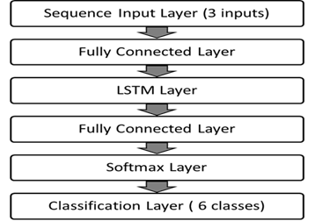
Figure 1: Structure of the ANN.
The ANN consisted of six layers:
- Input Sequence Layer (3 inputs).
- Fully Connected Layer.
- LSTM Layer (100 hidden nodes).
- Fully Connected Layer.
- Soft-Max Layer.
- Classification Layer.
MATLAB was used to create the ANN with 3 input units, 100 hidden-units in the LSTM Layer and 6 output units. An ADAptive Momentum estimation algorithm (ADAM) was used with a learning rate of 0.01 and 100 epochs.
3 Training and Testing the Deep Learning Architecture
MATLAB was used to train and test the Deep Learning Architecture. A (5000x4) matrix considered in Haddad and Sanders (2020) was used for testing and training. The matrix was divided into a 3:7 ratio to create testing and training sets respectively.
Figure 2 shows training progress using a learning rate of 0.01 and 100 epochs. As training progressed, training accuracy improved (shown as a blue curve in the upper half of figure 2). Training loss reduced (shown as an orange line in the lower half of figure 2). After completing 100 epochs, the training accuracy increased to more than 99%. The testing accuracy reached 97.53% when tested against the same testing set considered in Haddad and Sanders (2020). Figure 3 shows the confusion matrix generated from testing the architecture against the testing set.
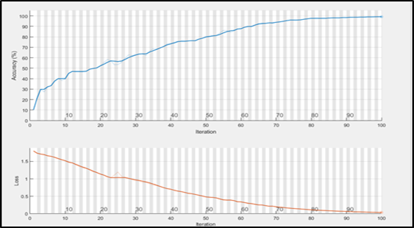
Figure 2: Screenshot of training progress. Training accuracy is shown as a blue curve (top) increasing and training loss is shown as an orange curve (bottom) decreasing.
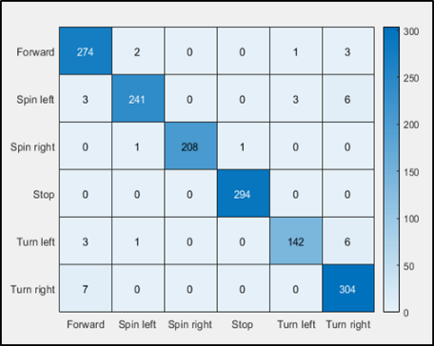
Figure 3: Confusion matrix used to assess the architecture accuracy.
The architecture required 1 minute and 15 seconds to finish 100 epochs with a learning rate of 0.01. The training accuracy reached 99.17%. The architecture achieved 97.53% testing accuracy.

4 Testing
The trained and tested system was used to deliver a safe driving route for smart wheelchairs using ultrasonic sensor array readings. Three scenarios were examined as a wheelchair drove through an environment with obstacles as shown in figure 4:
Scenario 1: Nothing detected (Pos. 1 in figure 4).
Scenario 2: Obstacles detected in front and to the right (Pos. 2 in figure 4).
Scenario 3: Obstacles detected in front and to the left (Pos. 3 in figure 4).
Six possible outcomes were considered as possible directions for a smart wheelchair: turn left, turn right, spin left, turn right, forward and Stop.
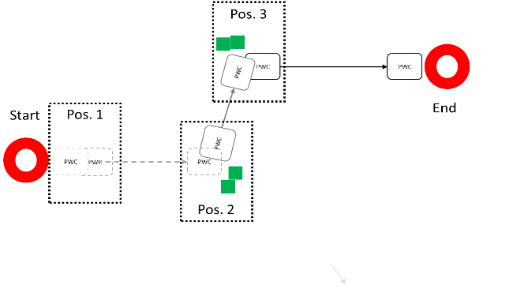
Figure 4: Smart wheelchair moving in an environment containing obstacles.
4.1 Scenario 1: No Obstacles Detected
At the start of the driving session, no obstacles were detected by the sensors as shown at Pos. 1 in figure 4. The value of D_{right} = 0.99, D_{centre} = 0.99 and D_{left} = 0.99.
The collision avoidance system output was “Forward” and shown by a red oval in figure 5.
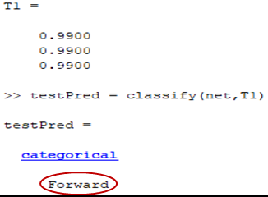
Figure 5: Output of the collision avoidance system for Scenario 1.
4.2 Scenario 2: Obstacle Detected in front and to the Right
As the wheelchair drove forward obstacles were detected in front and to the right as shown at Pos. 2 in figure 4. The value of D_{right} = 0.04, D_{centre} = 0.02 and D_{left} = 0.99.
The collision avoidance system output was “spin left” and shown by a red oval in figure 6.
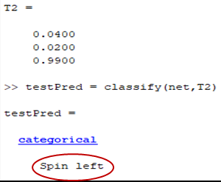
Figure 6: Output of the collision avoidance system for Scenario 2.
4.3 Scenario 3: Obstacles Detected in front and to the Left
As the wheelchair moved obstacles were detected in front and to the left as shown at Pos. 3 in figure 4. The value of D_{right} = 0.99, D_{centre} = 0.05 and D_{left} = 0.07.
The collision avoidance system output was “spin right” shown by a red oval in figure 7.
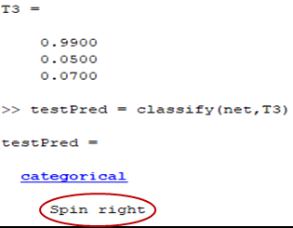
Figure 7: Output of the collision avoidance system for Scenario 3.
5 Discussion and Results
A new collision avoidance system for smart wheelchairs was created using a Deep Learning approach. Readings from an ultrasonic sensor array were considered as inputs to the Deep Learning approach. A Rule-based method similar to the Rule-based approach used by Haddad and Sanders (2020) was used to create sets used to train and test a new ANN. A 6-Layer ANN was created using MATLAB. MATLAB platform was used to train and test the ANN.
The new Deep Learning architecture achieved 99.17% training accuracy and 97.53% accuracy when tested against the same training and testing sets used by Haddad and Sanders (2020). The new architecture achieved higher accuracy than the architecture used in Haddad and Sanders (2020). Moreover, the new architecture required 42.75% less time to train the new ANN using the same training set, training platform and CPU used in Haddad and Sanders (2020).
The new collision avoidance system was tested. Three scenarios were considered. Readings from the ultrasonic sensor array were considered as inputs to the Deep Learning architecture. The collision avoidance system successfully drove a smart wheelchair away from obstacles and provided a safe route.
6 Conclusions and Future Work
The new collision avoidance system provided successful results when tested and it successfully steered smart wheelchairs away from obstructions. The ultrasonic sensor array measured the distance from the closest object to the left, centre, and right of the wheelchair. Sensor readings were used as inputs for the ANN.
The Deep Learning approach used in this paper provided more accurate results during training and testing than the approach presented in Haddad and Sanders (2020). Moreover, the new system required 42.75% less time to train the ANN against the same training set and using the same platform and CPU used in Haddad and Sanders (2020).
The new system could continuously learn to drive smart wheelchairs in new environments and would introduce some independence and reduce the need for helpers by using other computationally inexpensive and simple Deep Learning architectures.
The user could override the new system if required by holding a joystick or any other input device still in position. User input was combined so that the system would be overridden by the user. If no obstacles were detected, then the smart wheelchair would drive as instructed by a user.
Results showed that the system provided good results. The new system will be tested to meet safety standards before being trialled at Chailey Heritage foundation.
The system presented in this paper used dynamic and simple yet effective AI techniques for smart wheelchair navigation and can be expected to improve reliance and self-confidence, enhance mobility, increase autonomy, and provide a safe route for smart wheelchair users.
Future work will investigate general shifts in impairment from purely physical to more complex mixes of cognitive/physical. That will be addressed by considering levels of functionality rather than disability. New transducers and controllers that use dynamic inputs rather than static or fixed inputs will be investigated. Different AI techniques will be investigated and combined with the new types of controllers and transducers to interpret what users want to do. Smart inputs that detect sounds and dynamic movement of body parts using new contactless transducers and/or brain activity using EEG caps will be considered. The use of mixes of EEG, pre-processing, Fourier transform, and wavelet transforms will be investigated to determine user intentions.
References
Haddad, M., Sanders, D., 2019. Selecting a best compromise direction for a powered wheelchair using PROMETHEE, IEEE Trans. Neur. Sys. Rehab. 27 2 pp 228-235.
Haddad, M., Sanders, D., 2020. Deep Learning architecture to assist with steering a powered wheelchair, IEEE Trans. Neur. Sys. Reh. 28 12 pp 2987-2994.
Haddad, M., Sanders, D., Gegov, A., Hassan, M., Huang, Y., Al-Mosawi, M., 2019. Combining multiple criteria decision making with vector manipulation to decide on the direction for a powered wheelchair. In SAI Intelligent Systems Conference. Springer.
Haddad, M., Sanders, D., Ikwan, F., Thabet, M., Langner, M., Gegov, A., 2020c. Intelligent HMI and control for steering a powered wheelchair using a Raspberry Pi microcomputer. In 2020 IEEE 10th International Conference on Intelligent Systems-IS. IEEE.
Haddad, M., Sanders, D., Langner, M., Bausch, N., Thabet, M., Gegov, A., Tewkesbury, G., Ikwan, F., 2020d. Intelligent control of the steering for a powered wheelchair using a microcomputer. In SAI Intelligent Systems Conference. Springer.
Haddad, M., Sanders, D., Langner, M., Ikwan, F., Tewkesbury, G., Gegov, A., 2020a. Steering direction for a powered-wheelchair using the Analytical Hierarchy Process. In 2020 IEEE 10th International Conference on Intelligent Systems-IS. IEEE.
Haddad, M., Sanders, D., Langner, M., Omoarebun, P., Thabet, M., Gegov, A., 2020e. Initial results from using an intelligent system to analyse powered wheelchair users’ data. In the 2020 IEEE 10th International Conference on Intelligent Systems-IS. IEEE.
Haddad, M., Sanders, D., Langner, M., Tewkesbury, G., 2021b. One Shot Learning Approach to Identify Drivers. In SAI Intelligent Systems Conference. Springer.
Haddad, M., Sanders, D., Langner, M., Thabet, M., Omoarebun, P., Gegov, A., Bausch, N., Giasin, K., 2020f. Intelligent system to analyze data about powered wheelchair drivers. In SAI Intelligent Systems Conference. Springer.
Haddad, M., Sanders, D., Tewkesbury, G., Langner, M., 2021a. Intelligent User Interface to Control a Powered Wheelchair using Infrared Sensors. In SAI Intelligent Systems Conference. Springer.
Haddad, M., Sanders, D., Thabet, M., Gegov, A., Ikwan, F., Omoarebun, P., Tewkesbury, G., Hassan, M., 2020b. Use of the Analytical Hierarchy Process to Determine the Steering Direction for a Powered Wheelchair. In SAI Intelligent Systems Conference. Springer.
Langner, M., 2012. Effort Reduction and Collision Avoidance for Powered Wheelchairs: SCAD Assistive Mobility System, Ph.D. dissertation, University of Portsmouth.
Larsson, J., Broxvall, M., Saffiotti, A., 2008. Laser-based corridor detection for reactive Navigation, Ind Rob: An int' jnl 35 1 pp 69-79.
Milanes, V., Naranjo, J., Gonzalez, C., 2008. Autonomous vehicle based in cooperative GPS and inertial systems, Robotica, 26 pp 627-633.
Nguyen, V., et al. 2013. Strategies for Human - Machine Interface in an Intelligent Wheelchair. In 35th Annual Int Conf of IEEE-EMBC. IEEE.
Sanders D, Sanders D, Gegov A and Ndzi D 2017 Results from investigating powered-wheelchair users learning to drive with varying levels of sensor support Proc. of SAI Intelligent System (London) pp 241-245
Sanders, D., 2009. Comparing speed to complete progressively more difficult mobile robot paths between human tele-operators and humans with sensor-systems to assist, Assem. Autom. 29 3 pp 230-248.
Sanders, D., 2010. Comparing ability to complete simple tele-operated rescue or maintenance mobile-robot tasks with and without a sensor system, Sensor Rev 30 1 pp 40-50.
Sanders, D., 2016. Using self-reliance factors to decide how to share control between human powered wheelchair drivers and ultrasonic sensors, IEEE Trans. Neur. Sys. Rehab.25 8 pp 1221-1229.
Sanders, D., Bausch, N., 2015. Improving steering of a powered wheelchair using an expert system to interpret hand tremor. In the International Conference on Intelligent Robotics and Applications. University of Portsmouth.
Sanders, D., Gegov, A., 2018. Using artificial intelligence to share control of a powered-wheelchair between a wheelchair user and an intelligent sensor system, EPSRC Project, 2019.
Sanders, D., Gegov, A., Haddad, M., Ikwan, F., Wiltshire, D., Tan, Y. C., 2018. A rule-based expert system to decide on direction and speed of a powered wheelchair. In SAI Intelligent Systems Conference. Springer.
Sanders, D., Gegov, A., Tewkesbury, G., Khusainov, R., 2019. Sharing driving between a vehicle driver and a sensor system using trust-factors to set control gains. In Adv. Intell. Syst. Comput. Springer.
Sanders, D., Haddad, M., Langner, M., Omoarebun, P., Chiverton, J., Hassan, M., Zhou, S., Vatchova, B., 2020c. Introducing time-delays to analyze driver reaction times when using a powered wheelchair. In SAI Intelligent Systems Conference. Springer
Sanders, D., Haddad, M., Tewkesbury, G., 2021. Intelligent control of a semi-autonomous Assistive Vehicle. In SAI Intelligent Systems Conference. Springer.
Sanders, D., Haddad, M., Tewkesbury, G., Bausch, N., Rogers, I., Huang, Y., 2020b. Analysis of reaction times and time-delays introduced into an intelligent HCI for a smart wheelchair. In the 2020 IEEE 10th International Conference on Intelligent Systems-IS. IEEE.
Sanders, D., Haddad, M., Tewkesbury, G., Gegov, A., Adda, M., 2021b. Are human drivers a liability or an asset?. In SAI Intelligent Systems Conference.Springer.
Sanders, D., Haddad, M., Tewkesbury, G., Thabet, G., Omoarebun, P., Barker, T., 2020. Simple expert system for intelligent control and HCI for a wheelchair fitted with ultrasonic sensors. In the 2020 IEEE 10th International Conference on Intelligent Systems-IS. IEEE.
Sanders, D., Langner, M., Gegov, A., Ndzi, D., Sanders, H., Tewkesbury, G., 2016. Tele-operator performance and their perception of system time lags when completing mobile robot tasks. In 9th Int Conf on Human Systems Interaction. University of Portsmouth.
Sanders, D., Langner, M., Tewkesbury, G., 2010. Improving wheelchair‐driving using a sensor system to control wheelchair‐veer and variable‐switches as an alternative to digital switches or joysticks, Ind Rob: An int' jnl. 32 2 pp157-167.
Sanders, D., Stott, I., 2009. A new prototype intelligent mobility system to assist powered-wheelchair users, Ind Rob: An int' jnl. 26 6 pp 466-475.
Sanders, D., Tewkesbury, G., Parchizadeh, H., Robertson, J., Omoarebun, P., Malik, M., 2019b. Learning to drive with and without intelligent computer systems and sensors to assist. In Adv. Intell. Syst. Comput. Springer.
Tewkesbury, G., Lifton, S., Haddad, M., Sanders, D., 2021. Facial recognition software for identification of powered wheelchair users. In SAI Intelligent Systems Conference. Springer.

