Are human drivers a liability or an asset?
David Sanders, Malik Haddad and Martin Langner
University of Portsmouth, Portsmouth, PO1 3DJ, UK
david.sanders@port.ac.uk
Abstract. This paper investigates the relationship between near misses and human error that leads to a collision. A Smart wheelchair that can detect obstacles is used as an example. Many collisions are the fault of the driver and could be avoided if a sensor system was allowed more control of the vehicle. Some claim that eliminating a human driver from a control loop could eliminate collisions caused by human error. Others caution that human error may not disappear completely with the elimination of the driver and that new incidents may occur because of it. Analysis suggests that a human driver is attributable to many errors but that at the same time a human is vital for avoiding many accidents. The volume of near misses in this analysis is of a sufficient quantity to make some generalized conclusions about the nature of the detection and mitigation of collisions. It would strengthen the analysis if near misses from other types of driving were available. Near misses are a source of information about potential collisions as if a person is having more near misses then they may be becoming tired or distracted. Near misses were analyzed in order to examine what role on-board human drivers play in the occurrence and detection of the initial stages of a collision.
Keywords: Obstacle Detection, Collisions, Driver, Control, Disabled, Wheelchair.
- Introduction
Unmanned vehicles, mobile robots and assistive systems such as semi-autonomous powered wheelchairs are expected to revolutionize society and industry in the coming decades [1]. With improved sensor and computing capabilities, vehicles and powered wheelchairs of the future are expected to be safer and more efficient [2-4]. However, autonomy does not imply unmanned although benefits of autonomous operation may come from the absence of human drivers. One of the most frequently claimed benefits is the elimination or at least reduction of human error. An estimated 75-96% of accidents can be attributed to human error [5] and an obvious solution might be to remove human drivers, and therefore human error.
In addition, autonomous vehicles get into accidents because things sometimes go awry, such as an AI software bug or a hardware fault or because a person unexpectedly leaps in front of a vehicle etc.
Ahvenjärvi [6] explained that there is human interaction in many aspects of operations, and that all aspects are subject to human error. He explained that removing humans may simply shift the human error from the driver to the designers, programmers and maintenance personnel. Even if the majority of accidents can be partly or fully attributed to human error, the onboard human drivers can be vital to the mitigation of consequences if an accident does happen. Wróbel examined accident reports and assessed whether the accident would have happened on an autonomous vehicle, and once it had - would its consequences have been different if there had been no human to counteract them [7]. They concluded that a number of accidents (such as collisions) may be reduced but that the consequences of any accidents will be greater because there is less ability for a human driver to mitigate the consequences. Wróbel explained that their study was limited in that they were only able to investigate incidents where accidents happened and not when humans were successfully able to prevent an accident from happening. Fortunately, it is the norm for vehicles to operate without incident or accidents most of the time. From time to time incidents happen that require a human driver to react. Most of the time these incidents are resolved without consequences and without any need to involve other people.
The literature is a little one-sided in that it mainly contains analysis about instances when things go wrong, not when they go right [1]. The work described in this paper is attempting to partly bridge that gap by considering collisions and near misses that were close to resulting in a collision but where either the human driver, or a collision avoidance algorithm, may have prevented collision. This paper investigates the role played by the sensor system and the human driver in detecting incidents and starts evaluating whether sensors can detect near misses and adjust controllers to intervene to stop them from developing into collisions.
- Do near misses suggest that collisions may occur?
The theoretical background for the analysis is presented here. Section 2.1 is a brief explanation of a near miss and the reporting process. Section 2.2 introduces the conceptual accidents model used in this paper.

  - Near Misses
Detecting and reporting of near misses can serve to improve safety by learning from past experiences. In this work, sensor mounted on a wheelchair recorded near misses and drivers reported near misses. The object was to investigate whether near misses could predict later collisions so that preventative measures could be put in place. This stems from the idea that even though a near miss may not have consequences, there may be proportionality between near misses and collisions. That concept is called the “iceberg model” or “accident pyramid” developed by Heinrich [8]. An example of Heinrich’s Pyramid is in Fig.1.
Accident prevention has moved on since the pioneering work begun by Heinrich in the 1930s. It is now widely accepted that the linear causal understanding of accidents that Heinrich proposed, and that the accident pyramid implied, is simplistic [9]. The ratio of major to minor accidents and near misses varies greatly and the causes of minor incidents and accidents are often not the same [10]. Some, but not all accidents can be predicted by minor incidents but not all minor incidents have the potential to develop into accidents. Accidents are often a consequence of a combination of circumstances and frequently come as a surprise, according to “Normal Accident Theory” [11]. It follows that the number of accidents that were prevented from happening for one reason or another may never be realized. It may never even be noticed that an accident was close to occurring.
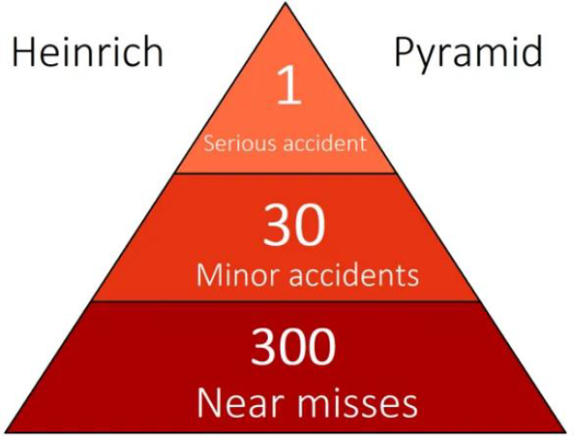
Fig. 1. Heinrich’s accident pyramid [12].
Evaluating safety performance based on the rate of near misses and/or minor incidents has been used [1,10]. One issue though is the sometimes tenuous relationship between minor incidents and accidents. Another equally important issue is the discrepancy between actual and reported incidents. There are many reasons why near misses are not reported. Sharing the experience of an accident that nearly happened with other people could ideally prevent it from happening again. There is, however, no obvious short-term incentive for an individual to report an incident. An individual may also fear being blamed, disciplined or embarrassed. If individuals feel that carers are unsupportive, complacent or insincere, they may be less inclined to report. In this work sensors were used to automatically report near misses.
The definition of a near miss can be ambiguous. Some people distinguish between unsafe conditions, unsafe acts, near misses, minor incidents, near accidents, etc. but others do not. Determining what qualifies as which, if any category, can be challenging. In this work a near miss was defined as detecting an object within a pre-set distance.
Near misses are not a perfect representation of how exposed a system or driver is to accidents but there is evidence for the importance of near misses as a tool to improving safety [13].

  - Bowties
A commonly used risk evaluation method to evaluate and understand causal relationships is the bowtie method, an example of which can be seen in Fig.2. The method is named after the shape, which resembles a bowtie. Causes are on the left and Consequences are on the right. In the center the bowtie converges in a Critical Event which is also called the top event. The Critical Event can be defined as an accident such as a collision [14]. Between the Causes and the Critical Event and between the Critical Event and the Consequences there are Barriers. A Barrier is in place to prevent, control or mitigate a hazard. Barriers can be physical barriers or other physical equipment, or they can be non-physical, such as procedures or policies. In this work the barrier is a sensor system, sometimes feeding an obstacle avoidance routine.
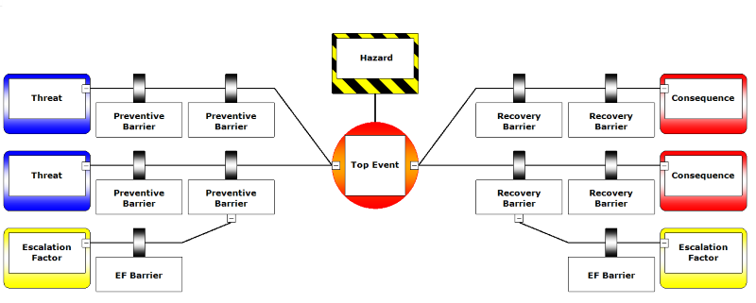
Fig. 2. Generic example of a bowtie [15].
There can be several Causes of a Critical Event and a Critical Event can have several Consequences. In this work the Critical Event was a collision. There can be many Causes of a collision and there can be many Consequences depending on the Barriers in place. Driving too fast for either the surface, situation or conditions is still one of the most common contributory factors in collisions. Distraction can be a major contributor (either by driver or carer) and even a quick glance away takes your eyes off the route for a second or two. Wheelchair users (and other drivers) can drive recklessly at least sometimes. And sometimes drivers are not aware of the risks around them (other vehicles and people). Finally, drivers can get tired or just may not have the full ability to drive safely without assistive systems or carers. By focusing on the Critical Event, a collision, it becomes evident whether there are sufficient Barriers in place. Although it is possible to define Causes, Critical Event and Consequences, it can be difficult to distinguish clearly between them [16]. The bowtie can be used both quantitatively and qualitatively to include them all. In this paper, the bowtie model used to understand the concept of developing collisions.
- Method and Testing
Safety-related information such as near misses for a wheelchair user or driver can contain sensitive information about an individual or can be time consuming to assemble and has not normally collected. A series of tests took place at the University of Portsmouth. Testing was undertaken to compare the number and type of near misses and collisions recorded when the system was being jointly controlled using a mixture of computer and human control, and when just being controlled by a human user. Several tests were conducted through a variety of courses. Half with the sensors just recording near misses and collisions and half with the sensors connected to a collision avoidance routine to provide automatic assistance. Obstacle courses were created for each test. The courses were within various corridors with some sloping and flat surfaces, walls, and doorways and extra obstacles were added in staggered formations.
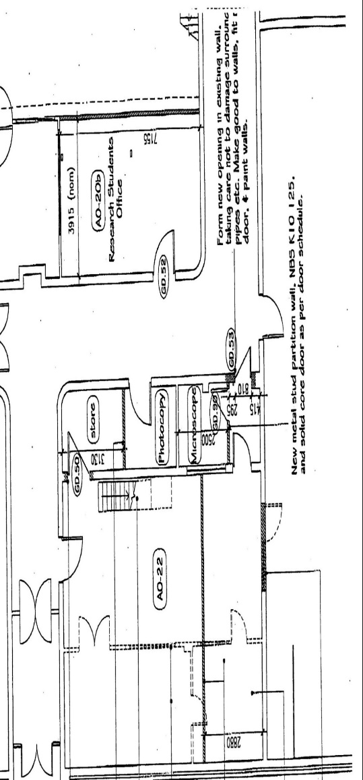
Staff and students at the University of Portsmouth volunteered to drive during the testing. They were mainly students. A clear explanation of the study was provided (including benefits and risks) and the University Ethics Committee approved the testing procedure. There were 11 males and 4 females.
Fig.3 is a sketch of Corridor Three. Arrows show a general route for a wheelchair. Shaded blocks are the obstacles in the wheelchair path. Corridor Three also included two double-doorways where one door was kept shut and the other open. That meant the chair had to be zig-zagged to pass through them.
Fig.3. Corridor Three.
103 near misses were recorded by the sensor system and examined to evaluate their relationship to collisions. The near misses originated from 13 different volunteer drivers. The near miss reports consisted of a time and a distance.
This section describes the method used in the analysis of near misses. Section 4.1. describes the scenario in which the analysis was undertaken. In Section 4.2. the initial selection of near misses for analysis is described and in Section 4.3. the further categorization of the near misses is explained.
Some assumptions about the on-board equipment and operation of the wheelchairs was made for the purpose of the analysis. The scenario was based on a powered wheelchair driving through various cluttered environments [17-23]. A microcontroller had access to all the inputs from the monitoring system on the wheelchair. The microcontroller could start, stop and operate the electric motors driving the wheelchair. If the joystick controlling the wheelchair was held in the forward position then control was effectively given to the sensors and the wheelchair operated autonomously; the wheelchair perceived and reacted to objects without any outside control.
The added complexity and possible additional sources of failure resulting from the remote monitoring are not considered.
The control system described in [24] was implemented where a Lyapunov-based technique was employed to guarantee convergence and robustness of the system. The basic principle of the technique was to account for disturbance such as veer to suitably steer the powered wheelchair on a desired path.
The categorization of the near misses was done in four steps. Near misses were first categorized into types of comparable incidents. There are large variations between near misses and exact evaluations of each incident were difficult. In the first categorization step, the outcomes from the initial selection were categorized into three near miss types; Very close, Close, and Marginal. The ranges were actually analogue but were simplified into the three categories.
- Results
The initial selection described in Section 3 resulted in 103 near misses from the testing. Categorizing the near misses resulted in the distribution shown in Fig. 4. The largest segment was Marginal, which represented 44% of the near misses. Close, which represented 37%, and the remaining 19% related to Very close.
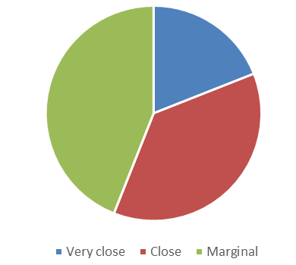

Fig.4. Near misses by type.
Fig.5. shows the number of near misses and the number of collisions.
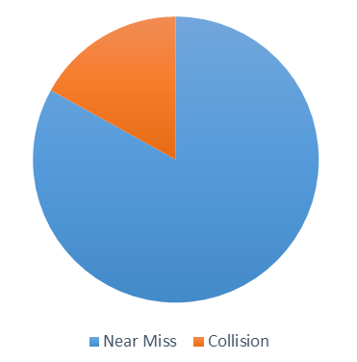
Fig.5. The number of near misses and the number of collisions.

Alarms on sensors and obstacle avoidance routines can warn of close, or projected close proximity to objects and obstacle avoidance routines can take evasive action.
The evaluation of whether a situation was dangerous or safe relied on the interpretation of different inputs about the actual situation and about intended future actions. Proximity alarms were often of little value and were often ignored [1].
Considering the causes of near misses recorded during testing:
- Human Error was responsible for 48% of the near misses.
- Equipment Failure was responsible for 3% of near misses.
- 49% were caused by External Influence.
Considering the causes of collisions recorded during testing:
- Human Error was responsible for 33% of collisions.
- Equipment Failure was responsible for 2% of collisions.
- 65% were caused by External Influence.
The number of near misses caused by Human Error was lower than the corresponding value for incidents that resulted in actual collisions. This discrepancy is probably due to a combination of different factors. Reporting bias must be considered as one of these. Only 15 collisions were reported but 21 collisions were detected. Fig. 6 shows the average number of collisions and near misses reported by drivers compared to the average number of collisions recorded by a researcher observing the test.
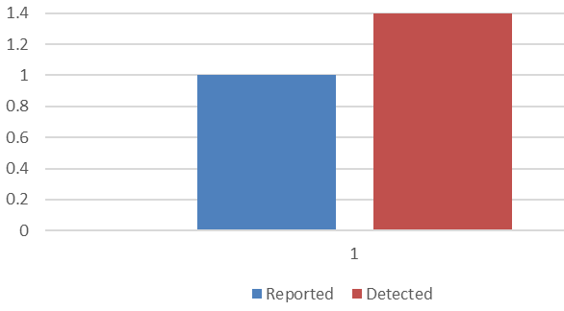
Fig. 6. Average number of collisions reported by drivers compared to the average number of collisions recorded by a researcher observing the test.
Drivers tended to under-report their near misses and collisions. Individuals were also more inclined to report equipment failures or failures resulting from external influences rather than their own unsafe behavior, since this could reflect badly on them [1]. It may also be easier to blame faulty equipment or other people rather than unsafe behavior. Fig. 7 shows the average number of collisions or near misses reported as their own fault compared to the average number of collisions recorded as the driver’s fault by a researcher observing the test.

Fig. 7. Number of collisions reported as their own fault compared to number recorded.
Near misses and collisions are shown in Heinrich’s accident pyramid in Fig. 8.
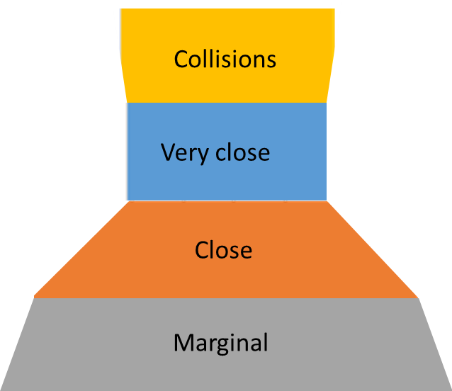
Fig. 8. Data recorded in Heinrich’s accident pyramid.
Another factor may be that the experiments and then resulting data used in this paper did not support deeper analysis of underlying or contributing factors. If the experiments had allowed for a more thorough investigation, then more detailed explanations for near misses and collisions might have been found. Another contributing factor could be that the causes of collisions tend to be different from near misses. Experienced and skilled drivers can record several near misses as they skillfully cut corners to drive more efficiently. Near misses can also be the result of the failure of a single barrier. Other barriers, for example the response of the human driver, might then prevent a near miss from developing into a collision.
- Discussion and conclusions
The volume of near misses in this analysis is of a sufficient quantity to make some generalized conclusions about the nature of the detection and mitigation of collisions. It would strengthen the analysis if near misses from other types of driving were available.
Near misses are not a perfect proxy for the distribution and frequency of collisions. Some incidents may have been milliseconds away from developing into a collision had they not been detected and stopped. Other incidents might have been stopped by several other layers of barriers and would therefore not have had any consequences, even if they had escaped initial detection and mitigation.
Any estimation of criticality and severity would just be speculative, because near misses are collisions that did not happen. Near misses are, despite all these reservations, a source of information about potential accidents. For example, if a person is having more near misses then they may be becoming tired or distracted. Human Error may be under-represented in this analysis. The term human error covers a wide range and variety of faults, one of which is “omission”, that is a failure to act. The discrepancies between near misses and collisions point to the role of the human driver in managing to act to stop collisions. Had a driver failed to act, near misses would often have resulted in a collision that would then have been attributed to Human Error due to omission.
Very Close near misses tended to disappeared when the collision avoidance system was activated, but not all.
If the collision avoidance system was not connected then potential collisions were detected later. If detected later then there was less time for the driver to stop the development of an incident into a collision.
Near misses were analyzed in order to examine what role on-board human drivers play in the occurrence and detection of the initial stages of a collision. The effect of autonomous operation on the ability to stop the development of incidents into collisions is also examined. Near misses are not a perfect representation of the distribution of accidents. Many near misses do not have the potential to develop into a collision and not all collisions can be predicted by near misses.
The near misses were divided into three types; Very close, Close, and Marginal. Compared to collisions, near misses might be under-represented. The explanation for this discrepancy may be a combination of factors relating to the way incidents were reported by the drivers and detected by the sensors. The discrepancy may also seen as evidence that on-board human drivers can sometimes prevent a near miss from developing into a collision.
In many cases when the sensors detected objects, the human driver would probably have detected them but possibly only after the incident had become more severe. This is an indication of the need for monitoring and detection equipment on the powered wheelchairs.
In almost all near misses, the possibility of stopping the incident developing into a collision may be the same whether the sensor system was assisting or not. This evaluation relates very much to the finding that the majority of 92% of the near misses occurred when the wheelchair was maneuvering close to an obstacle, rather than when something (such as another person or wheelchair) moved into the path of the chair.
Not all incidents related to human error can be expected to disappear with autonomous operation. For example, at least some human errors must occur because the driver was not seated correctly, or because of mistakes during maintenance work or because of errors in setting up assistive systems. Some near misses and accidents are direct causes of on-board human driver error that could be prevented if sensor systems assisted, while others would be caused by the introduction of semi-autonomous driving.
Whether the introduction of semi-autonomous driving aided by sensors will result in a net decrease or increase in the number of accidents must still be uncertain but it will depend on the technical capabilities of the powered wheelchair systems in the future. Future work is investigating decision making to assist with powered wheelchair control [25,26], AI systems [27-30], data collection [ 31-34], image processing [35-38] and systems to reduce veer [24,39]. On today’s wheelchairs, with existing technical systems, humans are still important for detecting near misses earlier and the ability to stop them developing into collisions.
Acknowledgment
This research was supported by the Engineering and Physical Sciences Research Council (EPSRC).
References
Stig Eriksen (2020) On-board Human Operators: Liabilities or Assets? 19th Conference on Computer and IT Applications in the Maritime Industries, pp 98-110.
Rødseth, Ø. J.; Burmeister, H.-C. (2012), Developments toward the unmanned ship, DGON ISIS 2012, Berlin.
Sanders D.A, Langner M, Tewkesbury G E. Improving wheelchair‐driving using a sensor system to control wheelchair‐veer and variable‐switches as an alternative to digital‐switches or joysticks. Industrial Robot: An international journal, 32(2), 157-167 (2010).
Sanders, D.A.: Using self-reliance factors to decide how to share control between human powered wheelchair drivers and ultrasonic sensors. IEEE Transactions on Neural Systems and Rehabilitation Engineering, 25(8), 1221-1229 (2016).
Allianz (2017), Safety and Shipping Review 2017, Allianz COLINS, D. (2018), What is the Heinrich Pyramid in Safety Management?, https://www.prosapien.com/blog/heinrich-pyramid
Ahvenjärvi, S. (2016), The Human Element and Autonomous Ships, TransNav, Int. J. Marine Navigation and Safety of Sea Transportation 10, pp.517-521.
Wróbel, K.; Montewka, J.; Kujala, P. (2017), Towards the assessment of potential impact of unmanned vessels on maritime transportation safety, Reliability Engineering & System Safety 165, pp.155-169
Heinrich, H.W.; Petersen, D.; Roos, N. (1980), Industrial Accident Prevension: A Safety Management Approach. New York
Salminen, S.; Saari, J.; saarela, K.L.; Räsänen, T. (1992), Fatal and non-fatal occupational accidents: identical versus differential causation, Safety Science 15, pp.109-118
Hale, A. (2002), Conditions of occurrence of major and minor accidents: Urban myths, deviations and accident scenarios, Tijdschrift Voor Toegepaste Arbowetenschap 15
Perrow, C. (1999), Normal accidents : living with high-risk technologies, Princeton University Press
Heinrich’s accident pyramid, downloaded from https://www.pro-sapien.com/blog/heinrich-pyramid.
Jones, S.; Kirchsteiger, C.; Bjerke, W. (1999), The importance of near miss reporting to further improve safety performance, J. Loss Prevention in the Process Industries 12, pp.59-67.
Markowski, A.S.; Mannan, M.S.; Bigoszewska, A. (2009), Fuzzy logic for process safety analysis, J. Loss Prevention in the Process Industries 22, pp.695-702
- https://www.cgerisk.com/knowledgebase/File:Bowtie_Diagram.png (downloaded January 2021)
De Ruijter, A.; Guldenmund, F. (2016), The bowtie method: A review. Safety Science 88, pp.211-218 EMSA (2014), Annual Overview of Marine Casualties and Incidents 2014, European Maritime Safety Agency, Lisboa
Sanders, D.A.: Using self-reliance factors to decide how to share control between human powered wheelchair drivers and ultrasonic sensors. IEEE Transactions on Neural Systems and Rehabilitation Engineering, 25(8), 1221-1229 (2016).
Sanders, D.A., Bausch, N.: Improving steering of a powered wheelchair using an expert system to interpret hand tremor. In International Conference on Intelligent Robotics and Applications, pp. 460-471. Springer, Cham (2015).
Sanders, D.A.: Using self-reliance factors to decide how to share control between human powered wheelchair drivers and ultrasonic sensors. IEEE Transactions on Neural Systems and Rehabilitation Engineering, 25(8), 1221-1229 (2016.).
Sanders, D.A., Gegov, A., Haddad, M., Ikwan, F., Wiltshire, D., Tan, Y.C. x. Rule-based Expert System to decide on direction and speed of a powered wheelchair; Sanders, D.A.: Using self-reliance factors to decide how to share control between human powered wheelchair drivers and ultrasonic sensors. IEEE Transactions on Neural Systems and Rehabilitation Engineering, 25(8), 1221-1229 (2016.).
Sanders, D.A., Gegov, A., Haddad, M., Ikwan, F., Wiltshire, D., Tan, Y.C. Adv. Intell. Syst. Comput. Vol. 868. Cham: Springer; 2019. Rule-based Expert System to decide on direction and speed of a powered wheelchair; p. 822-832.
Sanders, D.A., Haddad, M., Tewkesbury, G.E., Thabet, M., Omoarebun, P. and Barker, T., 2020, August. Simple expert system for intelligent control and HCI for a wheelchair fitted with ultrasonic sensors. In 2020 IEEE 10th International Conference on Intelligent Systems (IS) (pp. 211-216). IEEE. pp. 822-832.
Sanders, D.A., Haddad, M., Tewkesbury, G.E., Thabet, M., Omoarebun, P. and Barker, T., 2020, Simple expert system for intelligent control and HCI for a wheelchair fitted with ultrasonic sensors. In 2020 IEEE 10th International Conference on Intelligent Systems (IS) (pp. 211-216). IEEE.
NEW CONTROL PAPER
Haddad, M., Sanders, D., Thabet, M., Gegov, A., Ikwan, F., Omoarebun, P., Tewkesbury, P., Hassan, M.: Use of the Analytical Hierarchy Process to Determine the Steering Direction for a Powered Wheelchair. In: Arai K, Kapoor S, Bhatia R, (eds.). Intelligent Systems and Applications. IntelliSys 2020. Advances in Intelligent Systems and Computing, vol. 1252, pp. 617-630. Springer, Cham (2021).
Haddad, M.J., Sanders D A.: Selecting a Best Compromise Direction for a Powered Wheelchair Using PROMETHEE. IEEE Transactions on Neural Systems and Rehabilitation Engineering 27(2), 228-235 (2019).
Haddad M, Sanders D, Gegov A, Hassan M, Huang Y, Al-Mosawi M.: Rule-based Expert System to decide on direction and speed of a powered wheelchair. In: Arai K, Kapoor S, Bhatia R, (eds.). Intelligent Systems and Applications. IntelliSys 2019. Advances in Intelligent Systems and Computing, vol. 868, pp. 822-832. Springer, Cham (2019).
Haddad, M., Sanders, D., Langner, M., Bausch, N., Thabet, M., Gegov, A., Tewkesbury, G., Ikwan, F.: Intelligent control of the steering for a powered wheelchair using a microcomputer. In Arai K, Kapoor S, Bhatia R, (eds.). Intelligent Systems and Applications. IntelliSys 2020. Advances in Intelligent Systems and Computing, pp. 594-603. Springer, Cham (2021).
Haddad, M., Sanders, D., Ikwan, F., Thabet, M., Langner, M., Gegov, A.: Intelligent HMI and control for steering a powered wheelchair using a Raspberry Pi microcomputer. In 2020 IEEE 10th International Conference on Intelligent Systems (IS), pp. 223-228. IEEE, Bulgaria (2020).
Haddad, M., Sanders, D., Langner, M., Bausch, N., Thabet, M., Gegov, A., Tewkesbury, G., Ikwan, F.: Intelligent control of the steering for a powered wheelchair using a microcomputer. In Arai K, Kapoor S, Bhatia R, (eds.). Intelligent Systems and Applications. IntelliSys 2020. Advances in Intelligent Systems and Computing, pp. 594-603. Springer, Cham (2021).
Haddad, M., Sanders, D., Langner, M., Thabet, M., Omoarebun, P., Gegov, A., Bausch, N., Giasin, K.: Intelligent system to analyze data about powered wheelchair drivers. In Proceedings of SAI Intelligent Systems Conference (pp. 584-593). Springer, Cham. (2020).
Haddad, M., Sanders, D., Langner, M., Omoarebun, P., Thabet, M., Gegov, A.: Initial results from using an intelligent system to analyse powered wheelchair users’ data. In 2020 IEEE 10th International Conference on Intelligent Systems (IS) pp. 241-245. IEEE, Bulgaria (2020).
Sanders, D., Haddad, M., Tewkesbury, G., Bausch, N., Rogers, I. and Huang, Y.: Analysis of reaction times and time-delays introduced into an intelligent HCI for a smart wheelchair. In 2020 IEEE 10th International Conference on Intelligent Systems (IS) pp. 217-222. IEEE, Bulgaria (2020).
Sanders, D., Haddad, M., Langner, M., Omoarebun, P., Chiverton, J., Hassan, M., Zhou, S. and Vatchova, B.: Introducing time-delays to analyze driver reaction times when using a powered wheelchair. In Proceedings of SAI Intelligent Systems Conference pp. 559-570. Springer, Cham (2020).
Haddad, M., Sanders, D., Langner, M., Thabet, M., Omoarebun, P., Gegov, A., Bausch, N., Giasin, K.: Intelligent system to analyze data about powered wheelchair drivers. In Proceedings of SAI Intelligent Systems Conference (pp. 584-593). Springer, Cham. (2020).
Haddad, M., Sanders, D., Langner, M., Omoarebun, P., Thabet, M., Gegov, A.: Initial results from using an intelligent system to analyse powered wheelchair users’ data. In 2020 IEEE 10th International Conference on Intelligent Systems (IS) pp. 241-245. IEEE, Bulgaria (2020).
Sanders, D., Haddad, M., Tewkesbury, G., Bausch, N., Rogers, I. and Huang, Y.: Analysis of reaction times and time-delays introduced into an intelligent HCI for a smart wheelchair. In 2020 IEEE 10th International Conference on Intelligent Systems (IS) pp. 217-222. IEEE, Bulgaria (2020).
Sanders, D., Haddad, M., Langner, M., Omoarebun, P., Chiverton, J., Hassan, M., Zhou, S. and Vatchova, B.: Introducing time-delays to analyze driver reaction times when using a powered wheelchair. In Proceedings of SAI Intelligent Systems Conference pp. 559-570. Springer, Cham (2020).
Sanders D.A, Langner M, Tewkesbury G E. Improving wheelchair‐driving using a sensor system to control wheelchair‐veer and variable‐switches as an alternative to digital‐switches or joysticks. Industrial Robot: An international journal, 32(2), 157-167 (2010).

