Human machine interaction using zero force sensing switches incorporating self-adaptation
M Langner¹, D Sanders², G Tewkesbury², M Haddad², P Kyberd² and S Zhou²
¹ Chailey Heritage Foundation. North Chailey, Lewes BN8 4EF, UK
² University of Portsmouth. Anglesea Road, Portsmouth PO1 3DJ, UK
Email: mlangner@chf.org.uk
Abstract. A novel human machine interface is presented that ‘self-adapts’ to accommodate for changes in position between an operator and a non-contact sensor. Zero force sensing has been especially suitable for people with small amounts of movement force that has made switch operation difficult or impossible. A common issue with existing switches concerned maintaining a workable operating position for a user. Testing of new “auto adapting” sensors demonstrated the viability of the approach and optical sensors provided a workable solution, but problems were encountered in strong light. Further work addressed this problem.
- Introduction
The aim of this research is to create a “self-adapting” switch system that reacts and adapts to changes in distance between a sensor and a person so that intentional movement is detected.
Many young people at Chailey Heritage Foundation have multiple disabilities involving cognitive and physical impairments [1,2]. Input devices have included switches and joysticks [3-5] both require force and movement to operate [6].

Many young people at Chailey Heritage Foundation do not have enough fine movement control to successfully operate a joystick, alternatively, switches required an operating force with ‘felt contact’ and a micro switch provided a ‘click’ sound. These were important feedback attributes. Many young people could not exert force to operate a switch. New work described here considered those that only had fractional amounts of physical movement and strength because a standard switch option did not provide a workable solution for them.
An alternative to mechanical switches was required. Conventional commercially available contactless proximity switches / detectors were considered [4,7]. An industrial capacitive sensor was selected for a first prototype test system but frequent interventions were required to correct changes in sensor placement. Figure 1 shows a young person who did not have enough strength or movement to operate a conventional mechanical switch. He was a first candidate to try a capacitive proximity sensor. The switching point was set to operate between 15 to 20mm from the sensor. This was approximately equal to the amount of movement required to activate a standard mechanical button.
The white line shown in figure 2 is the fixed switching boundary, the movement between ‘On’ and ‘Off’ states. Using the setup, the young person was able to drive his powered wheelchair successfully. This sensor system was also used for activating his ‘yes’ and ‘no’ speech system.
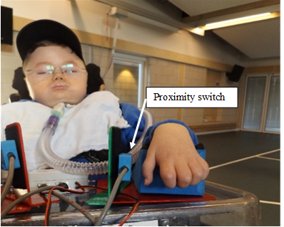 |  | 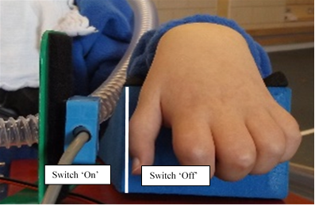
Figure 1. Young disabled wheelchair driver using a proximity switch. |  | Figure 2. Capacitive proximity switch setup operating boundary.

The sensor shown here was bespoke for a specific person; however, the principle of was transferable. Capacitive sensors worked well for close proximity object detection but the workable range was limited to 30 mm.
The next example shown in figure 3 was a young person who used mechanical stalk head switches for driving his wheelchair and operating his class computer. These were problematic as they often rubbed against his eyes and were often knocked out of position. Two other modes of detection with longer detection ranges were considered: ultrasonic and optical. Optical sensors were selected because of their low cost and small size. The optical system is shown in figure 4.
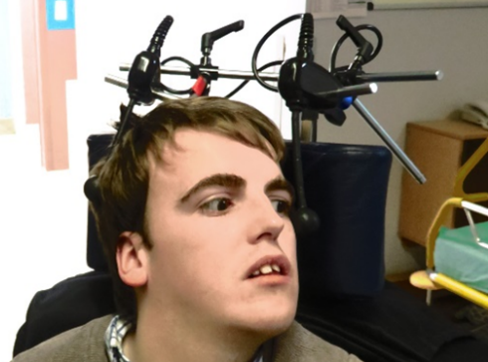 |  | 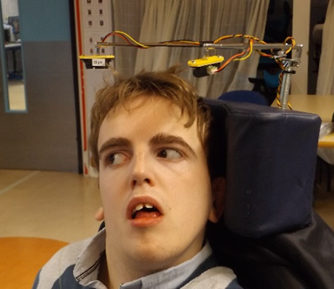
Figure 3. Head switch stalks. |  | Figure 4. Optical head switch.

When he moved his head to the left or right the drive system responded. Figure 5 shows that when his head moved to his right then sensor ‘A’ responded by detecting the reflected infrared. This young person successfully adapted to this even though there was no feeling of contact with a switch. A click sound from the switch relay confirmed activation. Comment from teachers, parents and carers suggested that although there was no physical tactile contact with the detector, the young person responded to the feedback provided by the powered wheelchair response. The Sharp sensors worked well and were cheap, however this sensor sometimes responded to spurious reflections. Consistent operation was essential for people with profound learning difficulties. Any false responses could quickly undermine learning.
Another sensor variant was created to address the challenges a young person had with involuntary gross arm movements. Teaching Assistants suggested the young person could signal using a ‘thumbs up’ gesture. A body worn system was introduced that detected his dominant thumb movement.
A small optical detector was purchased incorporating an Infrared LED and photo transistor. This worked as a retro reflecting sensor. An electronic interface was created to generate and detect changes in reflected light to provide a switching function. A sensitivity adjustment was incorporated. The resulting device shown in figure 6 shows the prototype being tested with the young person.
 |  | 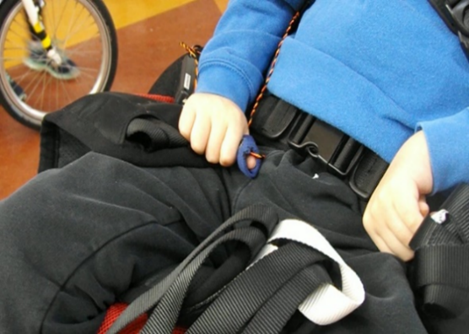
Figure 5. Sensor operation using a Sharp proximity sensor. |  | Figure 6. Optical thumb switch.

The small optical sensor was embedded in an elastic thumb bandage with a small window so that the sensor could “look out” this detected the separation distance between his thumb and forefinger. A working switching threshold was adjusted in the electronic interface, therefore enabling detection of small amounts of thumb movement. The switching output was reversible as he needed to activate the system by moving his thumb and forefinger apart as in a ‘thumbs up’ sign. As this was a body worn device, operation was unaffected by other distracting gross hand and arm movements.
- Optical Sensor
The young person shown in figure 1 had a degenerative condition and progressively lost functionality so that he was only able to move his left hand a few mm. Unfortunately, he was not able to operate the capacitive sensor he had previously used. Sharp retroreflective sensors that were used for the wheelchair driver shown in figure 4 were an alternative to mechanical switches. The optical Sharp sensor was tested and provided a well-defined trigger edge ‘dotted white line’ from his small hand movements and it is shown in figure 7.
However although the sensor was ‘background suppressed’, there were problems with ambient light causing unpredictable operation.
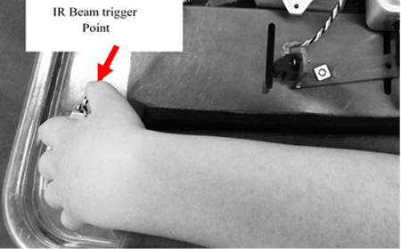
Figure 7. Optical thumb movement detection

The edge of the optical beam provided a precise trigger point and enabled him to steer his wheelchair. When medical interventions were carried out, the critical sensor position could be disturbed and it needed constant readjustment. This became frustrating for the young person and his support staff.
The Sharp sensor was selected because it was a cheap practical alternative to a mechanical switch for the young people in figures 4 and 6. There were issues that affected operation, most notably:

- False detection (stray pickup)
- Narrow beam detection area
- Desensitization in high ambient light
- Objects could not be reliably detected at distances shorter than 6cm

New work started to create a new input sensor considering:

- Range margins and limits
- Suitable target area and shape
- Ambient light tolerance
- Mounting adaptations and compactness
- Price

The examples described so far have used proximity detection where a fixed switching threshold was predetermined and was therefore analogous to switch function. The new developments needed the sensor to respond to a change in reflected light for a trigger point to occur.
The predefined switching point meant that frequent adjustments were required to maintain the best sensor position. As the sensitivity increased, so did problems associated with placement. Young people would seldom settle the same way each time. The sensor responded to an ‘absolute’ change of object position with respect to a fixed point of reference. The working operating point was often set by the person themselves or by helpers. Problems became significant when young people could not make these compensatory adjustments for themselves. Jolting and manual handling added to the problem.
Most young people were familiar with a standard switch. Contact-less systems operated through the same type of movement. The typical amount of movement ranged between 1-5mm for switches. One factor was to preserve the nature of switch operation that was consistent with learning and cause and effect’, where the action of moving toward it for activation and moving away for de-activation.
A prototype device is shown in figure 9 consisting of a photo transistor and two infrared LED’s. This mimicked a switch action. His head moved towards the sensor to switch ‘On’ and away to switch ‘Off’.

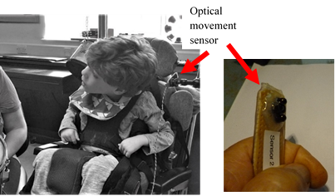
Figure 8. Experimental movement sensor.

This example was non-contact and the sensor was placed ‘somewhere’ near his head. This operated on the principle of ‘auto-adaptation’. Essentially the device responded to movement without an absolute fixed point of reference. The system responded to a dynamic change of distance, reducing the need for critical sensor placement. Figure 8 shows a young boy using the prototype sensor connected to a switch operated drum in his music class. Each time he moved his head towards the sensor, his drum beat.
- Adapting Systems
This work is creating input systems that can self-adapt to maintain a switching point. This potentially provided an increase in movement sensitivity that would not previously be practically obtainable with a fixed-point system. The new system was capable of detecting small movements (≤1mm). This level of fractional movement sensitivity could not be sustained without distance compensation.
The self-adapting dynamic Sensor offered a flexible alternative to a standard mechanical switch. Two ongoing approaches were developed for signal processing during this research, ‘analogue’ and ‘digital’. Having these options provided choice to match the specific individual needs of different users.
The analogue mode responded to the speed of dynamic change. This helped discriminate against small changes of position when movement speed was below a detection threshold. This took account of slow changes in operator position, ‘creep’. An additional mode was added so that the system responded to a finger or thumb ‘twitch’. This provided an output for momentarily activated systems.
Each twitch did not keep the wheelchair moving for long so a ‘hold delay’ was incorporated that electronically time stretched a twitch period to 3 seconds. During this window of time a young driver was able to keep driving by twitching his thumb before the end of each delay period.
Another mode of movement detection was implemented. To keep switch operation familiar, a ’bi-stable’ detection mode was used to replicate the function of a standard switch. This mode provided a switching output when a detected object moved towards the sensor. The output would stay ‘On’. The system output would switch ‘Off’ when the object moved away from the sensor. This was the same movement pattern required to activate a button switch.
The digital signal processing mode did not involve a time component and only responded to a change in the detected position of the object. This was more analogous to switch function and those with slow movements were detected because the system responded to relative changes of position. The system incorporated a sensitivity adjustment, so the amount of distance between the ‘On and Off’ switch positions could be personally matched. Other switch outputs could be provided digitally for example, ‘latched’ and ‘timed’ functions. Configurable attributes formed the design specification: adjustment of maximum and minimum object detector range limit, movement trigger sensitivity (speed ‘analogue’) / (distance ‘digital’), hysteresis level adjustment.
Simulated operating ‘click’, momentary control / Bi-stable control / Latched control / Timed control, movement feedback (output tagging, and analysis), and interchangeable optical detector heads for flexibility of application for specific individual needs. The detector range limit set the allowed parameters for the use of multiple detectors for users wanting to control several different things using different parts of their body. For example, hands, feet, legs, head or any part of the body that could be observed by a detector. The first prototype worked well, however when used outdoors or in areas of high ambient light, the system became de-sensitized and stopped. Further work continued to investigate improving the light immunity of the system without compromising sensitivity. A new sensor was created that consisted of three infrared LEDs and a photo transistor as shown in figure 9.
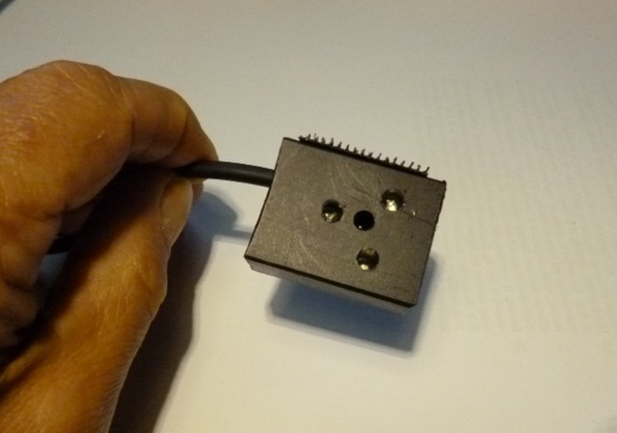 |  | 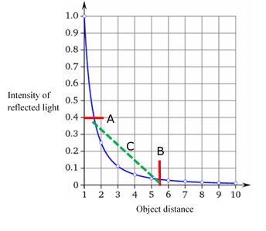
Figure 9. Optical sensor block. |  | Figure 10. Distance signal relationship.

The aim was to create a sensor that provided high movement sensitivity in direct sunshine. To test the prototype systems, a 1000-watt halogen lamp provided sunlight levels likely to be encountered during a mid-summer’s day (approximately 120-130 Klux). Experiments suggested that better immunity could be achieved by changing the operating wavelength of the Infra-red components to 850nm. The immunity could be improved further by placing an (optional) metalized plastic sheet over the detector sensor.
- Mitigating Environment Effects
Problems were encountered when driving outdoors. High ambient light desensitized the sensor. The infrared energy in sunlight swamped the reflected light. This was important because young people could not be expected to stay indoors to use the system. Using a sunshade was impractical and defeated the purpose of a universal sensing system. The transducers were re-engineered with the following points in mind: high sensitivity to a moving object, reduction of spurious reflections (background suppression), immunity to bright ambient light (sunshine), and multiple sensor configurations
The new sensor shown in figure 9 had a housing machined out of black plastic. The sensor block incorporated three IR LED’s and one phototransistor in the centre. The sensor block was made from black Delrin sufficiently thick to allow the optical components to be optically isolated. The outlook of the photo transistor was focused forward to reduce the impact of stray light. A three-point delta configuration provided a good balance of target object illumination for the photo diode receiver.
Operational considerations included maximum and minimum range. They were limited by the optical dynamic range of the phototransistor as the intensity of the detected reflected light tended to follow an inverse square law. So the maximum change in the detected output happened when an object was closest to the sensor. The graph shown in figure 10 shows the typical sensor output changed relative to distance.
Electronic signal amplification was optimized to operate between points ‘A’ and ‘B’. This was not the desirable linear relationship of distance versus output level. An approximate compensation strategy was applied by using a semiconductor diode in signal amplifier feedback that compensated to provide a (near) linear output (shown by the dotted green line ‘C’). The compensated operating points were then calibrated to a working prototype shown in figures 11 and 12.
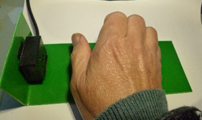 |  | 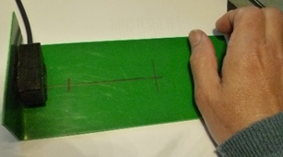
Figure 11. Sensor operating point (A). |  | Figure 12. Sensor operating point (B).

Interaction of the light paths (figure 13) of the photo transistor and LEDs was a significant factor. The useful detection area (window of response) varied depending on the size and nature of the reflecting objects area. Background suppression was achieved by the focused beams having the maximum light energy at the point of convergence.
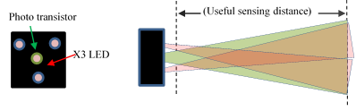
Figure 13. Sensor block and light paths.

A detected object could be a finger, hand or head, etc. The maximum detectible range was limited by electronically excluding the lower received signal value where the system could be limited to respond only to higher levels of signal value. The uncontrollable variables of object type, reflectivity and possibly environmental background light were mitigated by the system responding only to relative change of reflected light intensity, either in analogue or digital modes of signal processing. A detection distance cut-off was incorporated when two sensors were placed either side of someone’s head. A non-working zone existed to provide space for a user to separate the two channels of operation.
- Discussion and Conclusion
This work has shown that detection of finite (fractional) amounts of movement can be achieved with the sensors. Early trials detected the flicking of a thumb and suggested the use of a more transient movement detector. The incorporation of small sensors within a head rest for example could provide a more transparent control system. Optical sensors were selected because components were cheap, robust, small, reliable, configurable and directional. Research resulted in a tangible solution that can be tailored to meet personal movement patterns. The auto–adapting system offered greater flexibility compared to switches. Generally an individual has been expected to adapt their personal movements to fit an assistive system and that can be stressful and frustrating. This new work challenged that approach by offering an alternative that adapted to a user’s movements and reduced some constraints imposed by conventional switch systems. Future work will consider reaction times [8] and the delays they introduce [9] and ways of improving driving [10].
- References
[1] Krops LA, Hols DH, Folkertsma N, Dijkstra PU, Geertzen JH and Dekker R 2018. Requirements on a community-based intervention for stimulating physical activity in physically disabled people: a focus group study amongst experts. Disab Rehabil 40 20 pp 2400-2407
[2] Bos I, Wynia K, Almansa J, Drost G, Kremer B and Kuks J 2019 The prevalence and severity of disease-related disabilities and their impact on quality of life in neuromuscular diseases Disabil Rehabil 41 14 pp 1676-1681
[3] Sanders D, Langner M and Tewkesbury G 2010 Improving wheelchair‐driving using a sensor system to control wheelchair‐veer and variable‐switches as an alternative to digital‐switches or joysticks Ind Rob: An int' jnl 32 2 pp 157-167
[4] Sanders D, Haddad M, Tewkesbury G, Thabet G, Omoarebun P and Barker T 2020 Simple expert system for intelligent control and HCI for a wheelchair fitted with ultrasonic sensors Proc. of the 2020 IEEE 10th International Conference on Intelligent Systems-IS (Varna) pp 211-216
[5] Sanders D and Gegov A 2018 Using artificial intelligence to share control of a powered-wheelchair between a wheelchair user and an intelligent sensor system EPSRC Project, 2019–2022
[6] Langner M 2012 Effort Reduction and Collision Avoidance for Powered Wheelchairs: SCAD Assistive Mobility System Ph.D. dissertation, School of Mech. Eng., University of Portsmouth, UK
[7] Sanders D, Haddad M and Tewkesbury G 2021 Intelligent control of a semi-autonomous Assistive Vehicle Proc. of SAI Intelligent Systems Conference (Amsterdam) pp 613-621
[8] Sanders D, Haddad M, Tewkesbury G, Bausch N, Rogers I and Huang Y 2020 Analysis of reaction times and time-delays introduced into an intelligent HCI for a smart wheelchair Proc. of the 2020 IEEE 10th International Conference on Intelligent Systems-IS (Varna) pp 217-222
[9] Sanders D, Haddad M, Langner M, Omoarebun P, Chiverton J, Hassan M, Zhou S and Vatchova B 2020 Introducing time-delays to analyze driver reaction times when using a powered wheelchair Proc. of SAI Intelligent Systems Conference (Amsterdam) pp 559-570
[10] Sanders D, Haddad M, Tewkesbury G, Gegov A and Adda M 2021 Are human drivers a liability or an asset?” Proc. of SAI Intelligent Systems Conference (Amsterdam) pp 805-816

