Intelligent control of a semi-autonomous Assistive Vehicle
David Sanders, Giles Tewkesbury, Malik Haddad, Ya Huang and Briana Vatchova
University of Portsmouth, Portsmouth, PO1 3DJ, UK
david.sanders@port.ac.uk
Abstract. A control system for a powered wheelchair is described. The wheelchair is equipped with sensors to help a disabled user to steer their wheelchair. An innovative intelligent control schemes is presented. A model reference controller for veer regulation that can deal with variable operating conditions is presented. It is based on compensating the non-linear terms using an automatic adaptive scheme. The method specifically focuses on the design of a reliable veer controller capable of mitigating for uncertainties such as slopes, bumps, hills, differences in wheels and tires and changes to surfaces (for example one side more uneven than the other). The controller has been designed with a quasi-linear closed-loop behavior so that outer control loops can be added later such as path-following. A single powered wheelchair assistive agent was created to allow for future cooperation between wheelchair systems by sharing information. The work foresees the potential employment of semi-autonomous assistive agents within cooperative wheelchair systems.
Keywords: Autonomous, Assistive, Control, Vehicle, Disabled, Wheelchair.
- Introduction
There has been an increasing trend in developing semi-autonomous assistive systems capable of easing the burden of control and driving [1-5]. Some intelligent and Smart powered wheelchairs have evolved from research laboratory prototypes to commercial devices, providing a number of functionalities. A small number of semi-autonomous powered wheelchairs with more or less enhanced capabilities have been developed in recent years [6-11]. These have generally come from academic and research institutions [12-14.
Some powered wheelchairs have been using developing technology and control systems and intelligent powered wheelchair systems have become more reliable and affordable [15-20]. However, a number of specific applications remain dependent on human wheelchair operators, since current intelligent control technology still lacks adequate design, reliability, robustness or cost effectiveness. This leads to a need for innovation starting from the design phase, as well as redefining the concepts and methodologies for effective assistance, guidance, control and interaction with the user [21]. With this aim in mind, this work has the goal of presenting an innovative powered wheelchair controller.
Modularity was considered in the design as flexibility was important. Powered wheelchairs have to provide the capability of being adapted for different users and their needs, including reshaping of structures to modify payload capacity and maneuvering characteristics, as well as to add/substitute sensors and devices “on the fly” for different users.
An innovative intelligent control schemes is presented in order to face the variable operating conditions, ranging from lack of maneuverability to lack of spatial awareness or inability to position precisely. Effective and redundant velocity configurations were implemented to guarantee motion capabilities in different environments. Such configurations also required an advanced control scheme to execute the commands from the disabled user and to assist them, at the same time compensating for external disturbances and possible faults.
Control methods apply machine-learning approaches, which are recently arising interest in the community and providing encouraging results. A single powered wheelchair assistive agent has been created to allow cooperation between wheelchair systems by sharing information. The work foresees the employment of semi-autonomous assistive agents as cooperative wheelchair systems.
- The wheelchair
A Bobcat II Wheelchair was used as shown in figure 1. It was fitted with simple and tough Ultrasonic sensors [2,4,6].

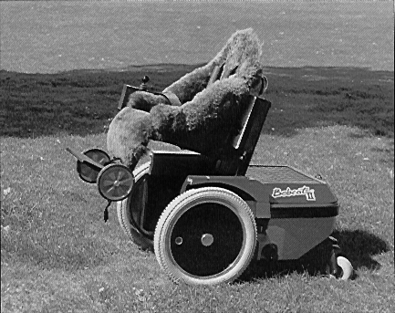
Fig. 1. The Bobcat II Wheelchair used in the research.
The wheelchair had different operating modes: (a) Controllers driven directly by Joystick data, (b) Sensors turned on and a computer adapts the course of the powered wheelchair using approaches that were recently published in the literature, and (c) Sensors turned on and the computer modified the course of the powered wheelchair using the expert system described in this paper.
A set of rules were employed: (a) The user of the wheelchair stayed in overall control, (b) The expert system only altered a course when necessary, and (c) The controller needed to produce smooth and controlled turns.
Signals from the ultrasonic sensors could contain a lot of noise so that there were misreadings. These were filtered out to improve reliability. A volume in front of the powered wheelchair was divided into grids. These grids were named “adjacent”, “intermediate” and “furthest“ (fig. 2). If objects were detected then they were classified as “adjacent”, “intermediate” or “furthest”. Sensors were mounted on the wheelchair so that their ultrasonic beams overlapped. Fig. 2. Shows the grid created by a single sensor.
Adjacent.
Intermediate.
Furthest.
1 m.
2 m.
Sample beam pattern.
0m.
1m.
1m.

Fig. 2. Ultrasonic transducer envelope showing the grid to classify ranges to objects.

The flexible design allowed the hosting of various types of control systems and sensors. An intelligent microcontroller controlled the wheel motors and could take over the control of the entire wheelchair if required. The hardware and software architecture was based on Commercial off-the shelf components.
- Control
This section presents the model reference controller for veer regulation based on the non-linear terms compensation by an automatic adaptive scheme. The development process is inspired by the methodology described in Ioannou and Sun (1995) [22] and more recently Bibuli et al [21]. This work extended that approach to non-linear veer dynamics. The method specifically focused on designing a reliable veer controller capable of mitigating model uncertainties, and providing a quasi-linear closed-loop behavior in such a way to subsequently design outer control loops such as path-following or other guidance schemes.

3.1. Modelling
The problem of developing an adaptive controller arises from the dynamics' model of the wheelchairs, which is corrupted by various uncertainties (size and shape of the human driver, different mechanical assists, mobility devices, life support, assistive, sensor and control systems used by each wheelchair driver).
The current model was developed at the University of Portsmouth [2, 4]. A combined modeling / identification procedure led to the following dynamics form:

𝑚 𝑢̇ = 𝑘𝑢 𝑢 |𝑢| + 𝑐𝑢𝑟 𝑢 |𝑟| + 𝑏𝑢 𝑓𝑢 (1) 𝑚 𝑣̇ = 𝑘𝑣 𝑣 |𝑣| + 𝑐𝑣𝑟 𝑣 |𝑟| + 𝑏𝑣 𝑓𝑣

𝐼𝑟 𝑟̇ = 𝑘𝑟 𝑟 |𝑟| + 𝑐𝑟𝑢 𝑟 |𝑢| + 𝑐𝑟𝑣 𝑟 |𝑣| + 𝑏𝑟 𝜏 (1)

Where the variables represent: u the surge speed, v the sway speed, i the veer-rate, fu the input surge force, fv the input sway force, τ the input torque along the veer axis, cxx terms being velocity coupling terms, bx the input coefficient terms, m the mass of the powered wheelchair and Ir the moment of inertia along the veer axis.
Because of the different size and weight of the various drivers and their equipment, there was a significant uncertainty about the dynamics. For that reason, a number of consolidated control methods were not suitable.

3.2. Controller design
Considering equation (1), describing the veer motion behaviour, the founding idea was to design a suitable law for input torque τ in such a way that the closed-loop system behaved as a linear system. A reference model could then be suitably defined to provide a virtual behaviour for the closed loop system. To achieve the model tracking, and thus provide reliable closed-loop veer-rate tracking, the generated torque law consisted of two main components: one to compensate the non-linear dynamics and the other to track the desired reference veer-rate input. They had a time-varying behaviour.
The objective of the control system was to define proper time-varying components for stability and tracking of the veer-rate controller. The goal was to design a suitable input control law to obtain a desired bounded and stable linear closed-loop behavior as:

𝑟𝑚̇ = −𝑎𝑚𝑟 + 𝑏𝑚 r* (2)

Where r* is the desired veer-rate reference, rm is the desired veer-rate response, am > 0 is the stable linear coefficient and bm is the input coefficient. The system described by eq. (2) is the ‘reference model’. The veer-rate signal is then able to track the rm state of the reference model by defining the τ control law as follows:

𝜏 = −(𝑡)𝑟 + 𝜆(𝑡)𝑟∗ (3)

With γ(t) and λ(t) being the online adapted dynamics’ compensating coefficients.
The form of the adaptive coefficients were designed following the procedure of Ioannou and Sun [22], obtaining the following adaptation formulas:

𝛾̇ = −𝜂𝛾 𝑒 𝑟 sgn(𝑏𝑟) (4)

𝜆̇ = −𝜂𝜆 𝑒 𝑟 ∗ sgn(𝑏𝑟) (5)

Where ηγ and γλ are gain factors to tune the adaptation rate, sgn(.) is the sign function and e is defined as the tracking error variable e = r – rm.
Fig.3 shows the model reference state and actual powered wheelchair's veer-rate with respect to a desired value. Although the jerky behavior of the r(t) signal (caused by environmental disturbance, absence of filtering etc), it can be seen that it tracks the reference rm(t).

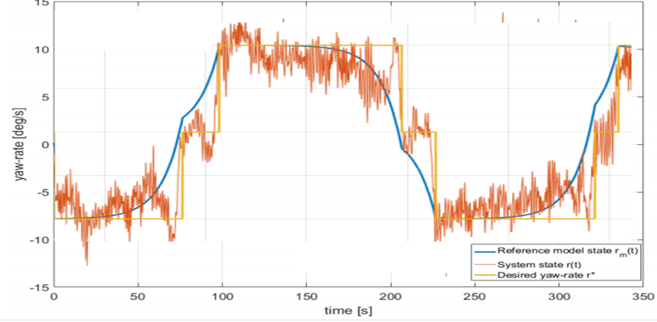

Fig. 3. Step response of the adaptive veer-rate controller during experiments

Once the veer-rate controller had been tuned, an external loop for heading regulation could be implemented; in this case, a simple Proportional-Derivative (PD) scheme was implemented. The Integral term in the heading control scheme was omitted to eliminate long oscillatory phases that would have extended the tuning phase. The behaviour of the dual-loop heading control is shown in Fig.4.
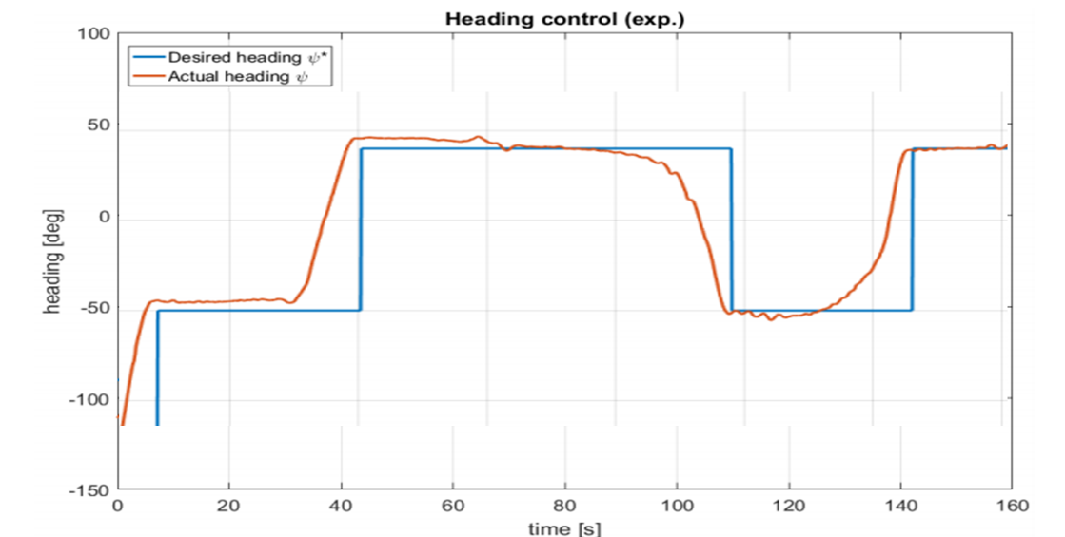
Fig. 4. Heading control response experiment - desired and actual heading

A piece-wise constant orientation is commanded to the powered wheelchair; a small drift from the desired value can be observed and it is caused by both the environmental disturbance and the lack of a integrative term in the heading control.

3.3. Path-following
A simple higher-level path-following module was written based on the path-following guidance system described in Bibuli et al. (2009) [23] where a Lyapunov-based technique was employed to guarantee convergence and robustness of the system.
The basic principle was to simulate the setting of the joystick to drive forward and then to use a veer-rate signal to compensate against to keep the powered wheelchair on the desired straight line path.
Since the guidance system was decoupled from the low-level controller, the integration of the guidance module was relatively straightforward. A set of results where the powered wheelchair was required to autonomously track a straight line is shown in Fig. 5.
Performance was satisfactory, especially considering the operating area included sloping ground that affected the direction of the powered wheelchair.
Fig. 5. Path-following response experiment along a simulated straight line
- Conclusions and Future Work
A control system for a powered wheelchair was presented. The wheelchair was equipped with ultrasonic sensors to help a wheelchair user to steer their wheelchair. An innovative intelligent control schemes was presented that could deal with variable operating conditions. The design and experimental evaluation of a model reference controller for veer regulation was presented that was based on compensating the non-linear terms using an automatic adaptive scheme.
The method specifically focused on the design of a reliable veer controller capable of mitigating for uncertainties such as slopes, bumps and hills, The controller was designed with a quasi-linear closed-loop behavior so that outer control loops could be added later such as heading control or path-following.
A single powered wheelchair assistive agent was created to allow for future cooperation between wheelchair systems by sharing information. The work foresees the potential employment of semi-autonomous assistive agents as cooperative wheelchair systems.
Testing will now move from simulation to real world trials and future work will investigate model-based prediction for navigation [24], Route Optimization [25], control [26] and voter based control [27], collision avoidance [28] and the perception of semi-autonomous intelligent vehicles such as Smart Powered Wheelchairs [29].
Acknowledgment
Research was supported by the EPSRC.
References
- Sanders D.A, Langner M, Tewkesbury G E. Improving wheelchair‐driving using a sensor system to control wheelchair‐veer and variable‐switches as an alternative to digital‐switches or joysticks. Industrial Robot: An international journal, 32(2), 157-167 (2010).
- Sanders, D.A.: Using self-reliance factors to decide how to share control between human powered wheelchair drivers and ultrasonic sensors. IEEE Transactions on Neural Systems and Rehabilitation Engineering, 25(8), 1221-1229 (2016).
Sanders, D.A., Bausch, N.: Improving steering of a powered wheelchair using an expert system to interpret hand tremor. In International Conference on Intelligent Robotics and Applications, pp. 460-471. Springer, Cham (2015).
Sanders, D.A.: Non-Model-Based Control of a Wheeled Vehicle Pulling Two Trailers to Provide Early Powered Mobility and Driving Experiences, IEEE Transactions on Neural Systems and Rehabilitation Engineering, 2018, Volume: 26, Issue: 1, pp 96 – 104.
Sanders, D.A., Gegov, A., Haddad, M., Ikwan, F., Wiltshire, D., Tan, Y.C. Adv. Intell. Syst. Comput. Vol. 868. Cham: Springer; 2019. Rule-based Expert System to decide on direction and speed of a powered wheelchair; p. 822-832.
Sanders, D.A., Haddad, M., Tewkesbury, G.E., Thabet, M., Omoarebun, P. and Barker, T., 2020, August. Simple expert system for intelligent control and HCI for a wheelchair fitted with ultrasonic sensors. In 2020 IEEE 10th International Conference on Intelligent Systems (IS) (pp. 211-216). IEEE.
Haddad M, Sanders D, Gegov A, Hassan M, Huang Y, Al-Mosawi M.: Rule-based Expert System to decide on direction and speed of a powered wheelchair. In: Arai K, Kapoor S, Bhatia R, (eds.). Intelligent Systems and Applications. IntelliSys 2019. Advances in Intelligent Systems and Computing, vol. 868, pp. 822-832. Springer, Cham (2019).
Haddad, M., Sanders, D., Langner, M., Bausch, N., Thabet, M., Gegov, A., Tewkesbury, G., Ikwan, F.: Intelligent control of the steering for a powered wheelchair using a microcomputer. In Arai K, Kapoor S, Bhatia R, (eds.). Intelligent Systems and Applications. IntelliSys 2020. Advances in Intelligent Systems and Computing, pp. 594-603. Springer, Cham (2021).
Haddad, M., Sanders, D., Thabet, M., Gegov, A., Ikwan, F., Omoarebun, P., Tewkesbury, P., Hassan, M.: Use of the Analytical Hierarchy Process to Determine the Steering Direction for a Powered Wheelchair. In: Arai K, Kapoor S, Bhatia R, (eds.). Intelligent Systems and Applications. IntelliSys 2020. Advances in Intelligent Systems and Computing, vol. 1252, pp. 617-630. Springer, Cham (2021).
Haddad, M.J., Sanders D A.: Selecting a Best Compromise Direction for a Powered Wheelchair Using PROMETHEE. IEEE Transactions on Neural Systems and Rehabilitation Engineering 27(2), 228-235 (2019).
Haddad, M., Sanders, D., Ikwan, F., Thabet, M., Langner, M., Gegov, A.: Intelligent HMI and control for steering a powered wheelchair using a Raspberry Pi microcomputer. In 2020 IEEE 10th International Conference on Intelligent Systems (IS), pp. 223-228. IEEE, Bulgaria (2020).
Haddad, M., Sanders, D., Langner, M., Bausch, N., Thabet, M., Gegov, A., Tewkesbury, G., Ikwan, F.: Intelligent control of the steering for a powered wheelchair using a microcomputer. In Arai K, Kapoor S, Bhatia R, (eds.). Intelligent Systems and Applications. IntelliSys 2020. Advances in Intelligent Systems and Computing, pp. 594-603. Springer, Cham (2021).
Sanders, D., Haddad, M., Tewkesbury, G., Bausch, N., Rogers, I. and Huang, Y.: Analysis of reaction times and time-delays introduced into an intelligent HCI for a smart wheelchair. In 2020 IEEE 10th International Conference on Intelligent Systems (IS) pp. 217-222. IEEE, Bulgaria (2020).
Sanders, D., Haddad, M., Langner, M., Omoarebun, P., Chiverton, J., Hassan, M., Zhou, S. and Vatchova, B.: Introducing time-delays to analyze driver reaction times when using a powered wheelchair. In Proceedings of SAI Intelligent Systems Conference pp. 559-570. Springer, Cham (2020).
Haddad, M., Sanders, D., Langner, M., Thabet, M., Omoarebun, P., Gegov, A., Bausch, N., Giasin, K.: Intelligent system to analyze data about powered wheelchair drivers. In Proceedings of SAI Intelligent Systems Conference (pp. 584-593). Springer, Cham. (2020).
Haddad, M., Sanders, D., Langner, M., Omoarebun, P., Thabet, M., Gegov, A.: Initial results from using an intelligent system to analyse powered wheelchair users’ data. In 2020 IEEE 10th International Conference on Intelligent Systems (IS) pp. 241-245. IEEE, Bulgaria (2020).
Haddad et al. Steering a powered wheelchair using a camera module and image processing algorithms. In: Arai K, Kapoor S, Bhatia R, editors. Intelligent Systems and Applications. IntelliSys 2021. Advances in Intelligent Systems and Computing. Accepted and in Press.
Haddad, et al. Steering a powered wheelchair using a camera module and image processing algorithms. In: 32nd IEEE Intelligent Vehicles Symposium, 2021. Accepted and in Press. IEEE, Japan (2021).
Haddad, et al. Novel Approach to Steer a Powered Wheelchair Using Image Processing Algorithm and Raspberry Pi. In: 32nd IEEE Intelligent Vehicles Symposium, 2021. Accepted and in Press. IEEE, Japan (2021).
Haddad, et al. A New System to Drive a Powered Wheelchair Using an Image Processing Algorithm. In: 24th IEEE International Conference on Intelligent Transportation - ITSC2021. Accepted and in Press. IEEE, USA (2021).
Marco Bibuli, Gabriele Bruzzone, Massimo Caccia, Cristiano Cervellera, Roberta Ferretti, Mauro Gaggero, Angelo Odetti, Enrica Zereik, Michele Viviani, Marco Altosole Evolution of Autonomous Surface Vehicles, 19th Int Conf on Computer and IT Applications in the Maritime Industries, Pontignano, 17-19 August 2020, Hamburg, 2020, pp 26-37. ISBN 978-3-89220-717-7
Ioannou, P.A.; Sun, J. (1995), Robust Adaptive Control, Prentice-Hall
Bibuli, M.; Bruzzone, G.; Caccia, M.; Lapierre, L. (2009), Path following algorithms and experiments for an unmanned surface vehicle, J. Field Robotics 26/8, pp.669-688.
Sanders et al. Model-based Prediction for Navigation Assistance using a Combination of Sensors. In: 24th IEEE International Conference on Intelligent Transportation - ITSC2021. Accepted and in Press. IEEE, USA (2021).
Sanders et al. Route Optimization using Forecasting, Wheelchair Modelling and Path Planning. In: 24th IEEE International Conference on Intelligent Transportation - ITSC2021. Accepted and in Press. IEEE, USA (2021).
Sanders et al. Control of a semi-autonomous powered wheelchair. In: 32nd IEEE Intelligent Vehicles Symposium, 2021. Accepted and in Press. IEEE, Japan (2021).
Sanders et al. Voter based control for Situation Awareness and Obstacle Avoidance. In: 24th IEEE International Conference on Intelligent Transportation - ITSC2021. Accepted and in Press. IEEE, USA (2021).
Sanders et al. An Assistance System for Collision Avoidance. In: 32nd IEEE Intelligent Vehicles Symposium, 2021. Accepted and in Press. IEEE, Japan (2021).
Sanders et al. The perception of semi-autonomous intelligent vehicles such as Smart Powered Wheelchairs. In: 32nd IEEE Intelligent Vehicles Symposium, 2021. Accepted and in Press. IEEE, Japan (2021).

