One Shot Learning Approach to Identify Drivers

Malik Haddad1, David Sanders1, Martin Langner1,2 and Giles Tewkesbury1

1 University of Portsmouth, Portsmouth, PO1 3DJ, UK

2 Chailey Heritage Foundation, North Chailey, BN8 4EF, UK  
malik.haddad@port.ac.uk

**Abstract.** This paper presents a new approach to identify users of shared powered mobility platfroms using One Shot learning algorithm. An electronic circuit is created using a Raspberry Pi and a camera module. Python programming language is used to create a program to control the function of the camera module and conduct One Shot learning to identify users. A user interface containing Start and Stop buttons is created to operate the camera module. If Start is pressed, the Python program will trigger the camera to take a snapshot, then the program will identify the face in that snapshot and perform facial recognition to compare that face with a database of user facial images. If a match was found a message box popped-up showing the user name. Once a user is identified, their settings and preferences can be downloaded to the shared powered mobility platform. If the face in the snapshot did not match any of the user facial images in the data base, a message popped-up showing that user was not found in the database. Practical testing showed the system behaved satisfactorily and successfully detected users. One Shot learning allowed new users to be added to the database without the need to retrain the whole system.

**Keywords:** Camera, Disabled, One Shot, Learning, Python, Wheelchair.

1. Introduction

The work presented in this paper describes a new approach to identify users of shared powered wheelchairs using One Shot learning algorithm. A system was created using a camera module and a Raspberry Pi. The work is part of broader research at Chailey Heritage Foundation and the University of Portsmouth funded by the Engineering and Physical Sciences Council (EPSRC) [1]. The main aims of this research are to use Artificial Intelligence (AI) techniques to increase mobility and improve the quality of life of disabled powered wheelchair users by improving their self-reliance and confidence.

Approximately 15% of the world population are having some sort of disability, and some of them have been diagnosed with significant mobility problems [2]. Due to modern medical achievements, ageing and the spread of long term health problems these numbers have been increasing [2,3]. People with disabilities often have lower quality of life than others [4].

Powered mobility is becoming more important to people with disabilities [5]. Powered mobility includes assistive devices such as powered wheelchairs or scooters. During the past three decades, researchers developed systems to enhance mobility and improve the quality of life of disabled users. Sanders et al. [6] used sensors to control powered wheelchair veer and improve driving. Langner [7] used a rotating ultrasonic transducer to produce a Scanning Collision Avoidance Device (SCAD). Sanders and Bausch [8] developed an expert system to analyze users’ hand tremor and improve steering. Sanders [9] studied self-reliance factors to create a system that shared control between ultrasonic sensors and wheelchair users. Sanders et al. [10,11] considered rule-based systems to provide steering routes for wheelchairs. Haddad et al. [12-14] used ultrasonic sensor array readings as inputs to Multi-Criteria Decision Making (MCDM) deciders and mixed the suggested output from the deciders with user desired directions to provide collision free routes for wheelchairs. Haddad and Sanders [15] applied a MCDM method, PROMETHEE II, to suggest a safe route. Haddad et al. [16,17] utilized microcomputers to create intelligent Human Machine Interfaces (HMI) used to safely steer powered wheelchairs. Haddad and Sanders [2,18] created a deep learning neural network to provide a safe steering direction for a powered wheelchair. Many researchers created systems to study and improve powered wheelchair driving [19-22]. Haddad et al. [23-25] used cameras and microcomputers to translate drivers hand movements to digital commands used to operate powered wheelchairs.

Interviews conducted by the authors with operational therapists, helpers and carers at Chailey Heritage Foundation/School revealed that many students used the same powered mobility platform to practice driving. Each driver had their own settings and preferences. Changing user settings required time and effort. Helpers/carers often struggled with changing wheelchair settings when changing users. Different users often required different interfaces, sensors and input devices.

This paper presents a new approach to identify users of shared powered mobility platforms. Once a user has been identified, their input device is triggered and the user settings are installed. The new approach is described in the next Section. Section 3 presents some results and discussion. Conclusions and future work are presented within Section 4.

1. The New Approach

A new approach to identify users of shared powered mobility platforms is presented. The new approach is based on One Shot learning algorithm. One-shot learning is an algorithm often used in computer vision for object recognition. It aims to learn information about object features from one, or a small number of training images. By learning object features, a One Shot learning algorithm can calculate the probability of the presence of an object in an image. If the probability is higher than a predefined threshold, the algorithm reports the presence of that object in the image.

A circuit connected a Raspberry Pi camera to a Raspberry Pi. The camera was directed towards the powered wheelchair users.

A Python program was created and installed on to the Raspberry Pi. The Python program controlled the function of the camera, triggered the camera to take snap shots, conducted facial identification and compared the snapshot to a database of user facial images. The new approach used the Python image processing algorithm “face_recognition” to compare the identified face in the snapshot to user facial images. The Block-diagram of the new approach is shown in Fig. 1. The Python program is shown in Fig. 2.

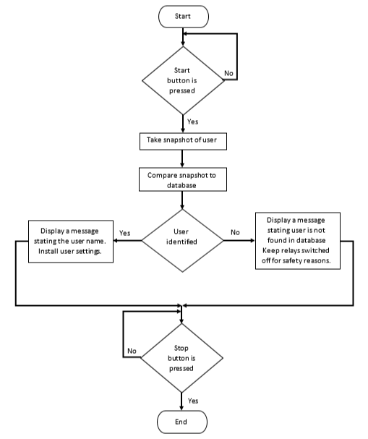

**Fig. 1.** Block-diagram of the new approach.

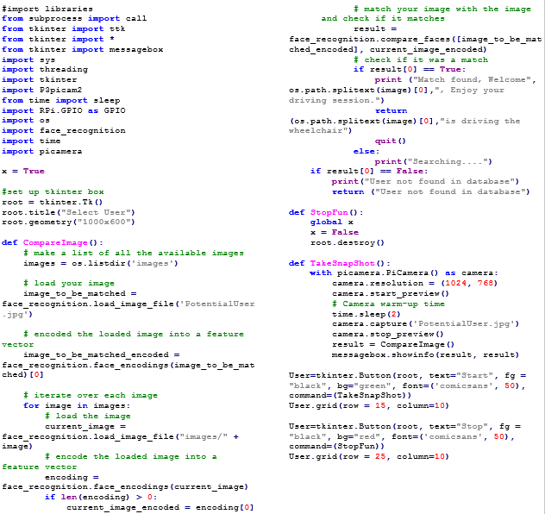

**Fig. 2.** Python program used in the new approach.

One Shot learning used a similarity function which input two images and output the degree of difference between the input images. If the two images were for the same individual, the function generated a small number. If the two images were for different individuals, the function would output a large number. A threshold could be used to set the degree of similarity.

To use the similarity function in image recognition, a new picture was compared to the images in the database. If the new image was for a person in the database, the function generated a small number when compared to that person and large numbers when compared to other images in the database. If the image was not in the database, the function generated larger numbers for all images in the database which implied that the image was not for any person in the database. That solved the problem of adding new users to the database without the need to retrain the whole system [26].

A simple User Interface (UI) was created containing two buttons: Start and Stop as shown in Fig. 3.

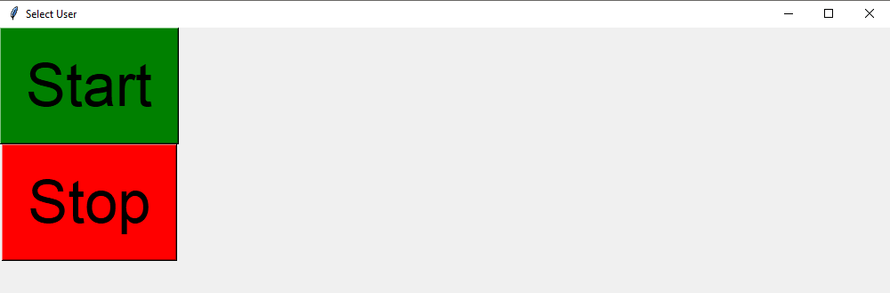

**Fig. 3.** Simple User Interface used to control the Python program.

The simple UI provided straightforward operation for powered mobility platforms and provided a suitable fit between desired commands and driver capabilities [27]. The UI provided a friendly and uncluttered design. When the Start button was clicked, the Python program triggered the Raspberry Pi camera to take a snapshot, then the program would identify the face in that snapshot and conduct facial recognition to compare that face with the database of potential users’ facial images. If a match was found a message box popped-up showing the user name as shown in Fig. 4.

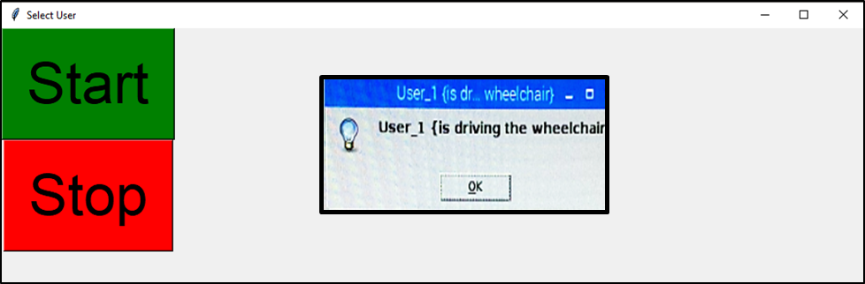

**Fig. 4.** UI showing a message box indicating the name of the identified user.

Once a user was identified, their settings and preferences could be downloaded to the shared powered mobility platform. If the face in the snapshot did not match any of the facial images in the data base, a message popped-up showing that user was not found in database as shown in Fig. 5. To exit the program, the Stop button should be clicked. When the Stop button was clicked, the UI was destroyed.

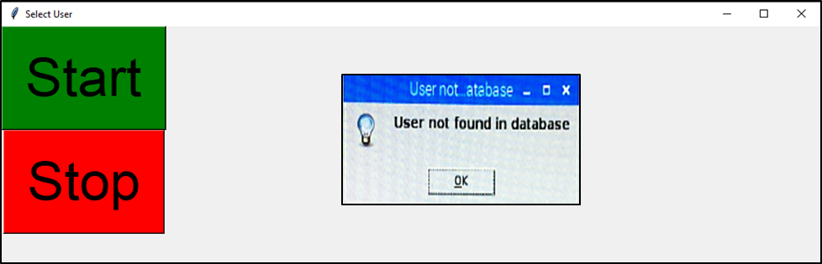

**Fig. 5.** UI showing a message box indicating user not found in database.

1. Discussion and Results

The new approach described in this paper used a One Shot learning algorithm to provide a more efficient outcome for facial recognition than a typical deep learning algorithm using a convolutional neural network, especially when a small learning set (small number of images for each individual) in a database was considered. An additional advantage was that One Shot learning did not require retraining of the whole system when adding a new user to the database.

The new approach was tested and successfully identified users in a database and did not match incorrect users in the database. Further testing will be conducted to identify a suitable location for the camera and the effect of ambient lighting on the accuracy of the new approach. New users could be digitally added to the system by uploading their facial image to the database. When a users was identified, their input device was triggered and the user settings were installed. Clinical trials will be conducted to assess the effectiveness of the new approach.

Reducing cost was one of the reasons behind this research. The new approach provided reliable results, reduced time taken in setting up, improved user autonomy and reduced the need and cost for carers.

1. Conclusions and Future Work

This paper presented a new approach to identify users of shared powered mobility platforms using a One Shot learning algorithm. An electronic circuit including a camera module and a raspberry Pi was created. Python programming language was used to create a program to control the function of the camera and conduct facial recognition.

The new approach used a simple friendly User Interface and reduced the amount of effort required by the helpers/carers to adjust the shared powered mobility plaform settings.

The authors are currently investigating other mathematically inexpensive AI techniques applied to powered mobility problems as part of a broader research to use artificial intelligence to share control of a powered-wheelchair between a wheelchair user and an intelligent sensor system [13].

Future work will consider creating new programs to install the identified user settings to the shared powered mobility platform. Also future work will investigate using AI algorithms and Artificial Neural Networks to improve driving capabilities for powered wheelchair users. Future work will also consider using a camera module and image processing algorithms to capture user movement used to control a powered wheelchair.

Acknowledgment

This research was supported by an EPSRC EP/S005927/1 project titled “Using artificial intelligence to share control of a powered-wheelchair between a wheelchair user and an intelligent sensor system”. Investigators: Sanders, DA and Gegov, AE. Senior Researchers Haddad MJ and Langner MC.

References

Sanders D, Gegov A. Using artificial intelligence to share control of a powered-wheelchair between a wheelchair user and an intelligent sensor system. EPSRC Project, 2019 – 2022. 2018.

Haddad, M.J., Sanders, D.A.: Deep Learning architecture to assist with steering a powered wheelchair. IEEE Transactions on Neural Systems and Rehabilitation Engineering, 28(12), 2987-2994 (2020).

Krops, L.A., Hols, D.H., Folkertsma, N., Dijkstra, P.U., Geertzen, J.H. and Dekker, R., 2018. Requirements on a community-based intervention for stimulating physical activity in physically disabled people: a focus group study amongst experts. Disability and Rehabilitation, 40(20), pp.2400-2407.

Bos, I., Wynia, K., Almansa, J., Drost, G., Kremer, B. and Kuks, J., 2019. The prevalence and severity of disease-related disabilities and their impact on quality of life in neuromuscular diseases. Disability and rehabilitation, 41(14), pp.1676-1681.

Frank, A.O. and De Souza, L.H., 2018. Clinical features of children and adults with a muscular dystrophy using powered indoor/outdoor wheelchairs: disease features, comorbidities and complications of disability. Disability and rehabilitation, 40(9), pp.1007-1013.

Sanders D.A, Langner M, Tewkesbury G E. Improving wheelchair‐driving using a sensor system to control wheelchair‐veer and variable‐switches as an alternative to digital‐switches or joysticks. Industrial Robot: An international journal, 32(2), 157-167 (2010).

Langner, M.: Effort Reduction and Collision Avoidance for Powered Wheelchairs: SCAD Assistive Mobility System, Doctoral dissertation, University of Portsmouth (2012).

Sanders, D.A.: Using self-reliance factors to decide how to share control between human powered wheelchair drivers and ultrasonic sensors. IEEE Transactions on Neural Systems and Rehabilitation Engineering, 25(8), 1221-1229 (2016).

Sanders, D.A., Bausch, N.: Improving steering of a powered wheelchair using an expert system to interpret hand tremor. In International Conference on Intelligent Robotics and Applications, pp. 460-471. Springer, Cham (2015).

Sanders, D.A.: Using self-reliance factors to decide how to share control between human powered wheelchair drivers and ultrasonic sensors. IEEE Transactions on Neural Systems and Rehabilitation Engineering, 25(8), 1221-1229 (2016.).

Sanders, D.A., Gegov, A., Haddad, M., Ikwan, F., Wiltshire, D., Tan, Y.C. Adv. Intell. Syst. Comput. Vol. 868. Cham: Springer; 2019. Rule-based Expert System to decide on direction and speed of a powered wheelchair; p. 822-832.

Sanders, D.A., Haddad, M., Tewkesbury, G.E., Thabet, M., Omoarebun, P. and Barker, T., 2020, August. Simple expert system for intelligent control and HCI for a wheelchair fitted with ultrasonic sensors. In 2020 IEEE 10th International Conference on Intelligent Systems (IS) (pp. 211-216). IEEE.

Haddad M, Sanders D, Gegov A, Hassan M, Huang Y, Al-Mosawi M.: Rule-based Expert System to decide on direction and speed of a powered wheelchair. In: Arai K, Kapoor S, Bhatia R, (eds.). Intelligent Systems and Applications. IntelliSys 2019. Advances in Intelligent Systems and Computing, vol. 868, pp. 822-832. Springer, Cham (2019).

Haddad, M., Sanders, D., Langner, M., Bausch, N., Thabet, M., Gegov, A., Tewkesbury, G., Ikwan, F.: Intelligent control of the steering for a powered wheelchair using a microcomputer. In Arai K, Kapoor S, Bhatia R, (eds.). Intelligent Systems and Applications. IntelliSys 2020. Advances in Intelligent Systems and Computing, pp. 594-603. Springer, Cham (2021).

Haddad, M., Sanders, D., Thabet, M., Gegov, A., Ikwan, F., Omoarebun, P., Tewkesbury, P., Hassan, M.: Use of the Analytical Hierarchy Process to Determine the Steering Direction for a Powered Wheelchair. In: Arai K, Kapoor S, Bhatia R, (eds.). Intelligent Systems and Applications. IntelliSys 2020. Advances in Intelligent Systems and Computing, vol. 1252, pp. 617-630. Springer, Cham (2021).

Haddad, M.J., Sanders D A.: Selecting a Best Compromise Direction for a Powered Wheelchair Using PROMETHEE. IEEE Transactions on Neural Systems and Rehabilitation Engineering 27(2), 228-235 (2019).

Haddad, M., Sanders, D., Ikwan, F., Thabet, M., Langner, M., Gegov, A.: Intelligent HMI and control for steering a powered wheelchair using a Raspberry Pi microcomputer. In 2020 IEEE 10th International Conference on Intelligent Systems (IS), pp. 223-228. IEEE, Bulgaria (2020).

Haddad, M., Sanders, D., Langner, M., Bausch, N., Thabet, M., Gegov, A., Tewkesbury, G., Ikwan, F.: Intelligent control of the steering for a powered wheelchair using a microcomputer. In Arai K, Kapoor S, Bhatia R, (eds.). Intelligent Systems and Applications. IntelliSys 2020. Advances in Intelligent Systems and Computing, pp. 594-603. Springer, Cham (2021).

Haddad, M., Sanders, D., Tewkesbury, G., Langner, M.: A Novel Collision Avoidance System for Steering a Powered Wheelchair Using Deep Learning Architecture. In: 24th IEEE International Conference on Intelligent Transportation - ITSC2021. *Submitted*. IEEE, USA (2021).

Haddad, M., Sanders, D., Langner, M., Thabet, M., Omoarebun, P., Gegov, A., Bausch, N., Giasin, K.: Intelligent system to analyze data about powered wheelchair drivers. In Proceedings of SAI Intelligent Systems Conference (pp. 584-593). Springer, Cham. (2020).

Haddad, M., Sanders, D., Langner, M., Omoarebun, P., Thabet, M., Gegov, A.: Initial results from using an intelligent system to analyse powered wheelchair users’ data. In 2020 IEEE 10th International Conference on Intelligent Systems (IS) pp. 241-245. IEEE, Bulgaria (2020).

Sanders, D., Haddad, M., Tewkesbury, G., Bausch, N., Rogers, I. and Huang, Y.: Analysis of reaction times and time-delays introduced into an intelligent HCI for a smart wheelchair. In 2020 IEEE 10th International Conference on Intelligent Systems (IS) pp. 217-222. IEEE, Bulgaria (2020).

Sanders, D., Haddad, M., Langner, M., Omoarebun, P., Chiverton, J., Hassan, M., Zhou, S. and Vatchova, B.: Introducing time-delays to analyze driver reaction times when using a powered wheelchair. In Proceedings of SAI Intelligent Systems Conference pp. 559-570. Springer, Cham (2020).

Haddad, M., Sanders, D., Langner, M., Tewkesbury, G.: Novel Approach to Steer a Powered Wheelchair Using Image Processing Algorithm and Raspberry Pi. In: 32nd IEEE Intelligent Vehicles Symposium, 2021. *Submitted*. IEEE, Japan (2021).

Haddad, M., Sanders, D., Tewkesbury, G., Langner, M.: Using Open Source Computer Vision Algorithms to Drive a Powered Wheelchair. In: 24th IEEE International Conference on Intelligent Transportation - ITSC2021. *Submitted*. IEEE, USA (2021).

Haddad, M., Sanders, D., Langner, M., Tewkesbury, G.: Steering a powered wheelchair using a camera module and Python Imaging Library. In: 24th IEEE International Conference on Intelligent Transportation - ITSC2021. *Submitted*. IEEE, USA (2021).

Fei-Fei, L., Fergus, R., Perona, P.: One-shot learning of object categories. IEEE transactions on pattern analysis and machine intelligence, 28(4), 594-611 (2006).

Lewis, C.: Simplicity in cognitive assistive technology: a framework and agenda for research. Universal Access in the Information Society, 5(4), pp.351-361 (2007).