Model-based Prediction for Navigation Assistance using a set of Sensors
D Sanders, G Tewkesbury, P Kyberd, S Zhou, M Haddad and S Simandjuntak
University of Portsmouth. Anglesea Building, Portsmouth PO1 3DJ, UK
Email: david.sanders@port.ac.uk
Abstract. Navigation assistance is a vital step towards higher level automation and intelligence. This paper presents a new conceptual design for an assistive system. It helps to manoeuvre powered wheelchairs in challenging situations so that more people can drive them. The method is based on dynamic motion prediction using sensors to provide information about the surroundings. Generic components of the assistive system are presented based on manoeuvre prediction. Wheelchair user behaviour was analysed while they were driving their wheelchairs. Other aspects are discussed, including the precision of the models built upon actuator and environmental data collected from a strategically selected set of sensors.

- Introduction
Powered wheelchairs and other mobility platforms have been equipped with assistive systems to avoid collisions [1-7] and aid with steering [8-14]. Such systems have assisted wheelchair drivers, especially when manoeuvring through doorways and through narrow gaps, or in complicated environments or adverse weather. Research described in this paper aims to create new control systems for powered wheelchairs [15-20]. Wheelchairs require high levels of safety and efficiency, especially when approaching obstacles or entering narrow spaces such as doorways. The prototype systems were created during the first phase of the project to process data when cope with an obstacle, optimise paths and automatically assist the user with selecting a safer path using a set of sensors.
- Background
Mobility problems can be tackled in many ways. A powered wheelchair or scooter could cause many problems if people could drive them. This paper considers ways of helping people to drive. However, many other solutions, devices and systems exist to assist people with disabilities including personal devices such as crutches, wheelchairs, white canes, and systems or devices built into the surrounding environment such as wheelchair ramps, textured platform slabs in railway stations and Pelican crossing beepers. Local bus services could be modified to be more accessible. Disabled people could equip with computers so that they can do more without the needing of more carers. Self-mobility has many advantages and some will be addressed in this work. The best solution would be one that was feasible, preferred by the person operating the system and affordable. That may not always be archived by a single technological solution.
  - Technology in the Environment
In the UK, shops and other public places are obliged to be accessible to disabled people. It is often assumed that “disabled” means “wheelchair user” so that making doorways wider and adding a ramp might be considered enough. Although a lot of disabled people are not in wheelchairs. Most environmental adaptations address problems and deficiencies in wheelchair performance. For example, lifts and ramps have been fitted instead of or as well as steps, doorways have been widened, thresholds made level, and door handles moved or automatic doors installed. Other adaptations include the addition of grab handles and handrails, and clear markings of accessible routes. People with sensory disabilities can usually move themselves. Adaptations made for people with sensory disabilities usually provide extra information, for example through high contrast signs. Audio signs can provide information and textured flooring, which with tactile and audio cues can improve safety greatly. People with cognitive disabilities can have information provided to them in a more accessible way. Buildings and their internal spaces can be constructed to make route finding easily memorable and intuitive. Colour coding of locations can make them more memorable and distinct. Simple changes may have significant impacts. Removing steps from shops could significantly improve accessibilities whilst the most important mobility aids are still wheelchairs.
  - Manual Wheelchair
Manual wheelchairs are used by many millions of people even today. There are many different models. The typical design of the majority of such wheelchairs are shown in Figure 1 from “Disability and Mobility: Problems of Navigation, Orientation and Locomotion, and Internal Report from the Bath Institute of Medical Engineering. The design is a compromise. The driving wheels are large to place the rims within easy reach of the wheelchair user, to move over uneven ground more easily and to have a low rolling resistance. Driving wheels are usually narrow and pneumatic but can be filled with puncture-proof polyurethane foam (although they have a higher rolling resistance). Castors are small and at the front with solid and hard rubber tyres. Hard tyres are less comfortable but reduce rolling resistance and make the wheelchair more manoeuvrable. But they make the wheelchair more difficult to operate on uneven or softer ground. Footrests are important for users’ comfortness. The backrest keeps the user upright in the chair, while its heights can vary. Some manual chairs are fitted with pushing handles. Wheelchair frames are similar to bicycle frames and are constructed in similar ways using steel, aluminium alloy, titanium or carbon fibre. There are specialist designs for special occasions, such as, off-road, skiing, downhill racing, rugby, basketball and tennis.
  - Powered Wheelchairs
If wheelchair users cannot use manual wheelchairs or find manual wheelchairs tiring, then powered wheelchairs are an alternative. A typical design of a powered wheelchair is shown in Figure 2.

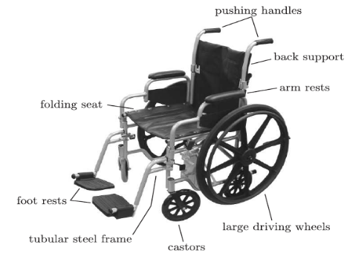 |  | 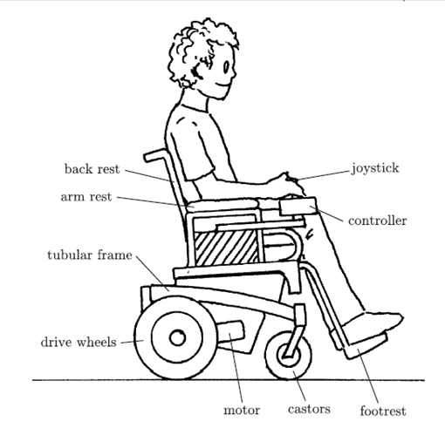
Figure 1. Main features of a manual chair [21]. |  | Figure 2. Features of a powered chair [21].

There have been three main configurations of powered wheelchairs, with driving wheels at the back, in the front or in the middle. Front wheel drive powered wheelchairs are more manoeuvrable and can climb curbs more easily. However, they can lose their traction on steeper gradients, especially on wet and slippery surfaces. They do allow a user to approach objects more closely. Centre wheel driven powered wheelchairs provide good traction and are manoeuvrable as the wheelchair user sits directly above the driving wheels but they can feel `tippy' when weight is transferred from the back to the front or vice versa when speeding up or slowing down. Rear wheel drive is the most common type because it is the most compact design. They are easier to be built and have the best traction when climbing. Most folding powered wheelchairs are rear wheel drive. The Bobcat II wheelchair used in this research was front wheel drive.
There are many designs of frame for powered wheelchairs. Frames are rigid and able to support the user and powertrain while keeping the centre of gravity low. They are usually made form welded steel tube (although aluminium is used as well). Driving wheels are smaller than a manual wheelchair, while just large enough to climb curbs. Tyres are most often treaded. Motors usually run on 24 Volts DC and are energy efficient, with ease of control (with a wide speed range) and can deliver high torques. Two 12 Volt sealed lead acid batteries tend to be used in series as they can deliver high currents, can be trickle charged for long periods, and are affordable. However, they are relatively heavy and could be damaged if completely discharged. Alternatives include Lithium and Nickel Metal Hydride batteries. Lithium in particular can deliver high currents, can be charged quickly, are lighter and have a higher energy density but more expensive.
Wheelchair controllers are complex. They take inputs from a human wheelchair user to manoeuvre wheelchair typically via a pair of motors. The controller must be able to make smooth operations in both directions and speeds. A joystick is usually a standard user interface and used by many disabled people. Pushing a joystick forward moves a powered wheelchair forward. Pulling a joystick sideways turns a powered wheelchair left or right. The further a joystick moves away from a neutral central position, the faster a powered wheelchair travel. However, a group of disabled people are not able to use joysticks, therefore other control options are made available such as head operated switches, chin operated joysticks and suck/blow controllers. Some power wheelchairs have additional features, for example, there are wheelchairs that can rise, wheelchairs with many different special seating configurations, and specific designs of off road powered wheelchair.
The research described in this paper used a Bobcat II wheelchair as shown in Figure 3. The Bobcat II wheelchair was controlled by a joystick and had ultrasonic sensors mounted on it to help a user to safely drive, avoid obstacles, and negotiate gaps, narrow spaces, and doorways.
- Components of The New Assistance System
Assistance for wheelchair navigation has been defined in this research as a visualization of the predicted dynamic motion of the wheelchair based on current joystick settings and relevant environmental forces. A ‘dynamic motion model’ formed the main basis for a manoeuvre prediction system, as shown in figure 4.

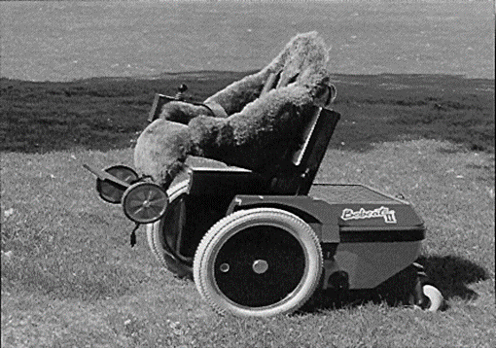 |  | 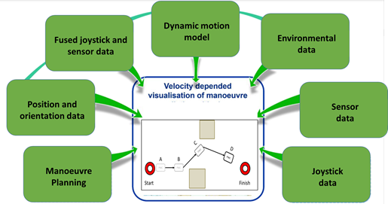
Figure 3. Bobcat II Wheelchair. |  | Figure 4. Components of the assistance system.

The dynamic model represented the relationship between the joystick configurations and the corresponding actions of the wheelchair. It considered the actuators and their collaborated effects, such as the different effects at various accelerations and velocities. The influences from external forces against actuator forces and matching timings should be considered. These can be formulated by the equations of motion with at least 2 Degrees Of Freedom. The relationship between joystick configurations and actuators’ responding forces, as well as the model parameters, such as those representing external forces, were collected and included in a number of lookup tables. The wheelchair-model parameters were tuned using programs in MATLAB as the wheelchair was simulated undertaking different manoeuvres to achieve a best outcome based on measured motion states and model data.
Lookup tables were generated from measurement data, their interpolation and extrapolation covering the complete setting ranges. The data covers whether they described the characteristic behaviour in all motion states of the wheelchair, especially when manoeuvring close to obstacles or in narrow gaps, for example doorways. Data was collected during typical wheelchair operations. The measurement equipment on board the wheelchair together with data collecting interfaces decided the quality of the data. Supplemental sensors may be needed to strengthen a sufficiently accurate model, in particular sufficiently accurate orientation and position data.
The measured actuator and sensor data needed to be synchronised and fused to with a set of consistent time stamps for a complete modelling. Each supplemental sensor had a different sampling rate and the data was synchronised. The model depended on fusing data, including assignment of weights to the data according to their quality in each situation. There were different options to assist in navigation using proximity recognition systems. Potential sensors were ultrasonics, cameras, radar or Light Detection and Ranging based sensors, which are often used in automotive industry. Ultrasonic sensors were selected for this work because they were robust and cheap. Distances to objects needed to be correlated with wheelchair position. When close to obstacles, the proximity data was given the highest weighting within the sensor fusion modules, partially because of the application and its high reliability.
An essential component of the model was the environmental data as well as their impact on the manoeuvrability of the wheelchair. An assistance system offered the opportunity to integrate environmental impacts within the dynamic motion model. Responding motion actions from the joystick commands with the impact from the environmental forces could be modelled. Adequacy would be evaluated by correlating the predicted path and the required space. This needed an appropriate map. Automatic adaptation of these monitoring parameters was needed.
It was possible that each wheelchair user could have a personal configuration set, which would allow alarms and hints to be given. The degree of automation was also increased by including collision avoidance and automatically calculated evasive paths.
- Manoeuvring Behaviour
Interviews, observations and automated data collection were used in this work. A questionnaire-based survey was created to collect and analyse individual behaviour data when driving. The first part of this survey addressed the conventional use of joysticks.
Automatic data collection evaluated joystick and sensor usages in terms of effectiveness and efficiency. The usage was classified on a scale from 0 (= never) to 10 (= always), depending on how frequently each parameter was used. Similarly, the data from carers and researchers observing tests were collected and evaluated. A list of the usual parameters were compiled, which included obstacles’ size, number of collisions, location of obstacles and distances to obstacles.
In the second phase of the project, interviewing with wheelchair users took place to elicit additional information. Different pictures were shown to users to learn about their possible reactions in different situations.
The personal opinions in the questionnaire-based survey varied widely and demonstrated the divested individual approaches to driving. Tendentiously, wheelchair users appeared to use absolute values than the relative. The location of the wheelchair, the reactive correction for veer and the distance to the target location were the most common values considered by the users. In addition, different distances were monitored regularly such as distance to obstacles or to other powered wheelchairs and people. The frequency of assessing the environmental factors depended on the ability and skills of the driver. Participants commented that the sensors were usually helpful but sometimes not. In some certain circumstances, the usage of some sensors slowed down the wheelchair unnecessarily and made inefficient manoeuvres.
The majority of clinicians and engineers considered the saving of manoeuvring data including manoeuvre points with velocities and actuator values as useful. The data were especially useful in the analysis of collisions or critical manoeuvres as well as in training sessions.
A further part of the survey addressed alarms depending on velocity and distance to obstacles. Most people thought it was a good idea but did not want to use it themselves. For the distances to obstacles, the majority preferred combinations of optical and acoustic alarms.
There was a need (at least in psychological terms) to personalise the assistance systems. Personalisation had different advantages. Each user could choose their own additional parameters depending on their individual circumstances. The user continued to be responsible for manoeuvring and the manoeuvre prediction calculated the future motion of the wheelchair resulting from joystick settings and external forces. The prediction provided a greater certainty in guidance accompanied by fewer actuator variations. Because of the precision, the mental knowledge base of an experienced user was further improved. During training, the prediction helped build a personal dynamic model without any extra risk.
- Proximity Recognition
Proximity recognition can be especially important in dark environment or if the user is visually impaired. A new proximity recognition system was created. A combination of ultrasonic and infrared sensors were installed on the wheelchair to detect hazardous objects surrounding the vehicle. Sensor fusion was used to fuse proximity recognition data.
Time of flight served as a measurement of the distance between sensors and obstacles. Sixteen independent active channels were used for simultaneous acquisition arranged with a 90° field of view. The module was mounted at the front of the wheelchair between the footrests. The accuracy of the sensor system could allow for precise object identifications in the future.
- Qualitative Study
A qualitative exploratory study was undertaken as part of a group project during an extended undergraduate degree at the University of Portsmouth. Individual interviews were conducted using a semi-structured interview guide with probes and open-ended questions. Participants were asked about their wheelchair use and any unmet mobility needs. Participants were then shown demonstrations of the new systems. After the demonstrations, participants were questioned regarding the new systems.
Two main themes emerged, namely, “Overcoming challenges” and “Useful features”.
  - Overcoming Challenges
These challenges most commonly related to the following categories and circumstances:
- Hazardous environments:
  - inaccessible buildings,
  - narrow entrances,
  - small elevators,
  - pavements in poor condition,
  - and narrow store aisles;
- Hazardous weather conditions:
  - Such as rain, fog, and snow,
  - or any condition causing poor visibility.;
- Special venues
  - shopping centers,
  - stadiums and
  - festivals.
After the demonstrations, volunteers reported that the new features could alleviate some of challenges. Obstacle avoidance was particularly highlighted, praised and recognised to reduce possible difficulties of wheelchair users.
Volunteers did express concerns regarding their ability of learning and using the new technology. They didn’t want the new technologies to weaken their own abilities. Volunteers mostly only perceived some of the features as being relevant. Several were skeptical about trusting the new systems more than their own knowledge and abilities, or were concerned about reliability. Others thought the new systems could respond more quickly in emergencies.
  - Useful Features
Two features were potentially the most helpful: obstacle avoidance and path following. Volunteers felt the new systems could be especially useful when they were tired as the new systems could reduce physical and cognitive effort. Volunteers thought the systems could be especially useful for people with: slow reactions, tiredness, poor upper extremity motor control or reduced vision. The new systems could also become increasingly useful as people age, and cognitive and visual impairments increase. The systems could be especially useful to people with slow progressive conditions that deteriorate so that manual control may be ineffective or even totally lost.
- Discussion and Conclusions
Assistive devices and changes to the environment could help provide independent mobility for people with disabilities. If a disabled person needed help in order to become mobile, then they were much less independent. This paper presented a new conceptual design and generic components for an assistive system. The method was based on dynamic motion prediction using sensors to provide information about the surroundings.
Relevant data must be acquired by sensors with sufficient precision to characterize motion and position in relation to obstacles. Collected data were filtered, synchronised and fused for modelling and online in real time for driving.
Conventional behaviour during driving was surveyed using a questionnaire-based survey followed up with interviews. Highly individual approaches were obvious in the responses, discussion about driving and in observing the driving.
It was concluded that the next developments of the system must offer customisable functionality. A personalized system could also provide an opportunity to introduce automation in a gentle manner.
In the second phase of the project, a higher level of automation and intelligence is planned. The developed methods will be demonstrated in real time and using real powered wheelchairs.
Proximity recognition systems will be redesigned to improve sensor fusion, considering the number of sensors and their combination (with different types) to adapt the sensor system. Processing of the sensor data was complicated because of the distribution and different types of sensors. Adequate proximity recognition is a precondition for assistive automated systems.

- References
[1] Haddad M, Sanders D, Langner M, Omoarebun P, Thabet M and Gegov A 2020 Initial results from using an intelligent system to analyse powered wheelchair users’ data Proc. of the 2020 IEEE 10th International Conference on Intelligent Systems-IS (Varna) 2 pp 241-245
[2] Okonor O, Gegov A, Adda M, Sanders D, Haddad M and Tewkesbury G 2019 Intelligent approach to minimizing power consumption in a cloud-based system collecting sensor data and monitoring the status of powered wheelchairs. Intelligent Systems and Applications . Advances in Intelligent Systems and Computing 1037 Springer pp 694-710
[3] Sanders D, Haddad M, Tewkesbury G, Thabet G, Omoarebun P and Barker T 2020 Simple expert system for intelligent control and HCI for a wheelchair fitted with ultrasonic sensors Proc. of the 2020 IEEE 10th International Conference on Intelligent Systems-IS (Varna) pp 211-216
[4] Haddad M, Sanders D, Langner M, Thabet M, Omoarebun P, Gegov A, Bausch N and Giasin K 2020 Intelligent system to analyze data about powered wheelchair drivers Proc. of SAI Intelligent Systems Conference (Amsterdam) pp 584-593
[5] Sanders D, Langner M, Bausch N, Huang Y, Khaustov S and Simandjuntak S 2019 Improving human-machine interaction for a powered wheelchair driver by using variable-switches and sensors that reduce wheelchair-veer Intelligent Systems and Applications Advances in Intelligent Systems and Computing 1038 Springer pp 1173-1191
[6] Sanders D, Tewkesbury G, Parchizadeh H, Robertson J, Omoarebun P and Malik M 2019 Learning to drive with and without intelligent computer systems and sensors to assist Intelligent Systems and Applications 1. Advances in Intelligent Systems and Computing 868 Springer pp 1171-1181
[7] Sanders D, Gegov A, Tewkesbury G and Khusainov R 2019 Sharing driving between a vehicle driver and a sensor system using trust-factors to set control gains Intelligent Systems and Applications 1. Advances in Intelligent Systems and Computing 868 Springer pp 1182-1195
[8] Sanders D, Sanders B, Gegov A and Ndzi D 2018 Results from investigating powered wheelchair users learning to drive with varying levels of sensor support Proc. Intelligent Systems Conference (London) pp 241-245
[9] Sanders D, Sanders B, Gegov A and Ndzi D 2018 Using confidence factors to share control between a mobile robot tele-operater and ultrasonic sensors Proc. of the 2017 Intelligent Systems Conference (London) pp 1026-1033
[10] Sanders D, Ndzi D, Chester S and Malik M 2016 Adjustment of tele-operator learning when provided with different levels of sensor support while driving mobile robots Lecture Notes in Networks and Systems 16 Springer pp 548-558
[11] Sanders D, Haddad M, Omoarebun P, Ikwan F, Chiverton J, Zhou S, Rogers I and Vatchova B 2020 Intelligent control and HCI for a powered wheelchair using a simple expert system and ultrasonic sensors Intelligent Systems and Applications 3. Advances in Intelligent Systems and Computing 1252 Springer pp 571-583
[12] Sanders D and Bausch N 2015 Improving steering of a powered wheelchair using an expert system to interpret hand tremor Proc. International Conference on Intelligent Robotics and Applications (Portsmouth) pp 460-471
[13] Haddad M and Sanders D 2020 Deep Learning architecture to assist with steering a powered wheelchair IEEE Trans. Neur. Sys. Reh. 28 12 pp 2987-2994
[14] Sanders D, Langner M and Tewkesbury G Improving wheelchair‐driving using a sensor system to control wheelchair‐veer and variable‐switches as an alternative to digital‐switches or joysticks Ind Rob: An int' jnl 32 2 157-167
[15] Haddad M and Sanders D 2019 Selecting a best compromise direction for a powered wheelchair using PROMETHEE IEEE Trans. Neur. Sys. Rehab. 27 2 pp 228-235
[16] Sanders D, Gegov A, Haddad M, Ikwan F, Wiltshire D and Tan YC 2018 A rule-based expert system to decide on direction and speed of a powered wheelchair Proc. of SAI Intelligent Systems Conference (London) pp 822-838
[17] Haddad M, Sanders D, Gegov A, Hassan M, Huang Y and Al-Mosawi M 2019 Combining multiple criteria decision making with vector manipulation to decide on the direction for a powered wheelchair Proc. of SAI Intelligent Systems Conference, (London) pp 680-693
[18] Haddad M, Sanders D, Langner M, Ikwan F, Tewkesbury G and Gegov A 2020 Steering direction for a powered-wheelchair using the Analytical Hierarchy Process Proc. 2020 IEEE 10th International Conference on Intelligent Systems-IS (Varna)pp 229-234
[19] Haddad M, Sanders D, Thabet M, Gegov A Ikwan F, Omoarebun P, Tewkesbury G and Hassan M 2020 Use of the Analytical Hierarchy Process to Determine the Steering Direction for a Powered Wheelchair Proc. of SAI Intelligent Systems Conference (London) pp 617-630
[20] Sanders D 2017 Using self-reliance factors to decide how to share control between human powered wheelchair drivers and ultrasonic sensors IEEE Trans Neur Sys Rehab 25 8 pp 1221-1229

