Voter based control for Situation Awareness and Obstacle Avoidance
D Sanders, G Tewkesbury, S Zhou, P Kyberd, M Haddad and S Khaustov
University of Portsmouth. Anglesea Road, Portsmouth PO1 3DJ UK
Email: david.sanders@port.ac.uk
Abstract. Situational awareness and obstacle avoidance for a powered wheelchair are considered. A voter-based control system uses the results from a path planner, sensors and image processing algorithms. A route planning system utilizes interval analysis, and image processing algorithms are used for obstacle detection. Voter based control is adapted from their results.

- Introduction
The architecture of a situational awareness system for a navigation system is presented. The system can be divided into two main parts: obstacle detection and collision avoidance. The collision avoidance system includes two major components, a higher-level route planning module and a lower-level reactive sub-system.
A Bobcat II Wheelchair was selected as a platform for the research. An image of the powered wheelchair is shown in Figure 1. The current state of the art for situational awareness for vehicles is briefly discussed in the following Section, mainly based on Liu et al [1] and Friebe et al [2]. The software architecture of the situational awareness, collision avoidance and control system is described in Section 3.
Various sensors and controllers could be attached to the microcomputer and therefor the wheelchair. Simple and reliable Ultrasonic sensors [3-5] and a forward looking camera were used in this research. An on board microcomputer collected and processed signals from the sensors and joystick for controlling the two wheelchair motors. A GPS module provided position, direction and speed data. The camera had a field of view of 25° horizontally and 19° vertically. The image was processed to estimate the amount of navigable space available for choosing a course within the field of view. The algorithms are described and results for test images are illustrated in Section 4.
The higher-level path planning module used interval analysis methods. Sets of waypoints were planned for a wheelchair route. The algorithm together with its simulation results and analysis are presented in Section 5. Close range objects and the visible navigable space extracted and interpreted from the captured images were used as an input into the lower-level reactive system integrated with the navigation system through a voter-based mechanism. The voter-based system was similar to that described by Less’ard-Springett et al [6], but was adapted to utilize the output from the image processing system based on [2]. This development with corresponding simulation results are discussed in Section 6. Further experimental results and evaluations are included in Section 7. Section 8 presents conclusions and future work.
- Situational Awareness and Obstacle Avoidance
Guidance techniques were classified by Lui et al in [1] as global path planning, local path planning and hybrid path planning. Global path planning used optimization methods such as Genetic algorithm, or heuristic search algorithms such as A*. Cost functions have included spatiotemporal characteristics, collision probability estimates, fuel consumption and weather influences. Local path planning included line-of-sight and potential field methods. Hybrid path planning combined global and local path planning, often utilising hierarchical architectures.
Methods can be classified as: (1) Protocol-free collision avoidance does not have any direct rules but, uses differential equations, level sets and optical flow; (2) Protocol-based collision avoidance adapts sets of rules for example A* and velocity obstacles.
Furthermore in [1], environment perception methods and sensors were classified as active or passive depending on whether the methods counted transmitting signals or not. Passive methods include monocular vision, stereo vision, and Infrared vision. Visible light based systems generally have a long range and consume less energy. However, range is affected by conditions such as light (for example direct sunlight), rain or fog. Active perception methods include Ultrasonics, LIDAR, Radar, and Sonar. Sonar was a valuable tool for detecting hard obstacles and helping to find safe routes.
- Software Architecture
The control system used a message based architecture for communication between threads responsible for sensor readings, communication, control and command execution. Figure 2 shows an overview of the software architecture for situational awareness and obstacle avoidance.

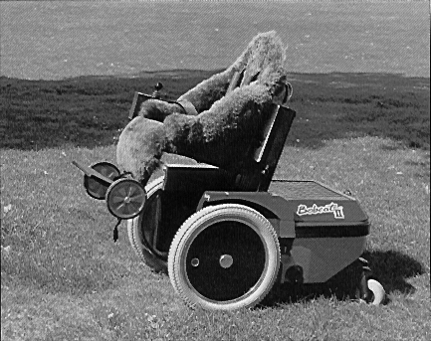 |  | 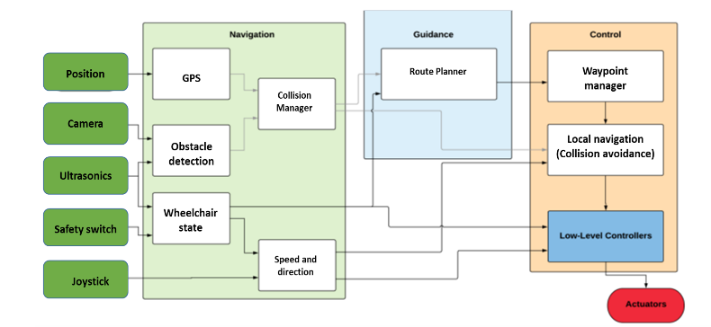
Figure 1. Bobcat II Wheelchair. |  | Figure 2. Software Architecture.

Sensor information was fed into the Collision Manager, a global state representation of obstacles and interacting structure. Interpretation is described in Section 5. The Collision Manager processed the message based system, and contained protected data to be shared between threads. The combination with Mission planning information was achieved in the higher level Route Planner described in Section 4. The output from the Route Planner was a new set of waypoints, which were fed into the Waypoint Manager. The Local Navigation Module controlled the target course provided by a joystick or from a pre-set route which was implemented by means of a voter based control system [6]. The image from the camera and the ultrasonics information, both stored in the Collision Manager, were used for collision avoidance which is described in Section 6.
- Higher Level Route Planning
Higher-level route planning adjusted the route defined by the waypoints to avoid collisions and ensure the route remained within a safe area. The Safe Areas were predefined based on static information about the environment, for example positions of walls and doors etc. The route Planner read the list of waypoints and checked if there was a risk of collision. If a potential risk was identified, the Route Planner modified the list of waypoints by justifying the positions of affected waypoints or adding new waypoints to avoid possible collisions, ensuring a safe route. Possible collisions were calculated by linearly extrapolating the trajectory of the wheelchair based on its speed and direction. The algorithm was applied in two main steps that were repeated for each trajectory segment and the trajectory between waypoints. The first step was to detect any possible collisions. If there was a chance of impact, then the path planning step was triggered. Interval analysis allowed the set of all feasible velocities to be determined, that is all velocities that allowed the wheelchair to stay within a Safe Area. This set was computed using a paving method. Secondly, the velocity closest to the initial velocity of the wheelchair was selected and used to calculate new waypoint coordinate(s).
  - Collision Detection
The collision detection algorithm was based on [7]. Interval analysis provided tools to find solutions to the sets of inequalities and equations. Some assumptions were made in order to implement the algorithm. The area of movement for the wheelchair was approximated by a 2-D plane with a fixed Cartesian frame O_{xy}. The joystick provided demanded speed, and direction while the GPS measured speed, direction and position at time t = 0 with a known accuracy. For calculating future positions, the speed and direction were considered as constants. Uncertainty was handled by interval analysis which was a key part of the approach. It was assumed that the segments of trajectory was linear:
(t) = a₀t + b₀ (1)
The vector b₀ is the initial position, and the vector a₀ is determined by the speed and line to be followed, that is by two consecutive waypoint positions. Waypoints were expressed in the fixed Cartesian frame of the two-dimensional plane. In a first approximation, the initial position was set to the first waypoint. Some estimates of the velocity on the trajectory segments were also carried out. It was possible to make an estimation of the velocity over a trajectory segment. In [7], Jaulin and LeBars proposed a method based on interval analysis to show that a trajectory was accurate. The trajectory was examined for possible collisions in a time interval [0, tmax].
∃𝑖 ∈ {1, … 𝑚}, ∃𝑡 ∈ [0,𝑡𝑚𝑎𝑥], m_{i}(t) = m₀(t) (2)
That is, if the following system has a solution:
{(𝑎₀ − 𝑎_{𝑖}).𝑡 + 𝑏₀ − 𝑏_{𝑖} = 0, 𝑡 ∈ [0,𝑡_{𝑚𝑎𝑥}], 𝑖 ∈ [1, … 𝑚], 𝑎₀ ∈ [𝑎₀], 𝑎_{𝑖} ∈ [𝑎_{𝑖}], 𝑏₀ ∈ [𝑏₀], 𝑏_{𝑖} ∈ [𝑏_{𝑖}] (3)
Expressed using interval analysis, this gives:
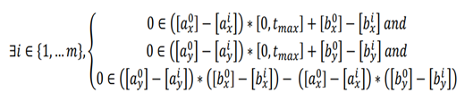 (4)
To check for collisions between waypoints, t_{max} was chosen so that the wheelchair reaches the second waypoint at t_{max}. An estimate of t_{max} was based on estimates of velocity between waypoints. For the case of several reference positions (waypoints). The collision detection scheme was applied for each segment if there are more than one waypoint. Initial positions of waypoints were updated to correspond to the estimated values at the beginning of each new trajectory segment.
  - Detecting Crossing of Safe Area Borders
A Safe Area was modelled as a number of polygons providing borders that the wheelchair should not cross. Each polygon was modelled by the list of the coordinates of its vertices. These coordinates were expressed in the fixed Cartesian frame in the two-dimensional plane. The crossing of borders algorithm was based on the example presented in [8]. Considering two boxes A_{box} and B_{box}. A_{box} is the initial position of the wheelchair, and B_{box} is the target position. The i^{th} vertex of a polygon is denoted by V_{i}. Let [A,B] denote the set of all the segments with an endpoint in A and an endpoint in B. For each polygon of the Safe Area, it was necessary to examine if:
∀𝑖, ∀𝑆 ∈ [𝐴, 𝐵], [ ,+1 ] ∩ 𝑆 = ∅ (5)
If this condition was true for all sides of all polygons, the wheelchair never crossed a Safe Area border. A simplified approach was used to implement this. An easier implementation was used. The contrapositive was considered instead and the corresponding relations were:
∃𝑖, { ∃𝑆 ∈ [𝐴, 𝐵], (𝑉_{𝑖} , 𝑉_{𝑖+1}) ∩ 𝑆 ≠ ∅ 𝑎𝑛𝑑
∃𝐷 ∈ (𝐴, 𝐵), [ , 𝑉_{𝑖+1} ] ∩ 𝐷 ≠ ∅ 𝑎𝑛𝑑
[𝑉_{𝑖} ∪ 𝑉_{𝑖+1}] ∩ [𝐴 ∪ 𝐵] ≠ ∅ (6)
Let (A,B) denote the complete set of lines supported by a point in A and a point in B, (V_{i}, V_{i+1}) the line supported by V_{i} and V_{i+1}, [V_{i}, V_{i+1}] the segment linking V_{i} and V_{i +1}, and [A∪B] and [V_{i} ∪ V_{i} +1] the smallest box including A and B or V_{i} and V_{i +1} respectively. The last condition is important for a special case, where all the points are aligned. In that special case, the two first conditions will be true even if the trajectory does not cross the polygon side. The first two conditions are not implemented directly, instead the equivalence in [2] was used. If that was true for one of the polygons of the Safe Area, then the trajectory of the wheelchair would cross the border determined by the polygon.
  - Path planning
Interval analysis was used for path planning. The set of all velocities that allowed the wheelchair to avoid collisions was computed to ensure it stayed within the Safe Area. Separator algebra was adopted.
A separator is an interval analysis tool that aims to approximate the solution set of an equation. A separator corresponding to the collision condition of each obstacle, and to the crossing condition of each side of each polygon of the Safe Area was constructed. Secondly, the convolution of all the separators was computed. Finally, the set of all the feasible velocities was computed with a paving method. In result, the velocity closest to the initial velocity of the wheelchair was chosen. This velocity was stored as the time when it would take the wheelchair to reach a waypoint with its previous velocity. This assumption allows the computation of a new waypoint which replaced the former one. To build the collision separators, the same conditions as for the detection part were used. In order to express these constraints as sets the following reformulation was used: ∃𝑖 ∈ {1, … 𝑚},
{[𝑏_{i𝑥}] − [𝑏_{0𝑥}] ∈ ([𝑎_{0𝑥}] − [𝑎_{i𝑥}]) ∗ [0,𝑡_{𝑚𝑎𝑥}] 𝑎𝑛𝑑
[𝑏_{𝑦𝑖} ] − [𝑏_{0𝑦}] ∈ ([𝑎_{0𝑦}] − [𝑎_{i𝑦}]) ∗ [0,𝑎_{𝑥}] 𝑎𝑛𝑑
([𝑏_{i𝑦}] − [𝑏_{0𝑦}]) ∈ ([𝑎_{0𝑦}] − [𝑎_{i𝑦}]) ([𝑎_{0𝑥}] − [𝑎_{i𝑥}]) ∗ ([𝑏_{i𝑥}] − [𝑏_{0𝑥}] (7)
For separators representing Safe Area border crossings, the same conditions as for the detection step could not be used. The two first conditions could be used, but not the third because it was a logical relation, and separators dealt with sets or arithmetic relations. The third condition was given by:
∃𝑖, [𝑉_{𝑖} ∪ 𝑉_{𝑖}+1] ∩ [𝐴 ∪ 𝐵] ≠ ∅ (8)
This condition was true if the two boxes were overlapping. Figure 3 illustrates an example of two overlapping boxes. Let [V_{i} ∪ V_{i+1}] represent the blue (upper) box, and [A∪ B] the red (lower). The two boxes are overlapping if:
{max(𝑑1,𝐷1)− max(𝐿1,𝑙2) ≤ 0 (9)
𝑎𝑛𝑑
max(𝑑2,𝐷2)−max(𝑙1, 𝐿2) ≤ 0 (10)
A paving of the set of feasible velocities, represented on the (V_{x}, V_{y}) plane, is illustrated in Figure 4.

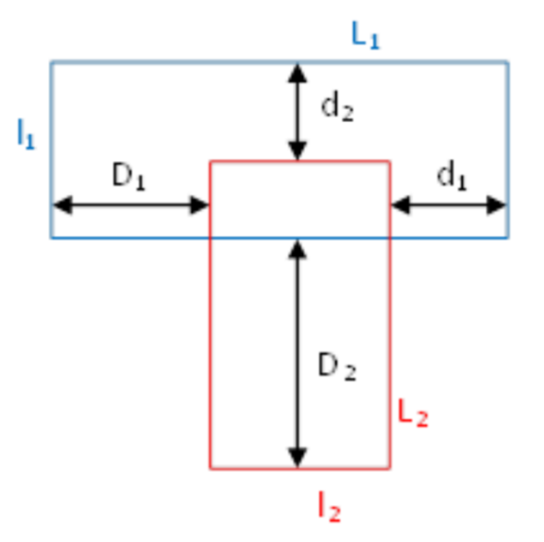 |  | 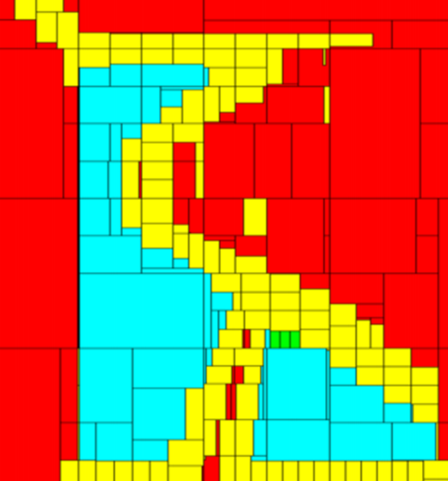
Figure 3. Two overlapping boxes [2]. |  | Figure 4. Result of the paving process.

In this simulation, there were three obstacles, and the Safe Area was defined by a square around the evolution area of the wheelchair. Speeds from 0 to 0.5m/s on V_{x} and V_{y} were explored. The red segments are inside the set of velocities that may lead to a collision or border crossing. The yellow boxes are on the border of this set. The light blue boxes are outside this set and represent a set of feasible velocities. The green box is the velocity selected by the algorithm.
- Image Processing
The image ahead of the camera was constructed from the ultrasonic sensors and the camera. Software handling camera frames was based on the computer vision library OpenCV. Pattern identification was used and targeting free space rather than potential obstacles. The navigation system was able to select a best route. Each frame was processed independently while the video handle was open.
First the algorithm checked if the camera was calibrated. If a green square was found, the thread was halted until calibration had finished. Second, frames were fed into a Gaussian filter to eliminate noise and through a Canny filter to outline objects’ contours. Then, the system defined a specific Region of Interest, excluding every part of the frame falling on the upper zone as the distance was negligible.
The frame was analysed column by column using a column width equal to 1° of bearing, clustering contours to detect obstacles; iterating from the bottom left corner to the top right corner, external elements identified were pushed to the Collision Manager to bridge the Obstacle Detection node with the Local Navigation node, using the voter system.
- Adaptation of The Voter Based Control System
Voter based systems were first developed at Carnegie Mellon University in the mid-1990s [8] and have a long history of real-world applications [9]. The Wheelchair used a voter-based control system for navigation and obstacle avoidance. Each voter had a specific objective that was translated into votes for the possible target courses of the wheelchair. The voter-based control system enabled separation of concerns and modularity. The voters were:

- Waypoint-Voter - movement towards waypoint.
- Manoeuvre-Voter - staying on the same course to avoid unnecessary manoeuvres
- Channel-Voter - staying within the channel between two consecutive waypoints.
- Proximity-Voter - avoiding close obstacles.

The votes were combined to decide the target course. The visual field representation of the image camera in the Collision Manager was used in the Proximity-Voter to react to potential collisions.
  - Free space in the visible field from the camera
The amount of free space in the visible field of the camera was added to the Collision Manager with the wheelchair’s current heading. In the Collision Manager, that information was inserted into a map where absolute bearing values were mapped to free space. The lower and higher limits for the currently visible field were also stored. Thus, if the wheelchair turned, a larger number of bearings would be available in the map, than those currently within the field of view. When a map value had not been updated for a set amount of time, the amount of free space at the bearing was gradually increased. After an additional amount of time, map values were considered outdated and would be deleted. In the tests described below, the time threshold to start increasing the free space was 5s, and the time threshold for deletion of old values was 10s.
  - Adaptation to Proximity-Voter
A number was given for each course in the camera’s field of view. That represented the relative distance of obstacle free space in a particular direction. Proximity-Voter used that information to calculate votes: Votes decreased in areas outside the current field of view; and if an obstacle was visible in a direction, votes were decreased for that direction. The decreasing rate depended on the relative distance of free space:
𝑣𝑜𝑡𝑒𝐴𝑑𝑗𝑢𝑠𝑡 = 𝑘∗(100−𝑟𝑒𝑙𝑎𝑡𝑖𝑣𝑒𝐹𝑟𝑒𝑒𝐷𝑖𝑠𝑡𝑎𝑛𝑐𝑒)/ 100 (11)
where k was a weighting factor.
The adjacent directions within a range of adjacentLimit degrees were also decreased.
𝑑𝑖𝑟𝑒𝑐𝑡𝑖𝑜𝑛𝐷𝑖𝑠𝑡 = 𝑎 (𝑑𝑖𝑟 − 𝑜𝑏𝑠𝑡𝑎𝑐𝑙𝑒𝐷𝑖𝑟) (12)
𝑑𝑖𝑠𝑡𝑎𝑛𝑐𝑒𝐹𝑎𝑐𝑡𝑜𝑟=(𝑎𝑑𝑗𝑎𝑐𝑒𝑛𝑡𝐿𝑖𝑚𝑖𝑡−𝑑𝑖𝑟𝑒𝑐𝑡𝑖𝑜𝑛𝐷𝑖𝑠𝑡)/𝑎𝑑𝑗𝑎𝑐𝑒𝑛𝑡𝐿𝑖𝑚𝑖𝑡 (13)
Thus, votes decreased with
𝑖𝑓 𝑑𝑖𝑟𝑒𝑐𝑡𝑖𝑜𝑛𝐷𝑖𝑠𝑡 < 𝑎𝑑𝑗𝑎𝑐𝑒𝑛𝑡𝐿𝑖𝑚𝑖t then 𝑣𝑜𝑡𝑒𝑚𝑎𝑥 ∗ 𝑣𝑜𝑡𝑒𝐴𝑑𝑗𝑢𝑠𝑡 ∗ 𝑑𝑖𝑠𝑡𝑎𝑛𝑐𝑒𝐹𝑎𝑐𝑡𝑜r (14)
Otherwise 0 (15)
If an obstacle was visible, then votes were increased in directions 90° left and right of the obstacle.
- Testing and Results
The control system of the wheelchair was set up to run on a computer simulation. Distance at closest point of approach was given for each test case. Five different experiments were completed with slightly different starting positions. Minimum and mean DCPA values were calculated. If an obstacle was within the field of view, information was added to the visible field representation, related to the distance to the obstacle.
𝑑𝑖𝑠𝑡𝑎𝑛𝑐𝑒 < 𝑚𝑎𝑥𝑉𝑖𝑠𝑖𝑏𝑙𝑒𝐷𝑖𝑠𝑡𝑎𝑛𝑐𝑒 if 𝑟𝑒𝑙𝐷𝑖𝑠𝑡𝑎𝑛𝑐𝑒 = 100 ∗ 𝑑𝑖𝑠𝑡𝑎𝑛𝑐𝑒 𝑚𝑎𝑥𝑉𝑖𝑠𝑖𝑏𝑙𝑒𝐷𝑖𝑠𝑡𝑎𝑛𝑐𝑒 (16)
Otherwise 0 (17)
This value was set for a range of adjacent bearings proportional to
𝑚𝑎𝑥𝑉𝑖𝑠𝑖𝑏𝑙𝑒𝐷𝑖𝑠𝑡𝑎𝑛𝑐𝑒 − 𝑑𝑖𝑠𝑡𝑎𝑛𝑐𝑒 𝑚𝑎𝑥𝑉𝑖𝑠𝑖𝑏𝑙𝑒𝐷𝑖𝑠𝑡𝑎𝑛𝑐𝑒 (18)
Closer obstacles occupied a larger space in the view. The maximum visible distance was set to 10m in the simulation. The DCPA was increased considerably for head-on cases, when using the Proximity-Voter. The DCPA was lower when using the Proximity-Voter rather than without it. The obstacle avoidance system increased the DCPA when obstacles were detected. A problem was experienced with the Voter based system that has been described in [9]. It occasionally fluctuated between two possible choices, and this could have led to near collisions. This oscillatory behaviour was occasionally observed. In all cases the wheelchair avoided obstacles.
- Conclusions and Future Work
Some potential problems became apparent with the Higher-Level Route Planning algorithm. A wheelchair user could constantly override the system, and that affected calculated speeds towards waypoints. Additionally when the collision avoidance calculation was performed for a long route, the uncertainty box could become large.
The narrow field of view of the imager simplified calculations but with a limitation. The algorithm performed significantly worse when only the currently visible information was used and detected obstacle bearings were not stored. The calculations needed input from the ultrasonic systems to work properly. The wheelchair would attempt to return to joystick controls immediately after losing sight of an obstacle, leading to smaller DCPAs. There would be cases where a collision could occur since the wheelchair was unable to detect an obstacle due to the narrow field of view. Another case could also happen when the wheelchair was unable to detect an obstacle in time to perform an appropriate maneuver. An option that would improve matters slightly would be to have a camera with a pan option that could cover a larger field of view. LIDAR and / or Radar might be another option.
The system always steered away from obstacles and worked well for wheelchairs approaching from ahead. More image processing tests are necessary in different weather and lighting conditions.
The voter-based system worked well in collision avoidance. The system occasionally switched between two possible choices, potentially leading to a near collision. To mitigate for this, Maneuver-Voter could be modified. Currently Maneuver-Voter increases votes slightly around the current heading to avoid unnecessary maneuvering. An alternative could be to increase votes around the previous selected course as that might increase the chance that a selected maneuver would be performed. Further work will include the system being evaluated in clinical trials.

- References
[1] Liu Z, Zhang Y, Yu X, and Yuan C 2016 Unmanned Surface Vehicles: An overview of 225 developments and challenges, Annual Reviews in Control, Elsevier 41, pp.71-93
[2] Anna F, Giammarco R, Le Gallic M, Rolinat C, Waller M 2018 Situational Awareness and Obstacle Avoidance for a Wind Propelled Marine Research ASV. 17th Int Conf on Computer & IT Apps in the Maritime Industries, Pavone, 14-16 May, Hamburg, Technische Universität Hamburg-Harburg, pp: 211-225. ISBN 978-3-89220-707-8
[3] Sanders D, Gegov A, Tewkesbury G and Khusainov R 2019 Sharing driving between a vehicle driver and a sensor system using trust-factors to set control gains Adv. Intell. Syst. Comput 868 Springer pp 1182-1195
[4] Sanders D, Gegov A, Haddad M, Ikwan F, Wiltshire D and Tan YC 2018 A rule-based expert system to decide on direction and speed of a powered wheelchair Proc. of SAI Intelligent Systems Conference (London) pp 822-838
[5] Sanders D 2016 Using self-reliance factors to decide how to share control between human powered wheelchair drivers and ultrasonic sensors, IEEE Trans. Neur. Sys. Rehab., vol. 25, no. 8, pp.1221-1229.
[6] Less’Ard-Springett J, Friebe A, Le Gallic M 2017 Voter based control system for collision avoidance and sailboat navigation, Robotic Sailing, Springer, pp.57-68.
[7] Jaulin L, Le Bars F 2013 A simple controller for line following of sailboats, Robotic Sailing 2012, Springer, pp.117-129
[8] Rosenblatt JK, 2010 DAMN: A distributed architecture for mobile navigation, J. Experimental & Theoretical Artificial Intelligence 9:2-3, pp.339-360
[9] Larson J, Bruch M, Halterman R, Rogers J, Webster R 2007 Advances in Autonomous Obstacle Avoidance for Unmanned Surface Vehicles, Defense Technical Information Center

