Maps to Arkham: Lovecraft, Landscape and Visual Poetry

Abstract:

The horror writer H. P. Lovecraft (1890-1937) is an enduring figure in contemporary genre writing and his legacy continues to shape the field of weird fiction. But he is a controversial character and, on a line by line level, a poor writer, and responding to his work prompts multiple challenges for the contemporary creative writer. My collection, Maps to Arkham, seeks to understand and disrupt this legendary figure through a series of visual poems which respond to Lovecraft’s attitudes towards language, walking and the landscape. This essay examines the artistic process of détournement, as theorized by the avant-garde Situationist group, and other visual poets’ approach to the concept, and contextualizes my own digital appropriation of Lovecraft’s fiction. Maps to Arkham provides a framework by which experimental poetry can write through a historical figure, both confronting and parodying them, and poses questions for the role of design software in visual poetry.

Key words: H. P. Lovecraft, visual poetry, digital poetry, creative writing, landscape, psychogeography, weird fiction, the situationists, architecture, Susan Howe.

Maps to Arkham: Lovecraft, Landscape and Visual Poetry

…Lovecraft’s body of work has reached the world. Today, it stands before us, an imposing baroque structure, its towering strata rising in so many layered concentric circles, a wide and sumptuous landing around each, the whole surrounding a vortex of pure horror and absolute marvel (Houellebecq 2005: 50).

H.P Lovecraft and Creative Writing

The first time I read Lovecraft I was disappointed. It was The Nameless City (1921), admittedly one of his earlier works. It begins…

When I drew nigh the nameless city I knew it was accursed. I was traveling in a parched and terrible valley under the moon, and afar I saw it protruding uncannily above the sands as parts of a corpse may protrude from an ill-made grave (2017: 5).

It’s not terrible, but I was expecting more. He is an enduring influence on some of contemporary writing’s greatest genre writers, musicians and filmmakers. Some of the most popular genre writers today are devoted fans. Stephen King, Neil Gaimen, and China Mieville have all cited him as an influence. Guillermo Del Toro and John Carpenter owe part of their cinematic style to him, writing and directing some of today’s most well-known horror films: Pans Labyrinth, Scary Stories to Tell in the Dark, the Hellboy trilogy, and The Fog, At the Mouth of Madness and the Halloween franchise, respectively. His influence on modern sci-fi is enormous. Del Toro highlights that one of the biggest sci-fi franchises, Ridley Scott’s Alien, encompasses a typically Lovecraftian premise - that of the unwitting expedition stumbling on a long-slumbering extra-terrestrial object (in Roland 2014: Kindle Loc. 2358). On a more literary scale, Joyce Carol Oates has spoken about him with reverence and responses to his work can be found in the feminist fiction of Angela Carter (Wisker 2019). His genre-defining stories have been reprinted next to some of sci-fi’s most respected contemporary voices: J. G. Ballard, Philip K. Dick and Ray Bradbury, for example (Roland 2014: loc. 3325). Kingsley Amis (1960) claimed he achieved a ‘memorable nastiness’ (2012: 25). Jorge Luis Borges dedicated a short story to him (There Are More Things 1975). He’s spawned a colossal seemingly-free-for-all fictional “Mythos” which writers today still respond to, most recently Lovecraft’s Monsters (Ellen Datlow: 2014). There’s Lovecraft board games, cuddly toys and enamel pin badges, as well as countless tattoos. There’s even a Lovecraft-inspired cookbook - The Necronomnomnom (Mike Slater, 2019). Lovecraft loomed, and still looms, large over the genre of Weird fiction and beyond. In fact. For any fan of horror, sci-fi or the Weird, the name Lovecraft is inescapable. He’s essential reading, as Neil Gaiman has said ‘‘You need to read him – he’s where the darkness starts” (Roland, Loc. 52). This is why, like me, you may be surprised when you start reading him.

This essay will explore his relationship to landscape, language, architecture, and walking, and my own attempts to understand him and his work via writing a collection of visual poems: Maps to Arkham, a sequence which appropriates and misappropriates his fiction in an act of Situationist détournement (an artistic ‘hijacking’). I’ll also reflect on the practices of visual poet Susan Howe, and her own relationship to source material; the idea that a fragmentation of material communicates a ‘felt fact’ of the original more effectively if it's distorted and scattered. My aim is to examine the possibilities and challenges in writing about, and through, a controversial historical character, as well as contexualise my own attempts at a détournement of his work. Maps to Arkham is a series of seven ‘maps’, each one a response to a popular Lovecraft story. Each map consists of a visual poem built from found text from the designated story, followed by a conventional poem. They’re designed to disorientate Lovecraft’s life and legacy, and in their own modest way, to challenge and understand him and the grim alien world he lived in.

On a line by line level, Lovecraft was not a good writer. The sentences are stodgy and packed with adjectives. The characters are undeveloped and rely on the same faux-academic voice in almost every tale, and the language is archaic, even for the early Twentieth Century. Lovecraft himself was far from endearing. Paul Roland (2014), in a recent biography, sums him up as ‘insufferable’, bound up with a ‘conceited belief in his own superiority’ (The Curious Case of H. P. Lovecraft: Loc. 426). And yet, despite the absence of craft, there is something which keeps you reading. Award winning writer China Miéville (2014) describes the challenge this presents to writers:

There’s something about that kind of hallucinatory intense purple prose which completely breaches all rules of “good writing”, but is somehow utterly compulsive and affecting’ (Loc. 2847, quoted by Roland) [emphasis my own].

Verbose. Melodramatic. A technical failure. He’s everything the creative writing teacher swears against. And yet, a year on from reading The Nameless City, I went on to dedicate a 70-page poetic sequence to his landscapes and spent every spare moment I had consuming his fiction, criticism, correspondence and biographies, as well as those of his contemporary influences. I was, and still am, obsessed. Lovecraft has this effect. Something keeps you reading, an impulse which actually relies on the fact he’s not a traditionally “good” writer. As Neil Gaimen says, “You do have to learn how to read him… it’s not a very efficient style…”. Yet it was Lovecraft’s inefficient prose and reverence for archaic and flowery language, the constant repetition of horror-filled adjectives; essentially everything “good writing” steers against, which inspired my own equally suffocating poetic response. The response was only partly prompted by his language, but also the vital role his landscapes play in grounding the ‘Weird’ firmly in our world.

Lovecraft and Fear

Lovecraft wrote in order to expose the mundane landscape as a site of alienation and horror and his approach to the Weird is characterized by, as Jeff Vandermeer (2011) describes, the “pursuit of some indefinable and perhaps maddeningly unreachable understanding of the world” (loc. 240). Untranslatability, atmosphere, and place are all key components of his work, but there is also a darker personal origin to his fiction.

As philosopher Michel Houellebecq (2005) has described, what is perhaps most surprising about researching Lovecraft is his ‘obsessive’ racism (loc. 252). In Lovecraft’s life the real fear was hate. He wrote cosmic horror: alien lifeforms, cities, and crafts being discovered on earth and bringing with them the threat of violence or societal collapse. But Lovecraft never believed in any of this. What scared him most was the horror of encountering anybody that was not white. His 1925 tale The Horror at Red Hook demonstrates the intense anger and fear he felt as he walks the multicultural streets of New York:

The population is a hopeless tangle and enigma; Syrian, Spanish, Italian, and negro elements impinging upon one another, and fragments of Scandinavian and American belts lying not far distant. It is a babel of sound and filth, and sends out strange cries… (2017: 785).

Albeit from the mouth of a fictional narrator, this attitude encapsulates Lovecraft’s own feelings, and biographer and critic S. T. Joshi (2011) refers to the tale as nothing more than a “shriek of rage” at the “foreigners” who he saw as taking over his city and ultimately his country (785). He had a starkly simplistic idea of nationality - “Foreigners” here is essentially anybody that did not look like him. But it gets worse. For Lovecraft, even scarier than the presence of other races and nationalities, was the mixing of those peoples. Above, the horror is in the “tangle and enigma” of a multicultural society, a confusion which “impinges” one group onto another and risks a “babel” in which, presumably, culture and tradition are lost. His ignorance is clear, and this fear of others meant he was rarely exposed to any other races in any significant way, meaning that these views went largely unchallenged. Considering his persistent influence, this calls into question the ethics of his significant role in modern sci-fi and horror storytelling. It’s not the role of this essay to provide an extensive critique of his views on race (see Paz 2012, Herrmann 2019, McConeghy 2020 for that), but any study on Lovecraft can’t afford to ignore it.

His fear of interracial contact is connected to his love of tradition. Throughout his life he held onto the comfort of his own English heritage, an irony, perhaps, considering that his fiction highlighted the insignificance of humanity in the wider cosmos. As the writer himself explains:

Tradition means nothing cosmically, but it means everything locally & pragmatically because we have nothing else to shield us from a devastating sense of ‘lostness’ in endless time & space (in Joshi: 1045-1046).

Throughout his life, Lovecraft sought security in a nostalgic vision of the past, a European heritage of noble land owners in which he did not have to be exposed to other races. Tradition symbolizes a comfort of familiarity, and a feeling of belonging in shared beliefs and rituals. Lovecraft’s hate and fear of any kind of racial “other” was a way of preserving this vision, and his fiction not only displays these traits, but relies on an embedded sense of prejudice for its effects. This debate is not new, and many Lovecraft scholars have highlighted that his racist beliefs underpin numerous aspects of his fiction, most notably Michel Houellebecq (2019 [1991]), Graham Harmen (2011) and Paul Roland (2014), although S. T. Joshi, while condemning his beliefs, does seek to separate them from his writing. There are also creative responses that confront his racism head on; Victor LaValle’s The Ballad of Black Tom (2016) and Tony Whitehead and Phil Smith’s Bonelines (2020) for example. Houellebecq describes Lovecraft’s writing as being ‘nourished’ by racism and Roland highlights that a fear of “physical contamination” from contact with aliens is the basis for numerous stories. This reflected his own sense of superiority. Lovecraft boasted about being descended from a long line of “unmixed English gentry”, despite the lack of any evidence for this (quoted in Roland: loc. 100). Prejudice and fear, even disgust, is a typical Lovecraftian attitude towards anything “alien”, a tension underlying much of his craft. Many of his stories feature cross-hybrids between humans and extraterrestrials, where the true horror, as in The Shadow Over Innsmouth is in discovering your own mixed breeding. The allusion to racial mixing is clear, and considering the racist basis of many of his most well-known tales, a modern reader needs to negotiate this prejudice. Victor’s The Ballad of Black Tom, which treads the same New York as Lovecraft but does so in the shoes of a black narrator, is dedicated to H. P. Lovecraft with the addition of ‘with all my conflicted feelings’ (6), a strikingly appropriate response to a figure that inspires and troubles at the same time.

So where does this leave fans of his fiction, and writers, like myself, who respond to his work? Harmen sums up the dilemma: “While abominable in ethical and political terms, Lovecraft’s racism is undeniably effective in purely literary ones” (60). As a storyteller, his racism is what has led to the growing sense of dread that permeates the atmosphere of his fiction, and it’s clear that without some formative years in multicultural New York, we would not have his most influential stories. New York was a turning point for Lovecraft, both in his attitude towards other races and on the influence that has on his work. The city was his first real exposure to a wider society. Houellebecq describes how his subsequent unemployment, poverty and depression fuelled a hate for who he saw as an undeserving competition:

The foreign creatures became competitors, enemies, who were close by and whose brute strength far surpassed his. It was then, in a progressive delirium of masochism and terror, that came his calls to massacre (2005: 32 [1991]).

New York was not kind to Lovecraft. In short, he could not find work and burnt through his wife’s income in order to sustain himself on an extremely meagre diet. Day after day of rejection ground him down and reinforced his view that he was not cut out for the modern world. This resentment turned to anger and depression as he became increasingly alienated from the world. His suffering fed his already established racism, eager to find something to blame other than himself. As Houellebecq notes, he could not negotiate a society that did not reflect solely “Anglo-Saxon origins”: “According to those close to him, when he crossed paths with members of other races, Lovecraft grated his teeth and turned rather pale, but would keep calm” (124). This is an anger based on fear and it’s Lovecraft’s experiences of the emotion, however unwarranted, and his ability to evoke them in his fiction, which have propelled him to fame. But none of this answers the dilemma articulated by Harman above - that racism is why his stories are so effective. To appreciate Lovecraft, is to encounter and recognize his racism. When I started this project, I was, like anybody that researches him, disturbed by the racist tirades in his letters and diaries, even more so when you consider how central that attitude is to his work. I considered, early on, abandoning the project. Perhaps he does deserve to be forgotten. But Maps to Arkham is an unconventional kind of appreciation. It takes the form of a parody, a conscious misappropriation of his work. Rather than a homage, it’s a “détournement”, a hijacking, as I’ll go on to explain. Despite his imposing reputation Lovecraft becomes a sulking and ridiculous presence, confronted with his own horrors. I take comfort in the fact that he would have hated the work, and me even more for corrupting the sanctity of his prose.

Lovecraft Country, Past and Future

…there is no place comparable to Lovecraft country in horror fiction with its tree-lined avenues and dignified academic institutions, isolated fishing villages and rural backwoods – each the very picture of normality – an idyllic setting whose tranquility will be destroyed with the unexpected incursion of unimaginable horrors (Roland: Loc. 3013).

Lovecraft’s stories are mainly set around New England, an area of America he romantically describes as full of “rolling meadows… deep woods, mystic ravines, lofty river-bluffs” and “gnarled hillside orchards”, essentially everything which makes up “a rural milieu unchanged since the seventeenth and eighteenth centuries” (in Roland: Loc. 234). His own rose-tinted view of place is central to the corrupted settings of his stories, and this idealism feeds into one of the most effective areas of his fiction - his blending of real and fictional topographies. This blending contributes a rich sense of realism to the horrors unfolding in the quiet and unsuspecting locales many will relate to (perhaps not from sight, but from cultural memory/reputation). For example, the infamous Innsmouth, from The Shadow Over Innsmouth, is a fictional place situated close to the non-fictional Massachusetts towns and cities of Ipswich, Rowley and Newburyport. Lovecraft also stresses the reality of these places. You will have learnt of Innsmouth, the narrator assures us in the opening line, due to the vast series of government raids and arrests there in February 1928, raids followed by the burning and dynamiting of homes along the waterfront. Lovecraft’s narrators often begin at the end, assuring us that we’re about to get the full story of rumored or suppressed mysterious places. These blends of fictional and non-fictional topographies and voices are not just for authenticity though. Rebecca Janicker (2007) describes how Lovecraft has the ability to unite “reality and fantasy, taking plausible locales and re-rendering them as sites of unnatural horror” (66). These ‘re-renderings’ serve Lovecraft's broader aim of twisting typically scenic and comforting landscapes into grotesque places abounding in a threatening alien-ness. Things are not what they seem, Lovecraft insists, especially in the places that comfort us.

The threatening landscape, one imbued with a brooding and ill-defined malicious presence, is a constant in his work, and reflects a wider Lovecraftian endeavor. As the first line of Michel Houellebecq’s (2019) critical biography on Lovecraft’s states “Life is painful and disappointing” (Loc. 289). This is Lovecraft’s message - we are living in a world of chaos, and the wider universe can offer, at best, an indifference. The sooner we come to terms with our own unimportance, the more we can avoid the insanity caused by the sudden shock of that unimportance. Essentially, venturing further into the places around us, risks provoking something which shatters our world view. This is the real horror for Lovecraft, not the something itself, but its role in instantly dismantling our grasp on reality, and this is what writers and filmmakers today latch onto.

Contributing to Lovecraft’s Mythos has a long tradition, encouraged by the author himself. His pulp-fiction contemporaries tipped their hats to him with shared citations, often of the “Necronomicon”, a controversial and dreaded occult text which owes its literary power to the fact that it’s never expanded on. S. T. Joshi (2013) explains the humble beginnings of the Lovecraftian universe as a procedure in which fellow writers would elaborate on a certain “myth-element” in his stories, an element which would then be co-opted back into one of his own works, and the game could continue on and on (935). In other words, Lovecraft invites other writers into his world, making them, and now us, agents in the development of the wider mythos.

The real “co-opting” began only after Lovecraft’s death in 1937, and continues into the 21st century. Cthulhu, an infamous octopus-headed being, features in only a handful of Lovecraft tales, but have gone on to, according to Chris Jarocha-Ernst’s A Cthulhu Mythos Bibliography & Concordance (1999), influence, or be cited in, over 2600 stories. Perhaps, the most recent of these in a major work of fiction is in Tony Whitehead and Phil Smith’s Bonelines (2020), in which tech-savvy Lovecraft cults haunt the quaint backwaters of South Devon.

As the above demonstrates, it’s not only Lovecraft’s creatures which can be “co-opt-ed”, but also the places they haunt. Many Lovecraft plots end just as the wider world is left to pick up the pieces of some intergalactic revelation or its attempted cover-up (a peculiarly convenient, if effective, trope of horror). Often, a shunning of place is required to protect the public. Again, failure to contain the knowledge of alien life is not just for national defense, but for the ensuing chaos this would bring to everyone’s grip on reality. After the Innsmouth raids in 1928, for example, the town's amphibious inhabitants were imprisoned in an off-shore military facility and have been there ever since. That’s the version as told by Brian Hodge at least. Hodge’s The Same Deep Waters as You (2013) is typical of the best of contributions to a Lovecraftian land/seascape. Hodge moves the story beyond the “little pisshole seaport” of Innsmouth (Loc. 1396). After the rumoured ancient city of R’lyeh is glimpsed by a series of unmanned submersibles in the depths of the Pacific, Cthulhu awakens, responds to a call from the an Innsmouth prisoner during a one-off ocean furlough, and, destroying the prison, he frees its inhabitants to return to their beloved and decrepit Innsmouth. Hodge returns Innsmouth’s residents back home, but the undisclosed nature of the prison and its work means its destruction will, like the 1928 raids, disappear from the news cycles swiftly. There’s a sense of homage in Hodge’s piece, and his descriptions of R’yleh are typically murky and vague, leaving it flexible for any other writers: “stretches of walls, suggestions of towers, some standing, some collapsed, all fitted together from blocks of greenish stone that could have been shaped by both hammers and razors” (Loc. 1881). The Same Deep Waters as You builds on the drama of decaying Innsmouth and gives us a tangible glimpse of infamous R’yleh. But more importantly, Hodge succeeds in invoking empathy for the half-alien half-human creatures, creating a more dynamic engagement with their character. There’s still fear, but also pity and respect, aspects generally lacking in Lovecraft’s fiction.

The Colour Out of Space (1927), with its shifting of a pastoral land into a mutating greying vegetative death due to a meteorite poisoning the soil, is the story often explored by critics for Lovecraft’s American Gothic ruralism (see Burleson 1993, Kneale 2006, Setiya 2021), but another tale, The Whisperer in Darkness (1930), sheds further light on the role of the language of the threatening rural landscape. Wilmarth, the story’s narrator, ventures into the “wild domed hills of Vermont” (54) in order to discuss the presence of some violent and strange “crab” like beings with a fellow academic. The landscape foreshadows the fatal revelations to come. The soil is fertile for “shadowy, marvelous, and seldom-mentioned beliefs” (68), and on the horizon lie “cryptical” hills. A sense of foreboding increases as Wilmarth gets closer to his goal, travelling through “the hill-crowded countryside with its towering, threatening, close-pressing green and granite slopes” (69). Obviously, this is not going to end well. The land is alive, hypnotic and fantastic. Even the road, that reliable sign of civility, is wild and irregular, forcing the narrator’s car to climb and plunge with its alien rhythm. In gorges “untamed rivers” (69) leap and in the forests, strange waters trickle insidiously. And yet, as we break through to fairer ground, the most dangerous aspect of the land is its ability to seduce us with a vision of an almost primeval pastoral:

Time had lost itself in the labyrinths behind, and around us stretched only the flowering waves of faery and the recaptured loveliness of vanished centuries—the hoary groves, the untainted pastures edged with gay autumnal blossoms, and at vast intervals the small brown farmsteads nestling amidst huge trees beneath vertical precipices of fragrant brier and meadow-grass (70).

Wilmarth finds a “necromancy” in this place, an ancestral connection to the folklore of the soil which hides in the corners of the world seemingly untouched by mechanization and modernity. But the pastures and great trees and recaptured loveliness do not provide any salvation. The untainted pastures reside over a story in which the skeptical Wilmarth has not, as he believes, been sitting with a peer discussing extra-terrestrial revelations, but with a dismembered body hosted by those extra-terrestrials. They have already killed his host and cut off his face and hands in order to impersonate him. All in the land of “gay autumnal blossoms”. Lovecraft’s landscapes are complex, sometimes hostile, sometimes utopian, but they’re always vivid, straining with adjectives and drama. This strain, a constant effort on the narrator’s part to attempt to articulate a vague and unexplainable sense of foreboding, naturally lands on the unsuspecting topography.

As well as functioning as a staging set for the wider mythos, the vividness of these locales and their juxtaposing of idyll and evil create Lovecraft’s ultimate writing aim, that of conjuring atmosphere, “a vivid picture of a certain type of human mood” (Lovecraft, 2020: 118). The mood aimed at is presumably one of anxiety, an uncertain and unreasonable sense of fear, one often associated with certain places. The fear is greatest when it’s unexplained, as cultural geographer Yi-fu Tuan (1979) explains, in Landscapes of Fear:

Anxiety is a presentiment of danger when nothing in the immediate surroundings can be pinpointed as dangerous. The need for decisive action is checked by the lack of any specific, circumventable threat (Loc. 83).

It’s this exact lack of any circumventable which makes Lovecraft’s landscapes so foreboding. We cannot find the source, so we cannot overcome it. Lovecraft’s monsters infect their surroundings, and the spread is so insidious that it’s impossible to know where to start the clean up. There’s a relentless sense of unease emanating from the land and yet its source is only revealed at the end. The overwhelming sense of anxiety throughout The Shadow Over Innsmouth is sustained more by the unusual characteristics of the town than by any obvious presence of immediate danger. Before we’ve even reached the “ill-rumoured and evilly shadowed seaport of death and blasphemous abnormality” (103), the bus ride from Arkham is suitably anxiety-ridden. Innsmouth is cut off by marshes and creeks and not covered on common maps or tourist guides. There’s rumors of devil worship and sacrifices, and that colors the increasingly desolate land as we approach. The town is half-abandoned, while the land is full of vague and dramatic anxieties. The smell of the sea has “ominous implications” (107). The site of Devil’s Reef, a thin black line offshore, carries “a suggestion of odd latent malignancy” and the air has an “unnatural stillness” (108). As we enter the town, it conjures an “olfactory disgust” and “feeling of menace” (108). But none of this has any specific source that we may be able to confront. Our first glimpse of something more obviously disturbing than the scenery is equally vague:

The door of the church basement was open, revealing a rectangle of blackness inside. And as I looked, a certain object crossed or seemed to cross that dark rectangle; burning into my brain a momentary conception of nightmare which was all the more maddening because analysis could not shew a single nightmarish quality in it (108).

Even this is dreadful because of a maddening feeling that it should not be. This atmosphere relies on Lovecraft’s writing style. The steady build of adjectives and his generally archaic prose combines in what Roland describes as “a sense of claustrophobia and impending danger…” (Loc. 468). Landscape is where Lovecraft’s style begins to justify itself; the heavy descriptive paragraphs are choked with adjectives and embody the suffocating presence of place.

Adjectivitis and the Past

Lovecraft was obsessed with heritage, finding solace in his belief that he was a Victorian noble born out of time. The Lovecraft country described above facilitated this, a realm of picturesque countryside fit for the English gentry. The fact that monsters lurk underneath is another reflection of the threat of the modern world. In Paul Roland’s words, he believed he was “the last real gentleman in an age of the common man” (Loc. 983), and this is why Lovecraft wrote like one. His old-fashioned style let him occupy the life he thought he was owed, one of a comfortable squire without the indignity of work. An easy target, perhaps, for a parody, but a promising one.

The irony of the writer is that, as much as we are drawn to words, we are constantly trying to produce work which transcends their necessity. The story comes first. But Lovecraft indulges in words. His style is that of a glutinous excess of adjectives, often the first habit to be challenged in any modern creative writing programme. If you need an adjective or adverb, the rule goes, then the noun is not strong enough. Is this the case for Lovecraft too? Take the opening of The Colour Out of Space (1927), Lovecraft’s favorite tale, for example.

West of Arkham the hills rise wild, and there are valleys with deep woods that no axe has ever cut. There are dark narrow glens where the trees slope fantastically, and where thin brooklets trickle without ever having caught the glint of sunlight. On the gentler slopes there are farms, ancient and rocky, with squat, moss-coated cottages brooding eternally over old New England secrets in the lee of great ledges; but these are all vacant now, the wide chimneys crumbling and the shingled sides bulging perilously beneath low gambrel roofs (2017: 14).

If we were to workshop the opening, you could reason that we don’t need to be told that the woods are ‘deep’ because we already know that they’re in valleys. Of course the glens are “dark” and “narrow” because they’re glens. Brooklets are always “thin’, and slopes, are by their very definition “gentle”. Something which is “bulging” is bound to be perilous. Similarly, “secrets” and “brooding” imply age, so “ancient”, “eternally” and “old” are all unnecessary. This is an unfair and simplistic summary, but demonstrates how a modern reader has to re-orientate their tastes to appreciate Lovecraft. Creative writers tend to approach adjectives and adverbs questioning what they detract from a piece of writing, but perhaps, in Lovecraft’s case, the question is more, what function do they perform? Take them away, and we’re left with…

West of Arkham the hills rise, and there are valleys with woods that no axe has ever cut. There are glens where the trees slope, and where brooklets trickle without ever having caught the glint of sunlight. On the slopes there are farms with cottages, brooding over New England secrets in the lee of ledges; but these are all vacant now, the chimneys crumbling and the sides bulging beneath gambrel roofs (14).

It is a neater description, certainly, but it’s simply not as foreboding. Lovecraft’s adjectives create a strained voice, anxious, even desperate, to convey threat. Everything is old. Everything is uncertain, and we should fear it. It’s this sense of urgent warning which adds an underlying tension, the inability to pinpoint the threat multiplying the need for caution. The narrator is so convinced of imminent danger, and the reader is naïve if they’re not. But Lovecraft’s baroque style serves a more personal purpose, that of clothing him from the realities of his modern world of unemployment, ill-health and depression. This clothing needed to be thick. Houellebecq sums up Lovecraft’s attitude as one of “absolute hatred” towards the modern world (71). Perhaps we can see Lovecraft’s adjectives as an attempt to cement another world around him, one so anxiously needed that a piling of description on description was the only prose style that could filter out real life. “Old” appears twenty times in The Colour out of Space, each one a dig into that other world. That world may be scary, but at least it’s a fear that can be controlled. My sequence aims to reverse that, to expose Lovecraft in a way he wouldn’t even recognize, but a look at two more influences are needed first, the first very Lovecraftian, the second, one he would have despised.

Psychogeography and Cyclopean Architecture

In At the Mountains of Madness, one of Lovecraft's most influential stories, a group of Arctic drilling explorers uncover a 50 million year old alien city which is made up of

no architecture known to man or to human imagination, with vast aggregations of night-black masonry embodying monstrous perversions of geometrical laws and attaining the most grotesque extremes of sinister bizarrerie (Lovecraft, 2017 [1931], 166).

The city is, like so many of Lovecraftian inventions, indescribable. It wriggles free of articulation because the human language lacks the words to describe it. It’s perverted ‘geometrical laws’ make it an impossibility, meaning its existence is both beyond reason and yet, for the survivors of the expedition, horrifyingly real. As mentioned earlier, this cognitive dissonance is the real danger, provoking madness and panic which could consume society. But Lovecraft’s interest in alien architecture stems from a more grounded origin, and is linked with his love of walking.

Lovecraft was obsessed with the “colonial” architecture of New England, seeking out buildings which, for him, embodied an older “untainted” and “pure” time, as S.T Joshi explains (638).

Physical structures were not enough; it was when those structures were still used for their original purposes that he was most enthralled, perhaps again because it represented for him the sense of time-defiance that was so central to his imagination (638).

There’s a sense of comfort here, an ability to defy time and escape the inevitable conclusion of life, but, as mentioned previously, a connection to an older way of life, however imagined, was also racially motivated. Joshi goes on to quote from one of Lovecraft’s notes on his visit to Portsmouth, a town in which “the Colonial age still liv’d untainted” and was full of “pure ENGLISH faces”. Lovecraft’s racism is painfully central here. Architecture was the most tangible evidence of the vision he had of the past, a genteel and ordered world in which he could be comfortable, whereas his fiction often featured its oppiste; distorted and disturbing alien structures. Nostalgia has a clear role to play here, and Lovecraft’s solace is based on a fantasy. Like his adjectivitis, it was a tool which protected him from his fears of the contemporary world. No matter how bad life got, he could take comfort in the explanation that some celestial mistake had delivered him into the wrong century. To say he was bitter about his current circumstances would be an understatement, but these vestiges of another idealized life soothed this resentment and fueled his racism. There was a surprising activity which aided his “time-defiance” - walking.

Lovecraft loved to walk, particularly during his time in New York (1924-1926). He took friends and colleagues on all-night epic journeys across more typically undeserving terrain: graveyards, alleyways, wharves, backstreets; anywhere holding some energy from the past. These walks were a big part of these New York years - friend and fellow writer Frank Belknap Long (1975) described how they would walk two or three times a week (115). David Haden (2011) explains how Lovecraft, in his walking habits, was something of a radical in 1920s America:

In a city just a few years away from the brink of a new car-borne hostility to the pedestrian, his walking, Lovecraft’s cross-cutting of histories, his seeking out of little known routes, his stopping to look up at the buildings instead of into shop windows, his stepping back into the street for a better view — all these acts can be seen as implicit varieties of subversion of the ‘normal’ commercial experience of the modern city (Loc. 78).

As Haden’s Book, Walking with Cthulhu, investigates, the puritanical Lovecraft actually formed a practice that foreshadowed the radical walking theorizing of the mid-twentieth century Situationists, a group of artists and political activists who played a part in the Paris Student Riots of May 1968. The Situationists were an anti-capitalist revolutionary group who theorized a world in which, according to Alastair Hemmens and Gabriel Zacarias (2020), “art” needed to be “abolished as a separate activity and integrated into the totality of everyday life” (3). Situationism had a precarious membership. The group, running from 1957 to 1972 and consisting of ten to twenty members at any one time, was headed up by Guy Debord. Stemming from Dada, Surrealism and, more directly, Lettritism, The Situationists developed artistic practices in order to undermine a capitalist agenda (The Spectacle), particularly that which is present in the urban environment. One technique was the dérive, or drift, an aimless wander which paid special attention to, and moving, in whatever way, with, the emotional and atmospheric effects of the environment. As Guy Debord, the leading voice of the movement, explains in Theory of the dérive (2006 [1958]), the dérive is not just about chance encounters with surprising elements of place, but about recognizing and counteracting the flows of direction which the urban environment facilitates.

...from a dérive point of view cities have psychogeographical contours, with constant currents, fixed points and vortexes that strongly discourage entry into or exit from certain zones (62).

It took a particular attention and mindset, let alone circumstance, to go against the dominant flows in a particular landscape. Essentially, radical walking is about navigating a pedestrian environment in such a way that you experience it differently to how you would usually, appreciating and pushing against its “psychogeographical contours”. In Haden’s description above, Lovecraft is directly challenging what Debord describes as the “currents, fixed points and vortexes” of the city. Shop windows are especially designed to wrestle your attention away from the street, but Lovecraft has eyes only for the buildings. People shun the creepy, dark or out-of-date pockets of the city, but Lovecraft spends all night searching for them. It’s a bizarre mix: the artistic avant-garde and the “self-consciously antiquated fossil with admirable technical skill but no real poetical feeling” (Joshi: 286). But, as Haden has pointed out, Lovecraft’s walking practices are surprisingly radical. Debord would call these types of investigations “psychogeographical”, studies into the environment’s “laws” and “effects” on the behaviors of individuals (2006 [1955]: 8). By going against the flows of pedestrian traffic, albeit probably non-existent at most times of night, Lovecraft inadvertently exposed and questioned those grooves embedded in urban planning, grooves which the Situationists would argue facilitated a damaging commercial focus which reorientated our streets around capitalist aims. The politics of the avant-garde and that of a proudly aristocratic horror writer are a jarring mix, but his approach to walking does reflect a wider sense of anti-capitalism. Houellebecq described him as “Resolutely anticommercial” and that “...he despised money and considered democracy to be an idiocy and progress to be an illusion” (Loc. 411). For both Lovecraft and the Situationists, this politics was bound up with the urban streets.

Architecture was a driving force of these walks. The Situationists sought an “urbanism designed for pleasure” (Constant [1951] in Knabb (2011): 71), rather than for commercial aims. The city streets are designed to attract us towards shops and restaurants, to govern our movements towards the flow of capital. Urbanism, according to the Situationists, was designed around Spectacle, a dazzling of glamor and want instead of art. This spectacle is embedded in the places we live and work, promising a false community and satisfaction, as Attila Kotanyi and Raoul Vaneigem (1961) explain in the Basic Program of the Bureau of Unitary Urbanism.

City planning must be understood as a society’s field of publicity-propaganda, i.e. as the organisation of participation in something in which it is impossible to participate (Knabb, 2011 [1961]: 87).

So where does Lovecraft fit into this world? Quite simply, he doesn’t. His motivations for exploring the city were not commercial, but architectural, weaving pathways against the spectacle of commercialism. He didn’t “participate” in the spending or even making of money in New York. In his own words, he shunned “a world which exhausted and disgusted” him (in Joshi: 697). Even here Lovecraft earns some Situationist credentials. The great mantra of a Situationist was “Never Work”, a philosophy strictly upheld, as artist Jean-Michel Mension remembers.

If someone had said… “I want to be a famous painter”, if someone had said “I want to be a famous novelist”, if someone had said, “I want in whatever way to be a success”, then that someone would have been tossed instantly out of the back room right through the front room onto the street. There was an absolute refusal… We rejected a world that was distasteful to us, and we would do nothing within it (in Ford 2005: 129).

Lovecraft was very much an accidental Situationist. He struggled to find work throughout his life, but particularly in New York, and he survived on an extremely meager budget. He had few, if any, employable skills and his lack of commercial awareness brought him constant rejection from potential employers. As Houellebecq writes, he was “inadaptable to the market economy” (120). He simply couldn’t afford to participate in the ordinary life of the street, and concluded that he did not belong there. Yet his walking habits do still embody a radical response to place and his negotiation of urban commercialism, coupled with a sense of alienation from the normal life of that environment, has fed into some of the fragmented visuals in Maps to Arkham.

The sense of failure and the city are bound up in his fiction, much of which revolves around nightmarishly huge and hostile urban environments in which alien creatures await discovery (Houellebecq: 122). Returning to At The Mountains of Madness, Lovecraft’s extended description of the city is suitably intimidating:

There were truncated cones, sometimes terraced or fluted, surmounted by tall cylindrical shafts here and there bulbously enlarged and often capped with tiers of thinnish scalloped discs; and strange, beetling, table-like constructions suggesting piles of multitudinous rectangular slabs or circular plates or five-pointed stars with each one overlapping the one beneath (166).

These aren’t the clean and straightforward lines of Lovecraft’s beloved colonial style, but a grotesque perversion of human architecture. It’s unrecognizable, a struggle against the land. Things are not exact. They are “strange”, “table-like”, full of suggestions rather than comforting actuals. Things are either “slabs” or “rectangular plates” or “five-pointed stars”, and most likely something in between. It is so horrific that human eyes don’t have the capacity to see it. It wriggles against language. These structures are horrific in their scale and age but their truly disturbing aspect is their ability to alienate. Lovecraftian cities are cold and dangerous, violent in their skylines and disgusting in their proportions. Humans have no place there.

Détournement and the Indescribable

…détournement is less effective the more it approaches a rational reply (Debord and Wolman in Knabb 2006 [1956]: p. 17)

The Lovecraftian and Situationist senses of architecture and walking have fed into the visual arrangements of Maps to Arkham. But there is one other Situationist theory which is central to the work, although it has little to do with Lovecraft’s life or writings. Détournement is the act of misappropriating a textual or visual source and creating a new arrangement of a source material. In French, detourner means to hijack, and the verb, as Craig Dworkin (2003) explains, signals some kind of “illicit diversions: embezzlement, misappropriation, hijack…” (13). This hijack of an original source, a painting or book, for example, relies on the new relations created between the source and its new arrangement. It celebrates a layering which is free to achieve excess:

...’also’ is the hallmark of the treated text’s appropriation. Keeping both source and derivative simultaneously in view, and making visible the traces of that double presence, the treated text is less a parasite on its source than a pair of sights (Dworkin: 136).

This means that, although plagiarism is a fundamental part of the practice, an act of détournement does not simply borrow words or images from another source, but re-arranges them in such a way that creates tension between the original and its rearrangement. The original’s presence is key to this depth of investigation in the artwork.

détournement is akin to collage, and stems from surrealist practices of the ‘found object”, as well as the notion of the ready-made (Hemmens et. al. 2020). Again, the relationship between the connotations of the source material and its new and unexpected arrangement is the striking potentiality of détournement. The new narrative meanings which are created are more of a focus than the inevitable re-considering of the original. Craig Dworkin, in Reading the Illegible, goes on to describe how the erasure work of artist Tom Philips plays with these dynamics. Philips’ A Humument is a collage work built on the pages of a Victorian novel, A Human Document by W.H. Mallock. Most words on a page are erased or obscured by a new artwork, exposing a new narrative in just a handful of scattered words..

There's still a story in A Humament, one told in the same words as the original novel, but one stemming from a highly curated and selective arrangement of those words. Each page in the re-worked novel takes on another design and employs a variety of writing tones and mediums. Visually, and in terms of medium, this is a far cry from the original Victorian novel. The colors are rich, and the erasures unpredictable and varied. At first glance, it’s tempting to think that A Humument is so far away from the cheap Victorian paperback it hijacks that the source is simply a convenient arrangement of words that happened to be available. But what makes this such a successful and complex détournement is that the original story still anchors the text and ghosts the radical new arrangement. Phillips “reiterates the conventional love story of his source” (135) and follows the hints of a single narrative through 400 pages of charmingly sketched over pages. The new protagonist, Toge, is the dialogue between the old and new meanings that the situationists aimed for in détournement. He exists not in the original, and not wholly in the new arrangement, but in between, relying on both sources for his world. All of this is to demonstrate that the misappropriation of a source text, the literal obscuring and confusing of its form, is, in actual fact, a homage to that original. No matter how far a detourned work strains to burst the original, it relies on its anchor as a starting point for its own narrative. The detourned elements are nothing without the original to keep it grounded. Maps to Arkham aims for the same. It distorts and manipulates Lovecraft’s fiction, spinning wildly new architectural maps from his words, but, no matter how far it departs from Lovecraft’s original aims, it remains tethered to him.

It’s worth saying, at this point, that Lovecraft would have hated postmodern artistic practices such as détournement, particularly that which I’ve performed on his own work. Lovecraft was a strict formalist, believing in the wholeness of set forms, rhythms and rhyme schemes, another reflection of his identity as a puritanical Victorian gentleman. He described T. S. Elliot’s The Wasteland as “confusion and turbulence”, a “hoax”; simply trivial and meaningless. According to Lovecraft, the radical was “an extravagant extreme” whose “truly artistic application is vastly more limited” (in Joshi: 670). Lovecraft’s formalism then, is only partly about the poetry itself, but another cementing of his identity as a person born out of time. A proper Victorian gentleman would be attracted to poetry in which technical skill is worn on the sleeve, rather than broken into fragments and wielded in more subtle arrangement.

Maps to Arkham and Susan Howe’s Frolic Architecture

The visual line. Not a nice poetic line, carefully controlled and closed. Instead, a haphazard line, random line, fulfilling itself by the brute force of its physical reality (Drucker 1998: 140).

Maps to Arkham is a roadmap to some of the most infamous locations in Lovecraft country. It forms a kind of anti-guide to the concretism of place, a mapping of the weird which disorientates as much as reveals. Aiming at a cross between, what Aleksandra Belitskaja, Benjamin James and Shuan McCallum (2020) term an “augmented architectural object” and a concrete poem, each visual rendering of a landscape is built from Lovecraft’s texts. The visual poem is then accompanied by a more typical poetic response. Both sides, the visual map and the line by line response, form a singular “map” enacting the Lovecraft mythos and its enduring influence.

The sequence started as a parody of Lovecraft’s adjectivitis; his obsession with architecture, walking, and landscape, but most of all, his repetitive, overwhelming prose style. The first few poems work through Lovecraft’s verbose prose. I took every adjective and adverb from The Nameless City and copied and pasted them into an A5 InDesign document. It formed a dense and threatening shape shifting in and out of legibility. The Gilman House, in which a band of degenerate Innsmouth amphibians raid the narrator’s room, was the second poem. The result was an even bigger and darker object, a force as large and complex as that at the door.

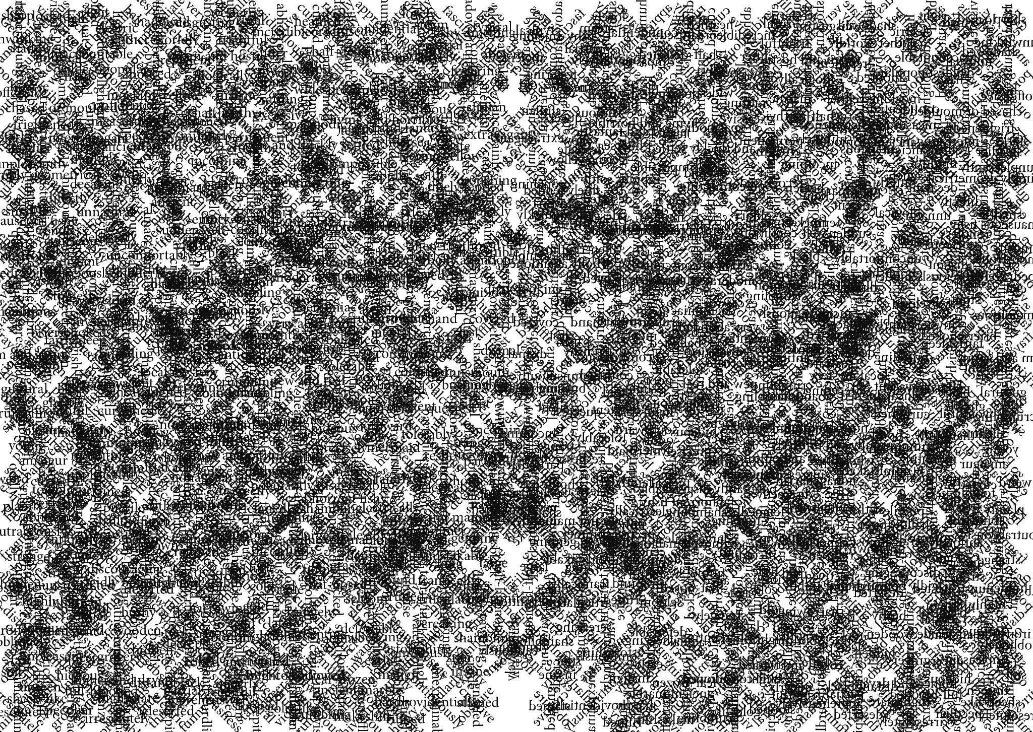

The process of creating these first two visual poems was tediously long. I trawled through the text, identified what I needed then arranged them on the page. It took countless hours of laborious repetition just to gather the building blocks, and even then, there was no definite aim. I didn’t want to begin with a prescribed notion of what each map would look like, but rather let each one emerge as a product of the circumstances of the individual landscape it responded to. There were three actors involved: myself, Lovecraft’s fiction, and the Adobe InDesign software. The process of collage occurred between us. This type of visual poetry is nothing new, although the use of InDesign does open up new possibilities for the use of the page. A closer look at another project which appropriates out-of-copyright found text will contextualize the détournement process.

Poet Susan Howe’s sequence Frolic Architecture (2010) appropriates text from the archives of eighteenth-century theologian Jonathan Edwards and his family. As she recounts in Spontaneous Particulars: The Telepathy of Archives (2014) the sequence is a collection of “letters, diaries, notebooks, essays, and more than twelve hundred sermons” (45). Howe’s “frolic” sense of space is packed with visual movements, sparks of half-legible texts acting against another in an unstable sense of time and place. Howe’s process relies on “intuition”, a “factual telepathy”, that allows her to feel the “enduring relations and connections between what was and what is” (43). The poems in Frolic Architecture perform a Situationist détournement; a creation, or rather, curation, resulting in a new organization of meaning, as Debord champions.

Restricting oneself to a personal arrangement of words is mere convention. The mutual interference of two worlds of feeling, or the juxtaposition of two independent expressions, supersedes the original elements and produces a synthetic organisation of greater efficacy (Debord and Wolman 2006 [1956]: 15).

This “greater efficacy” is similar to what Howe describes as the “felt fact” (2012: 47) of ideas. Although seemingly contradictory, it’s Howe’s intuitive re-positioning of material that leads to a greater efficacy of Edwards’ communication, or rather, the “felt fact” of those ideas rather than their direct articulation. In other words, it’s only by not saying something directly that we can more effectively communicate it. In distorting his sermons on faith, Frolic Architecture conveys Edwards’ themes of belief and morality in a surprising and engaging way. At a basic level, this type of response is more immediately innovative than an ekphrastic response. Instead of paraphrasing or reflecting his work, Howe distorts it, creating visual shards of individual meaning that create a web of the “felt fact’ of the Edwards materials, all relying on the actual text used. For Howe, this act of détournement, an embracing of mis-communication, is actually the heart of poetry’s communicative abilities. Howe describes poetry as the love of this fact, a visual and textual distillation of communication.

Howe expands on her process of writing the sequence in an interview with W. Scott Howard (2019), suggesting how it was the process itself that took precedence over any prescriptive aims:

I cut into passages from my transcriptions with scissors, turned and adjusted them, taped sections onto sections, ran them through the copier, then reworked and folded over the results. The mirroring effects leads me on (218).

This “mirroring” is key to approaching her détournement of the text. The poem looks inward but only in order to splinter new meanings from its own disparate shards. It’s clear that Howe’s process was open enough to allow a more instinctual curation to happen, each step of the process leading to the next one, and an overall picture forming only at the very end.

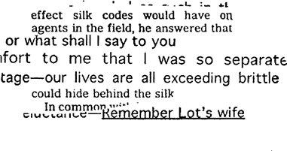

In the poem above, The “I” is fractured beyond recognition, a clearing of identity. The new arrangement of textual shards speaks back to their origins, calling not only to their previous lives, but to a hope of a future world. Howe’s response is a fragmentation of meaning that allows a disparate grouping of juxtapositions to grow of their own accord. In distorting texts, Howe returns their agency, the speaker(s) living and breathing again with an energy facilitated by the détournement process.

A Digital détournement

Just as Howe had the Edwards text, her own poetic and visual instincts, and scissors, glue and a photocopier all weighing in on the sequence, Lovecraft’s voice and the design software was suitably close as I digitally cut into the material. The third agent here, Adobe InDesign, formed a much bigger role than I had initially imagined, often guiding the build of each poem with the possibilities, limits and specific features of the software.

In The Akeley Farmhouse, Vermont, the “map” appropriates all the verbs and adverbs from Lovecraft’s The Whisperer in Darkness. To begin with, I built triangles from similar sized words, combining them into larger pyramids where possible. It’s a simple process which cuts through the heavy Lovecraftian fiction and exposes the weight his adjectives form.

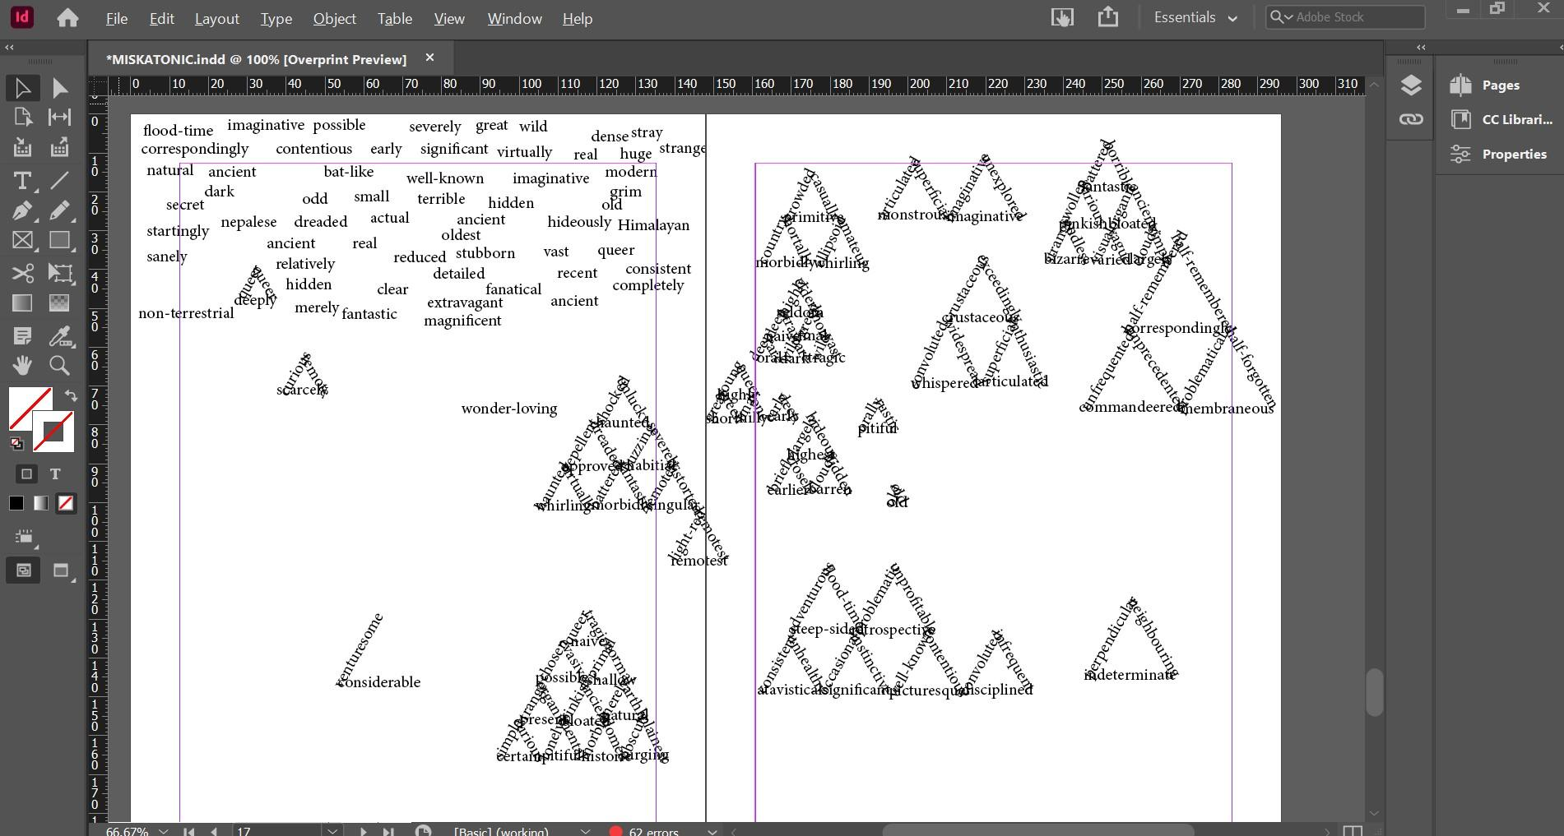

With each slow architectural build, a map started to emerge. The text on the left is in a kind of holding zone, awaiting shaping, while ladders of shaped text accumulated on the other side of the page. I layered and layered more pyramids on top until the text became dense, barely legible. Poet Joanna Drucker (1998) speaks about the “visual logic” of language on the page and I attempted to embody a Lovecraftian logic in the form of each map, as befitting to the individual story. As mentioned, the Vermont landscape of The Whisperer in Darkness is one heavy with a threatening pastoral and untainted wilderness: “…something in the collocation of roofs and steeples and chimneys and brick walls formed contours touching deep viol-strings of ancestral emotion” (69). At first, I struggled to find this threat on the page. But as the layering continued, more contour lines started to form.

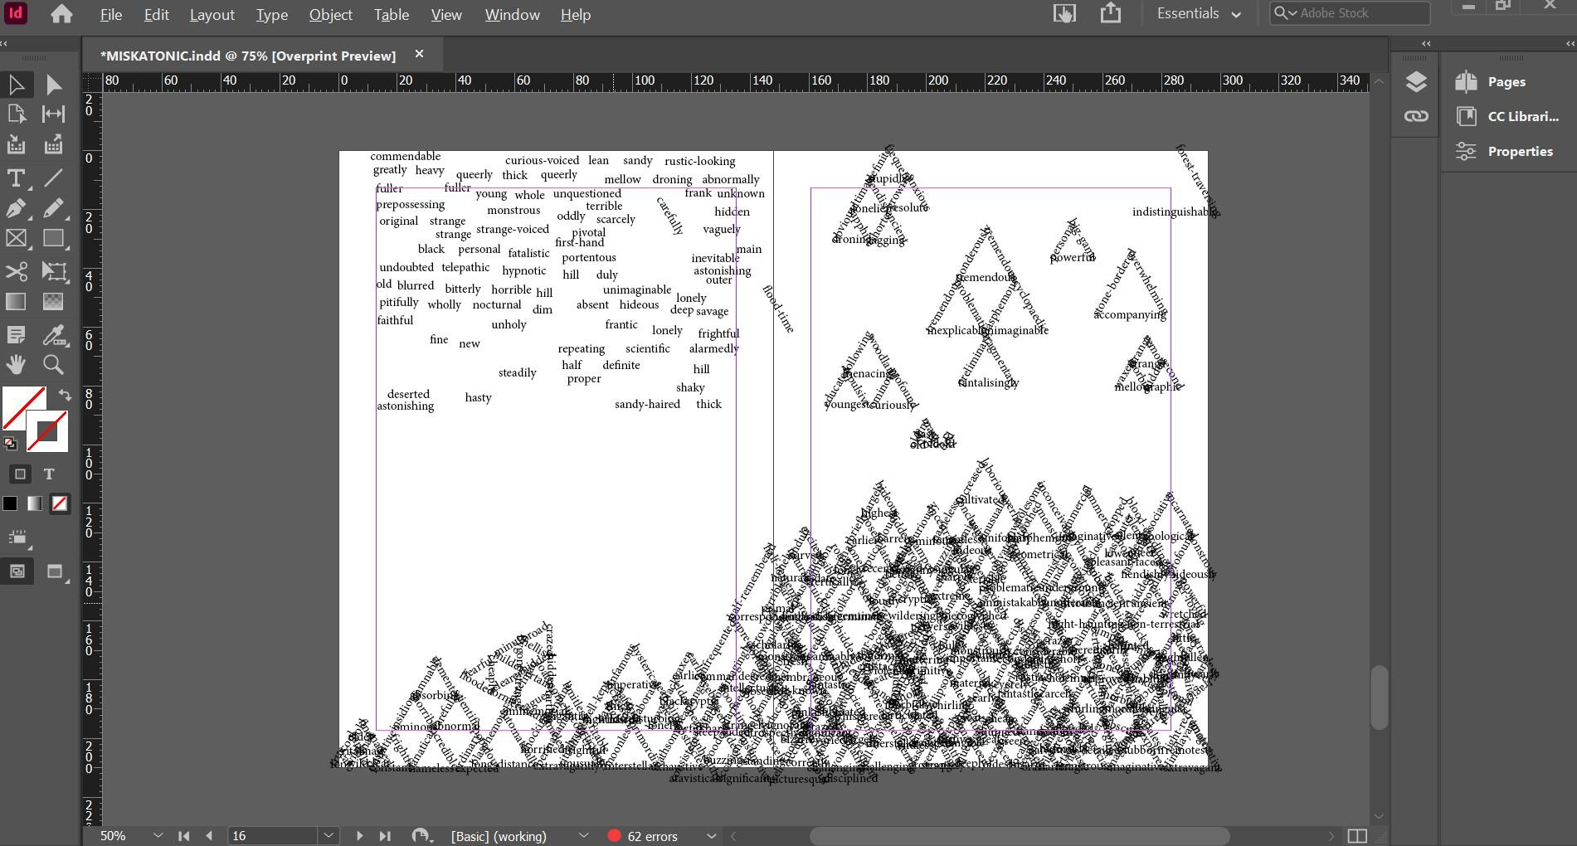

I followed these contours of text up the page, positioning pyramids into a heavy arrangement. The growing “map” felt like a kind of manufactured soil, black and sticky but struck through with steel-like lines which cemented the text in place. I wanted dense and overwhelming, and the text delivered. As the image built, focal points began to develop. Darker corners of text provided solid structures by which to navigate the emerging contours.

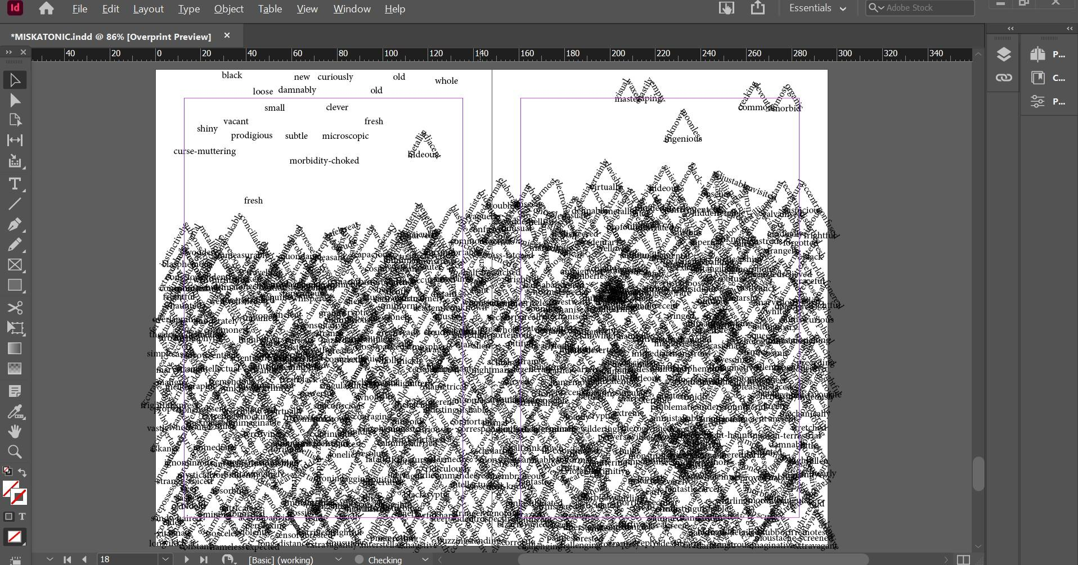

The InDesign rotate tool and general ease of positioning text had enabled me to build the image, but these are just the basics of the programme. The “Direction Selection Tool” has more promising potential. As I reached the end of the text, the page was nearly full. Big triangles popped out in the general scrum and a series of disjointed horizontal lines shifted the eye up and down. However, as a “map”, it didn’t embody Lovecraft’s Vermont. In The Whisperer in Darkness, the landscape is always shifting. The land is glimpsed and hinted at from a moving car and the story involves numerous locations. As one of the first lines makes clear, the need to escape, both from madness and the immediate circumstances, is there from the beginning:

To say that a mental shock was the cause of what I inferred—that last straw which sent me racing out of the lonely Akeley farmhouse and through the wild domed hills of Vermont in a commandeered motor at night—is to ignore the plainest facts of my final experience (54).

There’s an uncertainty here, a desperation to persuade and have an unbelievable experience validated. For the narrator’s sanity, it’s important that his story is convincing. Everything hangs on the tangibility of his observations. But currently the shape of the page was too strong, too sure of itself and comfortable in its own chaos. The map of this tale needed to be more fragmented, broken. I started to take random fragments of text using the Direction Selection Tool, arranging the unpredictable results on a fresh page. As every word, not just every triangle or every pyramid, is a separate, selectable, and moveable object, grabbing a handful of text is an unpredictable move. Although the image looks solid, it’s really just a huge cluster of disparate text. That means that the triangles painstakingly created earlier, are broken up in uncertain ways. Individual words end up as shards piercing out from the whole, while the original triangular shapes no longer form a clear pattern.

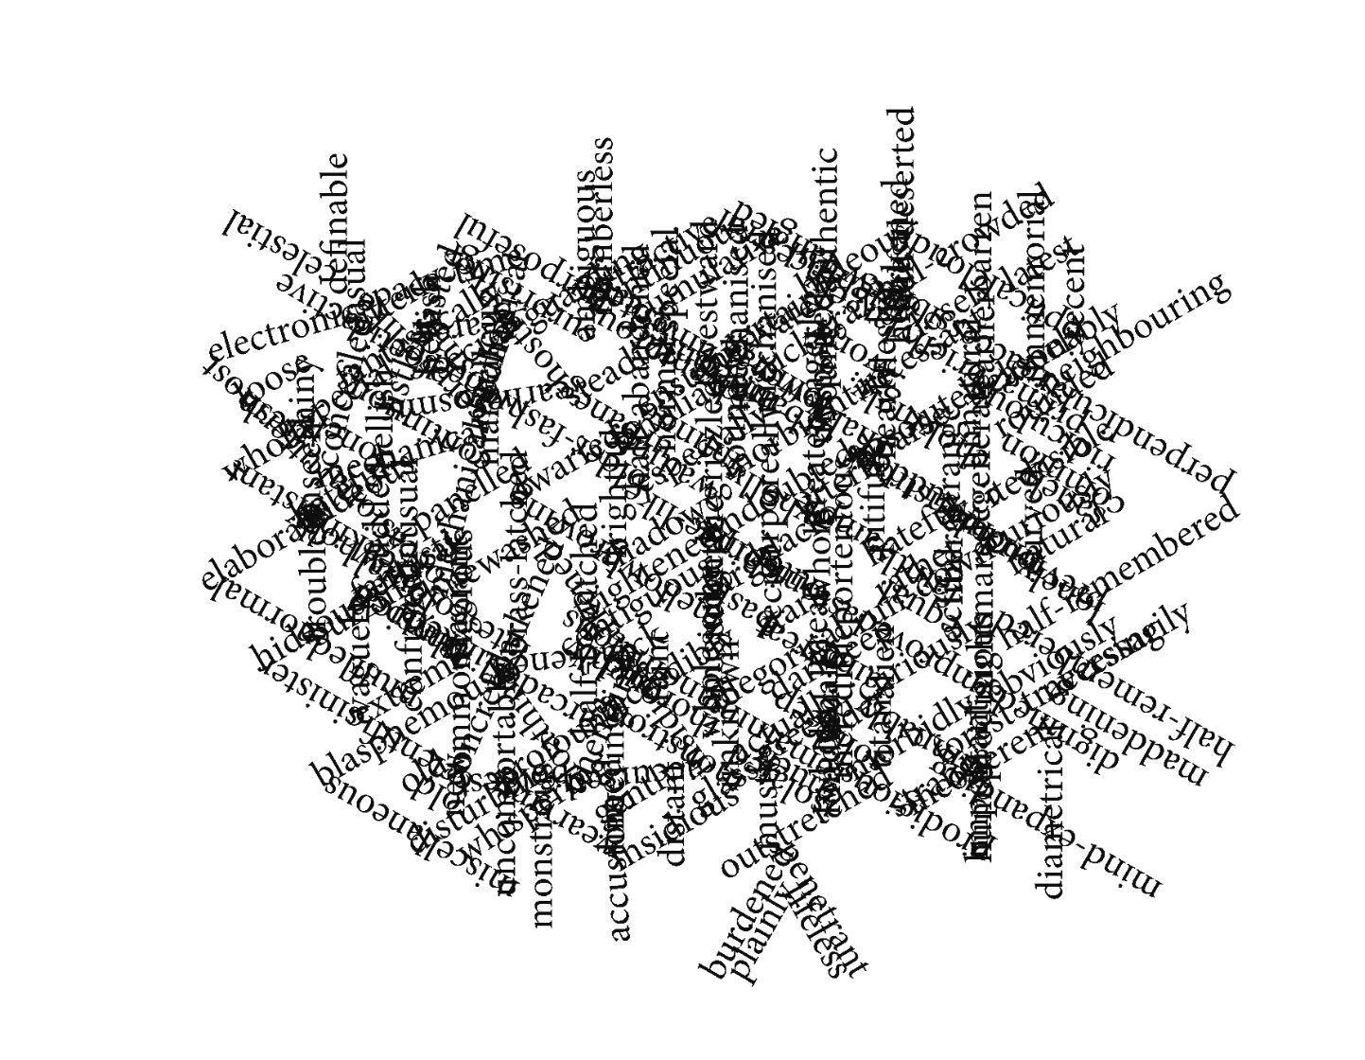

The unpredictable results of the tool leave the edges jagged, creating a more threatening yet fragile feel, while certain words are exposed as accidental poems. Everything here balances on burdened, plainly, lifeless and penetrant, for example, while, on the left, an elaborate, blasphemous and hideous are shot into the shape. This technique also leaves smaller selections of words in a stark and lonely expanse, its new arrangement strips it of the security of Lovecraftian over-description.

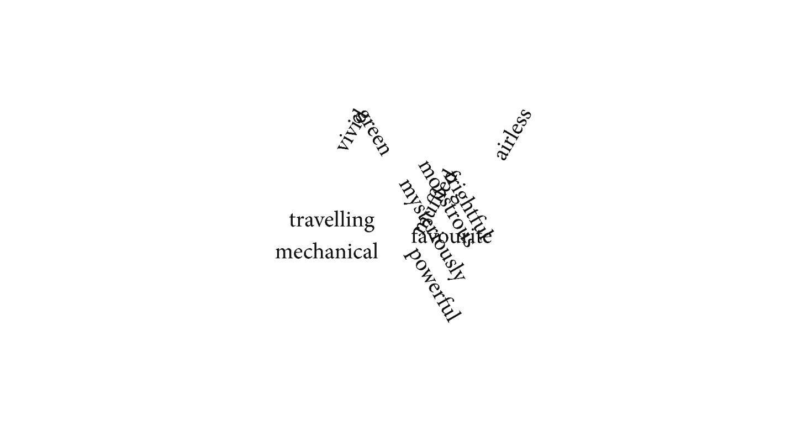
Reaching Arkham: A Conclusion

The city of Arkham is the central landmark in Lovecraft country, appearing throughout his stories as a stepping stone into otherworldly territory. It’s the city by which many of his protagonists navigate themselves and the world around them. It’s also an idyllic place, a haven of pastoralism and learning. As Daniel Harms describes, Arkham is situated on the Miskatonic River in Essex County, Massachusetts and was founded by religious “free-thinkers” (7) in the 17th Century. At its heart is the Miskatonic University, a nationally renowned institution with “the largest known collection of occult lore in the western hemisphere” (7). The city is a touchstone of Lovecraft’s disappointment in the real world. It’s a place of old values and academic gentility, a “haven for the scholar and antiquarian”, although Harm admits it “offers little for the casual traveler” (7). This last phrase is telling. Arkham is exclusive, appealing only to those who deserve it - the educated, whether officially so or not. I envision Arkham as the epitome of the Lovecraftian universe, peopled by white male literary professors and scientists, preferably with an aristocratic English heritage. In this pocket of time, Lovecraft can be safe.

But Arkham cannot stay that way and, as this essay has described, Lovecraft’s sanctuary deserves a détournement, hence the title, Maps to Arkham. These poems, and the landscapes they embody, envision an alternative capital of Lovecraft country, each one approaching but never spawning the actual city. They are a guide which churns up the soil and sky and leaves the pieces hanging. Anything whole is fragmented, and an unnatural order runs through the architecture of the page. It’s a place that can only ever exist on the page, distorted beyond legibility and ever-shifting in a process of horrifying instability.

Lovecraft hates this collection. He haunts it through necessity, but would otherwise take pleasure in seeing it destroyed. It’s thanks to works like this that nobody reads poetry anymore. What’s worse, his words are the very building blocks of this architectural mess. This collection is a labyrinth, each poem pushing Lovecraft further from his comfort zone. His writing has turned on him and is eating its own kingdom, word by word, paragraph by paragraph, and legend by legend.

Reference List

Amis, K. (2012 [1960]) New Maps of Hell. London: Penguin Classics.

Belitskaja, A., James, B., and McCallum, S. (2020) Augmented Architectural Objects. Basel: Birkhauser.

Burleson, D. (1993) Lovecraft’s The Colour out of Space. The Explicator. Vol 51, Issue 1, pp. 48-50.

Collignon, F. (2019) The Insectile Informe: H. P. Lovecraft and the Deliquescence of Form. Extrapolation. Vol. 60, No. 3, pp. 229-247.

Drucker, J. (1998) Figuring the Word. New York: Granary Books.

Dworkin, C. (2003) Reading the Illegible. Illinois: Northwestern University Press.

Haden, D. (2011) Walking with Cthulhu. Tentacli.

Harmen, G. (2011) Weird Realism: Lovecraft and Philosophy. Winchester: Zero Books.

Hemmens, A. and Zacarias, G. (2020) The Situationist International. London: Pluto Press.

Howe, S. (2010) That This. New York: New Directions.

Howe, S. (2014) Spontaneous Particulars: Telepathy of Archives. New York: W. W. Norton & Company.

Janicker, R. (2007) New England Narratives: Space and Place in the Fiction of H.P. Lovecraft. Extrapolation. Vol 48, No. 1. pp. 56-72.

Jarocha-Ernst, C. (1999) A Cthulhu Mythos Bibliography & Concordance. Washington: Armitage House.

Knabb, K (2006) The Situationist International Anthology. Berkeley: Bureau of Public Secrets.

H. P. Lovecraft (2017) The Complete Fiction. KTHTK.

Hodge, B. (2014) ‘The Same Deep Waters as You’ in Datlow, E. (ed) Lovecraft’s Monsters. San Francisco: Tachyon.

Houellebecq, M. (2019 [1991]) H.P. Lovecraft: against the World, Against Life. 3rd ed. USA: Cernunnos. Translated by Dorna Khazeni.

Joshi, S. T. (2013) I am Providence, the Life and Times of H.P. Lovecraft. New York: Hippocampus Press.

Joshi, S. T. (2014) Lovecraft and a World in Transition. New York: Hippocampus Press.

LaValle, V. (2016) The Ballad of Black Tom. New York: Tom Doherty Associates.

Long, F. B., (2019 [1975]) Howards Philips Lovecraft, Dreamer on the Nightside. Maryland: Wildside Press.

Roland, P. (2014) The Curious Case of H. P. Lovecraft. London: Plexus Publishing.

Tuan, T. (2013 [1979]) Landscapes of Fear. New York: Parthenon Books.

VanderMeer J. and VanderMeer, A., (2011) The Weird. London: Corvus.

Whitehead, T. and Smith, P., (2020) Bonelines. Axminster: Triarchy Press.

Bibliography

Callaghan, G. (2013) H. P. Lovecraft’s Dark Arcadia: The Satire. Symbology and Contradiction. Jefferson: McFarland & Company, inc., Publishers.

Writing the Uncanny, Essays on Crafting Strange Fiction ed. By Coxon, D and Hirst, R. V.. Great Britain: Dead Ink, 2021.

Fisher, M. (2016) The Weird and the Eerie. London: Repeater Books.

Gordon, J. (2003). Reveling in Genre: An Interview with China Miéville. Science Fiction Studies. Issue 91, Volume 30, Part 3.

King, S. (2019) ‘Lovecraft’s Pillow’ in Houellebecq, M. (author) H. P. Lovecraft: Against the World, Against Life. USA: Cernunnos. 3rd Ed.

Kneale, J. (2006) From beyond: H. P. Lovecraft and the place of horror. Cultural Geographies. Vol. 13, No. 1, pp. 106-126.

H. P. Lovecraft (2020) In the Mind of H. P. Lovecraft, a Collection of Essays. Read and Co.

H. P. Lovecraft (2020 [1938]) Supernatural Horror in Literature. Read & Co.

Oates, J. C., (1996) The King of Weird. The New York Review. Oct. 31st.

Setiya, K., (2021) "The Colour Out of Space": Lovecraft on Induction. Philosophy and Literature. Vol. 45, No. 1, pp. 39-54.

Wisker, G (2019) Desire, disgust and dead women: Angela Carter’s rewriting women’s fatal scripts from Poe and Lovecraft’, in Marie Mulvey-Roberts (ed), The Arts of Angela Carter: A Cabinet of Curiosities. Manchester: MUP.

H. P. Lovecraft - Fear of the Unknown. (2020) Frank H. Woodward (Dir.) 89 minutes. Indie Rights. Online streaming service. [featuring Guillermo Del Toro, Neil Gaiman and John Carpenter]

If the fact that such a widespread governmental operation on US soil doesn’t cause more public scrutiny seems odd, Lovecraft does provide prohibition as a cover, stressing that only the ‘Keener news-followers’ and ‘liberal organizations’ may have followed up on the fate of the prisoners, and these were met with ‘long confidential discussions’. Presumably the same can be said for the destruction of Hodge’s prison. (103).
See Joshi (p. 901).
The sequence is contained in That This (2010).

