The Use of Colour Names Over Repeated Trials
Maria Federica Norelli ¹, Alexandros Koliousis², Andrew Stockman³, Rhea T. Eskew Jr.⁴, Dimitris Mylonas²
¹Northeastern University London
²Northeastern University London
³University College London
⁴ Northeastern University Boston

Contact: Maria Federica Norelli, mn2122@students.nulondon.ac.uk

Abstract
Speakers group colour stimuli into categories that are commonly referred to by a name (e.g. pink, peach, and pale green). While the number of colour names in wide cultural use may vary across different languages, it has been shown that most languages have a small set of basic colour terms (BCTs) that are typically shared by speakers. The cognitive role of BCTs has been a subject of ongoing debate, with some proposing that the existence of primary basic categories may depend on structural and functional properties of the visual system. In this study, we investigate the effects of the duration of the experimental task on the use of colour names. In a lab-based colour naming experiment, we asked 17 English speakers to give unconstrained verbal responses for 216 presented colour samples, presented randomly one at a time against 7 different backgrounds. Test stimuli were 2 degrees uniformly coloured discs with a black outline of 1 pixel. The 216 colour stimuli were uniformly distributed in the CIE LMS parallelepiped. We collected a total of 26,504 unconstrained colour name responses. First, we consider the global entropy of the distribution of responses as a measure of all participants' colour vocabulary richness. We use the order of appearance of the backgrounds to group the responses in 7 bins and measure the entropy of colour naming responses for each bin. Our results show that the richness of colour vocabulary decreases as a function of the task duration. Second, we examine which colour names became more prevalent over trials as the vocabulary became impoverished. We found a positive correlation (R² = 0.8) between the use of BCTs and time-on-task, and a negative correlation in the case of non-BCTs (R² = -0.5), supporting that BCTs are easier to name than non-BCTs. However, across participants secondary basics have been used significantly more often (n = 5: brown, orange, grey, purple, and pink) (M = 1039, SD = 67) than primary basics (n = 6: black, blue, green, red, yellow, and white) (M = 773, SD = 49) over each of the 7 ordered backgrounds, t(12) = -8.48, p < .001, suggesting that secondary basics overall may cover larger regions of the cone excitation space than primary basics. Consistent with this explanation, a Pearson analysis showed a strong correlation (R² = 0.6) between frequency of BTCs and their corresponding volume in LMS cone excitation space.

Keywords: colour naming, task duration, entropy, basic colour terms.

Introduction
Across different languages, speakers possess the ability to categorize colour stimuli into distinct categories that are commonly identified by corresponding colour names such as pink, peach, and pale green. While the fundamental ability to categorise colours is a universal trait, the lexicon of colour names may vary in both size and complexity from language to language. For instance, a free-naming experiment revealed that English speakers employ thousands (n = 1166) of distinct monolexemic and plurilexemic colour names when labeling online the 600 simulated Munsell samples (Mylonas and MacDonald, 2016). In contrast, using the same colour set stimuli, the Himba community, a remote population in Namibia, offered only 24 distinct colour terms (Mylonas et al., 2022).
Cross-language variation in colour lexicon highlights the intricate interplay between neurophysiological factors, ecological influences, and cultural dynamics that shape the human experience of colour. Remarkably, the study of cross-language differences in colour categories, dating back at least to the pioneering work of Berlin and Kay (1969/1991), has established a crucial framework for understanding the mechanisms underlying the formation and evolution of colour categorization. According to their infuential account, most languages include a stock of so-called basic colour terms (BCTs), a limited set of colour terms that are typically shared and comprehended well by most speakers. This framework employs specific criteria to narrow down the potential candidates for BCTs, which are: (1) being monolexemic, (2) being applicable to a broad category of objects, (3) having a distinct scope from any other BCT, and (4) being psychologically salient. Based on these criteria, there are around eleven BCTs for most major modern languages. In English, the BCTs are the six primary colours of Hering’s Opponent Colour Theory - red, yellow, green, blue, black, and white - along with the secondary (grey, orange, brown, pink, and purple).
Berlin and Kay’s comparative study also suggests that the number of BCTs within different languages increases over time in a highly structured and predictable manner, with primary BCTs typically emerging before secondary ones in the development of BCT categorization. The temporal primacy of primary BCTs has often been explained in terms of perceptual salience and neurophysiological constraints (Hays et al., 1972; McDaniel, 1974; Kay and McDaniel, 1978). Recent research on infants' systems of colour categorization indicates that infants as young as four months exhibit categorical responses to colour stimuli, raising the possibility of an existing link between colour categorisation and the cone-opponent mechanisms in the retina. (Skelton et al., 2017). However, conclusive evidence for the existence of a biological basis for colour categories remains elusive.
Gibson et al. (2017) propose an alternative viewpoint for the inter-linguistic similarity found in colour systems. Based on experimental results showing a pattern of preference for warm over cool colour names, they suggest that the linguistic relevance of certain colour terms (and the way in which colour categories arise) depends on communicative needs rather than on neurophysiological properties of the visual system. Furthermore, recent findings have shown that the importance of primaries in the development of languages’ colour lexicon may be overstated. Mylonas and Griffin (2020) make the claim that every class of colour categories should share some common characteristics and show that classes of primary categories are less coherent than classes of BCTs and achromatic colour terms (white, black, and grey).
In this study, we investigate the effects of the duration of the experimental task on the use of colour categories, with a focus on BCTs and the supposed subclasses of primary and secondary BCTs. The next section introduces and describes the experimental setup, and our results are presented and discussed in detail in the subsequent sections.
A Colour Naming Experiment
A laboratory-based colour naming experiment was designed to collect unconstrained verbal responses and reaction times to a series of 216 colour stimuli. The experiment involved the participation of 17 English speakers. The mean age of participants was 36 years (SD = 16.5 years), with females provided 59% of the responses, males provided 29%, and 12% identified as non-binary. Participation was voluntary and the experimental sessions were conducted after obtaining written informed consent from the participants (Varnhagen et al., 2005). Before running the experiment, all participants were screened for colour vision deficiencies using the City University Test (Fletcher, 1978). In recognition of their commitment, participants were compensated with cash for their time and effort.

Colour stimuli were presented randomly, one at a time, on a calibrated CRT computer monitor against 7 different backgrounds. Throughout the experiment, participants adapted to 6 chromatic and 1 neutral, uniform, backgrounds, presented in random order. The test stimuli were 2 degree uniformly coloured discs with a black outline of 1 pixel. The 216 colour stimuli were uniformly distributed in the CIE LMS parallelepiped (CIE, 2006; Stockman & Sharpe, 2000). For each colour sample, the subject was asked to say out loud the colour name that she thinks best describes the colour sample and respond within 10 seconds for each sample. Notably, participants were free to use as broad or narrow names as they liked. We collected a total of 26,504 unconstrained colour name responses, using a head-mounted microphone to record the vocal responses.

The number of responses per name across all chips (global response rate) varied hugely. To give an example, the most frequent response (pink) was recorded 2733 times, hence a global response rate of 9,4%; while the least frequents (e.g. neon salmon) were produced only one, hence 0.003%. The final dataset encompassed a total of 675 distinct colour names. This included the 11 BCTs, 572 plurilexemic (more-than-one word) names and 92 monolexemic (single-word) but non-BCT colour names. When considering the frequency of these terms in the dataset, BCTs accounted for 54% of the colour lexicon, plurilexemics represented 32%, and monolexemic non-BCTs made up 14%. Notably, among the monolexemic non-BCTs, the most frequently occurring colour term was turquoise, a colour term often considered a potential candidate in the evolution of BCTs in languages of industrialized countries. (Zollinger, 1984, Mylonas and McDonald, 2016).

The Effects of Experimental Length on the Use of Colour Names
The first issue we wanted to address was how the duration of the experimental task impacted participants' colour vocabulary richness over time. We decided to use the global entropy of the distribution of responses as a measure of lexicon’s richness. Drawing from classical communication theory, the entropy equation offers a way to quantify the total information content within a complete probability distribution of an event, based on its frequency (Shannon, 1948).
Our method involved dividing the series of experimental trials into seven distinct bins, each corresponding to a specific point in the experiment's timeline, determined by the order of background presentations. These bins served as a means to monitor the evolution of color vocabulary richness as participants devoted varying amounts of time to the experimental task. Subsequently, we calculated the entropy of colour naming responses for each of these bins (Fig. 1).
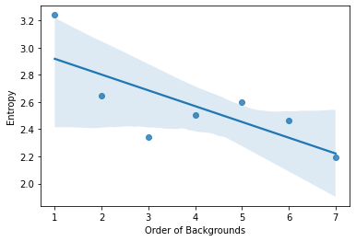

Fig. 1 – Richness of Colour Naming Vocabulary Over Repeated Trials
Our analysis revealed a strong trend: the richness of colour vocabulary decreases as a function of the task duration (R² = -0.7). More precisely, the entropy values exhibited a peak of 4.3 bits during the initial bin of trials, signifying the highest level of colour vocabulary diversity at the outset. Conversely, as the task advanced, the entropy dropped to a minimum of 3.8 bits in the final bin, clearly indicating a reduction in the variety of colour names employed by participants. This observation underscores the profound influence of the length of the experimental task on participants' use of their colour lexicon.
The second issue we set out to investigate was which class of colour terms experienced a global increase in usage as the colour vocabulary became more limited over trials. Specifically, we want to compare the use of BCTs and non-BCTs (Fig. 2). We used Pearson’s R correlation coefficient formula to calculate the strength of the association between the two classes of colour terms and the repeated trials of the experimental tasks. We found a positive correlation (R² = 0.8) between the use of BCTs and time-on-task, and a negative correlation in the case of non-BCTs (R² = -0.5). These findings align with the general claim that BCTs tend to be more prominent and easier to name compared to non-BCTs, and also support the idea of a certain level of independence between the richness and size of speakers’ colour stimuli and how their perceive colour stimuli.

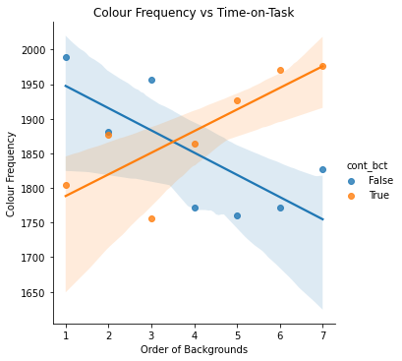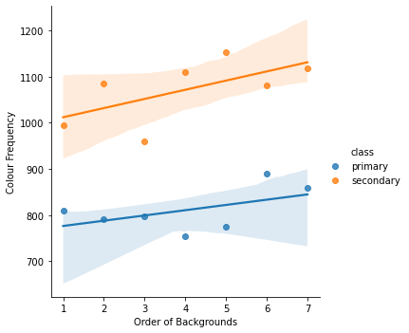

Fig. 2 – BCTs vs non-BCTs Over Repeated Trials Fig. 3 – Primaries vs Secondaries Over Repeated Trials

Finally, we want to assess the hypothesized special status of primary BCTs in colour categorisation systems, by comparing the use of secondary BCTs and primary BCTs over trials. As shown above (Fig. 3), secondary basics were used significantly more often (n = 5: brown, orange, grey, purple, and pink) (M = 1039, SD = 67) than primary basics (n = 6: black, blue, green, red, yellow, and white) (M = 773, SD = 49) across participants. To confirm this trend, we conducted a t-test to compare the means of the frequencies of primary and secondary BCTs over each of the 7 ordered backgrounds, yielding a significant result (t(12) = -8.48, p < .001). These findings suggest the hypothesis that secondary BCTs may encompass larger regions of the cone excitation space than primaries in colour space. To assess this hypothesis, we use a Pearson analysis to examinate the relationship between the frequency of BCTs and their corresponding volume in LMS cone excitation space. (Fig. 4) Our analysis unveiled a positive correlation (R² = 0.6), which challenges the notion of primary BCTs holding a superior status in colour categorisation systems.

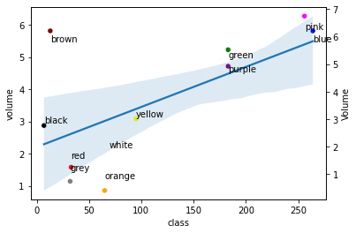

Fig. 4 – Relationship Between Volume and Frequency of BCTs Across All Trials

Conclusions
Based on a dataset collected in a laboratory-based experiment, our study discusses the use of colour categories over repeated trials and offers insights to assess the role of specific classes of colour categories, such as BCTs and primaries. Both classes have been often thought to have a special status in colour naming systems, influencing the debate between universalist and relativist over colour lexicons across and within different languages. In our analysis, we initially sought to understand how the duration of this task influenced participants' colour vocabulary richness. Through the calculation of global entropy, we found that as the task progressed, the richness of participants' colour vocabulary exhibited a noticeable decline. Indeed, our investigation into the usage of color terms over trials uncovered interesting patterns. We observed that BCTs held a special place in participants' vocabulary, as evidenced by their increased usage over time-on-task. In contrast, non-BCTs displayed a negative correlation, supporting the notion that BCTs are easier to use than non-BCTs. Additionally, our analysis challenge the presumed primacy of primary BCTs, as secondary BCTs were used more frequently, suggesting their potential coverage of larger regions in the cone excitation space. This finding questions the hierarchical prominence of primary BCTs in colour categorisation systems.
One issue relevant for our discussion concerns how speakers store and recall memories of colour terms and to which level of accuracy. The discussion of the relationship between colour naming, memory and perception has been characterized by two main perspectives: one suggesting that an individual's colour lexicon is largely independent of how humans perceive and remember colour stimuli (Heider, 1972), and the other claiming that the process of storing a colour in memory often implies some level of linguistic categorization (Kay and Kempton, 1984). Recent research, however, has demonstrated that the size of a speaker's colour lexicon is closely linked to their ability to memorize colours but remains independent of low-level perceptual variations (Hasantash and Afraz, 2020). We aim in future study to address the effect of individuals’ ability to memorize and store colour names in the memory on their use. In conclusion, this study aims to unveil the intricate relationship between linguistic categorisation and perception in the realm of colours.

References

Berlin, B., & Kay, P. (1969/1991). Basic Color Terms: Their Universality and Evolution. Berkeley:: University of California Press.

CIE-TC 1-36. (2006). CIE 170-1:2006 Fundamental Chromaticity Diagram With Physiological Axes (No. ISBN: 978 3 901906 46 6).

Fletcher, R.P. (1984). The City University Colour Vision Test. Ophthalmic and Physiological Optics, 4.

Gibson E., Futrell R., Jara-Ettinger J., Mahowald K., Bergen L., Ratnasingam S., Gibson M., Piantadosi S.T., Conway B.R. (2017). Color naming across languages reflects color use. Proceedings National Academic Science USA 114(40),10785–10790.

Hays, D. G., Margolis, E., Naroll, R., & Perkins, D. R. (1972). Color Term Salience. American Anthropologist, 74(5), 1107–1121.

Hasantash, M., Afraz, A. (2020). Richer color vocabulary is associated with better color memory but not color perception. Proceedings National Academic Science U.S.A. 117, 31046–31052.

Heider, E. R. (1972). Universals in color naming and memory. Journal of Experimental Psychology, 93(1), 10–20.

Kay, P., & Kempton, W. (1984). What is the Sapir-Whorf hypothesis? American Anthropologist, 86(1), 65–79.

Kay, P., & McDaniel, C. K. (1978). The Linguistic Significance of the Meanings of Basic Color Terms. Language, 54(3), 610–646.

McDaniel, C. K. (1974). Basic color terms: their neurophysiological bases. Paper presented to the American Anthropological Association, Mexico, D.F.

Mylonas, D. and MacDonald, L. (2016). Augmenting basic colour terms in english. Color Research. Application, 41, 32-42.

Mylonas, D. and Griffin, L. D. (2020). Coherence of achromatic, primary and basic classes of colour categories, Vision Research, 175, 14-22.

Mylonas, D., Caparos, S. & Davidoff, J. (2022). Augmenting a colour lexicon. Humanity Society Scientific Community 9, 29.

Shannon, C.E. (1948) A Mathematical Theory of Communication. Bell System Technical Journal, 27, 379-423.

Skelton A.E., Catchpole G., Abbott J.T., Bosten J.M., Franklin A. (2017). Biological origins of color categorization. Proceedings National Academic Science USA 114(21),5545–5550.

Stockman, A., & Sharpe, L. T. (2000). The spectral sensitivities of the middle- and long-wavelength-sensitive cones derived from measurements in observers of known genotype. Vision Research, 40 (13), 1711–1737.

Varnhagen, C. K., Gushta, M., Daniels, J., Peters, T.C., Parmar, N., Law, D., Hirsch, R., Takach, B.S., Johnson, T. (2005). How informed is online informed consent? Ethics Behavior. 15(1), 37-48.

Zollinger, H. (1984). Why just turquoise? Remarks on the evolution of color terms. Psychology Research 46, 403–409.

