The Documentary Drift: Lutyens, Cockington and Poetry

I did not set out to write a poetry collection about the architect Sir Edwin Lutyens (1869-1944). Influenced by Cecile Oak’s (2017) mythogeographical journey across South Devon in Anywhere, I set out to write a poetry collection exploring the pastoral contradictions of Cockington, a heritage village in the South West. But after an encounter with a collection of letters by Lutyens, who designed the village’s Drum Inn, the village soon became a fantastical theatre where his questions of language, craft and beauty could unravel. In this essay I’ll highlight the role that walking played in a bleeding together of a documentary and geographical landscape.
I began by walking through and around the village. I took different routes, visited at different times and generally sought out different conditions. My notes and photos from this time reflect just this; a place seen through the ever-shifting lenses of sunshine, tourism, rain, nostalgia and more sunshine. The tricky part was writing about it. I began the early poems with the date as a title and attempted to weave my notes into something more coherent:

I sucked the Domesday Book dry
leaves like cremated hearts.

And here and there
a dog barks
a wedding party

I was interested in multiplicities, how the village could be both a pastoral retreat and a complicated mash up of commodified rural tropes. Cockington is in a deep valley around a mile from Torquay sea front in South Devon, meaning that the village centre gives an impression of both undisturbed seclusion and claustrophobia. Approaching the village from different paths is key to understanding its appeal. From the South you pass through the wealthy suburbs and busy roads of sprawling Torquay. From the West you leave the hectic dual carriageway to amble along country lanes for a few miles, and the path from the North East crosses that same dual carriageway and patches of suburbs. These are only the major routes, and most people approach from the South, but the transition from urban to rural is an integral part of the tourists’ Cockington experience. Its deep valley has seemingly cut it off from the world of progress and commercialism. This is a place that you descend into. Here was one of the last pockets of innocence and charm, set within a picturesque village and immaculate country park. When the whole village was up for sale in 1946 the auctioneers’ brochure implored potential buyers to preserve Cockington’s ‘deep and fundamental beauty’, claiming that ‘A more perfect gem of rural beauty would be hard to imagine’. The village is sold along similar lines today. One recent TripAdvisor review mentions what a ‘hidden treasure’ it is and another is titled ‘A walk through Cockington to see Old World ways’ (Nov 2019). Of course, this is just one side of the village, but it was the side that, up until this project, I knew best.
To me, the village had always meant boredom. My family have run the Forge giftshop for nearly twenty years and when I was young I spent many long and slow days there waiting for something, anything, to happen. From the Forge’s open window, the scene rarely changed. The horse and carts touted for business and trotted up to the court as visitors wandered around gathering family members for photos. Opposite us, on the other side of the village centre were two other gift shops and two cafes, all, like us, disguised as something else. The Old Forge. The Schoolhouse. The Weaver’s Cottage. The Granary. Nothing is quite what it seems.
Simply walking the village as a visitor was a new experience. Up until then, it had always been a place of tension. Despite the picturesque cottages and trimmed lawns of the village centre, the Forge could be a place of isolation. Over the years I have given up feeling any sense of ownership of the place. As legal owners we are custodians at best, and capitalists at worse. For a surprisingly large part, The Forge belongs to people’s memories. ‘Why isn’t it a working forge’ is a persistent question with a fairly straightforward answer. It was the blacksmith himself who after years of dwindling trade, converted it into a gift shop in the 1970s. But a stalwart few refuse to accept it. I can understand why. The pastoral retreat that Cockington sells can only go so far.
Given these complications, it’s no surprise that the village is a mythogeographical hub, and it was Phil Smith’s numerous writings on Cockington that first gave me a new perspective on the place. Cecile Oak, the narrator of Smith’s Anywhere describes the confused role modern day Cockington plays. The village is something of a hangover from feudalism, a place in which ‘the contract with things is broken’. The rise of international shipping (or looting) in the Sixteenth Century led to a sense of things ‘melting into air’. Produce is no longer grown in nearby fields

nor are they ground in local mills, nor burnt down to lime in nearby kills, nor woven in the cottage down the lane, nor are they the fruits of the trade with equivalent produces elsewhere; instead they are driven by a surplus riven from its source, an alienation born of thousands of miles of splitting and rending (2017, Kindle Loc. 1063).

Cockington is a complicated place, seemingly still stumbling for a precise role. It boasts numerous craft studios and the shops specialise in locally produced gifts. In short, the village sells itself on loose ideas of old world charm and retreat, yet relies on a system of national tourism and digital marketing in order to upkeep any sense of the local and traditional. Perhaps this contradiction stems from the surplus being ‘riven from its source’? Perhaps the commercial village underneath the façade was far more authentic than the façade? I had these questions in my mind as I explored the village, and free from my role at the forge, I realised that I knew next to nothing about this place. Smith’s Cecile also taught me to look for Cockington’s future, a challenge when it feels so swamped with the past.

The pictorial sweep of the front lawn is suggestive of the so called ‘empty-space’ of theatre, theatre’s universalising fantasy that there is a neutral, virgin, non-space, a launch pad, a mere airport lounge in which great performers do greatness, unhindered.
Such is a place like this, but without greatness; just the ache for something special. (Kindle Loc. 1179)

But it took me a while to fully realise the potential of that ache. I was looking backwards. So far I had been walking with the lens of a commodified pastoral, seeking evidence that punctures Cockington’s film of a serene land. I found plenty. The rough sleepers. The struggling businesses. Death in every corner of the parkland. The stifled utopia under the car park. Then there’s just the simply bizarre finds that don’t fit anywhere. Abandoned fridges. Half of a fish dropped in a quarry. A Victorian cast iron drainpipe in the middle of the forest. The archives tell the story of the residents’ increasing desire for commercialisation as far back as the early twentieth century, and the local council’s crackdown on anything remotely progressive. At one point they stipulated what goods could be sold and how they should be displayed. So far, I had what I was looking for.
Yet the more I delved in Smith’s practice and writings, the more I realised I was refusing to allow myself to drift. It was all going too well. Smith states that Mythogeography, as opposed to psychogeography, aims to engage people with ‘theatre rather than politics’ (2012). This style of walking poses more questions than answers, and I had only been searching for answers. After a year or so of walking the village I had amassed piles of poems, most of them reports of my walks that I had attempted to tie together into a narrative. But the poems were predictable, more critiques than personal accounts.
There wasn’t enough theatre. I wasn’t fully drifting around the village, and so I couldn’t fully drift on the page. I have struggled with this relationship between walking and writing. The poetry needed to be something more than just a narrative report of my drifts, yet I wanted the loose ethos of the drift to influence the page. My attempts at writing up my walking felt too calculated, almost too easy. My approach to the village, and the page, needed less of an agenda. Again, Cecile Oak’s reflection on her journey gave me some guidance:

﻿I wonder if I have ever properly understood what research is. That only if I put myself at the mercy of my subject, only when I am caught up and becoming part of my subject and only when that subject is caught up and disrupted and diffracted by me – leaving a footprint, climbing a fence to trespass – am I really researching (Kindle Loc. 1718).

I wondered if I was trying too hard. I started to take different people to the village and resisted the urge to slip into tour-guide mode. Now the place began to open up rather than be closed down with critique. I stopped searching and theorizing and began to see the beauty in the place, even the beauty in its contradictions. A group of mostly South American researchers highlighted the abundant colours in The Rose Garden and Lakes, linking this quintessentially English locale to more tropical climes. Some colleagues were charmed by a particularly sunny day spent lounging around on Yonder Lawn in front of the Court. One person highlighted the boggling bureaucratic speak on a planning permission notice, a bizarrely wordy juxtaposition to the picture postcard scene around us. An adventurous friend led me through the undergrowth up and over unmapped trenches from where we could see the valley haze into horizon. Another took me on a nighttime raid of the Quarry where we stumbled across a seemingly ritualistic arrangement of animal skulls. My supervisor and I stood helpless as a resident lectured us about the correct length of the trees overhanging Cockington Lane, and for the first time I noticed an incredibly bulbous and proud horse chesnut crowning the lane. Most of these places I had seen before, but I was now seeing it through their eyes. I was beginning to let myself enjoy the village, sink into, as Cecile puts it, its own ‘hallucination’ (Kindle Loc. 1074). I began to simply walk. Crucially, I abandoned any idea of writing up each walk as a defined poem, but rather allowed these experiences to simmer together into what became the finished collection. Cockington was no longer just the Forge and a nostalgic pastoral. It was a haunted yet progressive landscape, a place of genuine beauty disguised by a façade of itself. In short, it unraveled into a place I no longer recognized or understood. Smith’s advice of Mythogeography as a collaboration was beginning to make sense:

No one makes a mythogeography until they learn how to walk in more than one body; until they can walk in a place where they are at home as if they were a stranger, and in a place where they are a stranger as if they were at home (Kindle Loc. 50).

And then in came Lutyens, my deceased co-conspirator. I had read a collection of his letters hoping to spot any mentions of Cockington’s Drum Inn which he designed in the early 1930s. This began a journey down a rabbit hole of his archives that spawned a new Cockington on the page, a village existing in, and only in, that ‘ache for something special’ that Cecile finds on the village’s Yonder Lawn.
Lutyens’ constant striving towards a perfect sense of beauty became a catalyst for questions of craft and led to my experiments with a visual and sonic page-based drift that were influenced by, but free from, the wonders and limitations of Cockington Village. He believed that architecture could achieve a level of beauty that language could not. Partly this reflected a frustration at what he felt to be his own inadequacy over articulating his feelings towards his wife, Lady Emily. In his letters, words are “impotent” (Hussey, 1953: 216), slippery animals that frequently eluded him, wielded by those who duped the public into a “government by phrases” (Percy and Ridley, 1985: 277). He saw the early twentieth century as a time in which “words, words, words” (295) seemed to be the only way to attain respect and fame, a society slipping away from the tangible into a world of ideas. In his modestly counter-cultural style, Lutyens even reflected Mythogeography. As Smith remarks, The Spectacle that plagues modern society was fueled by “... the advent of mass media in the twentieth century” and

manifested itself first as the dominance of images over things ...the dominance of representatives over what they represent.... the dominance of the ideas of freedom, democracy, happiness over people actually being free, happy and democratically active (2014: Kindle Loc. 175).
It’s a short leap (with more creative rather than critical intentions) to replace Smith’s “pictures” with Lutyens’ “words”. The link is one I built on when reconfiguring his character through the poems. A historical Lutyens was not enough. His Drum Inn was the pivotal point for a grandiose village extension consisting of shops and tearooms and a new green. It would have dwarfed the existing village. It was utopian in its scale and ambition, and its ghost began to accompany all of my walks. The fact that it never moved beyond paper is my greatest asset, and now me and Lut set out to re-envision the village with the only tools we had – language. As Gillian Darley in Villages of Vision, a study of strange Utopias, explains: “The picturesque village is surely the architectural expression of all the myths of rural life” (2007: 231). We aimed to take this to the extreme.
This new village, a palimpsest of past and future Cockingtons, can exist only in language, only on the open horizon of the page. For an architect, it’s an artistic fantasy: an unlimited budget, an absentee client and a boundless site. For a poet, the concept allows me to explore the limitations of visual and linguistic forms of beauty, holding up the word as a building in constant relation to its surroundings. We would build in language, and Cockington would be our launchpad.

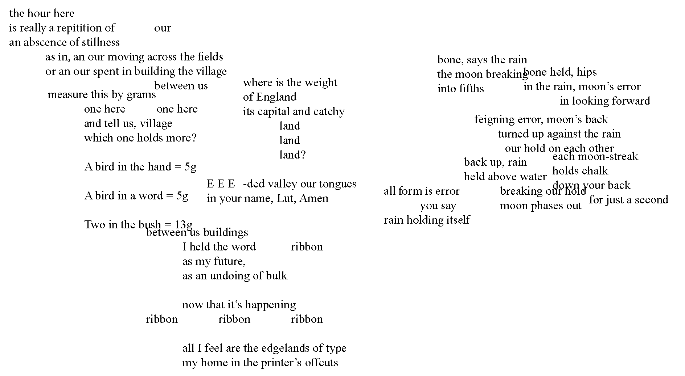

In the poems, “Lut”, is a complex construction, both hopeful and defeated, reborn and weighted, witty and inarticulate, contradictions spurned from glimpses of his historical character. My aim for Lut Lut Lut is to open up these contradictions of his relationship with language, pairing them with the beauty and disappointments of Cockington’s pastoralism. He spent most of his time away from home and his wife, and although he was ever distrustful of words, they were, at times, all he had to maintain his marriage. The Royal Institute of British Architecture hold the nearly five thousand letters between him and his wife, detailing the moments of tenderness, frustration and misery that span a life. Crucially, I do not propose any new understanding of his history or artistic ethos, and any ‘original’ insights into his character should not be taken as historical suppositions. Instead I propose a future for the man and his texts, with a new Cockington as the perfect playground.
Lutyens died in the early hours of New Years Day 1944, surrounded by designs for buildings never to be realised, and this collection of pages laid out in 2020 have formed from a splinter of his life among the scattered archival and published texts I have forced together. A young and idealistic lover speaks to his future failings as a husband and the heartbreak of a world abounding in ugliness. The pre-articulate urge for beauty is bogged down in the limitations of language as the stubborn designer in Lutyens ages into the rambling president of the RA softened into saying “we must be our own poets”.
My drifts took on a documentary landscape. His life, sketched out in biographies and scraps of book introductions, newspaper articles and personal letters, is riddled with complications and confusions. He was an imperialist and a humanist, a patriarchal Edwardian and a radical designer. The more I researched, the less I knew about him, but the more I realised the fragility involved in curating a life. The truth was that there was no singular Lutyens. The archives store a life glimpsed in haste, in postscripts, marginalia and the textual off-cuts never intended for posterity. I was reminded of Smith’s idea of an Anywhere:

In place of Utopia arose the idea of ‘anywheres’... the very unevenness of what has been explored, the bittiness, the unsatisfying half-interwoven, the tangle, the dissipation, these all began to seem hopeful, even utopian in an unutopian way, when subjected to wandering (Smith: 2012, Loc. 2267).

My wandering around the village influenced my wander around the RIBA archives. I requested boxes almost at random, noting down striking language from Lutyens, his wife, friends, and colleagues. I took time to feel the aged documents, sift through his typos and doodles, noting contradictions and disparities. On the back of the designs for Cockington’s utopian extension is a floating eastern dome. In his correspondence regarding Liverpool Cathedral is the extraordinary and unexplained line “The Devil Comes Lutyens” (more on this later). Between the boxes detailing the geometric sophistry of the somber and iconic WW1 Thiepval Memorial and Cenotaph are the pages of P & O Cruise logos morphed into colourful tigers and comic designs. Among his intimate love letters are doodles of googly eyes and figures peeking above the text. These details of his life can only be encountered through wandering through the RIBA catalogue. I had read through the numerous biographies and studies of his life and work, all attempting some kind of coherent narrative of the man himself. But here in the archives I could feel a sense of closeness to Lutyens’ life precisely because of its fragmentation. I was struck by the parallels of my walks through Cockington. The disparate nature of the archives forces you to drift across time, leaping through papers that may bear little relation to one another. There is no singular narrative, just as Cockington was a weave of competing places layering and re-laying a sense of place, the archives were the scattered odds and ends of stories. Returning to the quote above, the collection started resembling an ‘anywhere’, valuing a juxtaposing and awkward weaving together of Cockington’s pastoral dreams and excepts from Lutyens letters and Cockington’s archival documents:

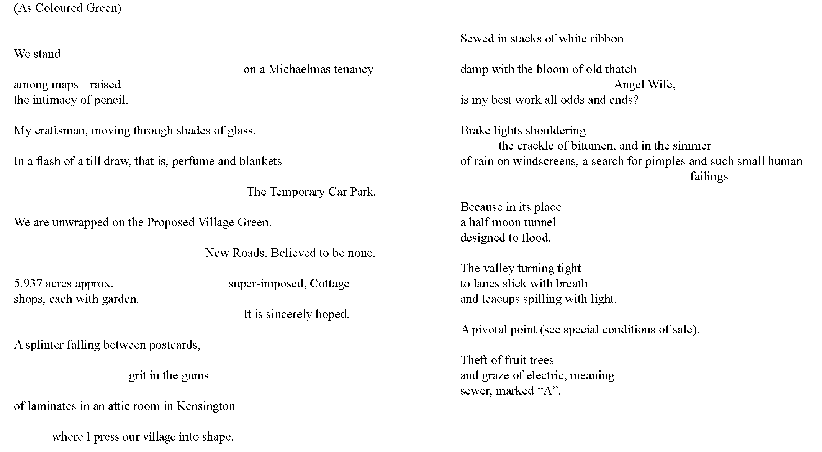

Expanding on the approach of “layering” a landscape, Smith encourages us to seek out the structures of place by disassembling the “already fragmenting evidence, seeking meaning in texture, grain, minutiae, details, marginalia and etiquette” (2017: Kindle Loc. 7993). A “layering” approach to landscape values a hypersensitivity to the everyday, in my case, a zooming in of the language of disparate archival materials. In Lut Lut Lut’s case this becomes a questioning of the accuracy of words. I became obsessed with the sound and feel of certain pastoral words. Meadow. Green. Brook. In the poems, we would hold these words up as words, neither condemning but nor fully believing them.
The question of craft remains. Why turn a man who distrusted words into a poet? For me, the answer was in the question. It was exactly this acute awareness of the slippery, ambiguous, even menacing nature of language that makes him already poet. He just didn’t use words. Christopher Hussey, Lutyens first major biographer describes him as a “poet in practice”, his buildings being...

such a union of visual harmonies, structural intricacies, overtones, fantasy and technical skill, that the result stirs in the beholder a spontaneous delight akin to that produced by a good poet by similar means (1953: 93).

I began to realise that it was my own increasingly obsessive interest in Lutyens that was at the core of the project. I shifted even further from viewing him as a historical figure and positioned myself as part of his story, my poetic voice challenging and intermingling with his own. Unexpectedly, the man who “distrusted words and those who wielded them” (Brown: X). became a poet-mentor, questioning my own sense of poetics and art. Rather than just noting his bewildering personality mix of playfulness and anxiety, I needed to embed it into the form and tone of the writing. There needed to be more visual and sonic play, accepting that play can be a serious act. As his most recent biographer Jane Ridley commented, “There was something slightly desperate about Ned’s clowning. Being a balding forty-two-year-old who refused to grow up wasn’t easy” (2002: 200).
His archives and literature became more textual playgrounds than scholarly wisdom and I was drawn deeper into questioning my own sense of language, visual play and movement, culminating in the concept of the text as an ever-shifting landscape:

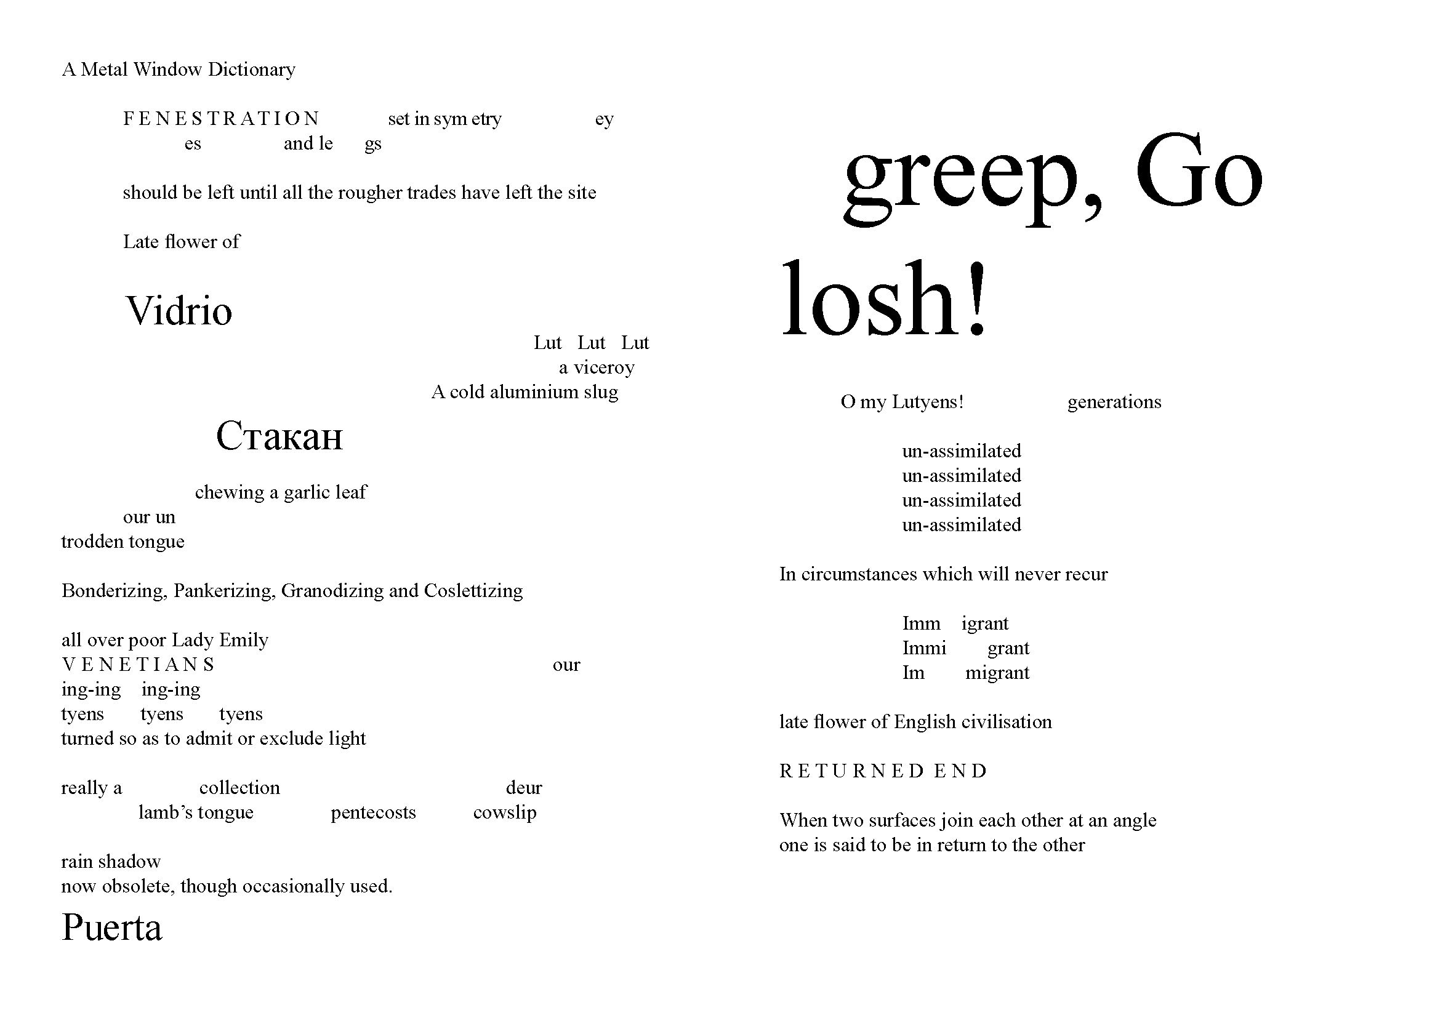

My drift extended to other texts and my search for language became a feature in the poetry. I plundered phrases from a number of craft books, the poem above taking phrases from A Metal Window Dictionary.
The poems are experiments of varying degrees, striking found text against found text in a way that further fragments their archival origins. The tension of the archives was in how it attempted to curate his life, and my experiences sifting through boxes and letters was a confusing mix of humour and minute human tragedy. In a box of letters (LuE/33/3/1-17) sent by Lutyens to the Canon Alexander regarding St Paul’s Cathedral were phrases that reached across to my experiences of Cockington. There are no replies. Each letter features a nugget of questioning advice in the top left. One reads:

it is at least a gain that
we are beginning to perceive
how small we are

(December 12th 1938).

The comment is without context and cast adrift from any details that may begin to explain it. I let this sense of a Lut character build or re-build from these fragments. The other letters follow this form, a nugget of wisdom tucked away in the top right. The lines are typed, with an inky heaviness on the ‘t’s. My photos of them are zoomed in, the words presented as an island of text surrounded by white. One reads “Christianity, like art, is the apotheosis of the commonplace”. Another: “parents will neither correct their children nor let them alone”, and “it is the congregation that preaches the sermon quite as much as the preacher”. And finally, “In times we ought to be listening to a still, small voice, we are deafened by the babble of the market-place.” All these unwarranted gems of advice from a man who avoided language. In the early 1940s a typed line reading “From the Exor. Of the late”, slips above the “From Sir Edwin L. Lutyens, O.M., P.R.A.”.
There is also an unsettling distance. Lutyens was not really in the archives, but nor was he entirely in his buildings, his biographies or his grave, but somewhere between them, or simply nowhere at all. Lut was borne from this distance, the human tragedy that a life, a works, and a death have no solidity.
The Lutyens’ letters became a lens by which to re-construct Cockington Valley; its topography and cultural histories, but also its future. Each poem is a gathering of splinters, curated to form a landscape around Lut, a figurehead for the hopes, dreams and disappointments invested in the land. I wanted a sense of a drift through place and space, the latter being that of the documentary fragments of the archives. Walking and stumbling across multiplicities began the project and eventually extended to the page, with the process of researching and writing the village being a narrative that runs alongside the more tangible written and experienced histories. It was important to engage with that multiplicity, to sneak in, but, at the same time, confuse, my presence as author. The poems would not just be showing up different sides of this village, but they would form a village of themselves, a new Cockington made up of fragments of sources.
It was only by letting go of the village in the first place and allowing myself to be led, both by the living and the dead, that I was able to experience its multiplicities. The act of walking, moving forward with no definite destination, both through a geography and an archive, reminded me that the fragments of time and place are in constant motion. The past is unsettled by our traipsing through it, splintering off into that all important future. This is the greatest lesson of my wanderings, recognising and following that ‘ache for something special’.

Item 4694Z/8 held at the South West Heritage Trust
Quoted in Hussey (1953: 560). From a letter to fellow architect Sir Herbert Baker.
In the case of ‘As Coloured Yellow’, text is lifted from document 4694Z/8, the 1946 sales brochure for the village, and a letter from Lutyens to his wife printed in Percy and Ridley’s 1985 collection, p. 247. The extract refers to his time in India.
Critall, W. F. 1953 A Metal Window Dictionary Batsford.

